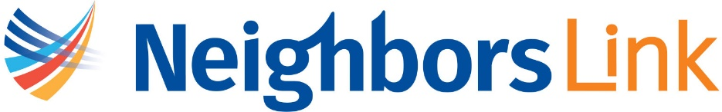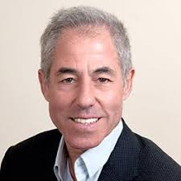

Board Prospect Sheet
Prospect Name | Steven H. Bloom
Contact Info | Email: sblooms5@gmail.com  Phone:
Biography | Mr. Bloom, CFA, has more than 30 years of experience in the alternative asset management business. He is currently managing his family investment office and is engaged in an advisory capacity with several hedge funds. In 1983, he was one of five founding partners of Susquehanna International Group, a global proprietary trading firm, and in 1999, he founded and managed Sagamore Hill Capital Management, a multi-billion-dollar multistrategy hedge fund. He worked as an environmental scientist at the Natural Resources Defense Council for several years before entering the investment field.  Mr. Bloom is chairman of the Binghamton University Foundation and is a member of the Dean’s Advisory Board at the University of the Michigan School of Public Health where he is active with social entrepreneurship initiatives. Mr. Bloom was awarded an honorary Doctor of Humane Letters degree from the State University of New York.
Geographic area | Armonk, NY
Years of involvement | Made first donation in 2023 and is a major donor to Neighbors Link
Range of giving and other  Organizational giving | Bloom actively involved with several philanthropic activities, including serving as a trustee at The New School and at the Binghamton University Foundation and is  a member of the Dean’s Advisory Board at the University of the Michigan School of Public Health where he is active with social entrepreneurship initiatives. He donates $25,000 yearly to the New School and Binghamton University. Has donated between $10,000 -$24,999 to Northern Westchester Hospital has donated $100,000 to the U Michigan school of Public Health. They sponsor a Bloom  Family Summer Internship in Genocide and Mass Atrocity Prevention at Binghamton University Successful applicants may receive up to $7,000.
Attendance of events | Attended 2024 Spring Gala. Visited Center in 2023
Key Staff/Board | Carola Otero Bracco
Why a good match?
Notes | Donated $50,000 to the Lincoln Project in 2023  Has donated to Antonio Delgado, Actblue, Max Rose, and other political candidates
Comments

