NEIGHBORS LINK CORPORATION

POLICIES AND PROTOCOLS PACKAGE

SEPTEMBER 2025

This is an informational document for the board of directors to be revisited over time by the board and its committees; this process will be discussed at the September 29th board meeting.



This document contains confidential materials that should not be shared without prior permission of the Executive Director of Neighbors Link.

Table of Contents
(if Navigation Pane is not on left of screen, Click View tab along top of screen in Word and Check “Show Navigation Pane”)

I. Organizational Policies/Guidelines 6
1. Bylaws (adopted by the Board 10/17/2022) 6
2. Articles of Incorporation (Amendment for Address Change in progress) 19
3. Conflict of Interest Policy Certificate 25
4. Whistleblower Policy 34
5. Committee Charters (approved by Board, April 2024) 37
II. HR Policies/Protocols 44
1. Neighbors Link Employee Handbook (Draft – being reviewed Pro bono Partnership 44
A. GENERAL 48
1. Neighbors Link’s Relationship with Trinet 48
2. Voluntary At Will Employment 50
3. Equal Employment Opportunity and Affirmative Action Policy 51
4. Probationary Period 51
5. Reasonable Accommodation Policy 51
6. Sexual Harassment Policy 53
7. Whistleblower Policy 67
B. COMPENSATION & BENEFITS 67
1. Compensation Rate 67
2. Employee Classifications 68
3. Overtime Pay 68
4. Online Time Recording System 68
5. Social Security & Medicare 69
6. Paid Holidays 69
7. Paid Time Off-Vacation Days 70
8. Paid Time Off - Sick and Safe Time Leave 70
9. Other Leave 71
10. Health Benefits 72
11. Retirement Plan 73
12. Professional Development 73
13. Tuition Reimbursement Program 73
14. Workers Compensation 74
15. Short-Term Disability 74
16. New York Paid Family Leave Program 74
17. Family and Medical Leave 75
18. Paid Parental Leave 79
19. Personal Leaves of Absence 80
20. Donation Leave Policy 81
C. ATTENDANCE POLICIES 82
1. Work Week 82
2. Lunch Period 82
3. Special Events 83
4. Severe Weather Conditions & Early Closings 83
D. STAFF CONDUCT 83
1. Standards of Conduct 83
2. Representing Neighbors Link 84
3. Confidentiality 84
4. Conflicts of Interest 85
5. Drug-Free & Alcohol-Free Workplace 85
6. Workplace Safety 86
7. Computer & Information Security 88
8. Personnel Record 90
9. Performance Evaluation 91
10. Performance Improvement Plan 91
E. EXPENSE REIMBURSEMENT 91
1. Credit Card Purchases 92
2. Mileage Reimbursement 92
F. BUSINESS TRAVEL 92
1. General Travel Requirements 93
2. Air Travel 93
3. Lodging 93
4. Out-Of-Town Meals 94
5. Ground Transportation 94
6. Personal Cars 94
7. Parking/Tolls 95
8. Entertainment and Business Meetings 95
9. Non-Reimbursable Expenses 95
G. TERMINATION OF EMPLOYMENT 95
1. Resignation 95
2. Release from Employment 96
3. Exit Interview 96
4. Return of Property 96
5. Accrued Benefits 97
6. Unemployment Insurance 97
7. Employment References 97
APPENDIX A – CONFIDENTIALITY AGREEMENT 98
APPENDIX B - EMPLOYEE ACKNOWLEDGMENT OF RECEIPT OF HANDBOOK 99
III. Financial Policies and Procedures 100
1. Financial Policies and Procedures March 2025 100
I. Introduction 102
II. Division of Responsibilities 103
III. Chart of Accounts and General Ledger 105
IV. Cash and Other Receipts 106
V. Investments (Policy approved by Board Jan 31, 2022) 108
VI. Inter-Account Bank Transfers 115
VII. Cash and Other Disbursements 116
VIII. Credit Card Policy and Charges 118
IX. Bank Account Reconciliations 119
X. Property and Equipment 120
XI. Personnel Records 121
XII. Payroll Processing 122
XIII. End of Month and Fiscal Year-End Close 124
XIV. Financial Reports 125
2. Check Signing, Bank Signatories, Capitalization Policy Resolutions Approved April 2025 126
3. Document Retention Policy (Draft in progress) 127
4. Insurance Coverage updated 9.23.2025 130
IV. Programs 132
1. Hiring Site Terms and Conditions 132

Organizational Policies/Guidelines

Bylaws (adopted by the Board 10/17/2022)

Adopted 10/17/22

AMENDED AND RESTATED BYLAWS OF
NEIGHBORS LINK, CORP.

ARTICLE I
Name, Purposes and Powers, Offices

Section 1.1 Name. The name of the corporation is Neighbors Link, Corp. (the "Corporation").

Section 1.2 Purposes and Powers. The purposes and powers of the Corporation shall be those set forth in the Corporation's Certificate of Incorporation, as from time-to-time amended, restated, or otherwise modified.

Section1.3 Offices. The principal office of the Corporation shall be located at 27 Columbus Ave., Mount Kisco, New York 10549, in Westchester County, New York. The Corporation may maintain additional offices at such other places within or without New York State as the Board of Directors (the "Board") may from time to time designate.

ARTICLE II
Membership

Section 2.1 No Members. The Corporation shall have no members.

ARTICLE III
Board of Directors

Section 3.1 Power of the Board of Directors. The Board shall be responsible for the strategic vision and direction of the Corporation with general oversight responsibilities for its business, property, and affairs. This includes hiring the Executive Director and approval of the budget, each requiring approval by a majority of the Entire Board.

Section 3.2 Qualifications of Directors. Each director shall be at least eighteen years old. An employee of the Corporation may not be a director. A director need not be a resident of New York State.

Section 3.3 Number of Directors; Terms. The Board shall consist of a minimum of
three and a maximum of thirty directors. Within these specified limits, the number of
directors may be increased or decreased by vote of a majority of the Entire Board. The terms of the directors shall be staggered by dividing the total number of directors into two, equal as possible, sections. Once annually, persons shall be nominated and elected by a majority of the Entire Board to replace those whose terms are expiring, each director thereafter to serve a term of two years.

Section 3.4 Vacancies and Newly Created Directorships. Vacancies occurring in the Board for any reason and newly-created directorships resulting from an increase in the authorized number of directors shall be filled by the affirmative vote of a majority of the Entire Board. Each director so elected shall be elected to the smallest section of directors and serve until the next meeting at which such section is scheduled to be reelected and until the director's successor is elected or until such director's death, resignation or removal.

Section 3.5 Resignation. Any director may resign at any time by delivering notice to the Chair or the Secretary in writing, by email, text or mail. The resignation shall take effect when such notice is so delivered, unless the notice specifies a later effective date, and the acceptance of such resignation shall not be necessary to make it effective.

Section 3.6 Removal. Any one or more of the directors may be removed for cause, or for any other reason, at any time by the affirmative vote of a majority of the Entire Board provided that notice of the proposed action shall have been transmitted to all directors at least one week before said meeting. The Board, in its discretion, may decide what constitutes “cause”. Missing more than three consecutive meetings of the Board may constitute cause for removal.

Section 3.7 Meetings. Meetings of the Board shall be held at such time and place as shall be fixed by the Board for business as needed with one meeting held annually for the election of officers and directors and one meeting for approval of the budget. Special meetings of the Board may be held at any time upon the call of the Chair or by written demand of at least one-fifth of the Entire Board.

Section 3.8 Type of Meetings. Meetings of the Board shall be held either in-person, telephonically, or virtually in accordance with Section 3.7.

Section 3.9 Notice of Meetings. Notice shall be given of meetings and each special meeting of the Board. Notices shall include a written agenda or a general notice of topic if a special meeting is called. Notice shall be provided either by email, text or mail; and notification shall be given one week prior to meeting, except in an emergency where every effort will be made to contact board members by email, text and voicemail. Notice shall include the date, time, and place of the meeting. Notice of any adjourned meeting shall be given to any director who was not present at the time of the adjournment, and to the other directors, if the time and place of the adjourned meeting were not announced at the meeting. Notice of a meeting need not be given to a director who submits a waiver of notice, in writing or via email, text or mail, to the Secretary before or after the meeting, or who attends the meeting without protesting, prior thereto or at its commencement.
Section 3.10 Quorum. Unless a greater proportion is required by law or by the Certificate of Incorporation or these Bylaws, at each meeting of the Board, a majority of the Entire Board shall constitute a quorum for the transaction of business. If a quorum is not present at any meeting of the Board, a majority of those directors present may adjourn the meeting until such a quorum is present. Directors who are present at a meeting but who are conflicted out of the vote are still counted in the quorum.

Section 3.11 Remote Participation in Meetings. Any one or more directors may participate in any meeting of the Board or any committee thereof by means of a conference telephone, videoconference, or similar communications equipment allowing all persons participating in the meeting to hear and speak to each other. Participation by such means shall constitute presence in person at a meeting for all purposes, including quorum and voting.

Section 3.12 Action at a Meeting. Except as otherwise provided by law, the Certificate of Incorporation, or these Bylaws, the affirmative vote of a majority of the directors present at a meeting of the Board, if a quorum is present at the time of the vote, shall be the act of the Board. However, an affirmative vote of at least two-thirds of the Entire Board is required in the following instances: 1) when all or substantially all of the assets of the Corporation are sold, leased, exchanged, or otherwise disposed (this does not include the leasing of space owned by the Corporation); 2) a purchase of real property when such property would, upon purchase, constitute all, or substantially all, of the assets of the corporation; 3) a plan of merger, consolidation, or dissolution; 4) revocation of a plan of voluntary dissolution; and 5) any loan or encumbrance of 30% or more of the total assets or the total income for the immediately prior fiscal year of the Corporation (whichever is smaller). Voting by proxy is not permitted.

Section 3.13 Action without a Meeting. Any action required or permitted to be taken by the Board or any committee of the Board may be taken without a meeting if all members of the Board or such committee consent to the adoption of a resolution authorizing the action. Such consent shall be submitted in writing or via e-mail. The resolution and consents thereto shall be filed with the minutes of the proceedings of the Board or notes of the committee.

Section 3.14 Organization of Meetings. At each meeting of the Board, the Chair, or, in the Chair's absence, the Vice Chair or a person chosen by the directors present, shall preside. The Secretary shall act as secretary of each meeting of the Board, shall record the minutes of each meeting and, upon their adoption by the Board, shall ensure that such minutes are filed with the permanent records of the Corporation. In the absence of the Secretary, the presiding officer of the meeting shall appoint a secretary of the meeting.

Section 3.15 Compensation of Directors and Officers. The Corporation shall not pay any compensation to directors or officers under Article V for their services as directors or officers of the Corporation, except that directors or officers may be reimbursed for reasonable and necessary expenses incurred in the performance of their duties to the Corporation. Subject to the Article IX of these bylaws, Director’s Conflicting Interest and Related Party Transactions, and applicable law, directors may receive reasonable compensation for services performed in other capacities for or on behalf of the Corporation pursuant to authorization by the Board.

ARTICLE IV
Committees

Section 4.1 Committees of the Board. The Board, by resolution adopted by a majority of the Entire Board, may designate from among the directors one or more committees of the Board, each consisting of three or more directors.

Each committee of the Board shall serve at the pleasure of the Board and shall have all the authority of the Board to the extent provided in the resolution of the Board establishing the committee. The Governance Committee shall develop and recommend each committee’s charter for approval by the Board, with each committee responsible for its own goals, except that no such committee shall have authority as to the following matters (this list is not exhaustive):

The filling of vacancies in the Board or voting vacancies in such committee, or the removal of voting vacancies in such committee;
The fixing of compensation of the directors for serving on the Board or on any committee; /
The amendment or repeal of the Bylaws or the adoption of new Bylaws;
The approval of amendments to the Certificate of Incorporation;
The amendment or repeal of any resolution of the Board which by its terms shall not be so amendable or repealable;
The sale, lease, exchange, or other disposition of all or substantially all the assets of the Corporation; I
The adoption of any plan of merger, consolidation, or dissolution of the Corporation; or
The election or removal of officers or directors.

Based on a recommendation developed by the Board Chair, Governance Committee Chair, and Executive Director, the Governance Committee will propose committee chairs to the Board for its approval.

Sections 3.8 through 3.13 of these Bylaws, which govern meetings, notice, quorum, participation in meetings by technology, action at a meeting, and action without a meeting, shall apply to committees of the Board and their members as well, with the date, time and place of such meetings set by the committees.

The designation of any committee of the Board and the delegation thereto of authority shall not alone relieve any director of their duty to the Corporation under Section 717 of the New York Not-for-Profit Corporation Act (Duty of directors and officers).

Any Board committee, other than the audit committee, may include non-voting members and non-Board members chosen by the Board. Non-voting and non-board members may participate, subject to the Conflicts Policy in Article IX, in the discussion of a matter but shall have no voting rights on any matter. The audit committee shall comprise, if required by applicable law, solely Independent Directors, as defined in Section 9.6(d) hereof.

Section 4.2 Executive Committee. The Executive Committee shall be chaired by the Board Chair and include all board officers. Subject to the Executive Committee charter as approved by the Board, the Executive Committee will recommend Executive Director compensation to the Board for its approval, review the Executive Director’s evaluations and annual goals, and address any emergency or time sensitive situations. The Board Chair will provide written notification of its decisions and actions to the Board as expeditiously as possible.

Section 4.3 Documentation. Each committee shall keep regular notes of its proceedings and report the same to the Board. Such documentation shall be retained with the permanent records of such committee.

ARTICLE V
Officers

Section 5.1 Officers. The officers of the Corporation may consist of a Chair, one or more Vice Chairs, a Secretary, a Treasurer, and such other officers with such titles as the Board shall determine, each of whom shall be chosen by and shall serve at the pleasure of the Board.

Section 5.2 Election, Term of Office, and Qualifications. The officers of the Corporation shall be elected by a vote of a majority of the Entire Board, from among the directors for a term of two years biennially, at a meeting of the Board. Each officer shall hold office until the earliest of such officer's successor being elected or such officer's death, resignation or removal. There shall be no limit to the number of times an officer can be re-elected to a particular office. One person may hold and perform the duties of more than one office, except that no person may serve as both Chair and Secretary or Chair and Treasurer. All officers shall be subject to the supervision and direction of the Board.

Section 5.3 Resignation. Any officer may resign at any time by delivering written notice to the Chair or the Secretary. The resignation shall take effect when such notice is so delivered, unless the notice specifies a later effective date, and the acceptance of such resignation shall not be necessary to make it effective.

Section 5.4 Removal. Any officer may be removed by the Board at any time, with or without cause by a vote of a majority of the Entire Board.

Section 5.5 Vacancies. A vacancy in any office arising from any cause shall be filled for the unexpired portion of the term by the Board.

Section 5.6 Powers and Duties of Chair. The Chair shall preside at all meetings of the Board. The Chair shall have and exercise general charge and supervision of the affairs of the Corporation and shall perform such other duties as may be assigned to them by the majority of the Entire Board, these Bylaws, or by law. With input from the Board and Executive Committee, the Board Chair performs the Executive Director evaluation. The Board Chair and Executive Committee recommend Executive Director compensation for approval by the Entire Board.

Section 5.7 Powers and Duties of Vice Chair. At the request of the Chair, or in the event of the Chair's absence or inability to act, a Vice Chair shall perform the duties and possess and exercise the powers of the Chair. If there is more than one Vice Chair, the majority of the Board shall determine which of them shall so perform the duties of the Chair under such circumstances. A Vice Chair shall have such other powers and perform such other duties as the Chair or the majority of the Entire Board may assign to the Vice Chair.

Section 5.8 Powers and Duties of Secretary. The Secretary shall:
Record and submit the minutes of all meetings of the Board;
Ensure that all notices and reports are duly given or filed in accordance with these Bylaws or as otherwise required by law;
In general, perform all duties incident to the office of Secretary and such other duties as the Chair or the majority of the Board may delegate to the Secretary; and
The Corporation shall be the custodian of the Corporation’s records.

Section 5.9 Powers and Duties of Treasurer. The Treasurer shall:
Have oversight of all financial records, funds, and securities of the Corporation, as well as any audit filings and records;
Provide or oversee the provision of a detailed statement of the condition of the finances of the Corporation whenever required by the majority of the Entire Board;
Oversee the preparation and filing of all legally required financial returns and reports, including, but not limited to, the Corporation's Form 990 and state charitable solicitation registrations;
In general, perform all the duties incident to the office of Treasurer, and such other duties as the Chair or the majority of the Entire Board may assign to the Treasurer; and, throughout the year provide or oversee the provision of a statement of the condition of the Corporation's accounts. Such report shall be filed with the minutes of the meeting.

ARTICLE VI
Financial Matters and Records

Section 6.1 Fiscal Year. The fiscal year of the Corporation shall be the calendar year.

Section 6.2 Execution of Instruments. The majority of the Entire Board shall determine which committee or individual will be authorized from time to time and in what manner on the Corporation's behalf to sign checks, drafts, or other orders for payment of money; to sign acceptance, notes, or other evidence of indebtedness; to enter into contracts; or to execute and deliver other documents and instruments.

Section 6.3 Records. The corporation shall keep correct and complete records of the accounts, activities, and transactions of the Corporation. These records shall include a current list of the directors and officers of the Corporation and their addresses, a copy of the Certificate of Incorporation, a copy of these Bylaws, and all minutes of meetings of the Board and committee notes. All records shall be kept in either electronic or written format.

Section 6.4 Prohibition against Loans. The Corporation is prohibited from making any loan to any director, officer or Key Employee (as defined in Section 9.6 below) of the Corporation. Similarly, the Corporation is prohibited from making a loan to a corporation, firm, association, or other entity (except a charitable corporation) in which one or more its directors, officers or Key Employees hold a substantial financial interest.

ARTICLE VII
Personnel

Section 7.1 Executive Director. The Board, by a majority vote of the Entire Board, may hire an executive director, who shall be charged with the administrative and executive management of the affairs of the Corporation, and who shall hold office at the pleasure of the Board. The Executive Director reports to the Board and is supervised directly by the Board Chair. The Board may delegate to the Executive Director any such powers and duties which are delegable as a matter of law, subject, in each case, to review by the Board. Compensation, performance goals, and evaluations will be determined by Executive Committee in accordance with Section 4.2.

ARTICLE VIII
Advisors

Section 8.1 Powers of Advisors. The Board may appoint from time to time any number of persons as advisors to the Corporation, to act either singly or as a committee or committees of the Corporation. Each advisor and committee shall hold such appointment at the pleasure of the Board and shall have only such authority or obligations as the Board may from time to time determine.

Section 8.2 Advisory Council. The Board may designate an Advisory Council. The Advisory Council and each of its members shall serve at the pleasure of the Board and may include non-board members. Members of the Advisory Council may be invited to attend meetings of the Board, but will not be entitled to vote on matters under consideration by the Board. The Advisory Council shall not have or purport to exercise any powers of the Board nor shall it have the power to bind the Corporation contractually.

ARTICLE IX
Directors' Conflicting Interest and Related Party Transactions

Section 9.1 Purpose. The Corporation's conflict of interest and related party transaction policy in Sections 9.1 through 9.6 hereof (the "Conflicts Policy") shall be as follows. All directors, officers, and Key Employees owe a duty of loyalty to the Corporation that requires them to exercise their powers in good faith and in the best interests of the Corporation. A conflict of interest occurs whenever the interests of the Corporation conflict with a competing Financial Interest of a director, officer, Key Employee or other Related Party. The purpose of this Conflicts Policy is to protect the interests of the Corporation, a tax-exempt not-for-profit corporation, when it is contemplating entering into a transaction or arrangement that might benefit a Related Party. This Conflicts Policy is intended to supplement, but not replace, any applicable state or federal laws regarding conflicts of interest applicable to not-for-profit and tax-exempt organizations.

Section 9.2 Duty to Disclose. Prior to their election to the Board or employment at the Corporation, and for each year of service thereafter, each director, officer and currently employed Key Employee must disclose in writing:
Any entity of which such person or a Relative of such person is an officer, director, trustee, member, owner, or employee and with which the Corporation has a relationship;
Any Financial Interest such person or a Relative of such person may have in any corporation, organization, partnership, or other entity which provides goods or services to the Corporation for a fee or other compensation; and
Any position or other material relationship such person or a Relative of such person may have with any not-for-profit corporation with which the Corporation has a business relationship.

These disclosure statements shall be submitted to the Secretary of the Corporation. A copy of each disclosure statement shall be kept in the Corporation's files and made available to any director, officer or currently employed Key Employee upon request. The Secretary also shall provide a copy of all completed statements to the Chair of the Board.

If at any time during their term of service, a director, officer, or Key Employee acquires any Financial Interest, or when any matter for decision or approval comes before the Board in which a Related Party has a Financial Interest, that Financial Interest or potential Related Party Transaction must be promptly disclosed in writing to each member of the Board, together with all material facts. Failure to disclose to the Board a known Financial Interest, a known Related Party Transaction or a known conflict of interest may be grounds for removal from the Board or termination from the Corporation.

Section 9.3 Review and Approval of Related Party Transactions. If the Corporation is contemplating entering into a Related Party Transaction, the Board must determine if the transaction is fair, reasonable, and in the best interests of the Corporation at the time of such determination before approving the transaction. All transactions, agreements, or any other arrangements between the Corporation and a Related Party shall be reviewed by the Board in accordance with the following.

Related Party's Involvement. At the Board's request, the Related Party to whom the potential conflict of interest relates may present factual information regarding the matter. However, the Related Party may not be present for, or participate in, the deliberation or vote on the matter giving rise to the conflict. The Related Party to whom the potential conflict of interest relates shall leave the room prior to the conduct of any deliberations or vote on the matter giving rise to the conflict and shall not attempt to influence improperly the deliberation or voting on the matter giving rise to the conflict.

A voting member of the Board or an officer who receives compensation directly or indirectly from the Corporation for services, or a director serving as a voting member of any committee whose jurisdiction includes compensation matters is precluded from voting or acting on matters pertaining to that director's or officer's compensation. However, no voting member of the Board or any committee whose jurisdiction includes compensation matters and who receives compensation, directly or indirectly, from the Corporation is prohibited from providing information to the Board or any committee regarding compensation.

Investigation of Alternative Transactions; Review of Comparability Data. As part of their investigation, the Board shall consider alternative transactions to the extent available. If the contemplated transaction pertains to compensation for services or the transfer of property or other economic benefit to a Related Party, the Board must determine that the value of the economic benefit provided by the Corporation does not exceed the value of the services, property, or other benefit received in exchange. As part of this determination, the Board shall obtain and review appropriate comparable data.

When considering compensation for services, comparable data may include, but is not limited to:
Compensation paid by similarly situated organizations;
The availability of similar services within the same geographic area;
Current compensation surveys compiled by independent firms; and/or
Written offers from similar institutions competing for the same person's services.

When considering a transfer of property, comparable data may include, but is not limited to:
Current independent appraisals of the property; and/or
Offers received in a competitive bidding process.

Approval Requirements. The Board may not approve any Related Party Transaction unless it determines that the transaction is fair, reasonable, and in the Corporation's best interest at the time of such determination. Approval requires the majority vote of the directors present at the meeting.

Documentation. The Board shall contemporaneously document in the minutes of their meeting:

The name(s) of the Related Party or Parties who disclosed or otherwise were determined to have a potential or actual Financial Interest and/or conflict of interest;
The nature of the potential or actual Financial Interest and/or conflict of interest;
Any actions taken to determine whether a Financial Interest and/or conflict of interest existed;
The Board's decision as to whether the Financial Interest and/or conflict of interest existed;
The names of the persons who were present for discussions and votes relating to any potential or actual conflict of interest or Related Party Transaction (including whether the Related Party or Parties left the room for all such discussions and vote);
The content of such discussions, including the discussion of alternative transactions; and
The decision by the Board to approve or not approve the Related Party Transaction.

Tax Issues. In determining whether to approve such contract or transaction, disinterested directors will take into account the restrictions regarding self-dealing under Section 4941 of the Internal Revenue Code of 1986, as amended (the "Code"), in the case of an organization classified as a Private Foundation, or excess benefit transactions under Section 4958 of the Code, in the case of an organization classified as a Public Charity.

Section 9.4 Annual Statements. Each director, officer and currently employed Key Employee shall annually sign and submit to the Secretary a statement which affirms such person: (a) has received a copy of the Conflicts Policy; (b) has read and understood the Conflicts Policy; and (c) has agreed to comply with the Conflicts Policy.

Section 9.5 Delegation to Audit Committee. The Board may delegate to the Audit Committee, if any, or any other authorized committee composed solely of Independent Directors, the oversight of, implementation of, and compliance with this Conflicts Policy, including the review and approval of any Related Party Transaction; provided that if the Related Party Transaction is of a magnitude that would otherwise require Entire Board approval, the committee shall submit the Related Party Transaction to the Board for consideration, with the committee's recommendation as to whether or not the transaction should be approved.

Section 9.6 Definitions.
Associated Entity: Any entity associated with the Corporation by a parent subsidiary or sister relationship.
Entire Board: The number of directors that were elected as of the most recently held election of directors, or in the interim period, as well as any directors whose terms have not yet expired, but excluding directors who have resigned.
Key Employee: A person who is, or has within the past five years, been in a position to exercise substantial influence over the Corporation's affairs. This includes, but is not limited to:
Heads of Corporation, Presidents, Executive Directors, Chief Executive Officers, Chief Operating Officers, or any person holding similar responsibilities;
Chief Financial Officers, or any person holding similar responsibilities;
"Highly compensated" employees (within the meaning of Section 4958 of the Internal Revenue Code and related guidance) who are in a position to exercise substantial influence over the Corporation's affairs;
Founders of the Corporation;
Substantial contributors to the Corporation;
Persons owning a controlling interest (through votes or value) in the Corporation; and
A nonstock entity controlled by any of the persons described in this section 9.6(B).
Financial Interest: A direct or indirect economic benefit from any transaction, agreement, or compensation arrangement involving the Corporation, including, but not limited to, direct or indirect remuneration, or gifts or favors that are not insubstantial.
Independent Director: A member of the Board who:
Has not been an employee or Key Employee of the Corporation or an Associated Entity within the last three years;
Does not have a Relative who is or has been a Key Employee of the Corporation or an Associated Entity within the last three years;
Has not received, and does not have a Relative who has received, more than $10,000 compensation from the Corporation (other than reimbursement for reasonable expenses) within the last three years;
Has neither been employed by, nor has had a substantial Financial Interest in, any entity that either made or received payments from the Corporation exceeding the lesser of $25,000 or 2% of the entity's gross revenues within the past three years (payments do not include charitable donations);
Does not have a relative who has a substantial Financial Interest or was an officer of any entity that either made or received payments from the Corporation exceeding the lesser of $25,000 or 2% of the entity's gross revenues within the past three years (payments do not include charitable donations); and
Is not in an employment relationship with, or under the control or direction of, any Related Party and does not receive payments subject to the approval of a Related Party.
Related Party:
Any current or former (within the past five years) director, officer or Key Employee of the Corporation;
Any director, officer, or Key Employee of an Associated Entity;
Any Relative of a director, officer, or Key Employee of the Corporation; or
Any entity in which a director, officer, or Key Employee or the Relative of a director, officer, or Key Employee has a 35% or greater ownership or beneficial interest, or, in the case of a partnership or a professional corporation, a direct or indirect ownership interest in excess of 5%.
Related Party Transaction: Any transaction, agreement, or compensation arrangement with the Corporation or an Associated Entity in which a Related Party has a Financial Interest.
Relative: A person's domestic partner, spouse, ancestors, siblings and their spouses, children and their spouses, grandchildren and their spouses, and great grandchildren and their spouses.

ARTICLE X
Insurance and Indemnification

Section 10.1 Insurance. The Corporation shall purchase and maintain Directors and Officers (D&O) insurance for purposes of indemnifying the Corporation for any obligations or expenses which it incurs as a result of its indemnification of directors, officers, employees and agents. The Corporation may also purchase and maintain any additional insurance policies deemed to be in the best interest of the Corporation. The finance committee shall review the Corporation’s insurance policies on an annual basis and report back to the Board.

Section 10.2 Indemnification. To the extent existing insurance coverage does not adequately cover a liability, and to the fullest extent permitted by law, the Corporation shall indemnify any person made, or threatened to be made, a party to, or who is involved in (including as a witness), any action or proceeding by reason of the fact that they are or were a director, officer, employee, or agent of the Corporation, against judgments, fines, amounts paid in settlement and reasonable expenses, including attorneys’ fees actually and necessarily incurred; subject to the provisions under New York State Not-for-Profit Corporation Law. No indemnification may be made to or on behalf of any such person if: (a) their acts were committed in bad faith or were the result of their active and deliberate dishonesty and were material to such action or proceeding; or (b) they personally gained financial profit or other advantage to which they were not legally entitled in the transaction or matter in which indemnification is sought.

ARTICLE XI
Amendments to Bylaws

Section 11.1 By-laws. Subject to the notice requirements of Section 3.9, these Bylaws may be adopted, amended or repealed in whole or in part at any meeting of the Board, at which a quorum is present, by the affirmative vote of a majority of the Entire Board or by unanimous written consent of the Board.

Section 11.2 Certificate. The Board may amend the Certificate of Incorporation at any meeting of the Board, at which a quorum is present, by the affirmative vote of a majority of the Entire Board or by unanimous written consent of the Board.

ARTICLE XII
Nondiscriminatory Policy

Section 13.1 Nondiscriminatory Policy. The Corporation will undertake and carry on its activities without regard to race, color, creed, gender, culture, age, marital status, disability, national origin or sexual orientation. The Corporation will not discriminate on any of these bases in administering its policies and programs.

Adopted on October 17, 2022

___________________________
Secretary Adrienne Marcus

Articles of Incorporation (Amendment for Address Change in progress)
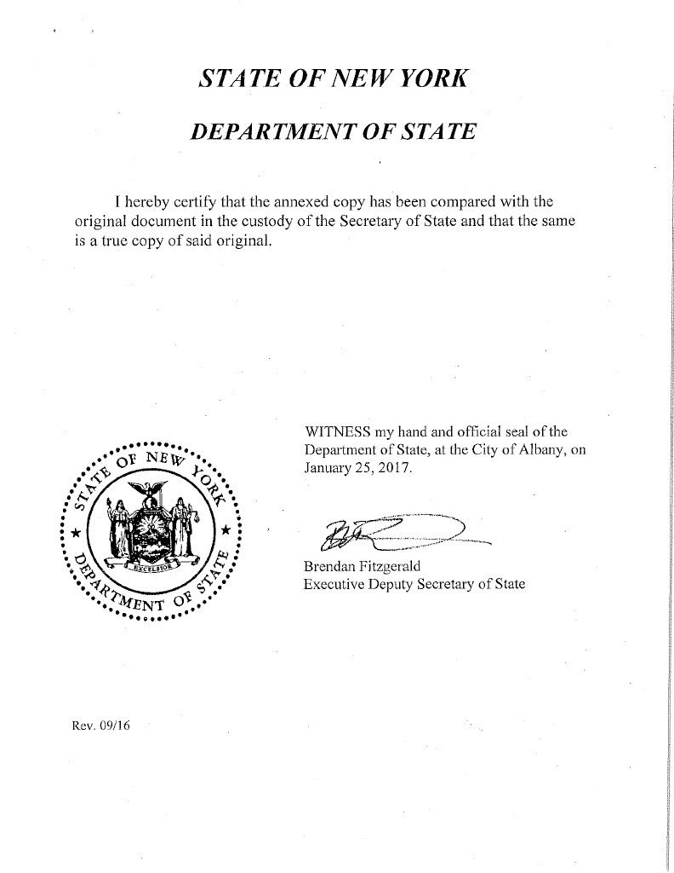
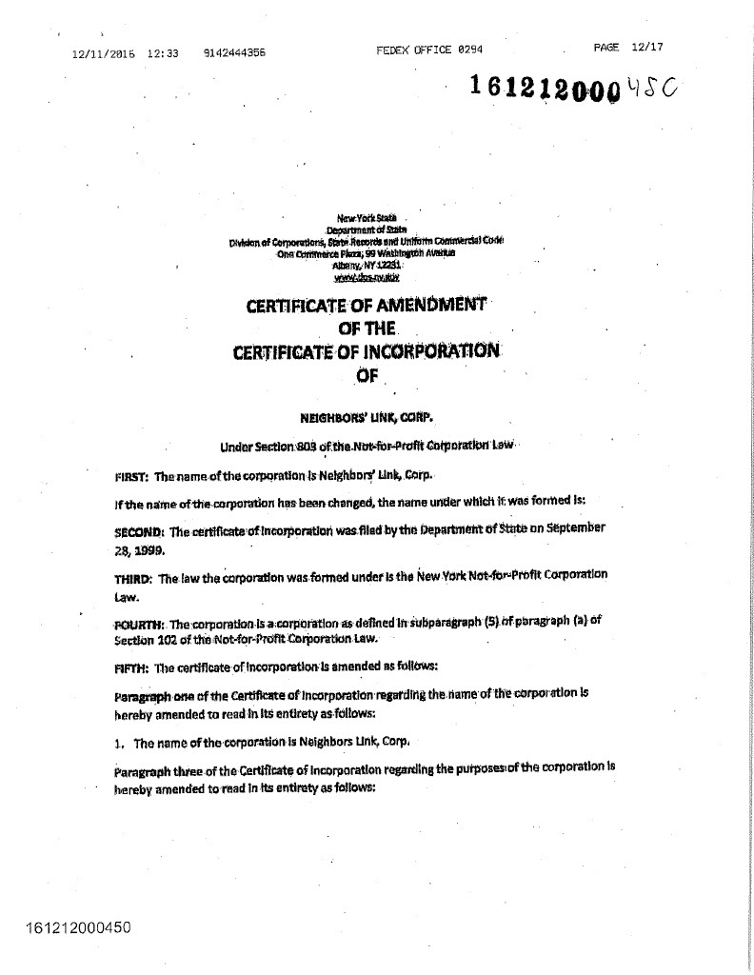
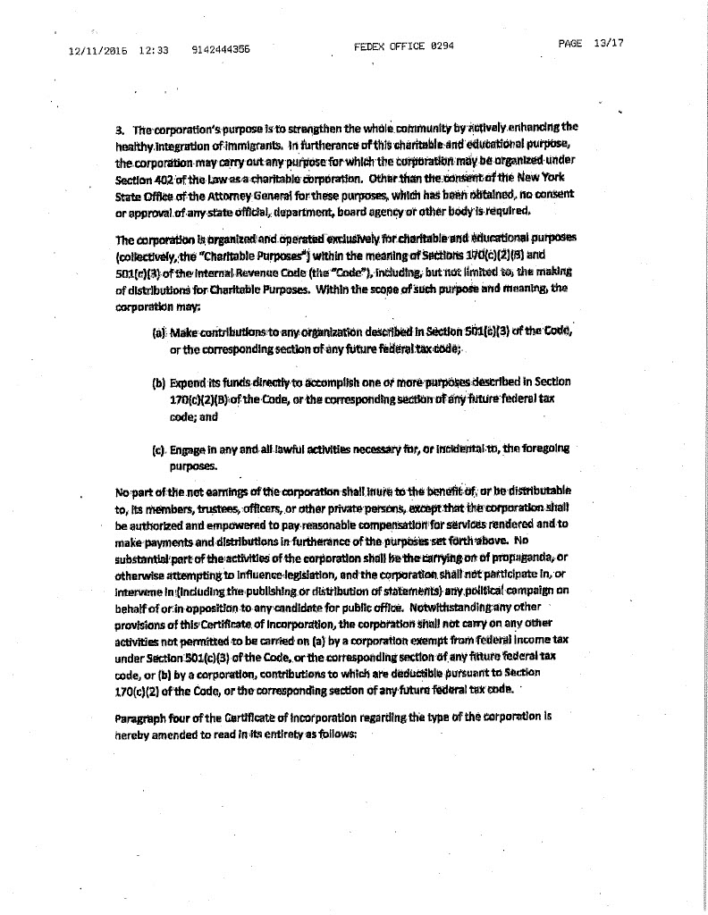
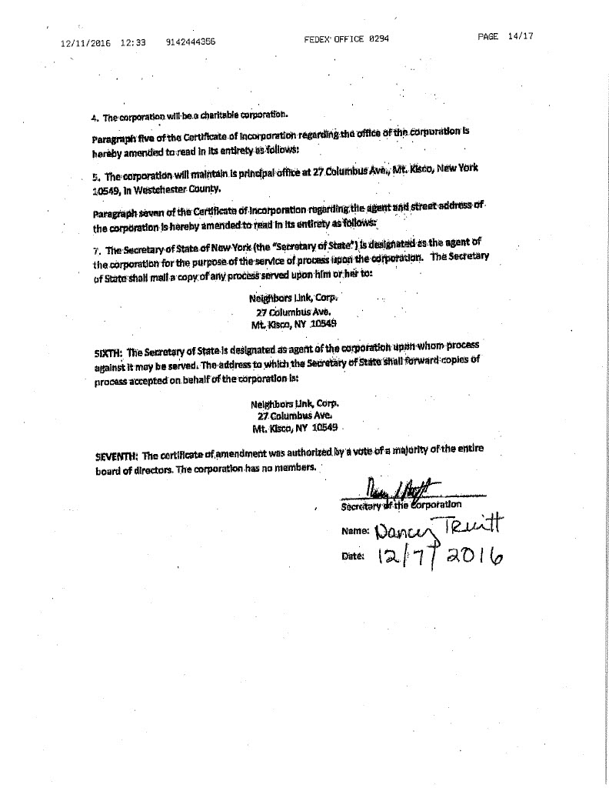
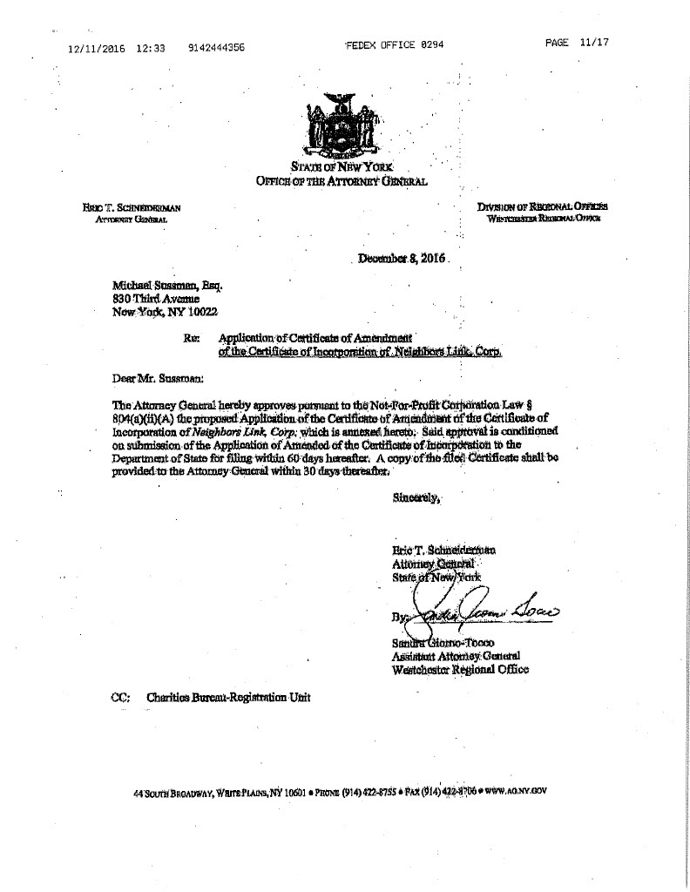
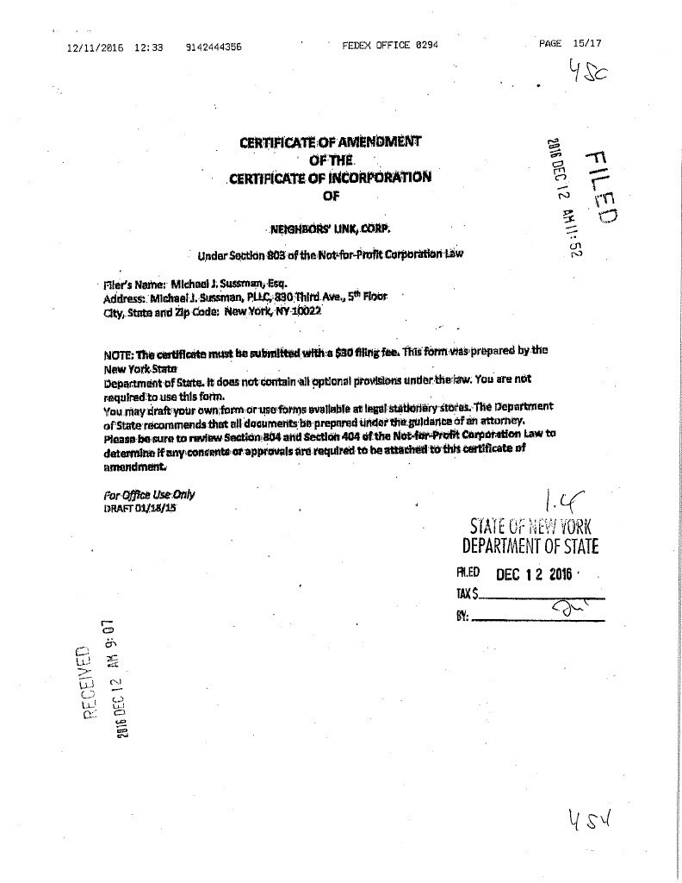

Conflict of Interest Policy Certificate

Neighbors Link

Conflict of Interest Policy Certificate

This certificate must be signed and delivered to the Secretary pursuant to the Neighbors Link, Corp. (the “Corporation”) Conflict of Interest Policy (the “Policy”) as set forth in the by-laws of the Corporation, at such times as specified in the Policy. Please see the Policy at the end of this certificate.

(a) ____ (initial) I have received a copy of the Policy;

(b) ____ (initial) I have read and understand the Policy; and

(c) ____ (initial) I agree to comply with the Policy;

The undersigned, by his or her signature, certifies as indicated above and acknowledges his or her understanding of the implications of the Policy.

__________________________________

Signature

__________________________________

Printed Name

________________________________

Position

________________

Date

Neighbors Link Corp. (the “Corporation”)

Potential Conflict of Interest Disclosure Form

Name: _________________________________________________

Title/Position: _________________________________________________

In responding to these questions, please note that a “yes” answer does not imply that the relationship or transaction is necessarily inappropriate or prohibited.

- Are you an officer, director, trustee, member, owner, or employee of any entity with which the Corporation has a relationship?

Yes ______________ No____________

If the answer is “yes” please list the names of such entities, your affiliation with that entity, and the approximate dollar amount of business involved with the Corporation in the past year:

- Are any of your Relatives an officer, director, trustee, member, owner, or employee of any entity with which the Corporation has a relationship?

Yes ______________ No____________

If the answer is “yes” please list the names of such entities, your Relative’s affiliation with that entity, and the approximate dollar amount of business involved with the Corporation in the past year:

- Do you have a Financial Interest in any corporation, organization, partnership, or other entity which provides goods or services to the Corporation for a fee or other compensation?

Yes ______________ No____________

If the answer is “yes” please list the names of such entities, the nature of your Financial Interest, and the approximate dollar amount of business involved with the Corporation in the past year:

- Do any of your Relatives have a Financial Interest in any corporation, organization, partnership, or other entity which provides goods or services to the Corporation for a fee or other compensation?

Yes ______________ No____________

If the answer is “yes” please list the names of such entities, the nature of your Relative’s Financial Interest, and the approximate dollar amount of business involved with the Corporation in the past year:

- Do you hold a position or have some other material relationship with any not-for-profit corporation with which the Corporation has a business relationship?

Yes ______________ No____________

If the answer is “yes” please list the names of such entities, the nature of your relationship (e.g., employee, board member), and the approximate dollar amount of business involved with the Corporation in the past year:

- Do any of your Relatives hold a position or have some other material relationship with any not-for-profit corporation with which the Corporation has a business relationship?

Yes ______________ No____________

If the answer is “yes” please list the names of such entities, the nature of your Relative’s relationship (e.g., employee, board member), and the approximate dollar amount of business involved with the Corporation in the past year:

- Are you aware of any other transaction in which the Corporation is a participant and in which you may have a conflicting interest?

Yes ______________ No____________

If the answer is “yes”, please identify the transaction and describe the potential conflict:

I affirm that the foregoing information is true and complete to the best of my knowledge and that should any of my responses to this questionnaire change at any time, I will notify the Corporation’s Board of Directors.

Name: | _________________________________________
Signature: | _________________________________________  Date: _________________

Excerpt from Amended and Restated Bylaws of Neighbors Link Corp., Adopted 10/17/22

ARTICLE IX
Directors' Conflicting Interest and Related Party Transactions

Section 9.1 Purpose. The Corporation's conflict of interest and related party transaction policy in Sections 9.1 through 9.6 hereof (the "Conflicts Policy") shall be as follows. All directors, officers, and Key Employees owe a duty of loyalty to the Corporation that requires them to exercise their powers in good faith and in the best interests of the Corporation. A conflict of interest occurs whenever the interests of the Corporation conflict with a competing Financial Interest of a director, officer, Key Employee or other Related Party. The purpose of this Conflicts Policy is to protect the interests of the Corporation, a tax-exempt not-for-profit corporation, when it is contemplating entering into a transaction or arrangement that might benefit a Related Party. This Conflicts Policy is intended to supplement, but not replace, any applicable state or federal laws regarding conflicts of interest applicable to not-for-profit and tax-exempt organizations.

Section 9.2 Duty to Disclose. Prior to their election to the Board or employment at the Corporation, and for each year of service thereafter, each director, officer and currently employed Key Employee must disclose in writing:
- Any entity of which such person or a Relative of such person is an officer, director, trustee, member, owner, or employee and with which the Corporation has a relationship;
- Any Financial Interest such person or a Relative of such person may have in any corporation, organization, partnership, or other entity which provides goods or services to the Corporation for a fee or other compensation; and
- Any position or other material relationship such person or a Relative of such person may have with any not-for-profit corporation with which the Corporation has a business relationship.

These disclosure statements shall be submitted to the Secretary of the Corporation. A copy of each disclosure statement shall be kept in the Corporation's files and made available to any director, officer or currently employed Key Employee upon request. The Secretary also shall provide a copy of all completed statements to the Chair of the Board.

If at any time during their term of service, a director, officer, or Key Employee acquires any Financial Interest, or when any matter for decision or approval comes before the Board in which a Related Party has a Financial Interest, that Financial Interest or potential Related Party Transaction must be promptly disclosed in writing to each member of the Board, together with all material facts. Failure to disclose to the Board a known Financial Interest, a known Related Party Transaction or a known conflict of interest may be grounds for removal from the Board or termination from the Corporation.

Section 9.3 Review and Approval of Related Party Transactions. If the Corporation is contemplating entering into a Related Party Transaction, the Board must determine if the transaction is fair, reasonable, and in the best interests of the Corporation at the time of such determination before approving the transaction. All transactions, agreements, or any other arrangements between the Corporation and a Related Party shall be reviewed by the Board in accordance with the following.

- Related Party's Involvement. At the Board's request, the Related Party to whom the potential conflict of interest relates may present factual information regarding the matter. However, the Related Party may not be present for, or participate in, the deliberation or vote on the matter giving rise to the conflict. The Related Party to whom the potential conflict of interest relates shall leave the room prior to the conduct of any deliberations or vote on the matter giving rise to the conflict and shall not attempt to influence improperly the deliberation or voting on the matter giving rise to the conflict.

A voting member of the Board or an officer who receives compensation directly or indirectly from the Corporation for services, or a director serving as a voting member of any committee whose jurisdiction includes compensation matters is precluded from voting or acting on matters pertaining to that director's or officer's compensation. However, no voting member of the Board or any committee whose jurisdiction includes compensation matters and who receives compensation, directly or indirectly, from the Corporation is prohibited from providing information to the Board or any committee regarding compensation.

- Investigation of Alternative Transactions; Review of Comparability Data. As part of their investigation, the Board shall consider alternative transactions to the extent available. If the contemplated transaction pertains to compensation for services or the transfer of property or other economic benefit to a Related Party, the Board must determine that the value of the economic benefit provided by the Corporation does not exceed the value of the services, property, or other benefit received in exchange. As part of this determination, the Board shall obtain and review appropriate comparable data.

When considering compensation for services, comparable data may include, but is not limited to:
  - Compensation paid by similarly situated organizations;
  - The availability of similar services within the same geographic area;
  - Current compensation surveys compiled by independent firms; and/or
  - Written offers from similar institutions competing for the same person's services.

When considering a transfer of property, comparable data may include, but is not limited to:
- Current independent appraisals of the property; and/or
- Offers received in a competitive bidding process.

- Approval Requirements. The Board may not approve any Related Party Transaction unless it determines that the transaction is fair, reasonable, and in the Corporation's best interest at the time of such determination. Approval requires the majority vote of the directors present at the meeting.

- Documentation. The Board shall contemporaneously document in the minutes of their meeting:

  - The name(s) of the Related Party or Parties who disclosed or otherwise were determined to have a potential or actual Financial Interest and/or conflict of interest;
  - The nature of the potential or actual Financial Interest and/or conflict of interest;
  - Any actions taken to determine whether a Financial Interest and/or conflict of interest existed;
  - The Board's decision as to whether the Financial Interest and/or conflict of interest existed;
  - The names of the persons who were present for discussions and votes relating to any potential or actual conflict of interest or Related Party Transaction (including whether the Related Party or Parties left the room for all such discussions and vote);
  - The content of such discussions, including the discussion of alternative transactions; and
  - The decision by the Board to approve or not approve the Related Party Transaction.

- Tax Issues. In determining whether to approve such contract or transaction, disinterested directors will take into account the restrictions regarding self-dealing under Section 4941 of the Internal Revenue Code of 1986, as amended (the "Code"), in the case of an organization classified as a Private Foundation, or excess benefit transactions under Section 4958 of the Code, in the case of an organization classified as a Public Charity.

Section 9.4 Annual Statements. Each director, officer and currently employed Key Employee shall annually sign and submit to the Secretary a statement which affirms such person: (a) has received a copy of the Conflicts Policy; (b) has read and understood the Conflicts Policy; and (c) has agreed to comply with the Conflicts Policy.

Section 9.5 Delegation to Audit Committee. The Board may delegate to the Audit Committee, if any, or any other authorized committee composed solely of Independent Directors, the oversight of, implementation of, and compliance with this Conflicts Policy, including the review and approval of any Related Party Transaction; provided that if the Related Party Transaction is of a magnitude that would otherwise require Entire Board approval, the committee shall submit the Related Party Transaction to the Board for consideration, with the committee's recommendation as to whether or not the transaction should be approved.

Section 9.6 Definitions.
- Associated Entity: Any entity associated with the Corporation by a parent subsidiary or sister relationship.
- Entire Board: The number of directors that were elected as of the most recently held election of directors, or in the interim period, as well as any directors whose terms have not yet expired, but excluding directors who have resigned.
- Key Employee: A person who is, or has within the past five years, been in a position to exercise substantial influence over the Corporation's affairs. This includes, but is not limited to:
  - Heads of Corporation, Presidents, Executive Directors, Chief Executive Officers, Chief Operating Officers, or any person holding similar responsibilities;
  - Chief Financial Officers, or any person holding similar responsibilities;
  - "Highly compensated" employees (within the meaning of Section 4958 of the Internal Revenue Code and related guidance) who are in a position to exercise substantial influence over the Corporation's affairs;
  - Founders of the Corporation;
  - Substantial contributors to the Corporation;
  - Persons owning a controlling interest (through votes or value) in the Corporation; and
  - A nonstock entity controlled by any of the persons described in this section 9.6(B).
- Financial Interest: A direct or indirect economic benefit from any transaction, agreement, or compensation arrangement involving the Corporation, including, but not limited to, direct or indirect remuneration, or gifts or favors that are not insubstantial.
- Independent Director: A member of the Board who:
  - Has not been an employee or Key Employee of the Corporation or an Associated Entity within the last three years;
  - Does not have a Relative who is or has been a Key Employee of the Corporation or an Associated Entity within the last three years;
  - Has not received, and does not have a Relative who has received, more than $10,000 compensation from the Corporation (other than reimbursement for reasonable expenses) within the last three years;
  - Has neither been employed by, nor has had a substantial Financial Interest in, any entity that either made or received payments from the Corporation exceeding the lesser of $25,000 or 2% of the entity's gross revenues within the past three years (payments do not include charitable donations);
  - Does not have a relative who has a substantial Financial Interest or was an officer of any entity that either made or received payments from the Corporation exceeding the lesser of $25,000 or 2% of the entity's gross revenues within the past three years (payments do not include charitable donations); and
  - Is not in an employment relationship with, or under the control or direction of, any Related Party and does not receive payments subject to the approval of a Related Party.

- Related Party:
  - Any current or former (within the past five years) director, officer or Key Employee of the Corporation;
  - Any director, officer, or Key Employee of an Associated Entity;
  - Any Relative of a director, officer, or Key Employee of the Corporation; or
  - Any entity in which a director, officer, or Key Employee or the Relative of a director, officer, or Key Employee has a 35% or greater ownership or beneficial interest, or, in the case of a partnership or a professional corporation, a direct or indirect ownership interest in excess of 5%.
- Related Party Transaction: Any transaction, agreement, or compensation arrangement with the Corporation or an Associated Entity in which a Related Party has a Financial Interest.
- Relative: A person's domestic partner, spouse, ancestors, siblings and their spouses, children and their spouses, grandchildren and their spouses, and great grandchildren and their spouses.

Whistleblower Policy
WHISTLEBLOWER POLICY

Neighbors’ Link, Corp. (the “Corporation”) requires its directors, officers, employees, and volunteers to observe high standards of business and personal ethics in the conduct of their duties. All representatives of the Corporation are expected to practice honesty and integrity in fulfilling their responsibilities and to comply with all applicable laws and regulations.

Reporting Responsibility

This Whistleblower Policy (the “Policy”) provides a means for directors, officers, employees, and volunteers of the Corporation to raise good faith concerns about behavior by or within the Corporation that is, or appears to be, illegal, fraudulent, dishonest, unethical, or in violation of any adopted policy of the Corporation (a “Suspected Violation”). It is the responsibility of all directors, officers, employees, and volunteers to comply with this Policy and to report Suspected Violations in accordance with the procedures set forth in this Policy.

A Suspected Violation may involve directors, officers, employees, volunteers, accountants, auditors, consultants, vendors, or other third parties. Examples of Suspected Violations which should be reported under this Policy include, but are not limited to: violations of federal, state, or local laws or regulations; fraud; theft; embezzlement; bribery; kickbacks; payment for services that are not rendered or goods that are not delivered; self-dealing; private inurement or private benefit (e.g., the Corporation’s assets being used for personal gain or benefit); destroying, altering, concealing or falsifying a document, or attempting to do so, with the intent to impair the document’s availability for use in an official proceeding; accounting or auditing irregularities, including providing false information to, or withholding material information from, the Corporation’s auditors, or supplying false or misleading information on the Corporation’s financial documents, federal tax returns (Form 990), or filings with state agencies; violations of ethical standards or corporate policies adopted by the Corporation; or planning, facilitating, or concealing any of the above.

In addition, actions which have not been taken and which a person believes are required to be taken to comply with laws, regulations, or corporate policies, are also Suspected Violations within the meaning of this Policy and should be reported.

Confidentiality

Reports of Suspected Violations will be kept confidential to the extent possible and permissible by law, consistent with the need to conduct a fair and adequate investigation and take necessary corrective action.

No Retaliation

No director, officer, employee, or volunteer who in good faith reports a Suspected Violation or who cooperates with an investigation of such a report (whether by the Corporation, its agents, or auditors, or by any law enforcement officials, government, or regulatory agency) shall suffer intimidation harassment, discrimination, retaliation, or, in the case of an employee, adverse employment consequences, because of such report. Any person who retaliates against someone who has reported a Suspected Violation in good faith will be subject to appropriate discipline and corrective action, up to and including termination of employment or volunteer status, or removal from office or the board.

Notwithstanding anything contained herein to the contrary, this Policy is not an employment contract and does not modify the employment relationship between the Corporation and its employees, nor does it change the fact that employees of the Corporation are employees at will. Nothing contained herein provides any director, officer, employee, or volunteer with any additional rights or causes of actions, other than those provided by Section 1107 of the Sarbanes-Oxley Act of 2002.

Oversight of Policy and Designation of Compliance Officer

The Audit Committee shall oversee the implementation of and compliance with this Policy. The Chair of the Audit Committee is designated as the Compliance Officer responsible for investigating and overseeing the resolution of all reported complaints concerning Suspected Violations, in accordance with the procedures set forth in this Policy.

Reporting Procedure

Any person may report a Suspected Violation, either in writing or verbally. The report should include any available documentation to support a reasonable basis for the allegation(s) and to assist in investigating the complaint.

Reports of Suspected Violations may be made anonymously. Anonymous reports should be detailed to the greatest extent possible, as follow up questions will not be possible.

All reports of Suspected Violations should be directed to the Compliance Officer. If the Compliance Officer is the subject of the Suspected Violation, or if a person is not comfortable reporting a Suspected Violation to the Compliance Officer or is unsatisfied with the response of the Compliance Officer, the person is encouraged to instead speak with his or her supervisor, or anyone in management with whom he or she is comfortable. In such cases, the manager to whom the Suspected Violation is reported shall in turn report such Suspected Violation to the Compliance Officer, unless the Compliance Officer is the subject of the report, in which case the manager shall submit the report to the Audit Committee. If the Compliance Officer is the subject of the report, the Audit Committee shall designate someone to act in place of the Compliance Officer and all references to the Compliance Officer in this Policy shall be applicable to such designee. Such report shall include a statement as to whether the Suspected Violation was reported first to the Compliance Officer; if it was not, the report shall indicate why.

Persons who report Suspected Violations are not responsible for investigating the activity or for determining fault or corrective measures.

Although a person is not expected to prove the truth of the allegation(s) asserted in his or her report, she or he must demonstrate reasonable grounds for concern and act in good faith. No investigation will be made of unspecified wrongdoing or broad allegations. A report that proves to be unsubstantiated and to have been made maliciously or with the knowledge that such allegations were false will be viewed as a serious offense.

Handling Reports of Suspected Violations

Unless the report is submitted anonymously or there are overriding legal or public interest concerns, the Compliance Officer will provide the person who made the report an acknowledgment of receipt of his or her report within ten business days.

All reports will be promptly investigated and resolved by or under the direction of the Compliance Officer. Depending on the Compliance Officer’s determination of the seriousness or severity of the report, the Compliance Officer may resolve a report without consulting others; discuss such report with the Audit Committee, any other Board Committee(s), or the Board of Directors before taking action; or refer the matter to the Audit Committee or the Board of Directors for action. The Compliance Officer may delegate the responsibility to investigate a report to one or more employees of the Corporation, or to any other individual, including persons not employed by the Corporation; provided that the Compliance Officer may not delegate such responsibility to an individual who is the subject of such report, or in a manner that would compromise the identity of a person who made a report anonymously, the confidentiality of the report, or the confidentiality of the investigation.

Appropriate corrective action will be taken if warranted by the investigation.

On at least a quarterly basis, the Compliance Officer shall provide the Audit Committee a written report identifying all reports of Suspected Violations made under this Policy during the preceding quarter or indicating that no such reports were made. The Compliance Officer shall also report to the full Board of Directors at least annually regarding such reports. Records of all reports and investigations shall be maintained in accordance with the Corporation’s record retention policy.

Questions and Distribution

Any questions, concerns, or suggestions regarding this Policy should be addressed to the Compliance Officer.

Copies of this Policy shall be distributed to all directors, officer, employees and volunteers providing substantial services to the Corporation.

* * *

Adopted by the Board of Directors of Neighbors’ Link, Corp. on February 23, 2015

Last updated: February 23, 2015

Committee Charters (approved by Board, April 2024)


COMMITTEE CHARTERS
Approved by board of directors: April, 2024 Board Meeting

- ADVOCACY AND COMMUNICATIONS COMMITTEE CHARTER

The Advocacy and Communications Committee provides strategic oversight and direction on the advocacy and communications initiatives of Neighbors Link.

Responsibilities

- Work with Neighbors Link staff on the development of an annual communications strategy focused on the organization’s work to strengthen the whole community through the empowerment and integration of immigrants.
- Provide direction to ensure that communications and advocacy functions are integrated with the other departments to broaden and deepen the community’s awareness and support, financially and otherwise.
- Work with Neighbors Link staff on the development of an annual advocacy strategy consistent with our mission and 501c3 tax classification. Ensure the strategy is flexible and allows for the inclusion of various advocacy issues that may surface throughout the year.
- Educate the Board regularly on advocacy and policy issues, paying special attention to how they align with our mission.
- Integrate and engage Friends of Neighbors Link in advocacy and recognize their significant contributions.
- Support the organization in outreach to elected officials on the highest priority advocacy issues.
- Semi-annually, review the implementation and impact of the communications and advocacy strategies.

- AUDIT COMMITTEE CHARTER

The Audit Committee assists the board to safeguard the organization’s financial integrity,
provide oversight of the financial reporting process, the audit process, the company’s system of
internal controls, and compliance with laws and regulations and best practices.

Responsibilities

- Oversee the annual independent audit process.
- Retain or renew the retention of an independent auditor to conduct the audit and annually review the auditor’s performance and independence.
- Review with the independent auditor the scope and planning of the audit before the audit begins.
- Upon the completion of the audit, receive all reports and management letters from the
independent auditor and review and discuss with the auditor (1) any material risks and
weaknesses in the internal controls identified; (2) any restrictions on the scope of the
auditor’s activities or access to information; (3) any significant disagreements between
the auditor and management; and (4) the adequacy of the Corporation’s accounting and
financial reporting process.
- Report the Audit Committee’s findings to the Board.
- Review the annual information returns (IRS Form 990 and the form NY CHAR 500, related schedules, and forms) and recommend for approval, signature, and submission by the appropriate officer.
- Ensure the organization complies with best practices and all required statutory policies, including risk-management, conflict of interest, whistleblower and all other policies as required by law.

- DEVELOPMENT COMMITTEE CHARTER

The Development Committee ensures the organization’s total development program is in concert with
the organization’s strategic direction and needs.

Responsibilities

- Review the annual development plan, which includes the development strategy and annual budget and make recommendations as appropriate
- Understand and recommend to the finance committee the revenue objectives for the annual budget.
- Ensure the Board is educated about the annual development plan along with recommendations
for funding the resources needed to meet the plan.
- Understand the financial returns on fundraising activities and ensure they are aligned with the
annual plan objectives.
- Monitor the actuals to budget progress throughout the year and ensure the Board is updated regularly.
- Encourage the Board’s full participation in fundraising activities including events, appeals and
Campaigns.
- Meet with key donors in alignment with the Development Director and Executive Director
- Introduce potential donors to the organization.
- Integrate and engage the Friends in fundraising and recognize their significant contributions.

- EXECUTIVE COMMITTEE CHARTER

Responsibilities

- Meet as it deems necessary to carry out its responsibilities.
- Recommend the succession plan to the Board of Directors for approval.
- Carry out the responsibilities as outlined in the Succession Plan in the event of a temporary or permanent absence of the Executive Director.
- Provide guidance and support to the Executive Director during emergency situations for the organization. In such situations, the Board Chair is authorized to act on behalf of the committee in other than legally binding obligations.
- Take action when required with a minimum of three of the four members present, provided that all three members vote in agreement.
- Formulate the ED annual goals and evaluate the ED’s annual performance.
- FINANCE AND PERSONNEL COMMITTEE CHARTER
(revision approved at the May 2024 board meeting)

The Finance and Personnel Committee is responsible for assisting the board in monitoring the
financial operations and financial health of the organization.

Responsibilities
- Oversee the timely preparation of financial statements & maintenance of financial records
- Monitor income and expenditures against projections.
- Review and recommend financial policies to the board, including internal controls and maintaining financial records in accordance with standard accounting practices.
- Present quarterly or monthly financial statements to the board, as well as the financial report required by the by-laws.

- Oversee budget preparation and financial planning
- Propose for board approval a budget that reflects the organization’s goals and board policies including the needs, expenses, and revenue of the organization.

- Collaborate with the Executive Director and CFO to safeguard the organization’s assets
- Review the organization’s insurance and risk-management procedures.
- Review capital spending budgets to insure the appropriate use of resources.
- Develop and modify an Investment Policy to manage the investment assets of Neighbors Link. The specific responsibilities of the committee as it relates to the Investment policy include:
    - Establish reasonable and consistent investment objectives, policy guidelines and allocations, which will direct the investment of the assets, to be reviewed by the Board of Directors on an annual basis.
    - Prudently and diligently select an Investment Manager for asset manager selection of funds.
    - Work with the Executive Director and Chief Financial Officer to communicate the organization’s financial needs to the Investment Manager on a timely basis.
    - Regularly evaluate the performance of the Investment Manager to assure adherence to policy guidelines and to monitor investment objective progress.
    - Develop and enact proper control procedures, replace an Investment Manager due to a fundamental change in the investment management process or for failure to comply with established guidelines, or based on performance.
    - Report on investment results and investment objective progress to the Board of Directors on a quarterly basis.

- Assist the board in understanding the organization’s financial affairs.
- Ensure that the board is well informed about the organization’s finances.
- Educate the board about financial matters.

- Review with Executive Director overall compensation and benefits strategy on an annual basis, including 401k plan.

- GOVERNANCE COMMITTEE CHARTER

The Governance Committee helps the Board reach its potential as an effective oversight entity, by recommending board education and ensuring proper governance practices, including compliance with state and federal statutory changes and board responsibilities.
Responsibilities
- Develop and implement a plan for recruiting and nominating diverse and skilled board members
- Ensure that new board members are oriented and assigned to committees in a timely manner
- Conduct a board self-assessment every two years; report results to the board and provide a progress update at midpoint
- Periodically review bylaws and make recommendations for changes to the board
- Review committee charters and make recommendations for changes to the board
- Work with staff to develop meaningful board education sessions
- Recommend officers, committee chairs and committee members to the board for approval
- Conduct other business as requested by the Chair or board

- LEGAL COMMITTEE CHARTER

The Legal Committee supports Neighbors Link by providing oversight and strategic input to the
Neighbors Link Community Law Practice (NLCLP).

Responsibilities

- Assist the Executive Director, Legal Director and NLCLP managing attorneys in assessing the
NLCLP’s scope and priorities.
- Follow current and future shifts in immigration policy.
- Provide strategic input regarding the scope and type of legal services provided by the NLCLP to
ensure the overall model addresses emerging legal needs of community members based on
current immigration policies and adequately prepares for future shifts based on immigration
projections.
- Monitor outcomes of NLCLP.
- Ensure the Board is well informed about important issues relating to the NLCLP including the
legal practice model and immigration policy.
- Interface with advocacy committee, as necessary, on pressing issues facing legal clients.
- Maintain oversight of risk management by advocating that the NLCLP has (i) sufficient
capacity/resources to address the legal needs of its clients and (ii) appropriate liability insurance
in place, consistent with the scope of its legal practice.
- Conduct other business as requested by the Chair or Board.

- PROGRAM COMMITTEE CHARTER

The Program Committee’s role is to support NL staff by providing oversight and a forum for strategic discussion regarding programming, including impact and community needs; to communicate programming information to the board bi-annually as well as to facilitate strategic board discussions in the area of programs; to make programming recommendations to the board; and to implement Board directives. The Program Committee will work with the Strategic Planning Committee when new programs move in new directions.

Responsibilities:

- Maintain general oversight of all existing, pilot, and proposed programming at Neighbors Link.
- Work with the Executive Director and leadership team to address strategic questions regarding programs, including whether current programs meet community needs.
- Ensure that mechanisms are in place to measure impact of programs; analyze those measurements and outcomes to identify strategic issues.
- Ensure the board is well informed about Neighbors Link programs and encourage board member visits to programming annually.
- Support NL staff in strengthening programs by offering expertise, reaching out to board members, identifying partnerships, etc.

- STRATEGIC PLANNING COMMITTEE CHARTER

The Strategic Planning Committee ensures the Board’s support and approval of Neighbors Link’s
strategic direction. This is accomplished through collaboration with the executive director, deputy
director and staff in the development and monitoring of long-term strategic priorities for presentation
to the Board for approval.

Responsibilities

- Collaborate with the executive director, deputy director and staff to develop and regularly
review the long-term strategic priorities of the organization for presentation and
recommendation to the Board for approval.
- Work with the executive director and deputy director to regularly review progress of the strategic
initiatives.
- Ensure the board is well informed and in agreement about Neighbors Link strategic direction.
- Support the executive director and deputy director by keeping current and informed on trends
and opportunities relevant to the strategic priorities of the organization

HR Policies/Protocols

Neighbors Link Employee Handbook (Draft – being reviewed Pro bono Partnership


Updated 9/3/2025
EMPLOYEE

HANDBOOK

DRAFT
Table of Contents
A. GENERAL 5
1. Neighbors Link’s Relationship with Trinet 5
2. Voluntary At Will Employment 7
3. Equal Employment Opportunity and Affirmative Action Policy 8
4. Probationary Period 8
5. Reasonable Accommodation Policy 8
6. Sexual Harassment Policy 10
B. COMPENSATION & BENEFITS 23
1. Compensation Rate 23
2. Employee Classifications 24
3. Overtime Pay 24
4. Online Time Recording System 25
5. Social Security & Medicare 25
6. Paid Holidays 25
7. Paid Time Off-Vacation Days 26
8. Paid Time Off - Sick and Safe Time Leave 27
9. Other Leave 27
10. Health Benefits 28
11. Retirement Plan 29
12. Professional Development 29
13. Tuition Reimbursement Program 29
14. Workers Compensation 30
15. Short-Term Disability 30
16. New York Paid Family Leave Program 30
17. Family and Medical Leave 31
18. Paid Parental Leave 35
19. Personal Leaves of Absence 36
20. Donation Leave Policy 37
C. ATTENDANCE POLICIES 38
1. Work Week 38
2. Lunch Period 38
3. Special Events 39
4. Severe Weather Conditions & Early Closings 39
D. STAFF CONDUCT 39
1. Standards of Conduct 39
2. Representing Neighbors Link 40
3. Confidentiality 40
4. Conflicts of Interest 41
5. Drug-Free & Alcohol-Free Workplace 41
6. Workplace Safety 42
7. Computer & Information Security 44
8. Personnel Record 46
9. Performance Evaluation 47
10. Performance Improvement Plan 47
E. EXPENSE REIMBURSEMENT 47
1. Credit Card Purchases 47
2. Mileage Reimbursement 48
F. BUSINESS TRAVEL 48
1. General Travel Requirements 48
2. Air Travel 49
3. Lodging 49
4. Out-Of-Town Meals 49
5. Ground Transportation 50
6. Personal Cars 50
7. Parking/Tolls 50
8. Entertainment and Business Meetings 50
9. Non-Reimbursable Expenses 51
G. TERMINATION OF EMPLOYMENT 51
1. Resignation 51
2. Release from Employment 51
3. Exit Interview 52
4. Return of Property 52
5. Accrued Benefits 52
6. Unemployment Insurance 52
7. Employment References 53
APPENDIX A – CONFIDENTIALITY AGREEMENT 54
APPENDIX B - EMPLOYEE ACKNOWLEDGMENT OF RECEIPT OF HANDBOOK 55

Dear Neighbors Link Staff,
I am very pleased that you are a part of our team! Each and every one of you contribute substantially to the success of our organization. Quite simply, you are the people that make this organization a special place to work. Together, we will work hard to implement our mission to strengthen the WHOLE community by actively enhancing the HEALTHY INTEGRATION of immigrants.
As an employee, you play a critical role in the success of Neighbors Link and all of your actions and hard work reflect directly on our organization. It is the professionalism and strong work ethic of our team that has earned Neighbors Link the strong reputation we have today, both among the community we serve and all our stakeholders. We recognize that the quality of your work and your commitment to excellence are vitally important to our mission.
Our strategy to EDUCATE, EMPOWER and EMPLOY includes the following program offerings:
- English as a New Language
- Worker Center and Workforce Development
- Legal Services and Advocacy
- Parent Education
- Academic Support for School Age Children

Our personnel policies have been created to guide our daily staff efforts and I hope that you will review them fully as you implement your responsibilities with us. If you have any questions or suggestions, always know that you can speak to me, contact your supervisor or reach out to Human Resources. Once you have fully reviewed these policies, please return the signed Employee Acknowledgment to Human Resources.
We look forward to your involvement as a member of the Neighbors Link team and I especially look forward to working alongside you to strengthen our whole community.

Sincerely,

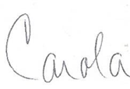

Carola Otero Bracco
Executive Director
Neighbors Link Corp.

The policies set forth in this Employee Handbook are not intended to state every policy of Neighbors Link in detail. As with all other policies, procedures, benefits, and other programs of Neighbors Link, Neighbors Link may modify these policies at any time, with or without advance notice to employees.
With respect to benefits, this Employee Handbook sets a general description of fringe benefits for eligible employees. Details of benefit eligibility requirements and coverage will be governed by the terms of the specific benefit plan documents. In the event of a conflict between this Employee Handbook and the terms of the benefit plan documents, the benefit plan documents shall govern.
From time to time, you will receive updated information concerning changes in policy as appropriate. If you have any questions regarding any policies, please contact Human Resources.
It is Neighbors Link’s intention to comply with all applicable federal, state and local laws and, in the event of a conflict between this Handbook and any applicable federal, state or local law, Neighbors Link will comply with the applicable law.
- GENERAL
  - Neighbors Link’s Relationship with Trinet
TriNet is a professional employer organization (PEO) that helps Neighbors Link administer pay and benefits, among other things. Neighbors Link employees are affiliated with TriNet through a co-employer relationship. TriNet has responsibility for paying wages, sponsoring and administering benefits, processing and maintaining certain worksite employee records, and performing other related Human Resources functions requested by Neighbors Link. Accordingly, TriNet is your employer of record for certain administrative purposes.
Neighbors Link is your employer for other administrative purposes and for purposes of managing your day-to-day work life (including, but not limited to, your hiring, hours of work, work schedule, compensation, place of work, job duties, supervision, performance, conduct, time off, discipline, termination, and other terms and conditions of your job). Neighbors Link has additional policies and procedures that apply to employees, relating to day-to-day work life. For questions on these policies, please reference this employee manual or contact HR.
Neighbors Link has selected the following comprehensive TriNet benefits package partially or fully paid by Neighbors Link:
Medical Insurance
TriNet offers access to a broad range of medical plans through national and regional insurance carriers including high-deductible health plans (HDHPs), PPOs and HMOs.
It is very important that you make careful decisions to elect or waive benefits that best meet the needs of your family. If you already have medical coverage, you may choose to waive TriNet-sponsored medical benefits. If you choose to waive medical coverage, you will still be able to enroll in other benefits, optional plans and flexible spending accounts.
Vision Insurance
TriNet also offers a high and a low vision plan nationally through two different carriers: Aetna and Vision Service Plan (VSP). These plan options ensure that you can choose the best plan and carrier for your individual vision needs.
Basic Life Insurance & AD&D
TriNet offers access to company-paid basic life and accidental death and dismemberment (AD&D) plans. Neighbors Link pays for basic life insurance coverage valued at $10,000 Basic Life & AD&D, which includes an equal amount of AD&D coverage.
Group Short-term and Long-Term Disability Insurance
If you are unable to work due to a non-work related condition, illness or injury, this insurance will pay a portion of your earnings. These plans are administered by The Hartford insurance company for Trinet.
Employee Assistance Program (EAP)
The EAP is available at no cost, even if you don't enroll in TriNet group benefits. You and your family members may access free, confidential counseling and referral services. This program provides 24-hour confidential assistance with personal, family and work-related concerns - plus online resources. The toll-free, dedicated EAP phone number is 1-888-893-5893.
For questions on any of the above benefits, please contact Trinet at
Phone: 800.638.0461 or Email: Employees@TriNet.com.

Retirement Plan
Neighbors Link offers a 401(k) retirement plan in which you may make voluntary pre-tax contributions toward your retirement after you have been with Neighbors Link for one year. Neighbors Link makes up to a 4% matching contribution. This benefit is offered through Trinet and administered by Empower. Questions about the retirement plan should be directed to Empower at 833-874-4015 or Neighbors Link Human Resources.

Optional Additional TriNet Benefits Available at Employee Expense:
Dental
TriNet's four dental carriers - Delta Dental, Aetna, Guardian Dental and MetLife - offer a high and a low national dental PPO plan that employees can select.
Flexible Spending Accounts (FSAs)
FSAs help you pay for eligible out-of-pocket health care and dependent day care expenses on a pre-tax basis. You determine your projected expenses for the Plan Year and then elect to set aside a portion of each paycheck into your FSA.
Pre-Tax Commuter Benefits
The commuter benefit plan allows you to set aside pre-tax dollars to pay for eligible commuting costs, such as expenses for parking, public transit and alternative forms of transportation. Passes can be delivered right to your home, or you can simply submit monthly receipts for reimbursement.
Supplemental Life Insurance
If you want extra protection for yourself and your eligible dependents, you have the option to elect supplemental life insurance. You may request coverage yourself for one to six times your annual salary, with a maximum benefit of $2,000,000. Spousal coverage is available in increments of $10,000 up to $250,000 and child coverage for $10,000. Note that amounts above guaranteed issue ($300,000 for you and $30,000 for your spouse) and certain coverage increases must be approved by the insurance carrier.
Supplemental Accidental Death and Dismemberment Insurance
AD&D covers death or dismemberment from an accident only. You may elect supplemental AD&D coverage in amounts of $25,000, $50,000, $100,000, $250,000, $500,000 or $750,000.
MetLife Voluntary Benefits
- Group Legal Services Plan
- Auto, Home, and Renters Insurance
- Pet Insurance

Aflac Voluntary Benefits
- Accident Insurance
- Hospital Indemnity Insurance
- Critical Illness Insurance
TriNet Marketplace
Discounts are available for vacation destinations, hotels, food, restaurants, car rentals, retail, and much more on the Trinet website.
For questions on any of these optional employee paid for benefits, please contact Trinet at
Phone: 800.638.0461 or Email: Employees@TriNet.com.

  - Voluntary At Will Employment
This handbook is not nor is it intended to be an employment contract -- express or implied. All Neighbors Link employees are employed “at will”, meaning that either the employee or Neighbors Link may end the employment relationship at any time, for any reason, without notice. Only the Neighbors Link Board of Directors may enter into an employment relationship other than this “at will” employment arrangement.
No Neighbors Link manager or representative, other than the Executive Director as authorized by the Board of Directors, may enter into any agreement contrary to the “at will” employment relationship. No such agreement, if made, shall be enforceable unless it is in writing and signed by both the employee and the Executive Director. In the event that a valid and enforceable employment agreement has been entered into between an employee and Neighbors Link, the provisions contained in that agreement shall supersede any contained in this handbook.
  - Equal Employment Opportunity and Affirmative Action Policy
Inherent in Neighbors Link’s policies and practices is a sincere commitment to the fair and equal treatment of all staff. It is the policy of this organization to provide equal employment opportunity with regard to all terms and conditions of employment, including but not limited to the hiring, training, advancement, performance management, and compensation of all staff. Accordingly, it is the policy of Neighbors Link to provide equal employment opportunities to all employees and applicants for employment without regard to ancestry, race, genetics, color, marital status, sex, religion, creed, age, disability, national origin, sexual orientation, gender identity, protected activity (i.e., opposition to prohibited discrimination or participation in proceedings covered by the anti-discrimination statutes) or any other classification protected by federal, state or local law or ordinance. Our affirmative action includes recruitment activities designed to reach all segments of our society, fair selection procedures, and the development and advancement of all staff without unfair partiality.
  - Probationary Period
The probationary period for regular full-time and regular part-time employees lasts up to ninety (90) days from date of hire. During this time, employees have the opportunity to evaluate Neighbors Link as a place to work and management has an opportunity to evaluate the employee. During this introductory period, both the employee and Neighbors Link have the right to terminate employment without advance notice or reason. The probationary period may be extended at Neighbor Link’s discretion.
  - Reasonable Accommodation Policy
Neighbors Link complies with the Americans with Disabilities Act (“ADA”) and the New York State Human Rights Law, which provide for nondiscrimination in employment against qualified individuals with disabilities. Neighbors Link also provides reasonable accommodation for such individuals in accordance with these laws. It is Neighbors Link’s policy to, without limitation:
- Ensure that qualified individuals with disabilities are treated in a nondiscriminatory manner in the pre-employment process and that employees with disabilities are treated in a nondiscriminatory manner in all terms, conditions and privileges of employment.
- Keep all medical-related information confidential in accordance with the requirements of the ADA and retain such information in separate confidential files.
- Provide applicants and employees with disabilities with reasonable accommodations, except where such an accommodation would create an undue hardship on Neighbors Link. Before making an offer, Neighbors Link may ask an applicant questions about ability to perform job-related functions. Neighbors Link may also ask an applicant to describe or to demonstrate how, with or without reasonable accommodation; he or she will perform job-related functions.
- Notify individuals with disabilities that Neighbors Link provides reasonable accommodation to qualified individuals with disabilities, by including this policy in the Neighbors Link employee handbook and in its corporate policies and procedures manual and by conspicuously displaying the Equal Employment Opportunity Commission’s poster on prohibiting discrimination against individuals with disabilities and other protected groups throughout Neighbors Link’s facilities.
Procedure for Requesting an Accommodation: Qualified individuals with disabilities may request reasonable accommodations to Neighbors Link’s Human Resources Department.
- On receipt of an accommodation request, a designated representative of Neighbors Link’s Human Resources Department will meet with the requesting individual to discuss and identify the precise limitations resulting from the disability and the potential accommodation that Neighbors Link might make to help overcome those limitations.
- If the request for a reasonable accommodation involves a leave of absence, the employee is advised that he or she must also comply with Neighbors Link’s Leaves of Absence (paid and unpaid) policy.
- If an individual's disability or need for reasonable accommodation is not obvious, Neighbors Link may request that the individual have an appropriate health care or rehabilitation professional provide information concerning, for example, the individual’s impairment; the nature, severity, and duration of the impairment; the activity or activities that the impairment limits; and the extent to which the impairment limits the individual's ability to perform the activity or activities.
- If the information provided by the individual is not sufficient (e.g., it does not include a description of individual’s physical limitations and expected duration of same) or if the form is not filled out by an appropriate health care or rehabilitation professional, Neighbors Link reserves the right to request that the individual supplement the documentation in a timely manner. If the documentation continues to be insufficient for Neighbors Link to properly evaluate the individual’s request for a reasonable accommodation, Neighbors Link may request that the individual meet with an appropriate health professional of the employer's choice, at Neighbors Link’s expense.
When necessary, Neighbors Link may require individuals to obtain updated information from an appropriate health care or rehabilitation professional so that Neighbors Link can evaluate a subsequent request for a reasonable accommodation or the continuing need for an ongoing accommodation.
The designated human resources representative and, if necessary, appropriate management representatives identified as having a need to know (e.g., the individual’s supervisor/department head), will determine the feasibility of the requested accommodation, considering various factors, including, but not limited to, the nature and cost of the accommodation, the availability of tax credits and deductions, external funding, the facility’s overall financial resources and organization, and the accommodation’s impact on the operation of the programs, including its impact on the ability of other employees to perform their duties and on the agency’s ability to conduct business.
Neither the ADA nor New York law requires Neighbors Link to provide personal use items (i.e., eyeglasses, hearing aids, wheelchairs etc.) or to make the best possible accommodation, to help an employee to perform essential job functions.

  - Sexual Harassment Policy
Sexual Harassment Policy for
Neighbors Link Corp.

Purpose and Goal
Neighbors Link Corp. is committed to maintaining a workplace free from harassment and discrimination. Sexual harassment is a form of workplace discrimination that subjects an employee to inferior conditions of employment due to their gender, gender identity, gender expression (perceived or actual), and/or sexual orientation. Sexual harassment is often viewed simply as a form of gender-based discrimination, but Neighbors Link Corp. recognizes that discrimination can be related to or affected by other identities beyond gender. Under the New York State Human Rights Law, it is illegal to discriminate based on sex, sexual orientation, gender identity or expression, age, race, creed, color, national origin, military status, disability, pre-disposing genetic characteristics, familial status, marital status, criminal history, or status as a victim of domestic violence. Our different identities impact our understanding of the world and how others perceive us. For example, an individual’s race, ability, or immigration status may impact their experience with gender discrimination in the workplace. While this policy is focused on sexual harassment and gender discrimination, the methods for reporting and investigating discrimination based on other protected identities are the same. The purpose of this policy is to teach employees to recognize discrimination, including discrimination due to an individual’s intersecting identities, and provide the tools to take action when it occurs. All employees, managers, and supervisors are required to work in a manner designed to prevent sexual harassment and discrimination in the workplace. This policy is one component of Neighbors Link Corp. commitment to a discrimination-free work environment.

Goals of this Policy:

Sexual harassment and discrimination are against the law. After reading this policy, employees will understand their right to a workplace free from harassment. Employees will also learn what harassment and discrimination look like, what actions they can take to prevent and report harassment, and how they are protected from retaliation after taking action. The policy will also explain the investigation process into any claims of harassment. Employees are encouraged to report sexual harassment or discrimination by filing a complaint internally with Neighbors Link Corp. Employees can also file a complaint with a government agency or in court under federal, state, or local antidiscrimination laws. To file an employment complaint with the New York State Division of Human Rights, please visit https://dhr.ny.gov/complaint. To file a complaint with the United States Equal Employment Opportunity Commission, please visit https://www.eeoc.gov/filing-charge-discrimination.

Sexual Harassment and Discrimination Prevention Policy:

- Neighbors Link Corp. policy applies to all employees, applicants for employment, and interns, whether paid or unpaid. The policy also applies to additional covered individuals. It applies to anyone who is (or is employed by) a contractor, subcontractor, vendor, consultant, or anyone providing services in our workplace. These individuals include persons commonly referred to as independent contractors, gig workers, and temporary workers. Also included are persons providing equipment repair, cleaning services, or any other services through a contract with Neighbors Link Corp. For the remainder of this policy, we will use the term “covered individual” to refer to these individuals who are not direct employees of the company.

- Sexual harassment is unacceptable. Any employee or covered individual who engages in sexual harassment, discrimination, or retaliation will be subject to action, including appropriate discipline for employees. In New York, harassment does not need to be severe or pervasive to be illegal. Employees and covered individuals should not feel discouraged from reporting harassment because they do not believe it is bad enough, or conversely because they do not want to see a colleague fired over less severe behavior. Just as harassment can happen in different degrees, potential discipline for engaging in sexual harassment will depend on the degree of harassment and might include education and counseling. It may lead to suspension or termination when appropriate.

- Retaliation is prohibited. Any employee or covered individual that reports an incident of sexual harassment or discrimination, provides information, or otherwise assists in any investigation of a sexual harassment or discrimination complaint is protected from retaliation. No one should fear reporting sexual harassment if they believe it has occurred. So long as a person reasonably believes that they have witnessed or experienced such behavior, they are protected from retaliation. Any employee of Neighbors Link Corp. who retaliates against anyone involved in a sexual harassment or discrimination investigation will face disciplinary action, up to and including termination. All employees and covered individuals working in the workplace who believe they have been subject to such retaliation should inform a supervisor, manager, or Human Resources. All employees and covered individuals who believe they have been a target of such retaliation may also seek relief from government agencies, as explained below in the section on Legal Protections.

- Discrimination of any kind, including sexual harassment, is a violation of our policies, is unlawful, and may subject Neighbors Link Corp. to liability for the harm experienced by targets of discrimination. Harassers may also be individually subject to liability and employers or supervisors who fail to report or act on harassment may be liable for aiding and abetting such behavior. Employees at every level who engage in harassment or discrimination, including managers and supervisors who engage in harassment or discrimination or who allow such behavior to continue, will be penalized for such misconduct.

- Neighbors Link Corp. will conduct a prompt and thorough investigation that is fair to all parties. An investigation will happen whenever management receives a complaint about discrimination or sexual harassment, or when it otherwise knows of possible discrimination or sexual harassment occurring. Neighbors Link Corp. will keep the investigation confidential to the extent possible. If an investigation ends with the finding that discrimination or sexual harassment occurred, Neighbors Link Corp. will act as required. In addition to any required discipline, Neighbors Link Corp. will also take steps to ensure a safe work environment for the employee(s) who experienced the discrimination or harassment. All employees, including managers and supervisors, are required to cooperate with any internal investigation of discrimination or sexual harassment.

- All employees and covered individuals are encouraged to report any harassment or behaviors that violate this policy. All employees will have access to a complaint form to report harassment and file complaints. Use of this form is not required. For anyone who would rather make a complaint verbally, or by email, these complaints will be treated with equal priority. An employee or covered individual who prefers not to report harassment to their manager or employer may instead report harassment to the New York State Division of Human Rights and/or the United States Equal Employment Opportunity Commission. Complaints may be made to both the employer and a government agency.

Managers and supervisors are required to report any complaint that they receive, or any harassment that they observe or become aware of, to Human Resources.

- This policy applies to all employees and covered individuals, such as contractors, subcontractors, vendors, consultants, or anyone providing services in the workplace, and all must follow and uphold this policy. This policy must be provided to all employees in person or digitally through email upon hiring and will be posted prominently in all work locations. For those offices operating remotely, in addition to sending the policy through email, it will also be available on the organization’s shared network.

What Is Sexual Harassment?

Sexual harassment is a form of gender-based discrimination that is unlawful under federal, state, and (where applicable) local law. Sexual harassment includes harassment on the basis of sex, sexual orientation, self-identified or perceived sex, gender expression, gender identity, and the status of being transgender. Sexual harassment is not limited to sexual contact, touching, or expressions of a sexually suggestive nature. Sexual harassment includes all forms of gender discrimination including gender role stereotyping and treating employees differently because of their gender.

Understanding gender diversity is essential to recognizing sexual harassment because discrimination based on sex stereotypes, gender expression and perceived identity are all forms of sexual harassment. The gender spectrum is nuanced, but the three most common ways people identify are cisgender, transgender, and non-binary. A cisgender person is someone whose gender aligns with the sex they were assigned at birth. Generally, this gender will align with the binary of male or female. A transgender person is someone whose gender is different than the sex they were assigned at birth. A non-binary person does not identify exclusively as a man or a woman. They might identify as both, somewhere in between, or completely outside the gender binary. Some may identify as transgender, but not all do. Respecting an individual’s gender identity is a necessary first step in establishing a safe workplace.

Sexual harassment is unlawful when it subjects an individual to inferior terms, conditions, or privileges of employment. Harassment does not need to be severe or pervasive to be illegal. It can be any harassing behavior that rises above petty slights or trivial inconveniences. Every instance of harassment is unique to those experiencing it, and there is no single boundary between petty slights and harassing behavior. However, the Human Rights Law specifies that whether harassing conduct is considered petty or trivial is to be viewed from the standpoint of a reasonable victim of discrimination with the same protected characteristics. Generally, any behavior in which an employee or covered individual is treated worse because of their gender (perceived or actual), sexual orientation, or gender expression is considered a violation of Neighbors Link Corp. policy. The intent of the behavior, for example, making a joke, does not neutralize a harassment claim. Not intending to harass is not a defense. The impact of the behavior on a person is what counts. Sexual harassment includes any unwelcome conduct which is either directed at an individual because of that individual’s gender identity or expression (perceived or actual), or is of a sexual nature when:

- The purpose or effect of this behavior unreasonably interferes with an individual’s work performance or creates an intimidating, hostile or offensive work environment. The impacted person does not need to be the intended target of the sexual harassment;

- Employment depends implicitly or explicitly on accepting such unwelcome behavior; or

- Decisions regarding an individual’s employment are based on an individual’s acceptance to or rejection of such behavior. Such decisions can include what shifts and how many hours an employee might work, project assignments, as well as salary and promotion decisions.

There are two main types of sexual harassment:

- Behaviors that contribute to a hostile work environment include, but are not limited to, words, signs, jokes, pranks, intimidation, or physical violence which are of a sexual nature, or which are directed at an individual because of that individual’s sex, gender identity, or gender expression. Sexual harassment also consists of any unwanted verbal or physical advances, sexually explicit derogatory, or discriminatory statements which an employee finds offensive or objectionable, causes an employee discomfort or humiliation, or interferes with the employee’s job performance.

- Sexual harassment also occurs when a person in authority tries to trade job benefits for sexual favors. This can include hiring, promotion, continued employment or any other terms, conditions, or privileges of employment. This is also called quid pro quo harassment.

Any employee or covered individual who feels harassed is encouraged to report the behavior so that any violation of this policy can be corrected promptly. Any harassing conduct, even a single incident, can be discrimination and is covered by this policy.

Examples of Sexual Harassment

The following describes some of the types of acts that may be unlawful sexual harassment and that are strictly prohibited. This list is just a sample of behaviors and should not be considered exhaustive. Any employee who believes they have experienced sexual harassment, even if it does not appear on this list, should feel encouraged to report it:

- Physical acts of a sexual nature, such as:
  - Touching, pinching, patting, kissing, hugging, grabbing, brushing against another employee’s body, or poking another employee’s body; or
  - Rape, sexual battery, molestation, or attempts to commit these assaults, which may be considered criminal conduct outside the scope of this policy (please contact local law enforcement if you wish to pursue criminal charges).

- Unwanted sexual comments, advances, or propositions, such as:
  - Requests for sexual favors accompanied by implied or overt threats concerning the target’s job performance evaluation, a promotion, or other job benefits;
    - This can include sexual advances/pressure placed on a service industry employee by customers or clients, especially those industries where hospitality and tips are essential to the customer/employee relationship;
  - Subtle or obvious pressure for unwelcome sexual activities; or
  - Repeated requests for dates or romantic gestures, including gift-giving.

- Sexually oriented gestures, noises, remarks or jokes, or questions and comments about a person’s sexuality, sexual experience, or romantic history which create a hostile work environment. This is not limited to interactions in person. Remarks made over virtual platforms and in messaging apps when employees are working remotely can create a similarly hostile work environment.

- Sex stereotyping, which occurs when someone’s conduct or personality traits are judged based on other people's ideas or perceptions about how individuals of a particular sex should act or look:
  - Remarks regarding an employee’s gender expression, such as wearing a garment typically associated with a different gender identity; or
  - Asking employees to take on traditionally gendered roles, such as asking a woman to serve meeting refreshments when it is not part of, or appropriate to, her job duties.

- Sexual or discriminatory displays or publications anywhere in the workplace, such as:
  - Displaying pictures, posters, calendars, graffiti, objects, promotional material, reading materials, or other materials that are sexually demeaning or pornographic. This includes such sexual displays on workplace computers or cell phones and sharing such displays while in the workplace;
  - This also extends to the virtual or remote workspace and can include having such materials visible in the background of one’s home during a virtual meeting.

- Hostile actions taken against an individual because of that individual’s sex, sexual orientation, gender identity, or gender expression, such as:
  - Interfering with, destroying, or damaging a person’s workstation, tools or equipment, or otherwise interfering with the individual’s ability to perform the job;
  - Sabotaging an individual’s work;
  - Bullying, yelling, or name-calling;
  - Intentional misuse of an individual’s preferred pronouns; or
  - Creating different expectations for individuals based on their perceived identities:
    - Dress codes that place more emphasis on women’s attire;
    - Leaving parents/caregivers out of meetings.

Who Can be a Target of Sexual Harassment?

Sexual harassment can occur between any individuals, regardless of their sex or gender. Harassment does not have to be between members of the opposite sex or gender. New York Law protects employees and all covered individuals described earlier in the policy. Harassers can be anyone in the workplace. A supervisor, a supervisee, or a coworker can all be harassers. Anyone else in the workplace can also be harassers including an independent contractor, contract worker, vendor, client, customer, patient, constituent, or visitor.

Sexual harassment does not happen in a vacuum and discrimination experienced by an employee can be impacted by biases and identities beyond an individual’s gender. For example:
- Placing different demands or expectations on black women employees than white women employees can be both racial and gender discrimination;
- An individual’s immigration status may lead to perceptions of vulnerability and increased concerns around illegal retaliation for reporting sexual harassment; or
- Past experiences as a survivor of domestic or sexual violence may lead an individual to feel re-traumatized by someone’s behaviors in the workplace.

Individuals bring personal history with them to the workplace that might impact how they interact with certain behavior. It is especially important for all employees to be aware of how words or actions might impact someone with a different experience than their own in the interest of creating a safe and equitable workplace.

Where Can Sexual Harassment Occur?

Unlawful sexual harassment is not limited to the physical workplace itself. It can occur while employees are traveling for business or at employer or industry sponsored events or parties. Calls, texts, emails, and social media usage by employees or covered individuals can constitute unlawful workplace harassment, even if they occur away from the workplace premises, on personal devices, or during non-work hours.

Sexual harassment can occur when employees are working remotely from home as well. Any behaviors outlined above that leave an employee feeling uncomfortable, humiliated, or unable to meet their job requirements constitute harassment even if the employee or covered individual is at home when the harassment occurs. Harassment can happen on virtual meeting platforms, in messaging apps, and after working hours between personal cell phones.

Retaliation

Retaliation is unlawful and is any action by an employer or supervisor that punishes an individual upon learning of a harassment claim, that seeks to discourage a worker or covered individual from making a formal complaint or supporting a sexual harassment or discrimination claim, or that punishes those who have come forward. These actions need not be job-related or occur in the workplace to constitute unlawful retaliation. For example, threats of physical violence outside of work hours or disparaging someone on social media would be covered as retaliation under this policy.

Examples of retaliation may include, but are not limited to:
- Demotion, termination, denying accommodations, reduced hours, or the assignment of less desirable shifts;
- Publicly releasing personnel files;
- Refusing to provide a reference or providing an unwarranted negative reference;
- Labeling an employee as “difficult” and excluding them from projects to avoid “drama”;
- Undermining an individual’s immigration status; or
- Reducing work responsibilities, passing over for a promotion, or moving an individual’s desk to a less desirable office location.

Such retaliation is unlawful under federal, state, and (where applicable) local law. The New York State Human Rights Law protects any individual who has engaged in “protected activity.” Protected activity occurs when a person has:

- Made a complaint of sexual harassment or discrimination, either internally or with any government agency;
- Testified or assisted in a proceeding involving sexual harassment or discrimination under the Human Rights Law or any other anti-discrimination law;
- Opposed sexual harassment or discrimination by making a verbal or informal complaint to management, or by simply informing a supervisor or manager of suspected harassment;
- Reported that another employee has been sexually harassed or discriminated against; or
- Encouraged a fellow employee to report harassment.

Even if the alleged harassment does not turn out to rise to the level of a violation of law, the individual is protected from retaliation if the person had a good faith belief that the practices were unlawful. However, the retaliation provision is not intended to protect persons making intentionally false charges of harassment.

Reporting Sexual Harassment

Everyone must work toward preventing sexual harassment, but leadership matters. Supervisors and managers have a special responsibility to make sure employees feel safe at work and that workplaces are free from harassment and discrimination. Any employee or covered individual is encouraged to report harassing or discriminatory behavior to a supervisor, manager or Human Resources. Anyone who witnesses or becomes aware of potential instances of sexual harassment should report such behavior to a supervisor, manager, or Human Resources.

Reports of sexual harassment may be made verbally or in writing. A written complaint form is attached to this policy if an employee would like to use it, but the complaint form is not required. Employees who are reporting sexual harassment on behalf of other employees may use the complaint form and should note that it is on another employee’s behalf. A verbal or otherwise written complaint (such as an email) on behalf of oneself or another employee is also acceptable.

Employees and covered individuals who believe they have been a target of sexual harassment may at any time seek assistance in additional available forums, as explained below in the section on Legal Protections.

Supervisory Responsibilities

Supervisors and managers have a responsibility to prevent sexual harassment and discrimination. All supervisors and managers who receive a complaint or information about suspected sexual harassment, observe what may be sexually harassing or discriminatory behavior, or for any reason suspect that sexual harassment or discrimination is occurring, are required to report such suspected sexual harassment to Human Resources. Managers and supervisors should not be passive and wait for an employee to make a claim of harassment. If they observe such behavior, they must act.

Supervisors and managers can be disciplined if they engage in sexually harassing or discriminatory behavior themselves. Supervisors and managers can also be disciplined for failing to report suspected sexual harassment or allowing sexual harassment to continue after they know about it.

Supervisors and managers will also be subject to discipline for engaging in any retaliation.

While supervisors and managers have a responsibility to report harassment and discrimination, supervisors and managers must be mindful of the impact that harassment and a subsequent investigation has on victims. Being identified as a possible victim of harassment and questioned about harassment and discrimination can be intimidating, uncomfortable and re-traumatizing for individuals. Supervisors and managers must accommodate the needs of individuals who have experienced harassment to ensure the workplace is safe, supportive, and free from retaliation for them during and after any investigation.

Bystander Intervention

Any employee witnessing harassment as a bystander is encouraged to report it. A supervisor or manager that is a bystander to harassment is required to report it. There are five standard methods of bystander intervention that can be used when anyone witnesses harassment or discrimination and wants to help.

- A bystander can interrupt the harassment by engaging with the individual being harassed and distracting them from the harassing behavior;
- A bystander who feels unsafe interrupting on their own can ask a third party to help intervene in the harassment;
- A bystander can record or take notes on the harassment incident to benefit a future investigation;
- A bystander might check in with the person who has been harassed after the incident, see how they are feeling and let them know the behavior was not ok; and
- If a bystander feels safe, they can confront the harassers and name the behavior as inappropriate. When confronting harassment, physically assaulting an individual is never an appropriate response.

Though not exhaustive, and dependent on the circumstances, the guidelines above can serve as a brief guide of how to react when witnessing harassment in the workplace. Any employee witnessing harassment as a bystander is encouraged to report it. A supervisor or manager that is a bystander to harassment is required to report it.

Complaints and Investigations of Sexual Harassment

All complaints or information about sexual harassment will be investigated, whether that information was reported in verbal or written form. An investigation of any complaint, information, or knowledge of suspected sexual harassment will be prompt, thorough, and started and completed as soon as possible. The investigation will be kept confidential to the extent possible. All individuals involved, including those making a harassment claim, witnesses, and alleged harassers deserve a fair and impartial investigation.

Any employee may be required to cooperate as needed in an investigation of suspected sexual harassment. Neighbors Link Corp. will take disciplinary action against anyone engaging in retaliation against employees who file complaints, support another’s complaint, or participate in harassment investigations.

Neighbors Link Corp. recognizes that participating in a harassment investigation can be uncomfortable and has the potential to retraumatize an employee. Those receiving claims and leading investigations will handle complaints and questions with sensitivity toward those participating.

While the process may vary from case to case, investigations will be done in accordance with the following steps. Upon receipt of a complaint, Human Resources:

- Will conduct a prompt review of the allegations, assess the appropriate scope of the investigation, and take any interim actions (for example, instructing the individual(s) about whom the complaint was made to refrain from communications with the individual(s) who reported the harassment), as appropriate. If complaint is verbal, request that the individual completes the complaint form in writing. If the person reporting prefers not to fill out the form, Human Resources will prepare a complaint form or equivalent documentation based on the verbal reporting;

- Will take steps to obtain, review, and preserve documents sufficient to assess the allegations, including documents, emails or phone records that may be relevant to the investigation. Human Resources will consider and implement appropriate document request, review, and preservation measures, including for electronic communications;

- Will seek to interview all parties involved, including any relevant witnesses;

- Will create a written documentation of the investigation (such as a letter, memo or email), which contains the following:
  - A list of all documents reviewed, along with a detailed summary of relevant documents;
  - A list of names of those interviewed, along with a detailed summary of their statements;
  - A timeline of events;
  - A summary of any prior relevant incidents disclosed in the investigation, reported or unreported; and
  - The basis for the decision and final resolution of the complaint, together with any corrective action(s).

- Will keep the written documentation and associated documents in a secure and confidential location;

- Will promptly notify the individual(s) who reported the harassment and the individual(s) about whom the complaint was made that the investigation has been completed and implement any corrective actions identified in the written document; and

- Will inform the individual(s) who reported of the right to file a complaint or charge externally as outlined in the next section.

Legal Protections and External Remedies

Sexual harassment is not only prohibited by Neighbors Link Corp. but it is also prohibited by state, federal, and, where applicable, local law.

The internal process outlined in the policy above is one way for employees to report sexual harassment. Employees and covered individuals may also choose to pursue legal remedies with the following governmental entities. While a private attorney is not required to file a complaint with a governmental agency, you may also seek the legal advice of an attorney.

New York State Division of Human Rights:

The New York State Human Rights Law (HRL), N.Y. Executive Law, art. 15, § 290 et seq., applies to all employers in New York State and protects employees and covered individuals, regardless of immigration status. A complaint alleging violation of the Human Rights Law may be filed either with the New York State Division of Human Rights (DHR) or in New York State Supreme Court.

Complaints of sexual harassment filed with DHR may be submitted any time within three years of the harassment. If an individual does not file a complaint with DHR, they can bring a lawsuit directly in state court under the Human Rights Law, within three years of the alleged sexual harassment. An individual may not file with DHR if they have already filed a HRL complaint in state court.

Complaining internally to Neighbors Link Corp. does not extend your time to file with DHR or in court. The three years are counted from the date of the most recent incident of harassment.

You do not need an attorney to file a complaint with DHR, and there is no cost to file with DHR.

DHR will investigate your complaint and determine whether there is probable cause to believe that sexual harassment has occurred. Probable cause cases receive a public hearing before an administrative law judge. If sexual harassment is found at the hearing, DHR has the power to award relief. Relief varies but it may include requiring your employer to take action to stop the harassment, or repair the damage caused by the harassment, including paying of monetary damages, punitive damages, attorney’s fees, and civil fines.

DHR’s main office contact information is: NYS Division of Human Rights, One Fordham Plaza, Fourth Floor, Bronx, New York 10458. You may call (718) 741-8400 or visit: www.dhr.ny.gov.

Go to dhr.ny.gov/complaint for more information about filing a complaint with DHR. The website has a digital complaint process that can be completed on your computer or mobile device from start to finish. The website has a complaint form that can be downloaded, filled out, and mailed to DHR as well as a form that can be submitted online. The website also contains contact information for DHR’s regional offices across New York State.

Call the DHR sexual harassment hotline at 1(800) HARASS3 for more information about filing a sexual harassment complaint. This hotline can also provide you with a referral to a volunteer attorney experienced in sexual harassment matters who can provide you with limited free assistance and counsel over the phone.

The United States Equal Employment Opportunity Commission:

The United States Equal Employment Opportunity Commission (EEOC) enforces federal anti-discrimination laws, including Title VII of the 1964 federal Civil Rights Act, 42 U.S.C. § 2000e et seq. An individual can file a complaint with the EEOC anytime within 300 days from the most recent incident of harassment. There is no cost to file a complaint with the EEOC. The EEOC will investigate the complaint and determine whether there is reasonable cause to believe that discrimination has occurred. If the EEOC determines that the law may have been violated, the EEOC will try to reach a voluntary settlement with the employer. If the EEOC cannot reach a settlement, the EEOC (or the Department of Justice in certain cases) will decide whether to file a lawsuit. The EEOC will issue a Notice of Right to Sue permitting workers to file a lawsuit in federal court if the EEOC closes the charge, is unable to determine if federal employment discrimination laws may have been violated, or believes that unlawful discrimination occurred by does not file a lawsuit.

Individuals may obtain relief in mediation, settlement or conciliation. In addition, federal courts may award remedies if discrimination is found to have occurred. In general, private employers must have at least 15 employees to come within the jurisdiction of the EEOC.

An employee alleging discrimination at work can file a “Charge of Discrimination.” The EEOC has district, area, and field offices where complaints can be filed. Contact the EEOC by calling 1-800-669-4000 (TTY: 1-800-669-6820), visiting their website at www.eeoc.gov or via email at info@eeoc.gov.

If an individual filed an administrative complaint with the New York State Division of Human Rights, DHR will automatically file the complaint with the EEOC to preserve the right to proceed in federal court.

Local Protections

Many localities enforce laws protecting individuals from sexual harassment and discrimination. An individual should contact the county, city or town in which they live to find out if such a law exists. For example, employees who work in New York City may file complaints of sexual harassment or discrimination with the New York City Commission on Human Rights. Contact their main office at Law Enforcement Bureau of the NYC Commission on Human Rights, 22 Reade Street, 1st Floor, New York, New York; call 311 or (212) 306-7450; or visit www.nyc.gov/html/cchr/html/home/home.shtml.

Contact the Local Police Department

If the harassment involves unwanted physical touching, coerced physical confinement, or coerced sex acts, the conduct may constitute a crime. Those wishing to pursue criminal charges are encouraged to contact their local police department.

Conclusion

The policy outlined above is aimed at providing employees at Neighbors Link Corp. and covered individuals an understanding of their right to a discrimination and harassment free workplace. All employees should feel safe at work. Though the focus of this policy is on sexual harassment and gender discrimination, the New York State Human Rights law protects against discrimination in several protected classes including sex, sexual orientation, gender identity or expression, age, race, creed, color, national origin, military status, disability, pre-disposing genetic characteristics, familial status, marital status, criminal history, or domestic violence survivor status. The prevention policies outlined above should be considered applicable to all protected classes.

  - Whistleblower Policy
Neighbors Link is committed to operating in compliance with all applicable laws, rules and regulations, including those concerning accounting and auditing, and prohibits fraudulent practices by any of its board members, officers, employees, or volunteers. It is the responsibility of every employee to report in good faith any concerns she or he may have regarding actual or suspected activities which may be illegal or in violation of Neighbors Link policies with respect to, without limitation, fraud, theft, embezzlement, accounting or auditing irregularities, bribery, kickbacks, and misuse of Neighbors Link’s assets, as well as any violations or suspected violations of high business and personal ethical standards, as such standards relate to Neighbors Link (each, a “Concern”).
Any Concerns should be reported as soon as practicable to the chairperson of Neighbors Link’s Audit Committee (the “Compliance Officer”). Any questions with regard to the scope, interpretation, or operation of this Whistleblower Policy should also be directed to the Compliance Officer. The Compliance Officer will promptly initiate an investigation into the matter. To the fullest extent possible, Neighbors Link will endeavor to keep complaints and any related investigations confidential.
No employee, who in good faith reports any violations under this policy, shall suffer harassment, retaliation, or adverse employment action. Any employee who retaliates against someone who has reported a violation in good faith is subject to discipline up to and including termination.

- COMPENSATION & BENEFITS
  - Compensation Rate
The employee’s offer letter or New York Form LS-54 specifies the initial rate of pay. Changes in pay will reflect the employee’s performance and the organization’s financial resources. Employees are paid semi-monthly, on the 7th and 22nd of the month. Direct deposit service is provided for all employees. Paycheck receipts detail earnings and deductions. Neighbors Link will supply employees with annual compensation information (Form W-2’s) needed to file federal and state income tax reports via the Trinet platform.
  - Employee Classifications
It is the intent of Neighbors Link to clarify the definitions of employment classifications so that employees understand their employment status and benefit eligibility. Each employee at Neighbors Link will fall into one of the following categories:
- Full-Time Employee: regularly scheduled to work 30 hours per week or more
- Part-Time Employee: regularly scheduled to work less than 30 hours per week
- Temporary Employee: works short-term assignments, for a limited duration of time
Each employee is designated either non-exempt or exempt for the purpose of federal and state wage and hours laws.
- Non-Exempt employees are entitled to be paid minimum wage and time and one-half the employee’s regular rate of pay for all hours worked in excess of 40 hours per week.
- Exempt employees receive the same salary every week regardless of the number of hours the employee works, except as otherwise set forth in this handbook.
Employees will be notified of their initial employment classification and their status as an exempt or non-exempt employee at the time of hire. If an employee changes positions or job responsibilities during their employment as a result of promotion, transfer, or otherwise, employees will be informed by Human Resources of any change in exemption status in writing. Employees may direct any questions regarding employment classification or exemption status to their direct supervisor or Human Resources.
  - Overtime Pay
Neighbors Link complies with federal and state laws regarding payment of overtime. Non-exempt employees are eligible for overtime pay for hours worked in excess of 40 hours each week. All overtime must have the prior approval of the supervisor. Overtime is paid at time-and-a- half for all hours worked over 40 hours during a one-week period (from Sunday to Saturday). Paid or unpaid time off taken during the week will not be counted as hours worked when calculating overtime pay.
  - Online Time Recording System
Neighbors Link uses an online time recording system to record hours worked. Both exempt and non-exempt employees must submit accurate time records by each payroll processing deadline. Time records should be rounded to the nearest ¼ hour. Falsifying a time record is a breach of Neighbors Link policy and is grounds for disciplinary action, including the possibility of discharge.

Neighbors Link has a procedure for entering time and effort within our electronic time sheet system. Employees enter hours worked (and any sick and/or vacation time) into an electronic time sheet system on a semi-monthly basis. The Grant Accounting manager record hours worked toward specific grant contracts directly on the employee time sheet. The employee approves the timesheet to ensure accuracy. Employee hours and effort are then reviewed and approved by their supervisor. The entire payroll is reviewed and approved by the Neighbors Link Accounting Manager and the Chief Financial Officer.

  - Social Security & Medicare
Neighbors Link employees are covered under Social Security and Medicare. These benefits include retirement income, disability income, survivor benefits and health insurance after age 65 or extended disability. Neighbors Link and employees share the cost of Social Security benefits. The Federal Insurance Contributions Act (FICA) requires both employee and employer to pay a percentage of employees’ earnings. Employees may contact the nearest Social Security Administration office for an account status report and more information on Social Security and Medicare benefits.
  - Paid Holidays
Full-Time Employees are immediately eligible for the paid holidays announced annually by administrative memo. Part-Time and Temporary employees are not paid for holidays, but may have their hours adjusted to ensure they do not lose compensation.
Please see the annual schedule for the days and dates for the following holidays:

- New Year’s Day
- Martin Luther King, Jr. Day
- Presidents’ Day
- Memorial Day
- Juneteenth Day
- Independence Day
- Labor Day
- Columbus Day
- Thanksgiving
- Christmas
Because of the nature of the Neighbors Link mission, not all programs can close on recognized holidays. Critical non-exempt Operations staff required to work on Neighbors Link holidays will receive one and one-half (1½) times their normal pay rate for holiday hours worked. A list of these eligible non-exempt Critical Operations holidays will be distributed by administrative memo each year.
  - Paid Time Off-Vacation Days
Time away from work to relax, pursue special interests, and enjoy family is critical for employee productivity and satisfaction. Paid Time Off (“PTO”) can be used for either vacations or personal reasons.
The scheduling of any PTO is subject to supervisory approval, to ensure that the organization can meet its commitments to clients. Eligible employees should request time off directly with their supervisor, at least two weeks in advance, and log the time through the online time recording system. PTO should generally be taken in minimum one day increments. Half days are permitted with supervisory approval.
After completing two months of service, Full-Time employees are eligible for PTO. Eligible employees accrue paid time off at the beginning of each calendar month at the rate set out below. Part-Time and Temporary employees are not eligible for PTO.
- Years 1 – 5 of service: 3 weeks (15 days) of paid PTO per calendar year (accruing 1.25 days per month after completion of the first two months of employment).
- Years 5+ of service: 4 weeks (20 days) of paid PTO per calendar year (accruing 1.67 days per month on or after the fifth anniversary of the employee’s hire date).
PTO may not be carried over to future years. If unforeseen events in December preclude completing PTO in that calendar year, the Executive Director may allow use of the remaining days in the first quarter of the subsequent calendar year.
No payments will be made in lieu of taking PTO, except Neighbors Link will pay all accrued and unused PTO if Neighbors Link terminates the employee for any reason other than “for cause” or if the employee terminates her or his employment after having given three weeks (non-exempt employees) or four weeks (exempt employees) advance written notice.
  - Paid Time Off - Sick and Safe Time Leave
Sick Leave: Neighbors Link provides paid sick leave for employees to tend to their own medical or other health issues, as well as the medical or health issues of covered family members (generally a spouse or child; domestic partner; parent; sibling; grandchild; grandparent; or child or parent of a spouse, domestic partner or household member). Full-time employees shall be entitled 40 hours of leave upon hire and then the sick bank is replenished to 40 hours of sick leave on January 1 of every year.
Part-time employees earn 1 hour of paid leave for every 30 hours of work, up to a maximum of 40 hours of leave. Part-time employees may carry over unused sick leave into the next calendar year, but part-time employees may not use more than 40 hours of sick leave per year.
Unused sick leave for full-time and part-time employees will not be paid on termination of employment for any reason
If an employee is absent for three or more consecutive days due to illness or injury, or if the employee’s use of sick leave creates a pattern or otherwise occurs under suspicious circumstances, then Neighbors Link may require supporting medical information verifying the absence, as well as the beginning and expected ending dates.
Safe Time Leave: Effective October 30, 2019, full and part-time employees working for 90 days or more who are victims of domestic violence or human trafficking may use up to 40 hours of paid leave each year to (a) attend or testify in criminal or civil proceedings related to domestic violence or human trafficking; or (b) move to a safe location. Employees can request leave verbally, in writing or by electronic means and should make a good faith effort to give advance notice if the reason for the leave is foreseeable. Neighbors Link may request reasonable documentation regarding the reason for the leave, and will keep confidential all information received absent written consent from the employee.
  - Other Leave
Bereavement leave: Full-Time employees are eligible for up to three days of paid leave per calendar year in the event of a death of an immediate family member. Immediate family includes a spouse, child, parent, sibling, grandparent, mother or father-in-law, daughter or son-in-law, or equivalent significant other. For this leave, a day is defined as the employee's regular hours of work for that day.
Voting leave: Employees may take up to three (3) paid hours either at the beginning or the end of the employee’s scheduled shift to vote in national, state and local elections. The employee must request leave at least two days prior to the election date and should coordinate the specific timing with his or her supervisor.
Jury Duty leave: Full-Time employees are eligible for up to one week of paid jury duty leave. Part- Time Employees required to miss work as a result of jury service shall receive their full wage up to a maximum of $40 for the first three (3) days of absence caused as a result of jury service. Prior to jury duty, the employee should notify his or her supervisor. Employees may keep any jury pay received from the state. Employees are expected to report for work during hours or days that their presence is not required on the jury panel. To qualify for jury duty leave, an employee must submit a copy of the summons to serve as soon as it is received to his or her supervisor. In addition, proof of jury service must be submitted to the employee's supervisor when the employee’s period of jury service is completed. Neighbors Link will make no attempt to have an employee's service on a jury duty postponed unless business conditions necessitate such action. For this leave, a day is defined as the employee's regular hours of work for that day.
Unpaid military leave: An employee who serves in the Army, Navy, Marine Corps, Air Force, Coast Guard, Reserves, Army or Air National Guard or Commissioned Corps of the Public Health Service may take leave without pay for active service, reserve drills or annual training, service school, or initial full-time or active-duty service. Employees seeking reinstatement following completion of service must apply for reinstatement within 90 days from their discharge active service; within ten days of completing service school, reserve duties, or annual training; or within 60 days of completing initial full-time or active duty training. Once reinstated, an employee may not be discharged within one year without cause.
  - Health Benefits
Medical health benefits are available for all Full-Time employees beginning the month following their hire date, through Neighbors Link’s designated group health insurance plan. Enrollment and plan information is available through Trinet. Employees have 30 days from eligibility to choose and enroll in one of the Trinet plans offered. All eligible employees are expected to enroll in health insurance coverage unless they are covered by another insurance plan. Employees should ask Human Resources if they have any questions.
Each employee is responsible for informing Human Resources of any qualified changes in life status affecting benefits. Employees are mandated to do this in writing and are required to produce proof of the qualifying event. Qualified life status changes may include marriage, declaration of domestic partnership, birth or adoption of a child, termination of a partner’s coverage or a change in a spouse’s or domestic partner’s employment status. Employees must also notify Human Resources of any change in address. Health benefit coverage ends on the last day of the month in which they are employees.
Employees covered under the Neighbors Link group health insurance plan are eligible for continuation of health insurance through the Consolidated Omnibus Budget Reconciliation Act (“COBRA”) at the employee’s cost upon resignation or termination of employment.
Neighbors Link reserves the right to change, either in part or completely, the insurance coverage offered to employees. Insurance providers, plans and employee contribution rates are re-evaluated annually.
  - Retirement Plan
Full-time and part-time employees are eligible for the 401k plan the 1st of the month following one year of employment, in accordance with the eligibility provisions of the plan. Neighbors Link adopted the Trinet 401 (k) Plan effective 5/1/2024, and Trinet uses Empower to manage the 401 (k) plan. Empower will send the employee a notice one month before their eligibility to the plan.

Neighbors Link determines what, if any, employer contribution is made to the Plan for eligible employees. Currently Neighbors Link matches 100% of the first 3% contributed, and 50% of the 4th and 5th percent, for a maximum 4% employer match for a 5% contribution. For more information, including questions on eligibility, the employer match, and the Summary Plan Description, please contact Human Resources.
  - Professional Development
It is a goal of Neighbors Link to provide training and professional development for staff members to enable them to perform their responsibilities as effectively as possible. Within budgetary and time limitations, staff may attend seminars, institutes, conferences and workshops related to immigration, social policy and related fields relevant to employees' responsibilities. Employees should contact their supervisor for prior approval for any requested staff development events.
  - Tuition Reimbursement Program
Neighbors Link believes that a well-rounded education, even outside the working environment, can enhance an employee’s skill base and make them more valuable to the organization. Subject to the Executive Director’s approval, Neighbors Link will reimburse eligible Full-Time Employees for tuition incurred for degree programs. Criteria for approval include:
- At least one year of employment with Neighbors Link prior to seeking reimbursement
- Applicability of the degree to the employee’s current or future position at Neighbors Link
- Coursework must meet requirements for an associate, bachelor’s or master’s degree
- Classes should be scheduled to not interfere with normally scheduled working hours
- Neighbors Link will reimburse for approved programs up to a maximum of $500 per calendar year, covering tuition fees only. Employees must submit proof of payment before reimbursement will be issued.
  - Workers Compensation
Workers Compensation is an insurance program that pays for medical care and finances income protection for accident or illness arising as a result of employment. Workers Compensation protection applies to employees who sustain work-connected (occupational) injury or illness in the office or while traveling on behalf of the organization. Neighbors Link provides coverage for employees under the Trinet Workers Compensation insurance program.
Employees must immediately report all work-related illness or injury in the office or while traveling on behalf of the organization to their supervisor, or if their direct manager is unavailable, then to another supervisor or Human Resources. TriNet has a 24-hour injury reporting service at 866-443-8489. Injuries that are medical emergencies should be treated with 911 assistance or at the nearest hospital emergency room. The manager will provide the employee with any required paperwork. The employee is expected to cooperate in the reporting process. Failure to report a work-related injury or illness immediately to a supervisor may affect the employee’s eligibility for and receipt of benefits.

  - Short-Term Disability
There are two programs for short-term disability. Trinet uses Standard Security Life to administer New York state Disability Benefits Law (DBL) for Neighbors Link. Under this insurance program, benefits are payable for non-work related injuries or illnesses for eligible employees beginning with the eighth consecutive day of illness and continuing for up to 26 weeks, where warranted. State law regulates the amount of the benefits payable under this plan. Additionally, there is a Short-term Disability Insurance plan (STD) administered by The Hartford (through Trinet) that is a secondary insurance for short-term disability. The employee is responsible for initiating the claims with both providers. Reinstatement cannot be guaranteed to an employee on Short-Term Disability leave except where covered by applicable federal, state & local statutes. An employee on a leave of absence (LOA) for their own serious health condition must submit a Fitness For Duty Certification completed by their health care provider before being permitted to return to work after their LOA.
  - New York Paid Family Leave Program
New York State’s Paid Family Leave Program provides wage replacement to eligible full-time and part-time employees. The program helps employees bond with a child, care for a close relative with a serious health condition, or help relieve family pressures when someone is called to active military service. The program also provides job-protected leave, and continuation of group health insurance coverage, provided that the employee continues to pay his/her portion of the premium cost.
The maximum paid benefit length is 12 weeks. This program is funded through employee payroll deductions. State law regulates the amount of the benefit payable under this plan. Trinet uses Standard Security Life to administer New York Paid Family Leave (PFL) for Neighbors Link. The employee is responsible for initiating the claims with Standard Security Life. Questions on filing for New York’s Paid Family Leave benefit may be directed to Human Resources.
  - Family and Medical Leave
Neighbors Link recognizes that there are cases when a leave of absence from active employment may be necessary for family or medical reasons such as the birth of a child. Employees must use any accrued PTO and sick time in conjunction with family and medical leave. Consistent with the Federal Family and Medical Leave Law, eligible employees are those who, at the time the leave commences, have been employed by Neighbors Link for at least 12 months and must have worked at least 1,250 hours during the previous twelve-month period. Leave may be taken for the following seven reasons:
- for the birth of a child or to care for a newborn;
- for the placement with the employee of a child for adoption or foster care;
- for a covered family member who has a serious illness (family member is defined as a spouse, parent, son or daughter excluding mother-in-law and/or father-in-law);
- for the employee’s own serious illness;
- for a covered service member (defined as spouse, parent, son or daughter, or next of kin) currently serving in the military, who has a serious illness or injury incurred in the line of duty on active duty (“Military Caregiver Leave”);
- for the qualifying military exigency of a covered family member (defined as a spouse, parent, son or daughter excluding mother-in-law and/or father-in-law), who is serving in the military, who is directly related to the family member’s active duty or call to active duty status in support of a contingency operation (“Military Exigency Leave”). In particular, qualifying exigencies are (1) short-notice deployment (leave permitted up to seven days if the military member receives seven or fewer days’ notice of a call to active duty), (2) military events and related activities, (3) certain temporary childcare arrangements and school activities (but not ongoing childcare), (4) financial and legal arrangements, (5) counseling by a non-medical counselor (such as a member of the clergy), (6) rest and recuperation (leave permitted up to five days when the military member is on temporary rest and recuperation leave), (7) post-deployment military activities, and (8) similar activities mutually agreed upon by Neighbors Link and the employee.; and
- to care for a spouse, son, daughter, parent or next of kin (nearest blood relative) who has incurred serious illness or injury in the line of duty in the Armed Forces, including the National Guard and Reserves, and that illness or injury: (1) has rendered the service member medically unfit to perform the duties of the member’s office, grade, rank or rating; (2) was incurred by a veteran who was a member or veteran of the Armed Forces within five years preceding the applicable medical treatment; or (3) was aggravated while the service member was serving on active duty.

Length of Leave: Under federal law, eligible employees are entitled to up to 12 weeks of unpaid leave within a 12-month period without loss of seniority or benefits except that eligible employees taking Military Caregiver Leave are entitled to up to 26 weeks of Military Caregiver Leave during a single 12-month period on a per-covered service member, per-injury basis.
To the extent that a husband and wife are both employed by Neighbors Link, they are permitted to take a combined 12 weeks of leave during the respective 12 month period if the leave is taken for the birth of a child, placement of a child for adoption or foster care. Leave taken to care for a child after birth, adoption, or a foster child placement must be taken in consecutive workweeks.
If an employee fails to return to work after an approved leave, his/her position at Neighbors Link will be considered abandoned and this will be treated as a voluntary termination of employment.
If an employee chooses not to return to work after the expiration of leave, he/she may be required to reimburse Neighbors Link for payment of insurance premiums during the family and medical leave.
Availability of Intermittent Leave: Leave requested because of the employee’s or family member’s serious illness and/or Military Caregiver Leave may be taken on an intermittent or reduced schedule basis when medically necessary. When necessary, Military Exigency Leave may also be taken on an intermittent or reduced schedule basis. Neighbors Link will follow applicable federal, state, and local laws in reviewing all such requests. The employee must advise Neighbors Link of the reasons why the intermittent or reduced schedule leave is necessary and the applicable treatment schedule, in addition to providing the other notice required for leave under this policy. As with other leaves, intermittent or reduced schedule leave must be supported by medical certification and/or the required certifications for Military Exigency Leave and Military Caregiver Leave. Neighbors Link may require an employee taking this type of leave to transfer temporarily to an alternative available position for which the employee is qualified, or modify the employee’s existing job, with an equivalent pay rate and benefits, to better accommodate the employee’s recurring periods of leave.
Medical Certification: If a leave of absence is taken because of the serious illness or injury of the employee’s family member or next of kin, the employee must provide a healthcare provider’s certification to Huma Resources. Likewise, any time an employee expects to be or is absent for more than five consecutive work days as the result of his or her own serious illness (including pregnancy), the employee will be required to submit an appropriate medical certification from his or her physician.
Human Resources will supply employees with the required certification form. Failure to submit such certification within the time frame requested may result in a delay or denial of leave. Neighbors Link reserves the right to require, at its expense, a second opinion from other healthcare providers certifying the employee’s serious illness. If the first and second medical opinions conflict, Neighbors Link may require a third opinion that is final and binding. Both the second and third medical opinions would be at Neighbors Link’s expense. Neighbors Link reserves the right to periodically require re-certification of the medical condition for which leave is taken. Neighbors Link shall pay for any recertification that is not covered by the employee's health insurance.
An employee who is away from work on a leave of absence as a result of his or her serious illness will be required to obtain a healthcare provider’s certification that he or she is able to return to work upon cessation of his or her serious illness. Failure to provide such certification at the time the employee wishes to return to work may result in the delay or denial of job restoration. In certain circumstances, Neighbors Link may also request such a certification from an employee taking leave intermittently.
Additionally, during the employee’s leave, Neighbors Link reserves the right to inquire periodically as to the employee’s intent to return to work.
Military Exigency Leave Certifications: Two types of certification are required for military exigency leave. One is a certification that the covered military member is a member of the National Guard or Reserves who is on active duty or called to active duty in support of a contingency operation. A copy of the military member’s active duty orders will normally be required and will contain the necessary information. The other certification is a statement from the employee (including available written support documentation) about the nature and details of the specific exigency, the amount of leave needed, and the employee’s relationship to the military member. The employee must provide both certifications within 15 days absent unusual circumstances.
Military Caregiver Leave – General Certification: Neighbors Link will require information from a healthcare provider and from the employee and/or covered service member to support military caregiver leave. The certification should include: (1) the service member’s military status and the care to be provided; and (2) a certification by the U.S. Department of Defense, Veterans Affairs, or TRICARE network or non-network health care provider of the service member’s serious injury or illness. The employee must provide both certifications within 15 days absent unusual circumstances.
Military Caregiver Leave Automatic Emergency Certification: The Department of Defense (DOD) may issue a special invitation to any member or members of a service member’s family when its healthcare provider has determined that the injury or illness is serious enough to warrant the immediate presence of a family member at the service member’s bedside. Such an invitation is referred to as an “invitational travel order” (ITO) or an “invitational travel authorization” (ITA). An ITO or ITA is issued to any member of the family (even if the employee’s own name is not on it) constitutes automatic certification of the serious injury or illness and remains in effect for the duration specified on it. In the absence of an ITO or ITA, medical certification may be required.
Employee Notification Requirements: Employees who expect or anticipate taking a family or medical leave are required to notify their supervisor of the leave dates at least 30 days in advance, or as soon as practicable. When the need for leave is unforeseeable, an employee must notify his or her supervisor as soon as practicable, typically the same or next business day on which the need for the leave becomes known to the employee. Employees who seek to take leave under this policy must obtain an Application for Leave Form from Human Resources.
Update of Leave Status: Employees on leave must furnish Human Resources with updates every three weeks.
Use of Accrued Paid Leave: Employees must use any available accrued PTO and sick leave in conjunction with any Family and Medical Leave.
Status of Employee Benefits: During the employee’s family or medical leave of absence, Neighbors Link will continue to provide health insurance coverage for the employee; however, the employee will remain personally responsible for paying his or her portion of the insurance premium (where applicable). Such payment may be made voluntarily prior to the leave, or on or before the normally scheduled payroll deduction date.
Additionally, if an employee is enrolled in Neighbors Link’s 401(k) plan, the employee will not be eligible for further contributions during any period of unpaid family and medical leave, but the status of the account will be active during the period of absence. Paid vacation and sick days will not accrue during the term of the leave. However, employees using PTO or sick leave as part of their family or medical leave shall continue to accrue PTO and sick leave during that portion of the leave covered by such PTO and sick leave.
Return from Leave: At the conclusion of the family or medical leave period, the employee will be returned to the same or an equivalent position with equivalent benefits, pay and other terms of employment. Employees who do not return to work at the end of their authorized leaves may be terminated. Further, employees who do not return to work will be required to repay any insurance premiums paid by Neighbors Link during the leave period unless such failure to return is caused by the continued serious illness of the employee or the employee’s family member, or other circumstances beyond the employee’s control. If this is the case, additional medical certification may be required.
If an employee fails to return to work after an approved leave, their position at Neighbors Link will be considered abandoned. This will be treated as a voluntary termination of employment on the part of the employee.
  - Paid Parental Leave
Purpose
At Neighbors Link we are proud to support our employees during major life transitions. This policy provides paid parental leave in connection with the birth, adoption, or foster placement of a child. Paid leave is coordinated with New York State-mandated benefits and topped up by Neighbors Link to ensure full salary during the covered period.

Eligibility
To be eligible, employees must:
Be employed full-time for at least 52 consecutive weeks prior to the start of leave
Be welcoming a new child through birth, adoption, or foster care placement

Parental Leave Benefits
Birth Parents
Eligible birth parents are entitled to up to 12 weeks of fully paid parental leave, structured as follows:

Leave Component Duration Source Pay Level
NY Disability (DBL) 6 weeks NY State Disability Insurance ~50% of pay (capped) NY Paid Family Leave 6 weeks NY State Paid Family Leave ~67% of pay (capped) Company Supplement 12 weeks Neighbors Link Top-up to 100% of pay

The employee must apply for both DBL and PFL.
Neighbors Link supplements those benefits so that the employee receives 100% of regular salary for all 12 weeks.
Additional unpaid time may be requested under FMLA (if eligible) or PTO if approved.
Additional recovery time under short-term disability may be taken if eligible that would be unpaid by the company.
Non-Birth Parents (Including Adoptive/Foster Parents)
Eligible non-birth parents are entitled to 6 weeks of fully paid leave, coordinated with NY PFL:

Leave Component Duration Source Pay Level
NY Paid Family Leave 6 weeks NY State Paid Family Leave ~67% of pay (capped) Company Supplement 6 weeks Neighbors Link Top-up to 100% of pay

The employee must apply for NY PFL.
Neighbors Link pays the difference to bring total compensation to full salary during the 6-week leave.

Additional Notes
All leave under this policy runs concurrently with applicable federal or state leave programs (e.g., FMLA).
Leave must be taken in full-week increments unless otherwise required by law.
PTO may be used to extend time off beyond the paid portion if approved.
Full-time employees who have been employed by Neighbors Link less than 52 consecutive months may still be eligible to take DBL or PFL, but the company supplement will not apply.

Job Protection
Your job is protected during the duration of leave under NY PFL and FMLA (if eligible). Upon return, employees will be reinstated to the same or comparable position. It is unlawful and against Neighbors Link policy to retaliate or discriminate against an employee who uses the Paid Parental Leave policy.

  - Personal Leaves of Absence
Full-Time and Part-Time employees who have completed 90 days of continual employment may request unpaid personal leaves of absence. Employees must request personal leaves in writing and receive approval from the Executive Director at least two weeks before the time they wish to begin the leave. Requests for more than 30 days personal leave require approval by the Executive Director. If the request for unpaid personal leave is necessitated by an emergency, the employee or a member of his/her immediate family must notify his/her supervisor or the head of the department as soon as it is practicable; this should be followed with a written explanation of the nature of the leave and the expected length of absence. In such emergency situations, the written explanation must normally be submitted within three days of the beginning of the leave.
Unpaid personal leave may be granted for justifiable reasons (e.g., childcare or to care for an ill family member not covered under Family Medical Leave) at Neighbors Link’s discretion, provided the leave does not seriously disrupt Neighbors Link’s operations.
Unpaid personal leaves are not granted until all accrued unused PTO and/or sick leave is exhausted. Employees must pay 100% of their own benefit costs, including both the employee’s and agency’s share, (i.e., medical, dental, life, etc.,) during unpaid personal leave.
Reinstatement cannot be guaranteed to employees returning from an unpaid personal leave. However, Neighbors Link endeavors to place employees returning from an unpaid personal leave in their former position or in a position comparable in status and pay, subject to budgetary restrictions, Neighbors Link’s need to fill vacancies, and the ability of Neighbors Link to find qualified temporary replacements.
If an employee fails to return to work after an approved unpaid leave, then his/her position at Neighbors Link will be considered abandoned and will be treated as a voluntary termination of employment on the employee’s part.
All questions regarding unpaid leaves of absence should be directed to Human Resources. Unpaid Leave of Absence Requests and medical certification forms are available from Human Resources.
  - Donation Leave Policy
Neighbors Link believes that staff should support their colleagues who are facing a major health crisis, whether their own or that of a family member. Participation in the program is entirely voluntary. The policy allows for the transfer of benefit time from one employee to another. Some of the rules below are necessary to comply with IRS rulings on the subject.

Qualifying Situations to Receive Leave:
- Only full-time employees who have been employed by Neighbors Link for six months or more are eligible to receive leave.
- The leave bank can only be used for Personal or Family Medical Emergencies. A Medical Emergency is a medical condition of an employee or an immediate family member that would lead to the worker’s absence from work for an extended length of time and cause a substantial loss of income. Immediate family member shall include but not limited to parent, parent-in-law, spouse, domestic partner, sibling, grandparents, or a child of an employee.
- Employees must submit a written request for leave donations that describes the specific medical emergency or medical condition for approval by the Executive Director.
- All other available paid leave must be exhausted before being considered for leave donation.
- Liquidation of leave for cash is not permissible.
- The recipient will receive paid leave at his or her normal rate of pay.
- All paid leave granted to the recipient employee is considered wages and is subject to appropriate tax withholding.
Donations of Leave:
- Only full-time employees who have been employed by Neighbors Link for six months or more are eligible to donate leave.
- The donor must submit a written request to the Controller indicating the amount of time to be donated and the name of the intended recipient.
- Leave must be donated in increments of 8 hours and the maximum amount of leave that may be donated by one employee is 40 hours per calendar year.
- Once a donation to the bank is made, it cannot be revoked.
- All donations are kept anonymous by management, but the donor may choose to self-identify. The Controller will verify that the donor has sufficient time available and notify the recipient of the amount of leave donated.
- Donor employees may not claim an expense, a tax deduction, or a charitable contribution for any of the leave donated under the plan
- ATTENDANCE POLICIES
Attendance and punctuality are very important at Neighbors Link and are considered an essential function of the job. An employee’s attendance and punctuality, as well as work performance, will affect pay increases and promotion opportunities. Absenteeism and tardiness, when deemed excessive, can be the basis for disciplinary action, up to and including possible termination of employment.
Whenever an employee cannot be present for work for any reason, other than a previously scheduled absence, the employee should notify the employee’s supervisor before the employee’s scheduled starting time or as soon thereafter as is practical. This will minimize disruptions to Neighbors Link services.
  - Work Week
Neighbors Link is open from 7 am until 10 pm every day of the year in Mount Kisco, and the other sites have slightly different hours depending on the location. An initial work schedule will be stated in an employee’s offer letter. To the extent that duties occasionally require evening or weekend work, accommodations should be made with supervisors to offset additional hours worked. Work should be performed at a Neighbors Link work site. Any work performed outside a work site must have advance approval by the employee’s supervisor.
  - Lunch Period
Employees are encouraged to take a lunch break. Non-exempt employees working at least 6 hours per day who start work before 1 p.m. may take a ½ hour of paid lunch time, to be taken between 11 a.m. and 2 p.m. Non-exempt employees working at least 6 hours per day and who start work between 1 p.m. and 6 p.m. may take a ½ hour of paid lunch time and an additional 30 minutes of unpaid lunch time midway between the start and end of the employee’s scheduled shift. Up to one hour of lunch time is permitted (½ hour paid; ½ hour unpaid), provided there is adequate coverage at Neighbors Link.
  - Special Events
Unless required to work by Neighbors Link as part of their essential work functions, employees who voluntarily elect to attend galas, receptions, or other fundraising or social events in the evenings or weekends are not performing work and will not be compensated for the hours spent at such events. While Neighbors Link welcomes the participation of all staff at such events, unless specifically assigned to work, attendance is entirely voluntary. If non-exempt employees wish to be assigned work at such an event, the employee should contact her or his supervisor, who may adjust work hours to permit attendance without incurring additional expense to Neighbors Link.
  - Severe Weather Conditions & Early Closings
In the event of inclement weather or other circumstances, Neighbors Link may decide to close the office. An e-mail communication will be sent to all staff alerting them of this decision. In these circumstances, non-exempt Full-Time and Part-Time employees scheduled to work during the period during which Neighbors Link is closed will receive pay for those hours. Should an employee feel unsafe traveling in severe weather when the office is open, he or she should contact their supervisor and receive approval to work from home. Eligible employees also have the option of taking paid time off during inclement weather if the office remains open.
- STAFF CONDUCT
  - Standards of Conduct
The organization expects that all employees will use good judgment and show consideration for their coworkers and clients. The rules of conduct apply to all staff. These requirements include, but are not limited to, the following:
- All staff is expected to conduct themselves in a professional manner suitable to a business environment, avoiding use of abrasive and profane language.
- All staff are expected to dress in business casual attire. For example, the following are not appropriate: spaghetti straps, short shorts, low neck lines or baggy/low hung pants. Neighbors Link reserves the right to inform employees that they are inappropriately dressed for the business environment. Please note that supervisors have discretion on the business casual attire based on the daily activities of their staff, and you can see more information in the procedures manual on the dress code.
- Staff is expected to maintain clean and orderly work areas and respect the rights of co- workers and clients for the same in commonly used areas of the facility.
- The destruction or defacing of company or personal property while representing Neighbors Link is not permitted.
- Solicitation is prohibited while on “working time.” “Working time” is all time when an employee is expected to be engaged in work tasks (i.e., excluding paid or unpaid breaks or meals, or before or after the employee’s scheduled shift). Solicitation includes but is not limited to sale of raffle tickets, household goods (such as Avon products), food products or personal items, as well as appeals for charitable contributions. Distribution of literature is prohibited while on “working time” or in “working areas” at any time. “Working areas” means all areas where Neighbors Link clients and customers receive services or are present (but excludes staff break rooms, parking lots, or similar areas where customer services are not provided).
  - Representing Neighbors Link
Employees should act professionally and responsibly whenever they represent the organization. We expect that employees will be good ambassadors to the community to help our mission by promoting a favorable image of Neighbors Link. Unless specifically authorized by the Executive Director, no employee is authorized to speak on behalf of Neighbors Link to members of the media or other outside organizations and individuals.
Financial Obligations: Unless specifically authorized by the Executive Director, no employee may commit the organization to financial or other obligations, including offering employment.
  - Confidentiality
Employees are exposed to a variety of confidential information about Neighbors Link and its volunteers, donors, and clients. It is the duty of every employee to respect the confidentiality of this information. Unless such information is public, it must be kept strictly confidential and used only for the purposes for which it was intended and disclosed to other personnel at Neighbors Link only if they have a need to know or to receive it. For example, names and other personal information of clients should only be disclosed when and as necessary to help arrange services that benefit them.
Neighbors Link will take strong action, possibly including immediate termination, against anyone making improper use of confidential information or contributing to a breach of confidentiality. The obligation of confidentiality is a continuing one that extends beyond an employee's termination of employment with Neighbors Link.
Nothing contained in this section or the Employee Handbook should be construed to restrict the right of Neighbors Link employees to engage in concerted protected or union activity, or to refrain from engaging in such activity, or to otherwise engage in conduct protected by Section 7 of the National Labor Relations Act.
On hiring, employees are required to sign a Confidentiality Agreement. See Appendix A for sample Confidentiality Agreement.
  - Conflicts of Interest
Neighbors Link employees are expected to adhere to the highest standards of personal and professional integrity and shall protect the interests of Neighbors Link. Personal gain shall not conflict with duty to Neighbors Link. The Executive Director is responsible for final decisions on any potential or actual conflicts of interest. Employees are responsible for declaring any potential or actual conflicts of interest. Employees must consult with the Executive Director prior to engaging in any activities that may be seen as a conflict of interest, such as, but not limited to:
- Having a vested interest in an external business which may provide materials or service to Neighbors Link
- Being offered services or materials as a result of employment or position with Neighbors Link
- Making use of a Neighbors Link position to solicit services or materials for personal gain
- Utilizing Neighbors Link equipment, services or materials for an external business
- Pursuing personal gain over the well-being or needs of Neighbors Link clients

Employment of relatives: Employment of family members and close relations of Neighbors Link employees is permitted as long as the candidate is qualified and will not be under the direct supervision of the Neighbors Link employee with whom they have a relationship. Family or close relation is defined as, but not limited to: siblings, parents, step parents, aunts, uncles, cousins, dependents, adopted dependents, spouses and domestic partners, and/or any person with whom the employee is involved in a romantic relationship.
Should a family member or close relation of a Neighbors Link staff member apply for an available position, the employee must disclose this information to the direct supervisor and the Executive Director prior to the interview process. Current employees may not exert influence or be involved in the interview process or decisions around salary, benefits and other compensation.
  - Drug-Free & Alcohol-Free Workplace
Neighbors Link is committed to maintaining a workplace where the safety and performance of our employees is not compromised by drug and/or alcohol abuse. The use of alcohol or unauthorized drugs can severely damage the reputation, effectiveness, and morale of Neighbors Link. The following rules apply to all employees:
- The sale, use, dispensing or possession of alcohol or alcoholic beverages on Neighbors Link’s premises is strictly prohibited, including at special events.
- Neighbors Link maintains a drug free working environment. All employees are prohibited from being under the influence of alcohol or unauthorized drugs during working hours or at Neighbors Link activities, including off-site activities.
- Neighbors Link prohibits the sale, possession, transfer, purchase, use or effects of alcohol, unauthorized drugs, controlled substances, and related material in the work environment or while conducting Neighbors Link business
- Any employee engaged in one of such prohibited acts will be subject to appropriate disciplinary and legal action, including, but not limited to, termination of employment. Unlawful activities will be reported to appropriate law enforcement officials.
- Neighbors Link reserves the right, consistent with applicable law, to require employees to submit to a drug test if an employee's conduct or job performance causes reasonable suspicion that the employee is using unauthorized drugs or alcohol.

Smoking policy: Smoking is prohibited in all Neighbors Link facilities, including private offices. The success of this policy depends upon the thoughtfulness, consideration and cooperation of both smokers and non-smokers. The right of the non-smoker to protect his/her health and comfort will take precedence over an employee’s desire to smoke.
  - Workplace Safety
Neighbors Link is covered against claims by persons injured on properties owned or occupied by Neighbors Link. It is the responsibility of employees to report to the Site Manager(s) any conditions which may constitute a hazard to safety, and to report any accident of which they have knowledge so that attention can be given to the injured party and the information passed on to the insurance carrier.
Any injury on the job, regardless of its seriousness, must be reported promptly in writing within 24 hours to Human Resources so that proper attention can be given to the injured employee and a record sent to the insurance carrier.
Workplace violence: Neighbors Link does not tolerate any type of workplace violence committed by or against current or former employees in or about Neighbors Link’s facilities or elsewhere at any time. Neighbors Link also will not condone any acts or threats of violence against Neighbors Link’s employees, clients, or visitors on Neighbors Link’s premises at any time or while they are engaged in business with or on behalf of Neighbors Link, on or off Neighbors Link’s premises.
In keeping with the spirit and intent of this policy, and to insure that Neighbors Link’s objectives in this regard are attained, it is the commitment of Neighbors Link:
- To provide a safe and healthful work environment, in accordance with Neighbors Link’s safety and health policy
- To take prompt remedial action up to and including immediate termination, against any employee who engages in any threatening behavior or acts of violence or who uses any obscene, abusive, or threatening language or gestures
- To take appropriate action when dealing with clients, former employees, or visitors to Neighbors Link’s facilities who engage in such behavior. Such action may include notifying the police or other law enforcement personnel and prosecuting violators of this policy to the maximum extent of the law.
- To prohibit employees, former employees, clients, and visitors from bringing firearms or other weapons onto Neighbors Link’s premises to establish viable security measures to ensure that Neighbors Link’s facilities are reasonably safe and secure, and to properly handle access to Neighbors Link facilities by the public, off-duty employees, and former employees.
In furtherance of this policy, employees have a “duty to warn” their supervisors, or Human Resources, of any suspicious workplace activity or situations or incidents that they observe or that they are aware of that involve other employees, former employees, clients or visitors and that appear problematic. This includes, for example, threats or acts of violence, aggressive behavior, offensive acts, threatening or offensive comments or remarks of the like. Employee reports made pursuant to this policy will be held in confidence to the maximum extent possible. Neighbors Link will not condone any form of retaliation against any employee for making a report under this policy.
Workplace searches: Neighbors Link seeks to safeguard its employees and the property of Neighbors Link, its employees, and clients. In addition, Neighbors Link seeks to prevent the possession, sales, and/or use of unauthorized drugs on Neighbors Link’s premises. Consequently, Neighbors Link reserves the right to question employees and all other persons entering and leaving our premises, and to inspect any packages, parcels, purses, handbags, briefcases, lunchboxes, or any other possessions or articles carried to and from Neighbors Link’s property.
In addition, Neighbors Link reserves the right to search any employee’s office, desk, files, locker or any other area or article on its premises. In this connection, it should be noted that all offices, desks, files, lockers, and so forth, are the property of Neighbors Link, and are issued for the use of employees only during their employment with Neighbors Link. Inspections may be conducted at any time at the discretion of Neighbors Link.
In conjunction with implementing this policy, Neighbors Link has posted notices in conspicuous places throughout our facilities informing all employees, prospective employees, clients, visitors, and all other persons of Neighbors Link’s policy and right to question individuals and conduct inspections.
Persons seeking to enter the premises who refuse to cooperate in an inspection conducted pursuant to this policy will not be permitted to enter the premises. Employees who refuse to cooperate with an inspection may be subject to disciplinary action, up to and including termination of employment.
Mandatory child abuse reporting: Certain professionals are required by law to report suspected child abuse or maltreatment to the appropriate respective state agencies. If you have any questions regarding this policy, please contact your supervisor, the Executive Director or Human Resources.
  - Computer & Information Security
Neighbors Link relies on its computer network to conduct its business. All rules and obligations described in this policy apply to all users of the Neighbors Link computer network, wherever they may ,be located. It is every employee’s duty to use the computer resources responsibly, professionally, ethically, and lawfully.
The computer system is the property of Neighbors Link. Users are permitted access to the computer system to assist them in the performance of their jobs. While the occasional personal use of the Neighbors Link computer system will not violate this policy, personal use of Neighbors Link’s computer system and equipment which interferes with Neighbors Link business operations should be avoided. Incidental personal and lawful non-commercial use is permitted when the use does not:
- interfere with the user’s performance of his/her duties;
- interfere with another user’s performance;
- have an undue impact on the operation of the computer system;
- interfere with the professional environment of Neighbors Link; or
- violate any other provisions of the Employee Handbook, or any other policy, guideline, or Neighbors Link standard.
Neighbors Link reserves the right to monitor all computer usage to protect the integrity and security of its systems and operations. Further, any personal or non-commercial use must conform to applicable law. Incidental personal use of the Neighbors Link computer system is a privilege that may be revoked at any time.
Upon separation from Neighbors Link, access to the Neighbors Link network will be removed at the end of the employee’s final day or sooner if deemed appropriate. All files on the Neighbors Link servers and equipment will be considered property of Neighbors Link. Employees cannot claim ownership of this work unless stated otherwise.
Personal mobile phones: Neighbors Link issues some mobile phones to designated employees, however, employees are permitted to access their work e-mail on personal mobile phones. Any employee connecting to the Neighbors Link computer network through her or his mobile or “smart” phone must give Neighbors Link the ability to remotely delete any Neighbors Link information from the device if the device is lost or stolen, or in the event the employee terminates employment. Employees should be aware that remotely deleting Neighbors Link information may also delete personal information stored on the device. Employees must immediately notify Neighbors Link’s Operations Staff if a device is lost, misplaced, or stolen to prevent third parties from accessing sensitive information.
Privacy expectations: Users should not have any expectation of privacy in anything they create, send, receive, or store on the Neighbors Link computer system, file backup service or in any database maintained or used by Neighbors Link. Neighbors Link has the right, but not the duty, to monitor any and all aspects of its computer system, including, but not limited to, monitoring sites visited on the Internet; material downloaded or uploaded by users to the Internet; and e-mails sent and received by users. At its sole discretion, Neighbors Link may access any and all information, files, or documents on any Neighbors Link computer or Neighbors Link network.
Prohibited activities: Material that is fraudulent, harassing, sexually explicit, profane, obscene, intimidating, maliciously defamatory, or otherwise intentionally hurtful may not be sent by e-mail or other forms of electronic communication (e.g. bulletin board systems, newsgroups, chat groups), downloaded from the Internet, or created, transmitted, displayed on, or stored on any Neighbors Link computer or computer system. Materials containing derogatory or inflammatory remarks about issues such as age, sex, race, creed, color, religion, disability, national origin, citizenship, marital status, physical attributes, or sexual preferences are prohibited, except for artwork or other property assigned to or used by Neighbors Link in the course of its business. Employees encountering or receiving this kind of material should immediately report the incident to their supervisor, or to Human Resources.
Conserving computer resources: Employees must not deliberately perform acts that waste computer resources or unfairly monopolize resources to the exclusion of others. These acts include, but are not limited to, sending mass mailings, spending excessive amounts of time on the Internet, streaming media, printing multiple copies of documents, or otherwise creating unnecessary network traffic. Because audio, video and picture files require significant resources, files of this sort may not be downloaded unless they are business-related.

Blocking inappropriate content: Neighbors Link may use software to identify and block access to sexually explicit or similarly offensive Internet sites, or other Internet sites that Neighbors Link deems unnecessary for business purposes. In the event an employee nonetheless encounters sexually explicit or similarly offensive material while browsing the Internet, immediately disconnect the site, regardless of whether the site was subject to company blocking software.
Social media: Employees are discouraged from personal use of social media during working time (defined as time when employees are supposed to be working, but excluding paid or unpaid break time or meal periods, or before or after work). “Social media” is defined as websites and applications that enable users to create and share content or to participate in social networking. Social media sites such as Facebook, Instagram, Tumblr, Snapchat, and Twitter may be used during working time for work purposes and must not distract employees from their work.
Duty of care: Employees should endeavor to make each electronic communication truthful and accurate. Employees should use the same care in drafting an e-mail and other electronic documents as they would for any other written communication. Please keep in mind that anything created or stored on the computer system may, and likely will be, reviewed by others. E-mail messages can form contractual documents, which may bind Neighbors Link. Further, e-mail messages could be subject to legal discovery and may be admissible as evidence in a court of law. It is therefore vital that all e-mail messages are accurate and do not inadvertently commit Neighbors Link in any manner that was not specifically intended.
Users should exercise caution when addressing and sending messages to ensure that e-mail messages are not inadvertently sent to the wrong individuals. All users should take care not to send e-mail to unintentionally broad groups of recipients.
Games and entertainment software: Employees may not use Neighbors Link’s Internet connection to download games or other entertainment software, or to play games over the Internet.
Passwords: Users are responsible for safeguarding their passwords for access to the computer system. Individual passwords should not be printed, stored online or given to other individuals, staff members or otherwise. Users are responsible for all transactions made using their passwords. Employees may not share their passwords without prior approval from Operations. No user may access the computer system with another user’s password or account. The use of passwords to gain access to the Neighbors Link computer system or to encode particular files does not imply that individuals should have any expectation of privacy in the material they create or receive.
  - Personnel Record
A confidential personnel file will be maintained for all staff members. Personnel files are the property of Neighbors Link. The personnel file includes pre-employment records such as the application for employment and résumé. The personnel file generally also contains other employment records, including emergency contact information, performance reviews, salary change approval forms, benefit enrollment forms, etc. Human Resources should be notified in writing any time there is a change in any employee information, i.e., address, telephone, emergency contact information, name, marriage, dependent information, etc. Employees are required to keep their personnel records current so that proper contact can be made in the event of an emergency.
Employees are welcome to review their file by appointment and in the presence of their supervisor or HR. Work references from previous employers and documents relating to Neighbors Link criminal investigations are not available for review. Files may not be removed from the premises of Neighbors Link. If upon review of your personnel file you disagree with any of the information contained therein, you may ask Human Resources to remove or correct such information. If Neighbors Link does not agree to make the requested removal or correction, you may submit a written statement explaining your position. Such statement shall be maintained as part of your personnel file.
  - Performance Evaluation
Full-Time employees are evaluated annually on a calendar year basis. During the annual performance review process, employees have the opportunity to critique their own performance prior to the supervisor completing the review. The performance appraisal is based on the supervisor’s determination of how well the employee has met the performance standards and position objectives for the job.
The employee and the supervisor will discuss and sign the evaluation. The requirement of the employee’s signature on the performance plan appraisal is intended only to verify the employee’s participation in the evaluation process and does not signify agreement or concurrence with the content of the evaluation itself. The written appraisals become part of the employee’s personnel file.
In addition, less formal discussions about the employee’s performance will be conducted at other times as appropriate. The supervisor should document the substantive elements of any mid-year reviews in the employee’s personnel file.
  - Performance Improvement Plan
The supervisor may develop a performance improvement plan for any employee whose performance is unsatisfactory and expected to improve. As appropriate, the employee may be placed “Under Performance Review” for a limited period, such as three months, during which performance improvement is required.
- EXPENSE REIMBURSEMENT
Employees who spend their own money on materials required by Neighbors Link are eligible for reimbursement. Expenses are reimbursed through the semi-monthly payroll. Employees must alert their supervisor for approval prior to incurring the cost. Expenses that were not approved in advance are not guaranteed to be reimbursed. Reimbursements must be submitted in a timely manner and approved by the direct supervisor. Expenses older than two months will not be reimbursed by Neighbors Link. Employees must provide receipts to be eligible for reimbursement.
  - Credit Card Purchases
Staff members receiving a Neighbors Link credit card understand and agree to the following conditions:
- The card may be used only for expenses approved by Neighbors Link, and must never be used for personal purchase.
- All itemized expenses for all purchases must be maintained and submitted, along with relevant program assignment and description of the expense.
  - Mileage Reimbursement
Neighbors Link will reimburse employees for the use of their privately owned automobile in the conduct of necessary and official business at the then-applicable IRS-approved rate. Transportation expenses between your home and your main/regular place of work are personal commuting expenses and not reimbursable. Only mileage in excess of your daily personal commuting expenses is reimbursable through the semi-monthly payroll.
When an employee must use his or her vehicle for business, mileage reimbursement shall be at a rate established by IRS regulations. This rate includes all charges for gas, oil, maintenance, repairs, and insurance; no other charges will be reimbursed. All reasonable and necessary parking and toll charges will be reimbursed.

Travel outside your normal business days, such as weekends and holidays, is fully eligible for mileage reimbursement without deducting your personal commuting expenses for that day.
Mileage reimbursement requests should be submitted on a monthly basis, but no more than two months after travel has occurred. Forms must be approved by the direct supervisor.
- BUSINESS TRAVEL
Neighbors Link recognizes that employees may be required to travel or incur other expenses from time to time to conduct organizational business and to further its mission. When incurring business expenses, Neighbors Link expects employees to:
- exercise discretion and good business judgment with respect to those expenses
- be cost conscious and spend Neighbors Link’s money as carefully and judiciously as the individual would spend his or her own funds
- report expenses, supported by required documentation, as they were actually spent
  - General Travel Requirements
Advance Approval. All trips involving air travel or an overnight stay must be approved in advance by the Executive Director.
Personal and Spousal Travel Expenses. Individuals traveling on behalf of Neighbors Link may incorporate personal travel or business with their Neighbors Link-related trips; however, employees shall not arrange Neighbors Link travel at a time that is less advantageous to Neighbors Link or involving greater expense to Neighbors Link in order to accommodate personal travel plans. Any additional expenses incurred as a result of personal travel, including but not limited to extra hotel nights, additional stopovers, meals or transportation, are the sole responsibility of the individual and will not be reimbursed by Neighbors Link. Expenses associated with travel of an individual’s spouse, family or friends will not be reimbursed by Neighbors Link.
  - Air Travel
General. Air travel reservations should be made as far in advance as possible in order to take advantage of reduced fares. Neighbors Link will reimburse or pay only the cost of the lowest coach class fare for direct flights from a New York area airport. Exceptions must be approved in advance by the Executive Director.
Saturday Stays. Employees are not required to stay over Saturday nights in order to reduce the price of an airline ticket. An individual who chooses to stay over a Saturday night shall be reimbursed for reasonable lodging and meal expenses incurred over the weekend to the extent the expenses incurred do not exceed the difference between the price of the Saturday night stay ticket and the price of the lowest price available ticket that would not include a Saturday night stay. To receive reimbursement for such lodging and meal expenses, the individual must supply, along with the Expense Report, documentation of the amount of the difference between the price of the Saturday stay and non-Saturday stay airline tickets.
Frequent Flyer Miles and Compensation for Denied Boarding. Employees traveling on behalf of Neighbors Link may accept and retain frequent flyer miles and compensation for denied boarding for their personal use. Individuals may not deliberately patronize a single airline to accumulate frequent flyer miles if less expensive comparable tickets are available on another airline.
  - Lodging
Employees traveling on behalf of Neighbors Link may be reimbursed at the single room rate for the reasonable cost of hotel accommodations. Convenience, the cost of staying in the city in which the hotel is located, and proximity to other venues on the individual’s itinerary shall be considered in determining reasonableness. Employees shall make use of available discount rates for hotels. “Deluxe” or “luxury” hotel rates will not be reimbursed.
  - Out-Of-Town Meals
Employees traveling on behalf of Neighbors Link are reimbursed for the reasonable and actual cost of meals (including tips) subject to a maximum per diem meal allowance of:
- $20 for breakfast, including tips
- $20 for lunch, including tips
- $35 for dinner, including tips
Employees will not be reimbursed for a meal when a conference is providing a meal for the employee at that time of day.
  - Ground Transportation
Employees are expected to use the most economical ground transportation appropriate under the circumstances and should generally use the following, in this order of desirability:
- Hotel Courtesy Cars: Many hotels have courtesy cars, which will take you to and from the airport at no charge. The hotel will generally have a well-marked courtesy phone at the airport if this service is available.
- Airport Shuttle or Bus: Airport shuttles or buses generally travel to and from all major hotels for a small fee. At major airports such services are as quick as a taxi and considerably less expensive. Airport shuttle or bus services are generally located near the airport’s baggage claim area.
- Uber Car/Taxis: When courtesy cars and airport shuttles are not available, an Uber car or taxi is often the next most economical and convenient form of transportation when the trip is for a limited time and minimal mileage is involved. An Uber car or taxi may also be the most economical mode of transportation between an individual’s home and the airport.
- Rental Cars: Car rentals are expensive, so other forms of transportation should be considered when practical. Employees will be allowed to rent a car while out of town provided that advance approval has been given by the Executive Director and the cost is less than alternative methods of transportation.

  - Personal Cars
Employees are compensated for use of their personal cars when used for Neighbors Link business. When individuals use their personal car for such travel, including travel to and from the airport, mileage will be allowed at the then-applicable IRS rate per mile. In the case of individuals using their personal cars to take a trip that would normally be made by air (e.g. New York to Washington, DC) mileage will be allowed at the currently approved rate; however, the total mileage reimbursement will not exceed the sum of the lowest available round trip coach airfare.
  - Parking/Tolls
Parking and toll expenses, including charges for hotel parking, incurred by employees traveling on Neighbors Link business will be reimbursed. The costs of parking tickets, fines, car washes, valet service, etc., are the responsibility of the employee and will not be reimbursed. Employees should use off-airport facilities when parking their personal cars at airports.
  - Entertainment and Business Meetings
Reasonable expenses incurred for business meetings or other types of business-related entertainment will be reimbursed only if the expenditures are approved in advance by the Executive Director.

Directors are allowed to spend $120 per year per person (full-time and part-time administrator employees) for departmental team building and welcome meals for new employees. Team building activities need to be pre-approved by HR.

  - Non-Reimbursable Expenses
Neighbors Link maintains a strict policy that expenses in any category that could be perceived as lavish or excessive will not be reimbursed, as such expenses are inappropriate for reimbursement by a nonprofit, charitable organization. Expenses that are not reimbursable include, but are not limited to:
- First or business class tickets or upgrades
- Limousine travel
- Liquor or bar costs
- Spa, exercise, or hotel movie charges
- Clothing or toiletry purchases
- Parking Tickets
- TERMINATION OF EMPLOYMENT
  - Resignation
Employees may resign at any time. Employees who voluntarily decide to leave Neighbors Link are expected to give written notice three weeks in advance for non-exempt employees, four weeks for exempt employees, and six weeks for the management leadership team. This will aid Neighbors Link in planning for future staffing requirements. Resignations should be submitted in writing to the employee’s immediate supervisor, Human Resources, and the Executive Director. Resignations should state the last planned work day.
Resigning employees may be asked to leave Neighbors Link before their notice period has expired. Neighbors Link reserves the right to limit vacation time for employees who have given notice of their resignation.
  - Release from Employment
Release from employment occurs for certain reasons, including reduction in the workforce, the end of an assignment, reorganization, or unsatisfactory work performance including habitual lateness or excessive absenteeism.
  - Exit Interview
Human Resources will generally schedule exit interviews during the last week of employment. The exit interview provides an opportunity for the employee to share their honest feedback on their work experiences, reasons for leaving and suggestions for improvement.
  - Return of Property
Employees are responsible for Neighbors Link equipment, property and work products that may be issued to them and/or are in their possession or control, including but not limited to:
- Credit cards
- Office/building keys
- Computers, electronic/voice mail codes, email and Neighbors Link server passwords
- All property purchased by Neighbors Link
- Intellectual Property (e.g., written materials and work products) and;
- Phones

In the event of separation from employment, or immediately upon request of the Executive Director, employees must return all Neighbors Link property that is in their possession or control. Where permitted by applicable law, Neighbors Link may withhold from the employee’s final paycheck the cost of any property, including intellectual property, which is not returned when required. Neighbors Link may also take any action deemed appropriate to recover or protect its property.
Upon separation, former employees may not access any documents or e-mails on the Neighbors Link network. All passwords will be changed in a timely fashion to protect Neighbors Link’s interests. All files saved on the Neighbors Link network are considered the property of Neighbors Link.
  - Accrued Benefits
Upon resignation of employment following three-weeks’ (non-exempt employees) or four-weeks’ (exempt employees) notice or upon termination of employment other than termination for cause, accrued PTO owed through the last day worked will be paid upon departure in accordance with applicable state law. Unused PTO will not be paid to employees terminated for cause or those who fail to provide notice of termination as set forth in this handbook.
  - Unemployment Insurance
Neighbors Link pays the cost of applicable state unemployment insurance for all eligible employees. Employees should contact the nearest state unemployment office immediately upon leaving employment for assistance in determining their eligibility for unemployment compensation.
  - Employment References
All requests for information about current, retired or terminated employees are to be directed to Human Resources. Employees who wish to have any information divulged must sign a consent release form. It is the policy of Neighbor Link to only confirm dates of employment and title of employee.

APPENDIX A – CONFIDENTIALITY AGREEMENT
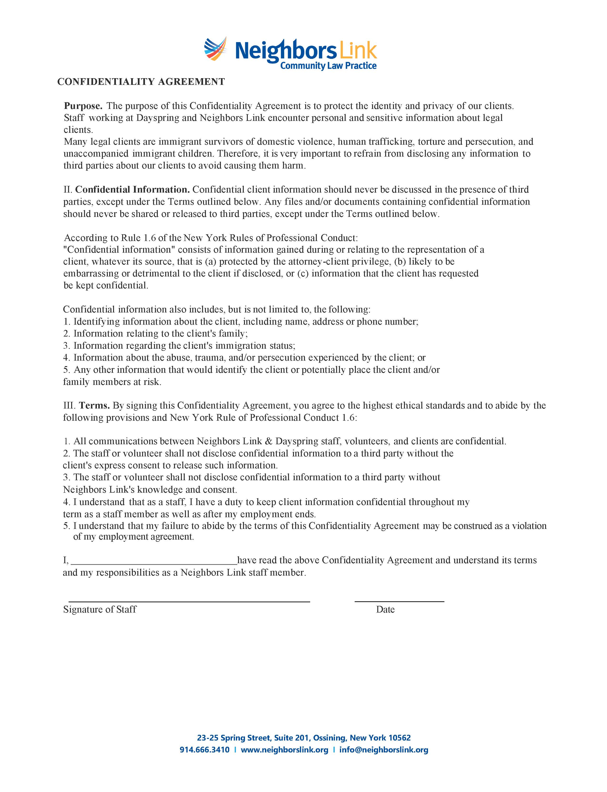

APPENDIX B - EMPLOYEE ACKNOWLEDGMENT OF RECEIPT OF HANDBOOK
I have received and read a copy of the Neighbors Link Employee Handbook which outlines the policies, practices, and group benefits of the organization.
I understand that the information in this Handbook is subject to change as situations warrant and I understand that changes in the policies may supersede, revise, or eliminate the policies in the Handbook given to me on the date indicated below. I further understand that future changes in policy will be communicated to the staff as appropriate. I accept the responsibilities to familiarize myself with the current policies and to keep informed of future changes.

Employee Signature:

Name (please print):

Date:

Please return this signed acknowledgement form to Human Resources

Updated 10/18/2022

Financial Policies and Procedures

Financial Policies and Procedures March 2025

NEIGHBORS LINK CORPORATION

ACCOUNTING
POLICIES AND PROCEDURES

MARCH 2025

Table of Contents
I. Introduction 3
II. Division of Responsibilities 4
Board of Directors 4
Executive Director 4
Chief Financial Officer 4
Deputy Director 5
Sr. Accounting Manager 5
Accounting Manager 5
Development Associate 5
III. Chart of Accounts and General Ledger 6
IV. Cash and Other Receipts 7
V. Investments (Policy approved by Board Jan 31, 2022) 9
VI. Inter-Account Bank Transfers 16
VII. Cash and Other Disbursements 17
VIII. Credit Card Policy and Charges 19
IX. Bank Account Reconciliations 20
X. Property and Equipment 21
XII. Personnel Records 22
XIII. Payroll Processing 23
XIV. End of Month and Fiscal Year-End Close 25
XV. Financial Reports 26
XVI. Addendums 27

I. Introduction

The purpose of this manual is to describe all accounting policies and procedures currently in use at Neighbors Link Corporation and to ensure that the financial statements conform to generally accepted accounting principles; assets are safeguarded; guidelines of grantors and donors are complied with; and finances are managed with accuracy, efficiency, and transparency.

All Neighbors Link Corporation’s staff with a role in the management of fiscal and accounting operations are expected to comply with the policies and procedures in this manual.

These policies will be reviewed periodically and revised as needed by the staff and approved by the Executive Director and Finance Committee of the Board of Directors.

II. Division of Responsibilities
The following is a list of personnel who have fiscal and accounting responsibilities:

Board of Directors

- Reviews and approves the annual budget
- Reviews annual and periodic financial statements and information
- Reviews Executive Director's performance annually and establishes the salary
- Two members of the board will be appointed by the board to be authorized signers on the bank accounts
- Reviews periodic actual to budget financial reports
- The Finance Committee reviews and advises staff on internal controls and accounting policies and procedures. The Finance Committee oversees organizational financial planning, reviews the financial statements and annual budget in detail, including review of personnel expense budget, and recommends to the board the approval of the annual budget.
- The primary function of the audit committee is to ensure the organization carries out an independent outside audit. The specific duties include hiring an auditor, reviewing the audit report with the auditor and assuring the board that the financial statements reflect the organization's financial condition.

Executive Director
- Reviews and approves all financial reports including cash flow projections
- Sees that an appropriate budget is developed annually
- Reviews and signs all issued checks and/or approves check signing procedures
- Reviews and approves all contracts and seeks Board approval on any non-budgeted contracts.
- Reviews and approves all grant submissions
- Approves inter-account bank transfers
- Is on-site signatory for all bank accounts
- Reviews completed monthly bank reconciliations and reviews bank statements for irregularities.
- Oversees the adherence to all internal controls
Chief Financial Officer
- Monitors program budgets
- Reviews all payrolls and is responsible for all personnel files
- Reviews and manages cash flow
- Reviews reimbursements and fund requests
- Processes all inter-account bank transfers
- Assists Executive Director with the development of annual and program budgets
- Monitors grant reporting and appropriate release of temporarily restricted funds
- Monitors and makes recommendations for asset retirement and replacement
- Reviews, revises, and maintains internal accounting controls and procedures
- Reviews all financial reports
- Reconciles all bank accounts
- Opens incoming mail and directs to appropriate department. Counts any cash in safe from program manager and matches to pre-numbered receipts prepared by program manager. Cash amount added to deposit slip.

Deputy Director
- Reviews completed bank reconciliations and bank statements for irregularities.

Sr. Accounting Manager
- Assists with data entry into accounting system and integrity of accounting system data
- Processes invoices and prepares checks for signature
- Assists with processing payroll
- Assists with maintaining general ledger
- Assists with preparation of monthly and year-end financial reports
- Mails vendor checks
- Prepares grant reports
Accounting Manager
- Assists with data entry into accounting system and integrity of accounting system data.

- Processes invoices and prepares checks for signature.

- Assists with processing payroll

- Mails vendor checks.
- Assists with preparation of supporting documentation for grants reporting.
- Assists with preparation of monthly and year-end financial reports.

Development Associate
- Copies checks received and makes bank deposits.
- Emails scanned copy of checks/deposit package to Executive Director, Devel Director, Deputy Director and Chief Financial Officer.

III. Chart of Accounts and General Ledger

Neighbors Link Corporation has designated a Chart of Accounts specific to its operational needs and the needs of its financial statements. The Chart of Accounts is structured so that financial statements can be shown by natural classification (expense type) as well as by functional classification (Family Center, Education, Operations, Development, Administration. ReSET). The Chief Financial Officer is responsible for maintaining the Chart of Accounts and revising as necessary. The Chart of Accounts is attached to this manual as an addendum.

The general ledger is automated and maintained using our accounting software, QuickBooks Online.

IV. Cash and Other Receipts

Cash* and other receipts generally arise from:

- Contracts and Grants
- Direct donor contributions
- Fundraising activities
- Program income*
- Donated Gift Cards**
*Note that in 2024, there was cash received for Learning and Summer Links Programs, minimal cash from other Programming including ESL, Workforce Development and Family Center. In addition, there was minimal cash from chairs and table rentals.
** In 2024, gift card donations were received for the Mercado in Nov/Dec (holiday program for children’s toys) and minimal other gift card donations during the year.

The receipts are received in the following forms
- Mail (check)
- Website (credit card)
- Phone/manual key entry (credit card)
- Stock donations
- Cash directly at Neighbors Link 27 Columbus Ave for minimal amount for rental of chairs, tables or for summer links/learning links program and other programming.
- Donated Gift Cards

The principal steps in the cash and other receipts process are:

Mailed Checks: The Chief Financial Officer opens all mail and directs to appropriate personnel.

Cash from rental of tables/chairs*: The center manager tallies cash received. The cash and tally sheets are dropped through slot in locked safe in Executive Director’s office. The Chief Financial Officer prepares a summary of cash tallies, counts the cash, and adds to deposit slip. The Development Associate goes to the bank and deposits cash/checks.

Donations: The Development Associate makes copies of the checks with letters received (donation packet). The donation packet is scanned and sent to Executive Director, Deputy Director, Devel Director and Chief Financial Officer. Development Associate prepares deposit slip and deposits checks using the deposit slip that Chief Financial Officer opens in the mail. Checks are entered into Donor Perfect by Development Associate.

Program Income*: The Chief Financial Officer counts the program income cash and adds to the deposit slip. The Development Associate takes all checks and cash to TD Bank for deposit.

Credit Card Donations: Most credit card donations are made through the encrypted Neighbors Link website portal, which is administered by Donor Perfect (“Weblink” product). Some donors choose to make donations by phone or event reply cards. The Development Associate enters these transactions directly into Donor Perfect (“Instacharge” product). A QuickBooks credit card summary report is created for all credit card donations. Credit card information for Instacharge transactions are redacted before filing.

Stock Donations: Stock donors receive Schwab donation instructions from the Development Director and are encouraged to let the Development office know when a stock donation is pending. Once the stock gift is received, it is liquidated and a check for the net proceeds is sent to NL to include in the donor database and the general ledger. Development sends acknowledgement with number of shares and date stock received, but the donor determines the value of their own donation.

Gift Card Donations: In Nov/Dec 2024, there was a drive for gift card donations for the Mercado. Gift cards arrived in the mail or were dropped off at 27 Columbus. Gift cards were logged by the volunteer coordinator and were recorded with donor information so that the Volunteer Coordinator could generate thank you letter. Gift cards used for Mercado events were logged. Gift cards remaining were counted and logged in the inventory by the Sr. Acctg Manager and kept in the safe.

The Development Associate generates thank you letters for all donations. The Executive Director signs thank you letters and they are mailed to donors.

The Chief Financial Officer enters all deposit information into QuickBooks and files the deposit paperwork.

QuickBooks and Donor Perfect are reconciled by Chief Financial Officer on a monthly basis. QuickBooks deposits for Other Program Income are agreed to back up documentation as received from center manager and program managers. The income recorded is compared to budget and prior year.

V. Investments (Policy approved by Board Jan 31, 2022)
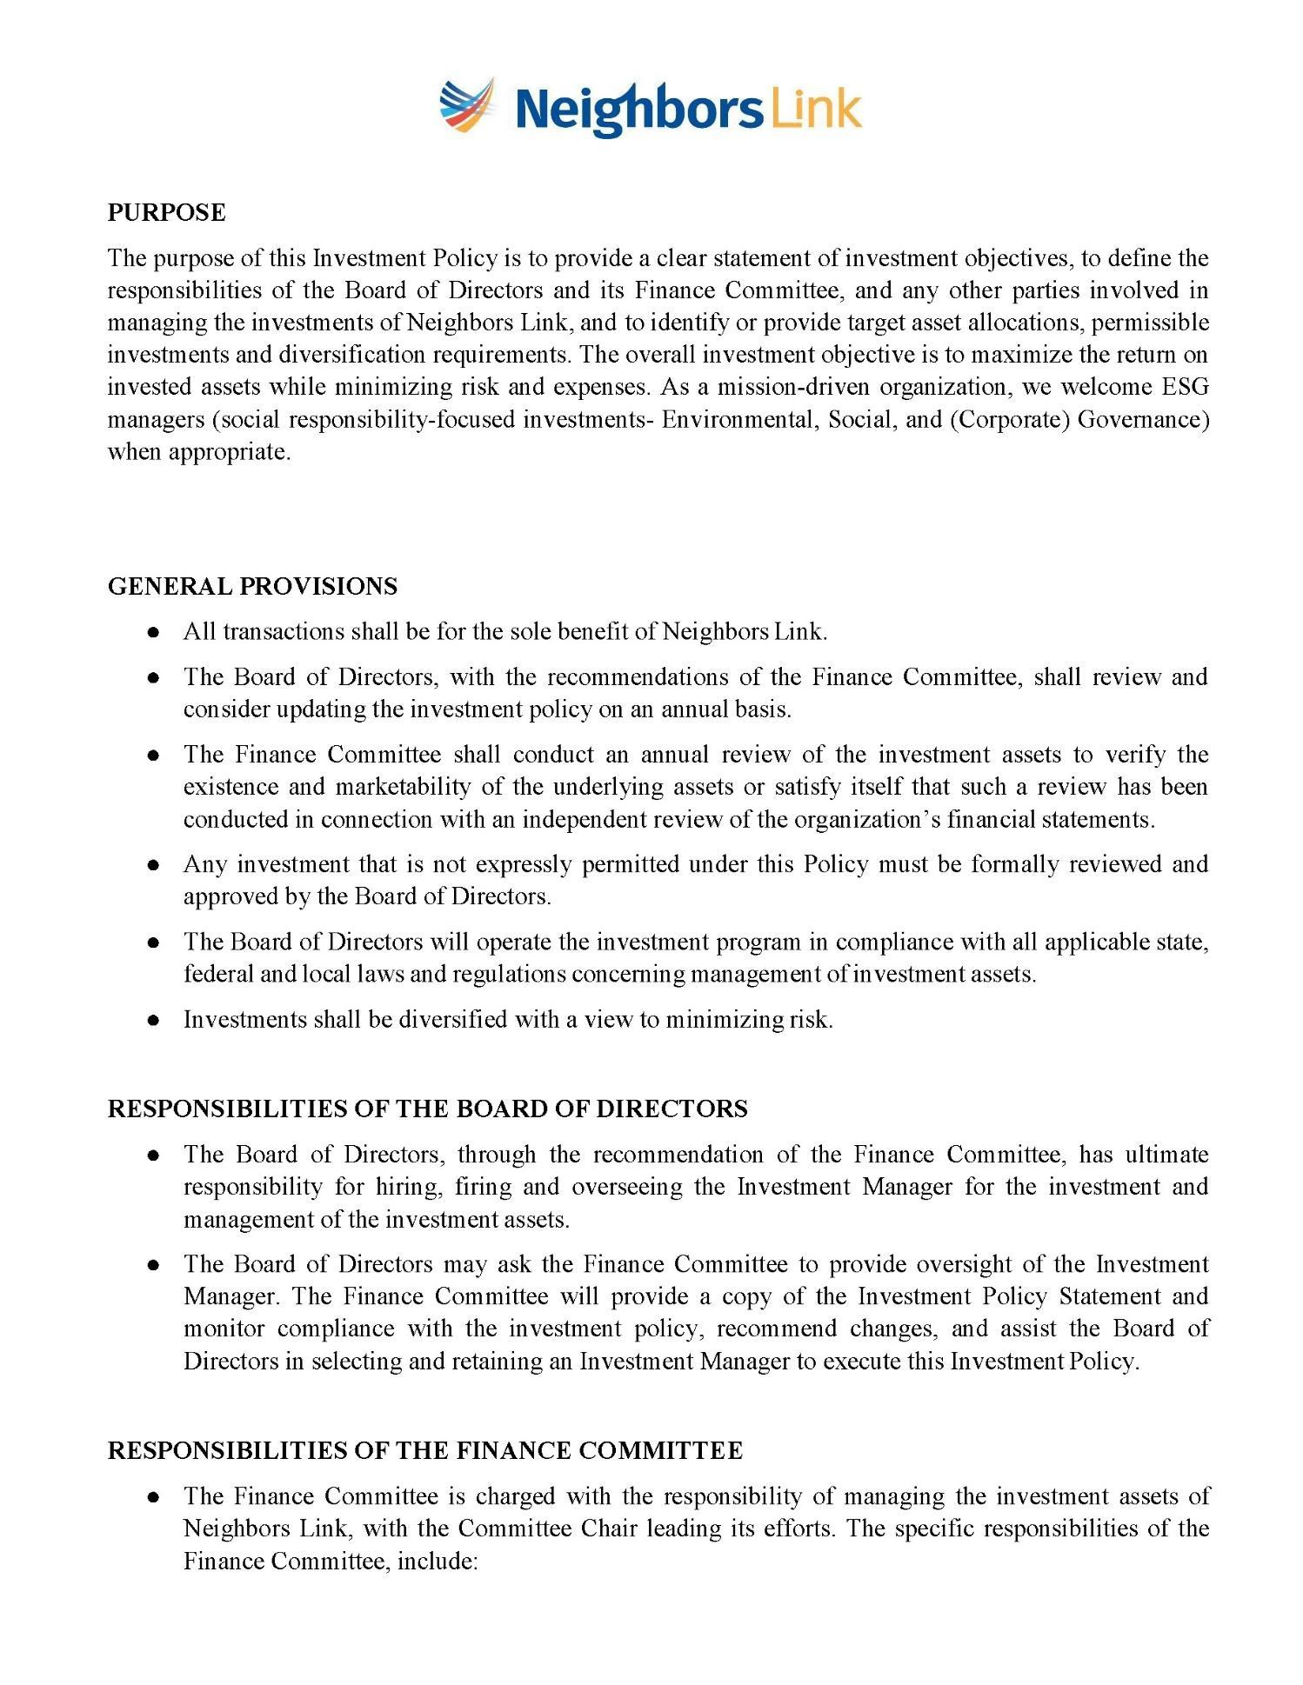
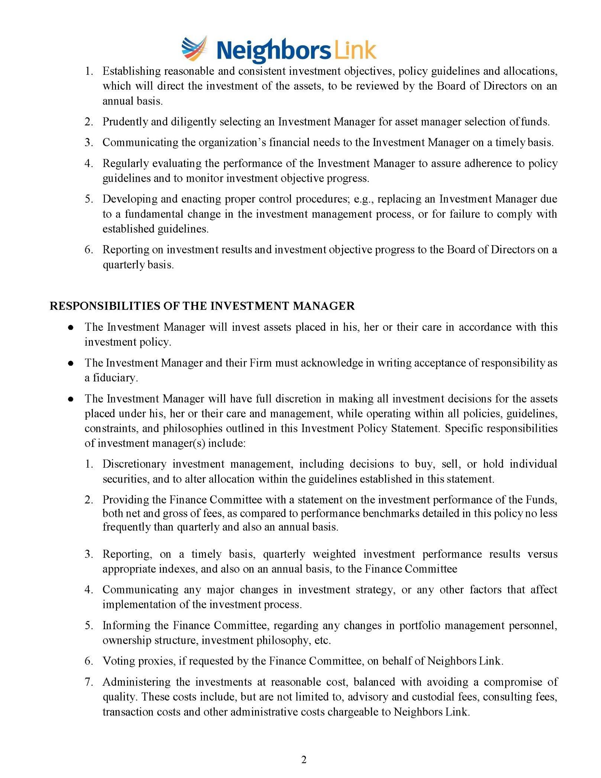
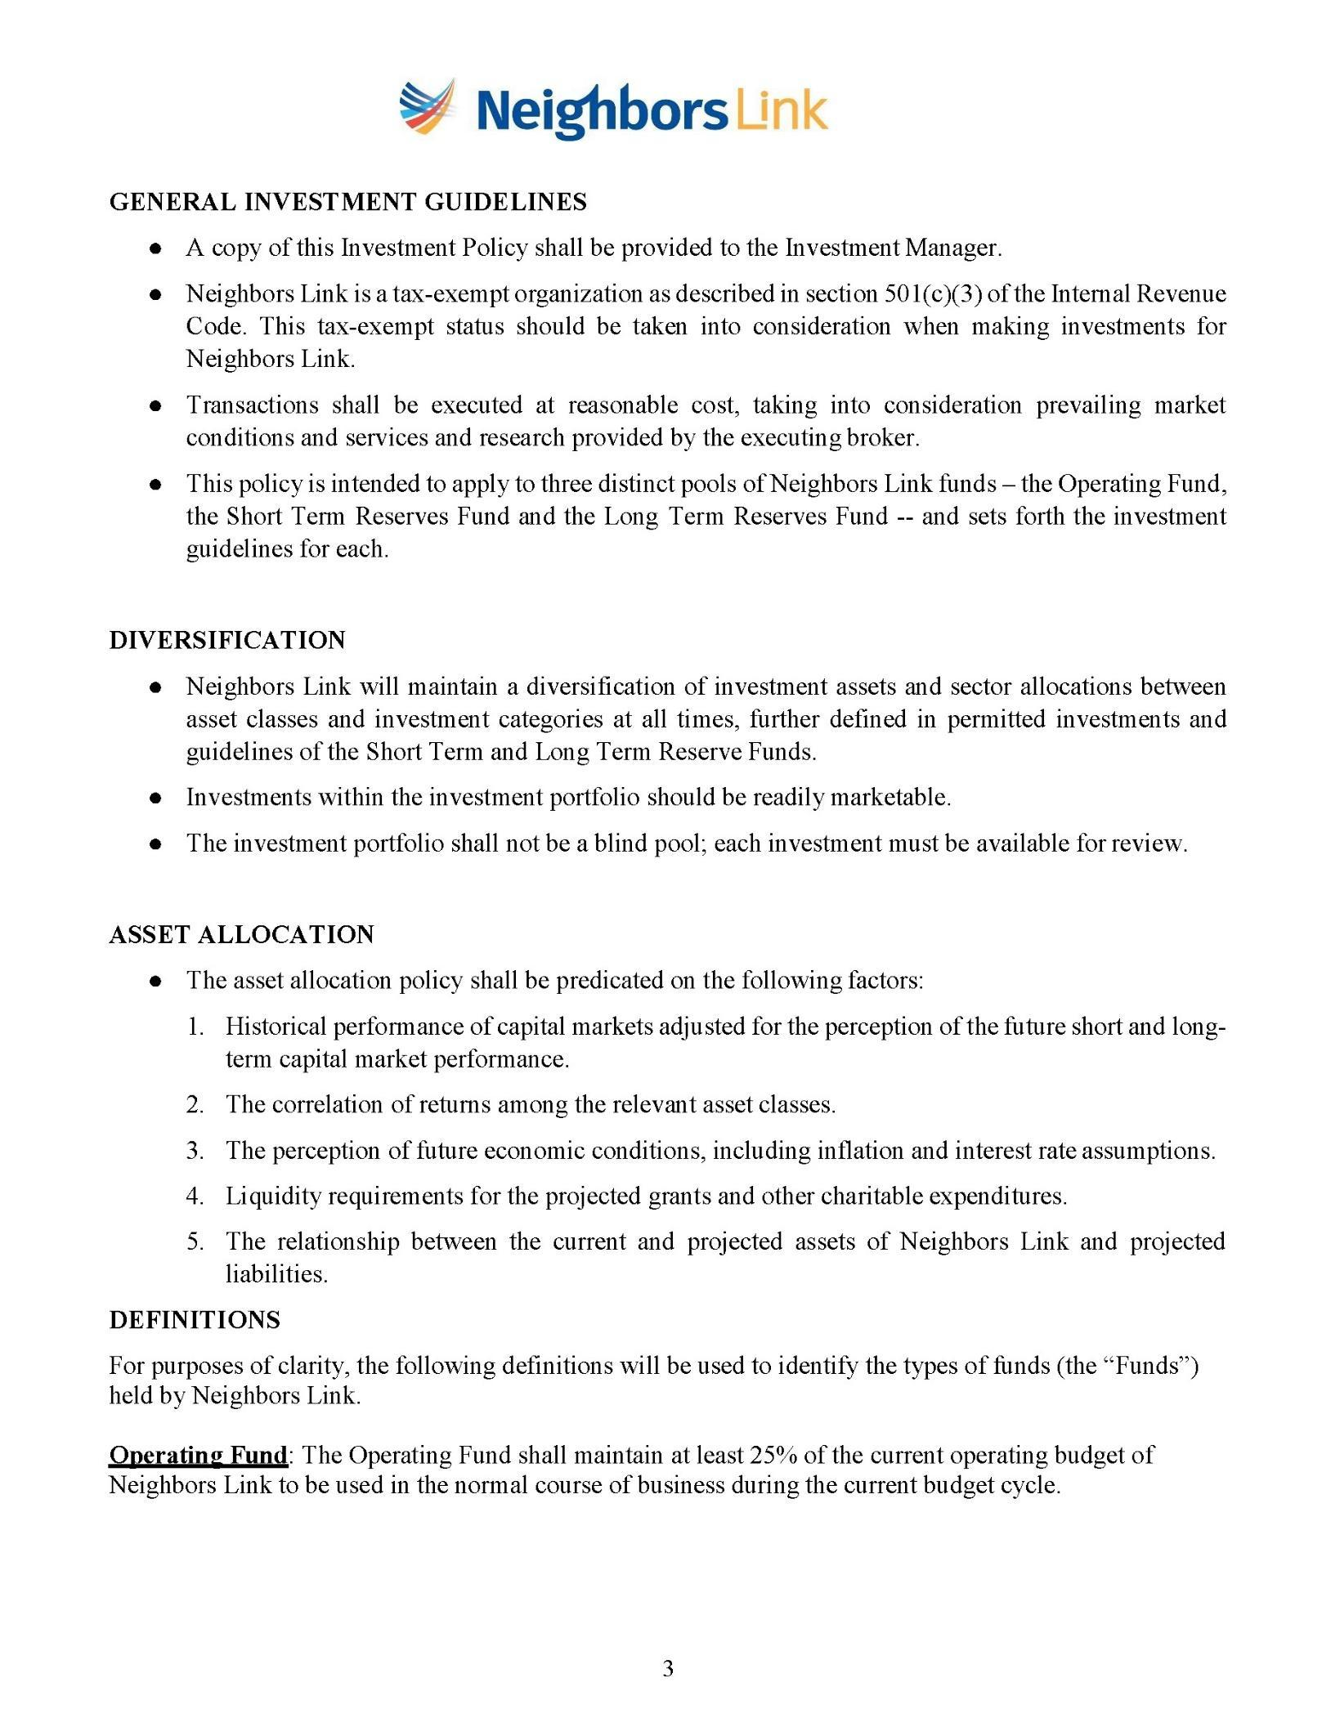
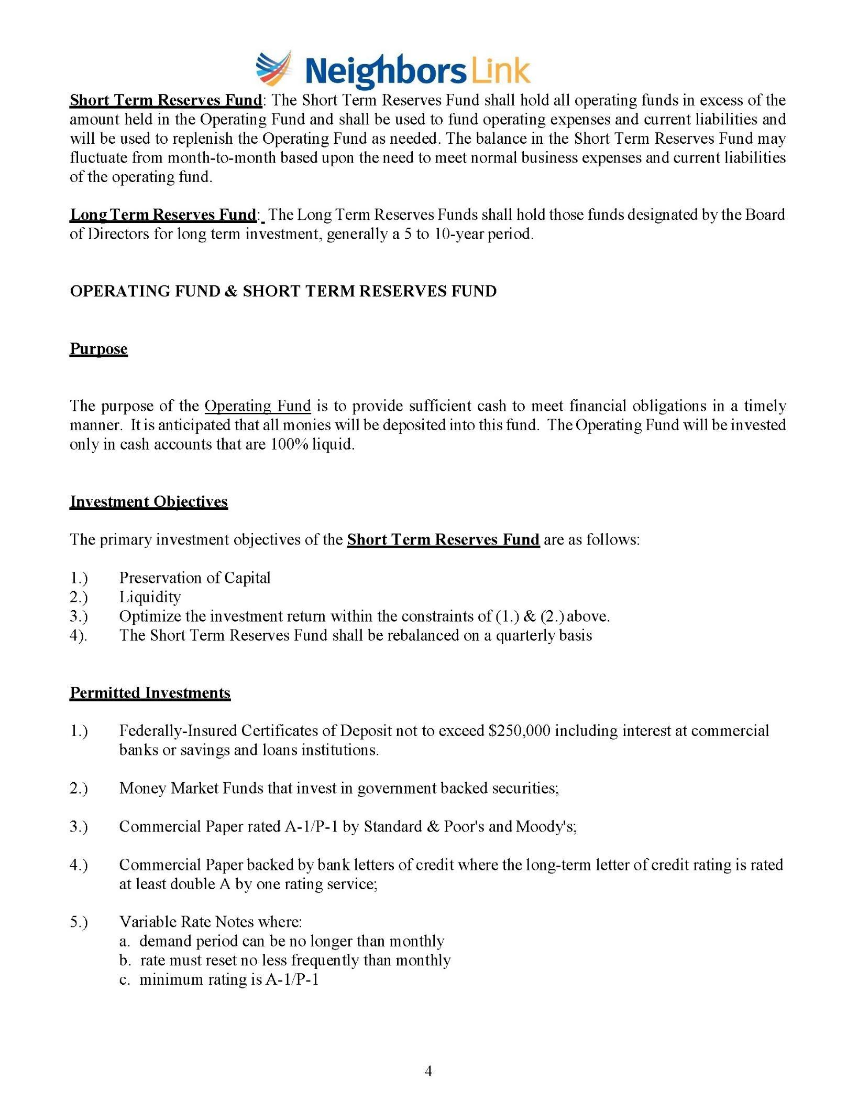
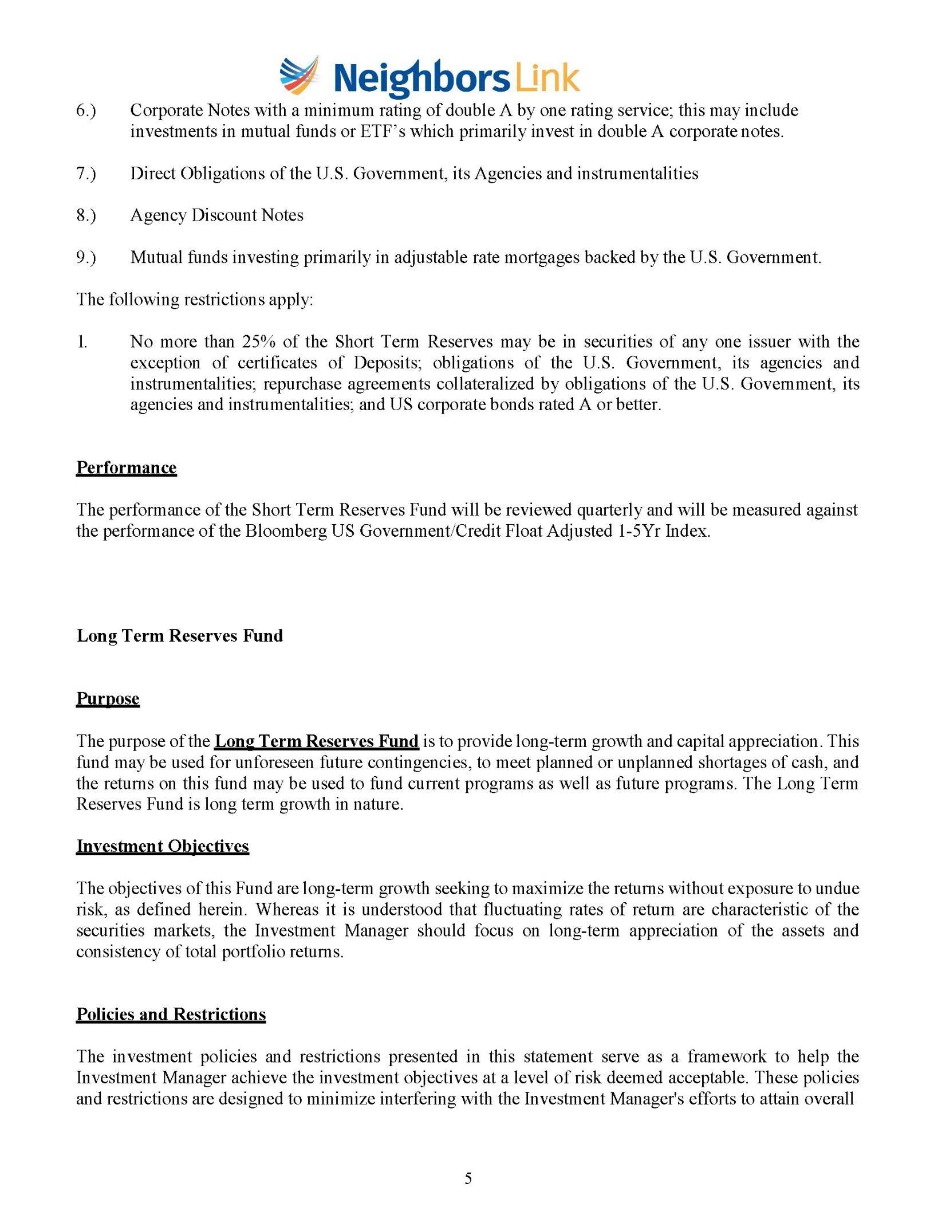
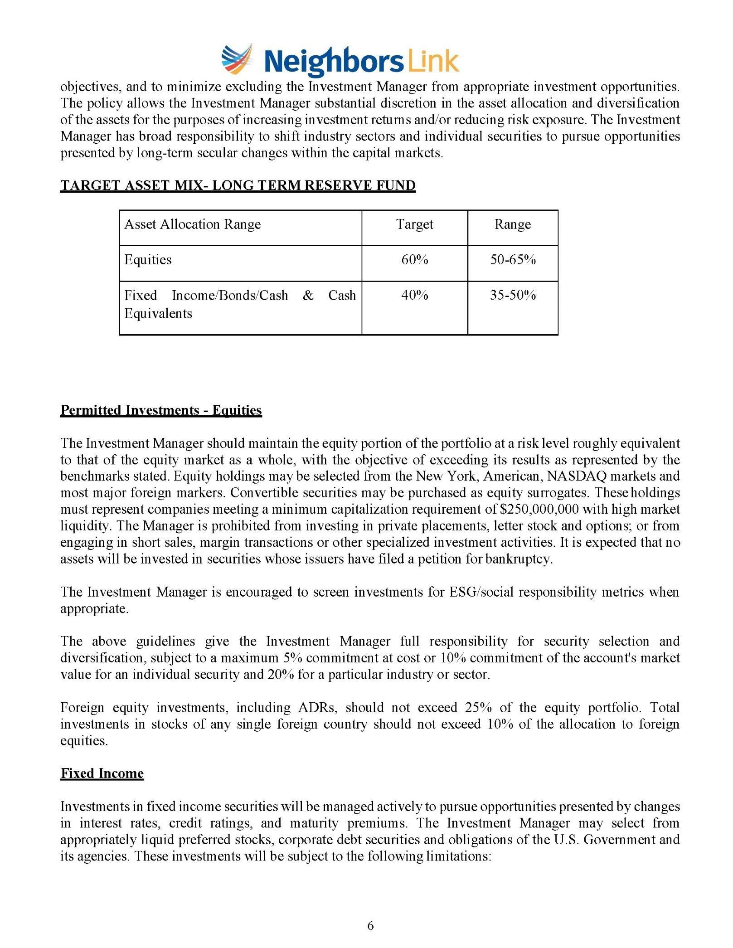
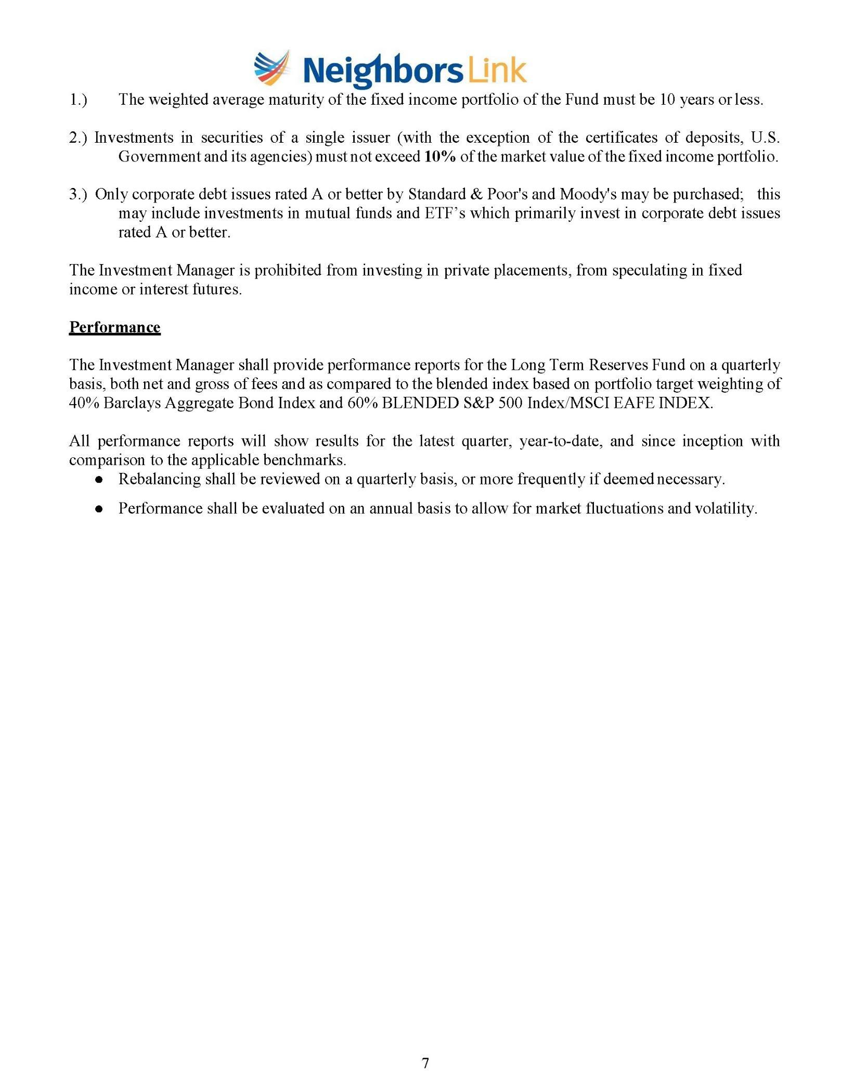

VI. Inter-Account Bank Transfers

The Chief Financial Officer monitors the balances in the bank accounts to determine when there is a shortage or excess in the checking account. The Chief Financial Officer recommends to the Executive Director when a transfer should be made to maximize the potential for earning interest.

VII. Cash and Other Disbursements

Cash disbursements are generally made for:

- Payments to vendors for goods, services, memberships, subscriptions, taxes
- Expense reimbursements

Other disbursements in 2024 included:

- Debit Card – Cash Relief to clients and an Operations Debit Card for small approved cash requirements (tips, small moving jobs and furniture assembly)
- Gift Card Distribution – generally in conjunction with Mercado, Christmas Eve and small $ at other times for clients in need
- Hot Food Tickets – Assistance to clients in need

Mail: The Chief Financial Officer opens all mail and distributes invoices to Sr. Acctg Manager and Accounting Manager who obtain review, approval and coding where needed from Directors.

Invoices are obtained from a combination of on-line portals, email and mail. Invoices are shared electronically with the appropriate manager for review and approval.

Check Process: Once an invoice is approved, the Sr Accounting Mgr. or Accounting Mgr. enters the data in QuickBooks and a two-part check/check stub is generated. The check/stub is attached to the invoice (check package). The check package is submitted to the Executive Director for signature. All checks over $10,000 require second approval by Elisa Burns, the Board Chair (Treasurer, C Robinson is also copied on this approval). Once signed, the check package is returned to the Sr. Accounting Mgr. for mailing and filing.

In early 2025, we implemented Positive Pay with TD Bank for our main operating bank account. We load our check run information into TD Bank ETreasury system and all checks presented on our account are matched to this information. We are notified if there are any Suspect checks and we review and approve them or they are rejected.

Current bank signatories:
Carola Bracco - Executive Director
Elisa Burns - Board Chair
Barbara Jackson - Board Member (recently passed away; responsibility will be assigned to new Board Member)

A list of invoices to look for each month is reviewed by Sr. Accounting Mgr. to help ensure completeness and timeliness of expenditures recorded.

Expense Reimbursements: Staff and volunteers must complete an Expense Reimbursement Form for all reimbursements, including mileage reimbursements. Supervisors must authorize Expense Reimbursement Forms, and receipts must accompany requested reimbursement amounts. Approved expense reimbursements are sent to the Finance Group. The approved reimbursements are entered into the Trinet system as a reimbursement and the amount is paid as part of payroll processing by direct deposit. The reimbursement amount shows up as either travel, mileage or other on the employee payroll direct deposit stub. (See more on Payroll Processing in Section XIII)

Electronic Funds Transfer/Auto Debit Payments

Several vendors have Electronic Funds Transfer (EFT) agreements with Neighbors Link through the TD Bank checking account. The Executive Director must contact TD Bank to authorize additional users as an added safeguard. Current EFT agreements:

Paychex (payroll disbursements)
US Postal Service (bulk mailings)
Transfirst (credit card payments through online credit card system)
Hardland Clarke (checks and deposit slips)
Amazon Smile (matching donor gift program)

There are several vendors set up with TD Bank for auto debit payments. TD Bank requires signature from Executive Director on their form to allow the auto debit to be set up and processed. Monthly statements/invoices are reviewed and approved by manager and coding information is provided if necessary (most will go to a standard general ledger account). Sr. Accounting Mgr will enter the payments to the appropriate GL account as an EFT in Quickbooks which will be matched up to the Bank Statement by the Chief Financial Officer during the reconciliation.

Debit Card Program:

Debit card distributions are approved by the MAP Project Manager for MAP Grant Program, Directors or if for ReSET, by ReSET treasurer. Operations Manager pulls the debit cards from the unloaded/inactive debit card inventory and provides serial # to Sr. Acctg Manager and Accounting Manager. The Acctg Manager enters the approved distributions by Neighbors Link Client, with debit card serial number into Debit Card Distribution Spreadsheet. Based on the balance in the prefunding account and the total $ amount of debit card load, the Chief Financial Officer initiates $ amount for wire transfer to USIO’s San Antonio Bank account (the bank account for prefunding debit cards). Once account is funded, Acctg Manager loads debit cards using debit card portal. For each debit card load session, a reconciliation is performed of balance at USIO to balance on ledger. Unloaded Debit card inventory is periodically checked with physical card count. Debit cards loaded are generally distributed the next day. Loaded cards are kept in a safe until distribution. Debit card receipts are received from the client.

Gift Card Distributions:

Gift card inventory log is maintained by Sr Accounting Mgr which is updated for gift card donations received, and distributions. Gift cards are kept in the safe. Gift card distributions are approved by Directors. Directors notify CFO and Senior Accounting Mgr when cards are needed from the safe for distributions. CFO or Senior Accounting Mgr removes cards from safe and Senior Accounting Mgr updates gift card inventory log. Periodically, gift card inventory in log is verified with physical count.

Hot Food Tickets Distribution:

In 2024, there were two hot food distributions: El Tesoro in Mount Kisco and Pio Pio in Ossining.

Numbered tickets are distributed daily from 27 Columbus to worker center workers for a $9 meal from El Tesoro. The tickets and recipients are logged. Tickets distributed must be used the same day which is determined based on the ticket number range. Restaurant charges Neighbors Link credit card weekly (# hot meal tickets X $9). A picture of the tickets submitted to El Tesoro for food is provided to support the number of meals charged to credit card. A similar program is in place with Pio Pio, in Ossining.

The hot food distribution program was discontinued in 2025.

VIII. Credit Card Policy and Charges

Eight employees (Executive Director, Development Director, Deputy Director, Director of Legal Services and the Director of Operations and Community Development, CFO, Family Center Director and Workforce Development Director) plus the ReSET treasurer have Neighbors Link credit cards, to use for Neighbors Link purchases. Personal purchases are not allowed on the NL credit cards.

The receipts for all credit card charges will be given to the Accounting Manager within one week of the credit card statement close, along with proper documentation. The Accounting Manager matches receipts to credit card transactions for each month’s statement and enters the account posting information into Quickbooks with review by the Sr. Accounting Manager. The monthly credit card statement is attached to the check when submitted to the Executive Director for approval and signing.

IX. Bank Account Reconciliations

- The Chief Financial Officer performs a timely reconciliation as follows: a comparison of dates and amounts of deposits as shown in the accounting system and on the statement, a comparison of inter-account transfers, an investigation of any rejected items, a comparison of cleared checks with the accounting record including amount, payee, and sequential check numbers.
- The Chief Financial Officer will verify that voided checks, if returned, are appropriately defaced and filed.
- The Chief Financial Officer will investigate any checks that are outstanding over six months.
- The Chief Financial Officer will attach the completed bank reconciliation to the applicable bank statement, along with all documentation.
- The reconciliation report will be reviewed, along with the bank statement for unusual balances and or transactions. The reconciliation is reviewed by the Executive Director. An additional review of the reconciliation report is performed by the Deputy Director.

X. Property and Equipment

Property and equipment includes items such as:

- Office furniture and equipment
- Computer hardware
- Computer software
- Leasehold improvements

It is the organization’s policy to capitalize all items which have a unit cost greater than five thousand dollars ($5,000). Items purchased with a value or cost less than five thousand dollars ($5,000) will be expensed in the period purchased.

The depreciation period for capitalized assets is based on the estimated useful lives of the assets, generally 3-5 years or the length of the lease.

- A Fixed Asset Log is maintained by the Director of Operations including date of purchase, asset description, cost, identification number, life of asset.
- Annually, a physical inspection and inventory will be taken of all fixed assets and reconciled to the general ledger balances.
- The Chief Financial Officer shall be informed in writing of any change in status or condition of any property or equipment.
- Depreciation is recorded at least annually. Depreciation is computed using the straight-line method over the estimated useful lives of the related assets. Any impaired assets discovered during the inventory will be written down to their actual value.
- Neighbors Link Corp will always seek to maximize value and cost-effectiveness in procurement and purchasing. Purchases over $5,000 shall require at least 3 competitive bids, quotes and or comparison shopping.

XI. Personnel Records

- All personnel files contain the following documents: an application and/or resume, date of employment, position and pay rate, authorization of payroll deductions, W-4 withholding authorization, termination data where applicable, written approval for background check, a signed acknowledgement of receipt of Employee Handbook, an emergency contact form, and other forms as deemed appropriate by the Chief Financial Officer. Starting at the end of 2019 when we moved to Paychex on-boarding, all new I-9’s and W-4’s are digitized and kept within the Paychex system. Starting December 16, 2023, we moved to Trinet on-boarding and all documents are kept within the Trinet system.
- All employees will fill out an I-9 form and submit the allowable forms of identification to the Chief Financial Officer.
- The completed I-9 forms will be kept in a secure location separate from the personnel files.
- All personnel files are to be kept in a secure, locked office and accessed only by authorized personnel.

XII. Payroll Processing

Effective Dec 16, 2023, Neighbors Link became part of the Trinet Professional Employer Organization (PEO). Neighbors Link employees became co-employed by the PEO. It means we still have complete control over our business, including hiring and termination of our employees, but the PEO is responsible for various employee administration tasks such as payroll processing, benefits administration, workers compensation coverage, and other HR services. The PEO is the employer of record for payroll tax purposes, which means they are responsible for collecting and remitting payroll taxes. Trinet files a form 941 and NYS 45 for clients under a TriNet federal employer identification number. With each payroll, Neighbors Link gets an invoice from Trinet for payroll, employer paid benefits, workers comp insurance and payroll processing fees. Employee paid benefits and disability are deducted directly from employee paychecks. Employees can review their pay stubs online at Trinet. Starting with pay periods after Dec 16, 2023, payroll was processed through Trinet.

Approved Payroll Amounts:
Staff compensation is approved by the Board of Directors as part of the annual budget process. Any changes to salaries or pay rates during the year must be approved by the Executive Director. All changes in salary or status are noted and approved on an Employee Change Form or in an offer letter. Any pay changes for the Executive Director are communicated from the Board of Directors to the Chief Financial Officer in writing.
Employees submit changes in tax withholding status or direct deposit service to Trinet. Eligible full-time employees now select annual health care plans through Trinet and acknowledge the corresponding payroll withdrawal amounts in the Trinet system. Eligible employees also manage 401(k) plan fund choices and contribution amounts through the Trinet portal. 401(k) funds are automatically withdrawn by Trinet during the payroll cycle and contribution reports are available for both Neighbors Link and employees on demand. Neighbors Link adopted the Trinet 401(k) plan effective 5/1/2024. Trinet uses Empower to manage the 401(k) plan so employees who participate in the plan now have a new Empower 401(k) account for payroll contributions and Neighbors Link matching funds.

Payroll Cycle:
- Timesheets are prepared in the online time log service that is part of the payroll system, Paychex. The pay cycle is semi monthly, starting on the 1st and the 16th of the month.
- Timesheets are to be kept on a daily basis and eligible employees can request vacation and sick time through the portal, which is available online and via smart phone application.
- Timesheets are approved online by the employee and the employee’s supervisor. The Chief Financial Officer and Accounting Manager Mgr review the approved time logs prior to the payday. The time recorded in Paychex is entered manually into the Trinet system by the Accounting Manager with review by the CFO. Reconciliations are performed to ensure that time entered in Paychex agrees to time entered into the Trinet payroll. The Chief Financial Officer reviews the hours summary and the payroll register before payroll is submitted. Any changes to the standing information of the payroll register from the prior period including addition of new employees or changes in base pay rate is approved by the Executive Director before the change can be made.
- The Chief Financial Officer/Accounting Mgr. will process payroll in a timely manner and review vacation time, holiday hours, sick time, and any other information deemed necessary to properly reflect time worked.
- Employees choose direct deposit to a designated bank account. Their paycheck is deposited directly into the designated account on the payroll date. The employee can view their check stub online in Trinet.
- The Chief Financial Officer will review payroll expenditures and allocations monthly.
- The Accounting Mgr enters payroll information into QuickBooks. The Trinet payroll register and associated “invoice” for cash requirements are used for the payroll entry.
- Neighbors Link is part of the Trinet quarterly federal and state payroll tax filings.
- All W-2 statements are issued to employees prior to January 31st of the following year for the prior calendar year. W-2s are available to employees on Trinet. The Accounting Mgr prepares and files annual Form 1099’s electronically to IRS (contractor payments) after Sr. Accounting Mgr and CFO review and approval. For 2024, the Form 1099s were mailed to contractors prior to January 31, 2025 using the Quickbooks service.

XIII. End of Month and Fiscal Year-End Close

- The Chief Financial Officer, Sr. Accounting Manager and Accounting Manager prepare all standard monthly and year-end journal entries. The audit trail is maintained on Quickbooks and supporting documentation is maintained.
- Neighbors Link is on a cash-basis, with accrual adjustments made at year-end for audited financial statements. At the end of each month, the Chief Financial Officer will review that all cash accounts match the bank reconciliations. Additionally, at year-end, the Chief Financial Officer will review that fixed assets accounts reflect all purchases, write-downs and retirements, accounts receivable and payable accounts match outstanding amounts due and owed.
- The income and expense accounts review will include reconciliation to amounts received and expended and verification that payroll expenses match the payroll reports.
- Once the final fiscal year-end financial statements are run, reviewed, and approved by the Chief Financial Officer and Executive Director, no more entries or adjustments will be made into that year’s ledgers.
- At the end of the fiscal year, the outside auditor will prepare the annual Return for Organization Exempt from Income Tax (IRS Form 990). The return will be presented to the Executive Director, the Board Finance Committee, and the Board Chair for their review and approval. The return is then filed with the Internal Revenue Service by the annual deadline.
- All other appropriate government filings including those required by the state tax board and attorney general’s office will be completed and filed with the appropriate agency.
- ReSET: Neighbors Link is the fiscal sponsor for ReSET Westchester, Inc. Month-end procedures include a cash transfer from the ReSET bank account to Neighbors Link bank account for checks and other expenses paid by Neighbors Link on behalf of ReSET during the month. In addition, settle-up entries are recorded at each month end for expenses and revenues recorded related to ReSET so that the ReSET bank account equals the payable to ReSET on the statement of financial position and ReSET revenue and expenses offset each other.

XIV. Financial Reports

The Chief Financial Officer will prepare the monthly and annual financial reports. The reports will include: statement of cash position, statement of activity, budget versus actual report for the organization, statement of cash flow, and any other requested reports.

Periodic and annual financial reports will be submitted to the Finance Committee and Board of Directors for review and approval.

Check Signing, Bank Signatories, Capitalization Policy Resolutions Approved April 2025
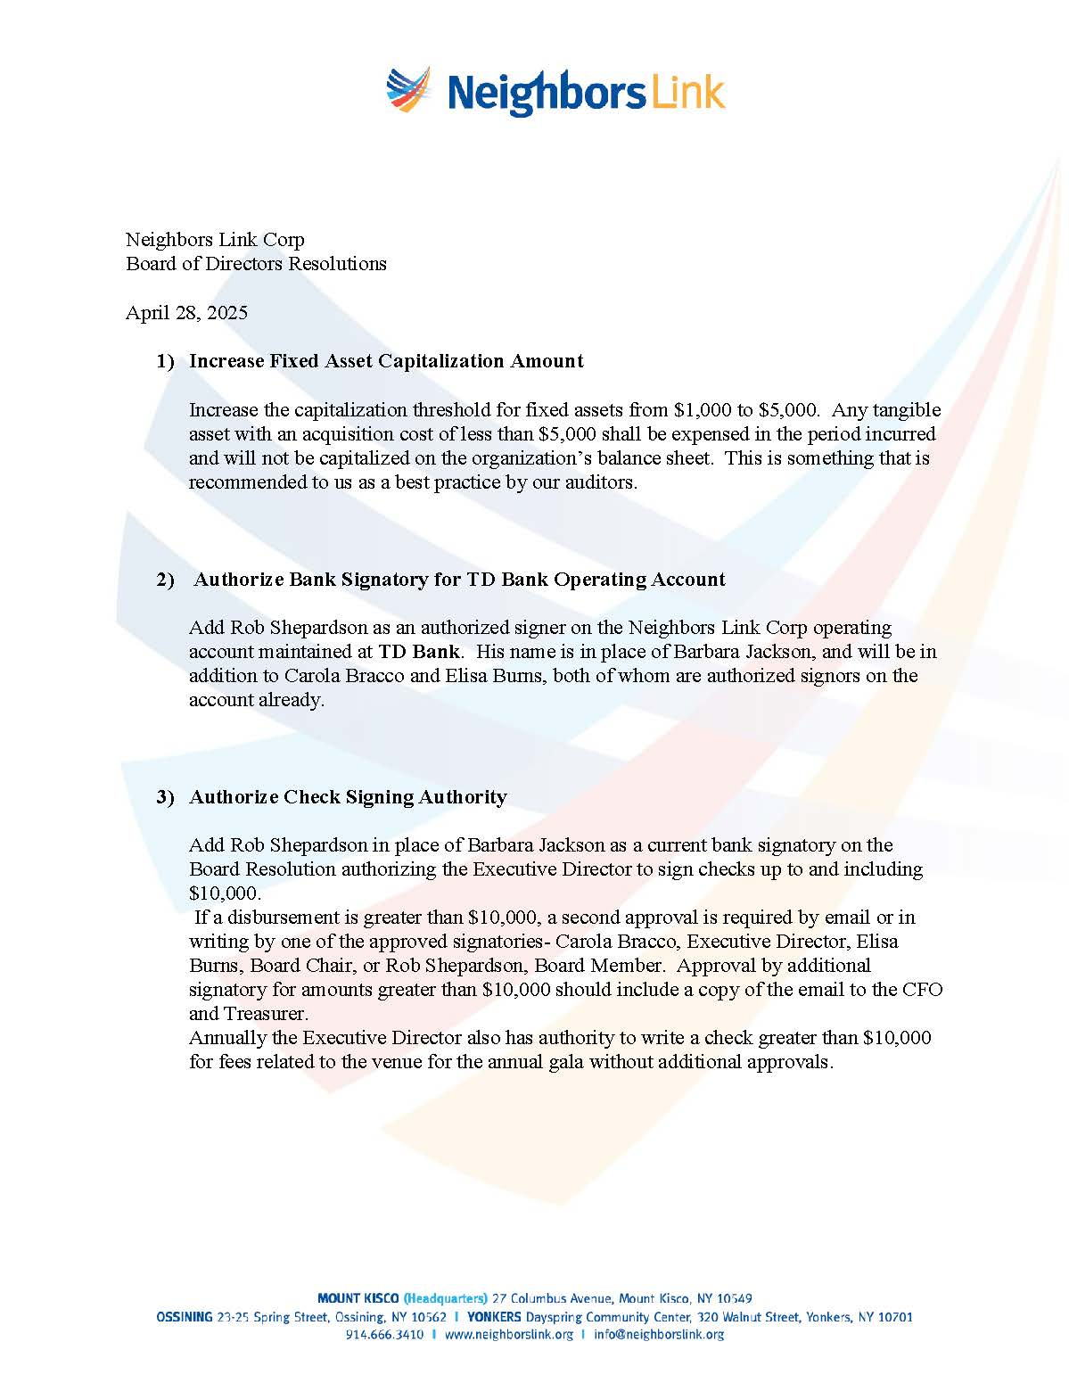

Document Retention Policy (Draft in progress)


Document Retention/Destruction Policy draft in progress
August 13, 2025

This policy specifies how important documents (hardcopy, online or other media) should be retained, protected, and eligible for destruction. The policy also ensures that documents are promptly provided to authorities in the course of legal investigations or lawsuits. The organization’s staff, volunteers, members of the Board of Directors and independent contractors (via agreements with them) are required to honor these rules.
Document Retention Schedule
The following types of documents will be retained for the following periods of time. At least one copy of each document will be retained according to the following schedule.

Corporate Records
Article of Incorporation and Amendments | Permanent
Letter of Determination granting tax exempt and/or charitable status | Permanent
By Laws | Permanent
Board policies | Permanent
Resolutions | Permanent
Board meeting minutes | Permanent
Sales tax exemption documents | Permanent
Tax or employee identification number designation | Permanent
Annual corporate filings (CHAR 500, for example) | Permanent
Trademarks/Patents and Related Papers | Permanent

Financial Records
Chart of Accounts (Quickbooks) | Permanent
Fiscal Policies and Procedures | Permanent
Audits | Permanent
Financial statements | Permanent
General Ledger (Quickbooks) | Permanent
Check registers/books (Quickbooks) | 7 years
Expense Reimbursement Documents | 7 years
Bank deposit slips | 7 years
Cancelled checks | 7 years
Invoices | 7 years
Investment records (deposits, earnings, withdrawals) | 7 years
Property/asset inventories | 7 years
Petty cash receipts/documents | 7 years
Credit card receipts (electronic) | 7 years

Tax Records
Annual tax filing for the organization (IRS Form 990) | Permanent
Payroll registers | Permanent
IRS Form 1099 and 1096 Filings | 7 years
Payroll tax withholdings | 7 years
Payroll tax returns | 7 years
W-2 statements | 7 years

Personnel Records
Personnel Files: Resumes, employee offer letters, pay rate changes, performance reviews, confirmation of employment letters | 7 years after termination
Pension Plan and Employee Benefit Plan | Permanent
Workers’ Compensation Injury records  Other Workers’ Compensation records | 18 years after injury  7 years
I-9 Forms | For former employees, 3 years from date of hire or 1 year from date of termination, whichever is longer
Time reports | 7 years

Insurance Records
Insurance Policies and Correspondence | 10 years after expiration of policy

Contracts
Employee contracts | 7 years after termination
Construction contracts | Permanent
Legal correspondence | Permanent
Loan / mortgage contracts | Permanent
Leases / deeds | 7 years after expiration
Vendor contracts | 7 years
Warranties | 7 years

Donations / Funder Records
Grant contracts and Grant Reports | 7 years after grant payments complete
Donor lists | 7 years
Grant applications | 7 years
Donor acknowledgements | 7 years
Grant Award Letters | 7 years or until restrictions met

DonorPerfect Data | Permanent

Management Plans and Procedures
Strategic Plans | 7 years
Staffing, programs, marketing, finance, fundraising and evaluation plans | 7 years
Disaster Recovery Plan | 7 years

Salesforce, Intake and Attendance Forms
Salesforce Program and Services Data | Permanent
Intake and Attendance Paper Forms | 7 years

Document Protection
Documents (hardcopy, online or other media) will be stored in a protected environment for the duration of the Document Retention Schedule. Computer backup media will be included.

Document Destruction
Hardcopy of documents will be destroyed by shredding after they have been retained until the end of the Document Retention Schedule. Online copies will be destroyed after they have been retained until the end of the Document Retention Schedule.

Provision of Documentation for Investigations or Litigation
Documents requested and subpoenaed by legally authorized personnel will be provided within 5 business days. The Board Chair and Executive Director will authorize provision. No documents will be concealed, altered or destroyed with the intent to obstruct the investigation or litigation.

All other paper documents (not specifically described in this policy) will be destroyed after 3 years.

All other electronic documents on the server, google drive and local files, including emails (not specifically described in this policy) will be deleted from individual computers, databases, networks after 7 years. NEED LEGAL INPUT GMAIL AND SLACK

Insurance Coverage updated 9.23.2025
Neighbors Link Corp Summary of Insurance updated 9.23.2025
Coverage |  | Description | Term | Limits | Company | Premium
General Liability INCL Abuse and Molestation and Social Professional | Covers 3rd party lawsuit brought against you for bodily injury and property damage |  | 8/1/25-26 | $1,000,000 occurrence  $2,000,000 aggregate | Alliance Nonprofits | $17,464
Commercial Umbrella | Excess Liability Above GL Only |  | 8/1/25-26 | $1,000,000 liability | Alliance Nonprofits | $1,373
Commercial Umbrella | Excess Liability Above GL Only |  | 9/16/25-8/1/26 | $2,000,000 liability | Century Surety | $3,105
Excess Professional Liability | Any professional services advice, not including attorneys |  | *9/23/25- 8/1/26 | $1,000,000  liability | Kinsale | $9,151
Property Insurance | Contents, Computers, and Improvements & Betterments |  | 8/1/25-26 | See below | Hartford | $3,735
Employee Dishonesty | Employee Theft |  | 8/1/25-26 | $1,000,000 | Chubb | $2,561
Directors and Officers with Employment Practices | Liability to cover the individual board members for wrongful acts |  | 9/25/25-26 | $3,000,000 D&O  $3,000,000 EPLI | CNA (Continental Casualty Co) | $5,833
Cyber Security | Liability for Hacking Incidents |  | 11/19/24 - 25 | $1,000,000 per claim | Chubb | $3,638
Employed Lawyers Professional | Liability for the in-house lawyers that work for NL and volunteers |  | 6/1/25-26 | $1,000,000 occurrence  $2,000,000 aggregate | Cincinnati Specialty Underwriters  (CSU Producer Resources Inc) | $19,244
Disability (ST & LT) & PFL | Off the job injury |  | With PEO- | 60% of wages | The Hartford | $15,069
Workers Compensation | On the job injury |  | With PEO | $2,000,000 | Aon Risk Services | $25,454
Total Premiums |  |  |  |  |  | $106,627

Property Insurance (Additional Information)
350 Lexington Avenue, Mount Kisco, NY - $210,000 Business Personal Property (BPP), $65,000 Computers, $1,410,813 Improvements & Betterments
23-25 Spring Street, Ossining, NY - $80,300 BPP, $46,000 Computers, $188,000 I&B
320 Walnut Street, Yonkers, NY - $13,700 BPP, $10,000 Computers
*Binding requested

Programs

Hiring Site Terms and Conditions

Terms and Conditions
of Neighbors Link Hiring Site and Job Bank

These Terms and Conditions govern your use of Neighbors Link Hiring Site, Job Bank and Neighbors Link (jointly, “NLHS”). They also provide notice of some of its policies. Please read carefully.

If you do not accept the Terms and Conditions stated here, do not use this service. By using this service, you are indicating your acceptance to be bound by these Terms and Conditions. The terms “you” and “user” as used herein refer to all individuals and/or entities accessing this service for any reason whatsoever.

Neighbors Link Hiring Site is a program of Neighbors Link, a non-profit organization, charging no fee for its hiring site and job referral services. NLHS acts solely as an information exchange venue facilitating the matching of prospective employees and prospective employers. NLHS assumes no responsibility for job applicants’ qualifications for a job. It is recommended that employers request references from employees working in their homes or businesses. Any assistance provided by NLHS in making known prospective employees’ purported skills is facilitation only and such information is not verified or guaranteed by NLHS.

In connection with your use of this service, NLHS has not undertaken to act as a representative of either prospective employees or prospective employers. Such parties are responsible for negotiating all financial and other arrangements directly with each other, and to seek any remedies and/or redress directly from the other party in the event of any dispute. NLHS is not responsible for any state or federal taxes, which shall be the sole responsibility of the prospective employer and/or the prospective employee.

NLHS is not involved in the actual transaction between prospective employers and prospective employees. As a result, NLHS has no control over the quality, safety or legality of the jobs. In addition, note that your use of NLHS involves risks, including but not limited to the risk of physical harm, of dealing with strangers, foreign nationals, underage persons or people acting under false pretenses, for which NLHS assumes no responsibility. You assume all risks associated with dealing with other users with whom you come in contact through NLHS.

In the event that you have a dispute with one or more users of NLHS, you release NLHS (and our agents, officers, directors, representatives and employees) from claims, demands and damages (actual and consequential, direct and indirect) of every kind and nature, known and unknown, suspected and unsuspected, disclosed and undisclosed, arising out of or in any way connected with such disputes. NLHS is not to be considered to be an employer with respect to your use of this service and NLHS shall not be responsible for any employment decisions, for whatever reason made, made by any entity using NLHS.

You agree to defend, indemnify and hold harmless NLHS, its agents, officers, directors, representatives and employees, from and against any claims, actions or demands, including without limitation reasonable legal and accounting fees, alleging, arising or resulting from your use of the service or your breach of the terms of these Terms and Conditions. NLHS shall provide notice to you promptly of any such claim, suit, or proceeding and shall assist you, at your expense, in defending any such claim, suit or proceeding.

These Terms and Conditions are governed by the internal substantive laws of the State of New York without respect to its conflict of laws principles. Jurisdiction for any claims arising under this agreement shall lie exclusively with the state or federal courts within Westchester County, New York. If any provision of these Terms and Conditions are found to be invalid by any court having competent jurisdiction, the invalidity of such provision shall not affect the validity of the remaining provisions of these Terms and Conditions, which shall remain in full force and effect. No waiver of any term of these Terms and Conditions (which must be in writing signed by an authorized representative of NLHS) shall be deemed a further or continuing waiver of such term or any other term. These Terms and Conditions constitute the entire agreement between you and NLHS with respect to the use of NLHS.
Release:

I hereby confirm that I have received a copy of the Terms and Conditions of Neighbors Link Hiring Site and Job Bank. I will not use the services of NLHS unless I accept these Terms and Conditions.

Company Name:_____________________________
Name:_____________________________________
Signature:__________________________________
Date:______________________________________

“Relative” means your domestic partner, spouse, ancestors, siblings and their spouses, children and their spouses, grand children and their spouses, and great-grandchildren and their spouses.
“Financial Interest” means a direct or indirect economic benefit from any transaction, agreement, or compensation arrangement involving the Corporation, including, but not limited to, direct or indirect renumeration, or gifts or favors that are not insubstantial.

