NEIGHBORS LINK CORPORATION

BOARD ORIENTATION PACKAGE

OCTOBER 21, 2026



This document contains confidential materials that should not be shared without prior permission of the Executive Director of Neighbors Link.

Table of Contents
(if Navigation Pane is not on left of screen, Click View tab along top of screen in Word and Check “Show Navigation Pane”)

I. Mission of Neighbors Link and Strategic Goals 4
1. Strategic Planning Priorities (approved by Board Jan. 31, 2022) 5
2. Excellence Award 6
3. Article: One Step Closer To Dayspring 8
II. Board Overview and Resources 12
1. Our Website and The Board Portal 12
2. Board Organization 12
3. Role of the Board 15
4. Board Engagement Opportunities 16
5. Board Directory 17
6. Board Meeting Calendar 2026 18
7. Board Meeting Calendar 2027 19
8. Sample Board Agenda 20
9. Committee Meeting Dates 2026 21
10. Committee Meeting Dates 2027 22
11. Committee Charters 23
12. Governance Committee: New Board Member Process 29
13. Board Candidate Information 30
14. Board Committee Structure Guidelines 32
15. Board Election Dates 34
III. Expectations and Responsibilities of the Board 36
1. Conflict of Interest Policy Certificate 36
2. Whistleblower Policy 45
3. Board Member Condensed Biography 48
4. Board Self Evaluation 49
IV. Locations 66
V. Organizational Chart 67
VI. Programs at Neighbors Link 68
1. 2025 Program Impact – Presented at March 2, 2026 Board Meeting 68
2. Advocacy Priorities – Legislative Newsletter June 2026 77
VII. Financial Reports and 2026 Budget 80
1. Financial Trends 80
2. The Inclusion Campaign – Executive Summary 81
3. Campaign Update September 2025 82
4. 2026 Budget Presentation 84
VIII. Insurance Coverage Overview (updated Oct 18, 2025) 96
IX. Lobbying Regulations 98
X. Appendix 113
1. Employee Emergency Fund 113
2. Client Cash Relief Program 115

Mission of Neighbors Link and Strategic Goals



MISSION

The mission of Neighbors Link is to strengthen the whole community by actively enhancing the healthy integration of immigrants.

Strategy: Educate, Empower, Employ

Strategic Planning Priorities (approved by Board Jan. 31, 2022)

NEIGHBORS LINK STRATEGIC PLANNING PRIORITIES
Updated: January 14, 2022
Approved by BOARD OF DIRECTORS January 31, 2022

Introduction
Neighbors Link is a highly successful organization which has grown steadily, delivering increasingly strong results relative to its mission of the healthy integration of immigrants. Critical to this mission is to empower clients with an array of programs and community gathering places, while engaging with the broader community and advocating publicly for healthy immigrant integration. All of these efforts rely on strong partnerships with other community organizations to leverage Neighbors Link’s strategies as well as provide services and programs outside Neighbors Link’s areas of focus.

As the organization continues to deliver current programs and services, the strategic plan emphasizes priorities to ensure the organization continues to thrive, while addressing the ever-growing and ever-changing needs of the communities we serve. Over the next five years, therefore, Neighbors Link will focus specifically on three key strategic priorities:

Strategic Priority 1: Enable clients’ unfettered participation in the digital economy and digital education.

To address the inadequate access to information technology experienced in the communities we serve, including the ability of the client population to leverage the internet, computers, and telephones, Neighbors Link will undertake to improve digital literacy and provide pathways to accessibility, affordability, and digital skills.

Strategic Priority 2: Empower upward mobility of clients.

Neighbors Link will enhance client access to improved career pathways through acquisition and development of skills, expanded educational achievement opportunities, and expanded work force development opportunities. Because mental health wellbeing is key to personal development and advancement, Neighbors Link will help address clients’ mental health needs through its resources as well as those of partner organizations,

Strategic Priority 3: Strengthen the organization as it grows.

In order to ensure that the organization has the tools and resources it needs for future sustainability and strength, Neighbors Link will invest additional resources in the following: (1) internal technology and infrastructure capabilities; (2) human resources management, including employee mental health wellbeing and training and development; (3) increased capabilities for analysis of program outcomes; and (4) long-term internal financial planning and investment.

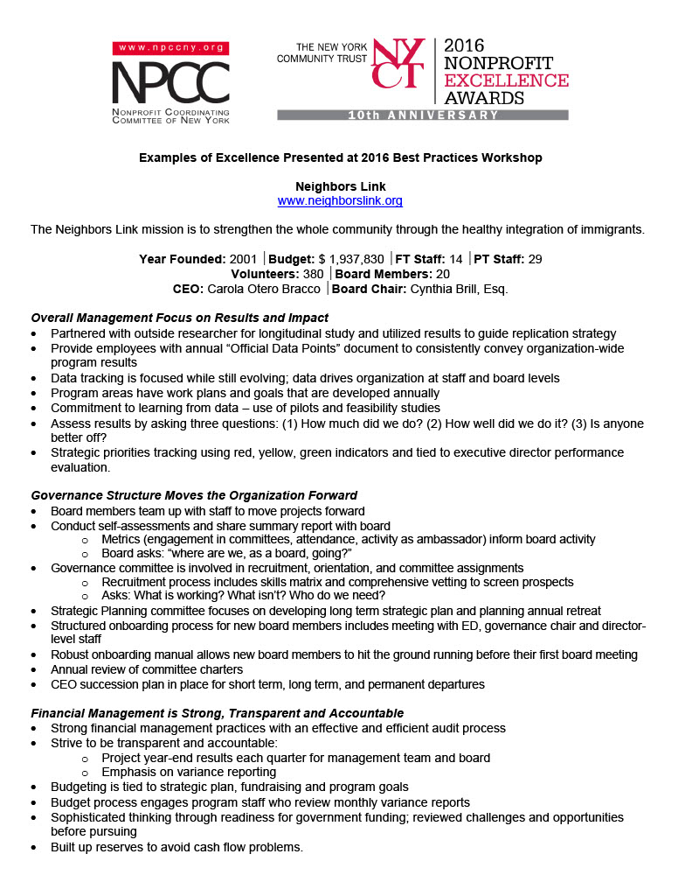
Excellence Award
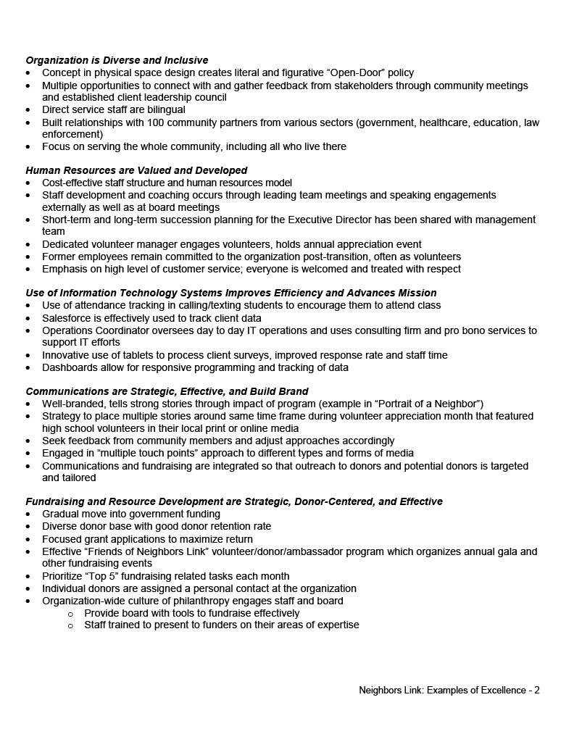


Article: One Step Closer To Dayspring
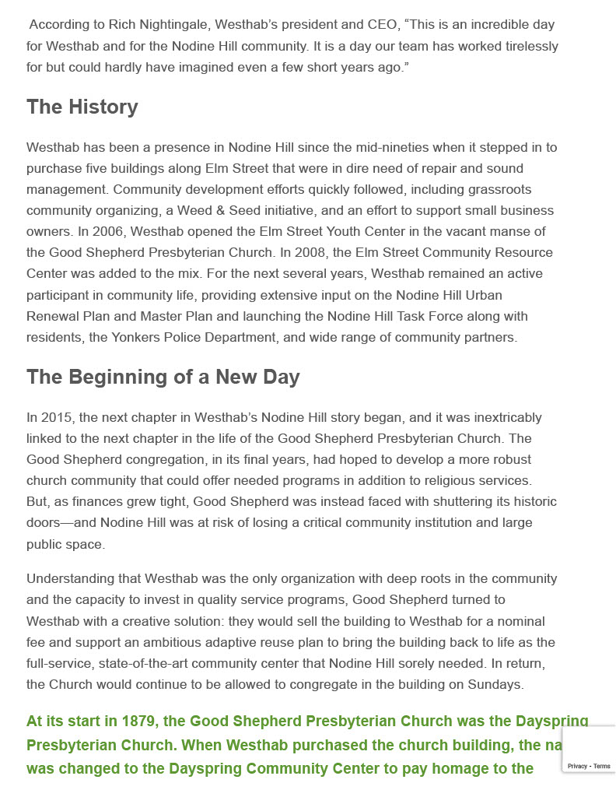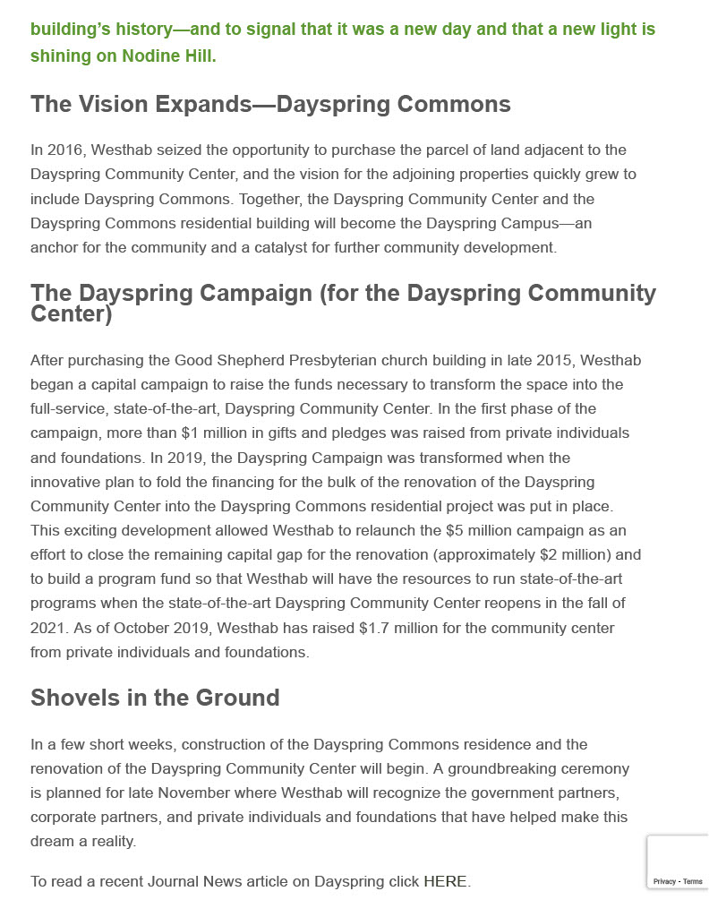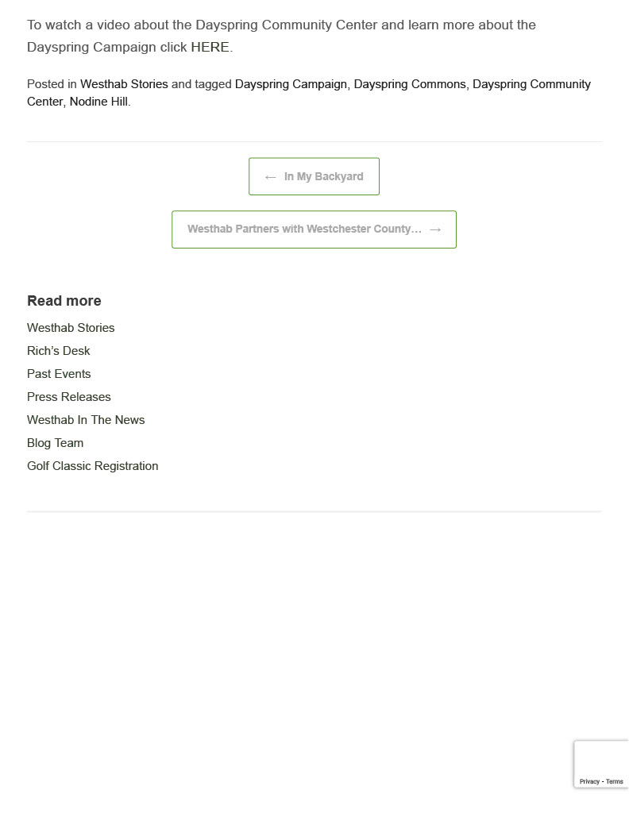

Board Overview and Resources

Our Website and The Board Portal

The Board Portal is accessed through our Neighbors Link Website under “Who We Are”. The portal is password protected. The password is changed every six months and is provided by our Communications and Social Media Manager, Katie Graves-Abe, email: kgraves-abe@neighborslink.org

Documents for Board Meetings are uploaded to the portal on Thursday before a Board Meeting and are organized by Board Meeting Date.

General Documents are also kept on the Board Portal in three sections:

- Current Versions of the Board Calendar, Contacts and Structure
- Organizational Documents
- Additional Reference Documents

Board Organization
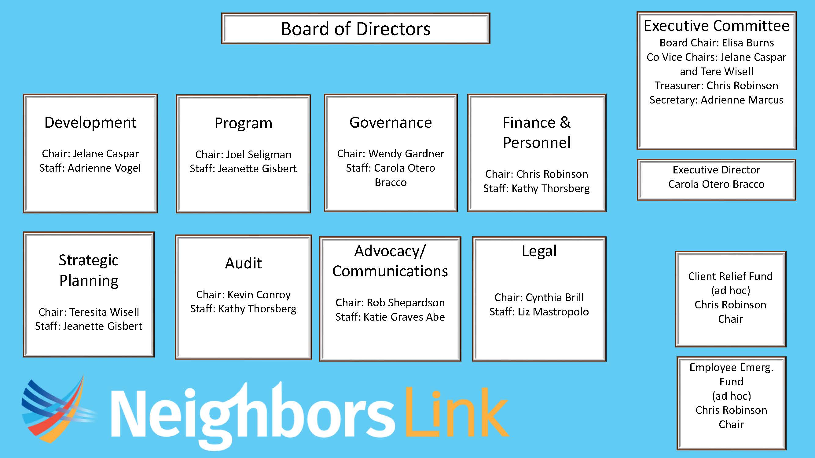


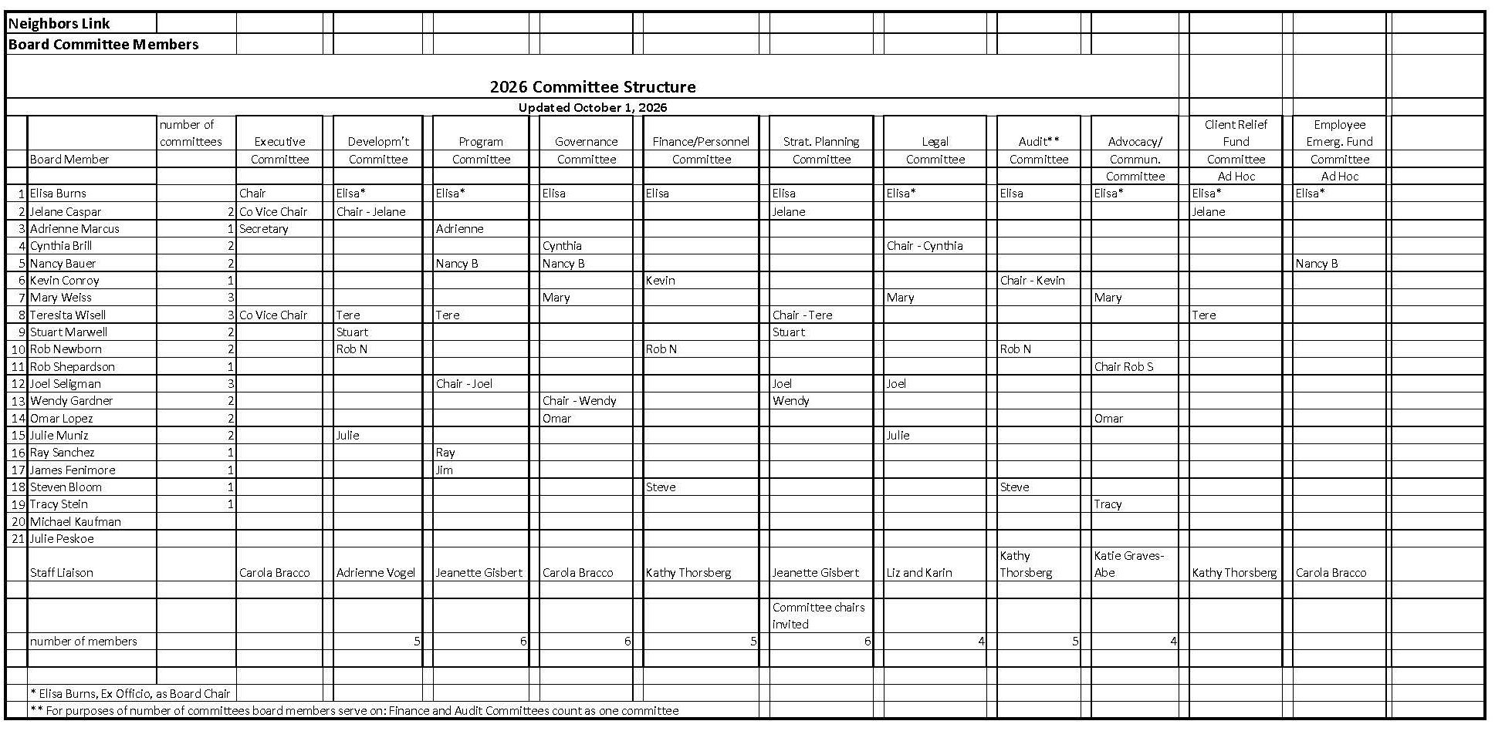

Role of the Board



Role of the Neighbors Link Board

- Effectively represent the needs of the community that we have chosen to serve – the “mission.”
- Preserve, enhance and effectively deploy the resources of the organization – financial and non-financial, tangible and intangible (its “brand,” community reputation, access, etc.).
- Assure the effectiveness and sustainability of the organization to deliver on its mission.
- Plan for the long-range future of the organization and its mission.
- Continually enhance the effectiveness of the Board, especially in an evolving environment.
- Enhance and protect the effectiveness of the Executive Director.

As approved by the board of directors

Board Engagement Opportunities



Board Directory

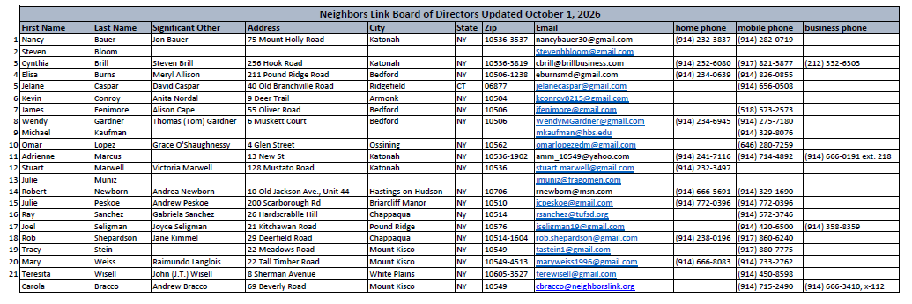

Board Meeting Calendar 2026


2026 Neighbors Link Board of Directors Meeting
Schedule
As of October 7, 2025
Mondays 6:00 – 8:00 pm
Month | Date | Notes
January | No meeting | 1/19 - Martin Luther King Day
February | Feb 2 | 2/16 - Presidents Day
March | Mar 2
April | Apr 13 | 4/1 – Passover begins  4/5 – Easter Sunday
May | May 11 | 5/25 - Memorial Day
June | No meeting | 6/19 - Juneteenth (Observed)
July | July 13 | Friday, 7/3 - Independence Day (Observed)
August | No Meeting
September | Sept 28 | 9/7 - Labor Day  9/11 – Rosh Hashanah begins  9/20 – Yom Kippur begins
October | No Meeting | 10/12 – Columbus Day
November | Nov 2 | 11/26 - Thanksgiving
December | Dec 7 | 12/4 – Hanukkah begins  Friday, 12/25 - Christmas Day

Board Meeting Calendar 2027



2027 Neighbors Link Board of Directors Meeting Schedule
As of October 21, 2026
Mondays 6:00 – 8:00 pm
Month | Date | Notes
January | No meeting | 1/18 - Martin Luther King Day
February | Feb 1 | 2/15 - Presidents Day
March | Mar 1 | 3/28 – Easter Sunday
April | Apr 12 | 4/21 – Passover begins
May | May 10 | 5/31 - Memorial Day
June | No meeting | Friday, 6/18 - Juneteenth (Observed)
July | July 12 | Monday, 7/5 - Independence Day (Observed)
August | No Meeting
September | Sept 27 | 9/6 - Labor Day
October | No Meeting | 10/1 – Rosh Hashanah begins  10/10 – Yom Kippur begins  10/11 – Columbus Day
November | Nov 1 | 11/25 - Thanksgiving
December | Dec 13 | 12/24 – Hanukkah begins  Friday, 12/24 - Christmas Day (Observed)

Sample Board Agenda


Committee Meeting Dates 2026

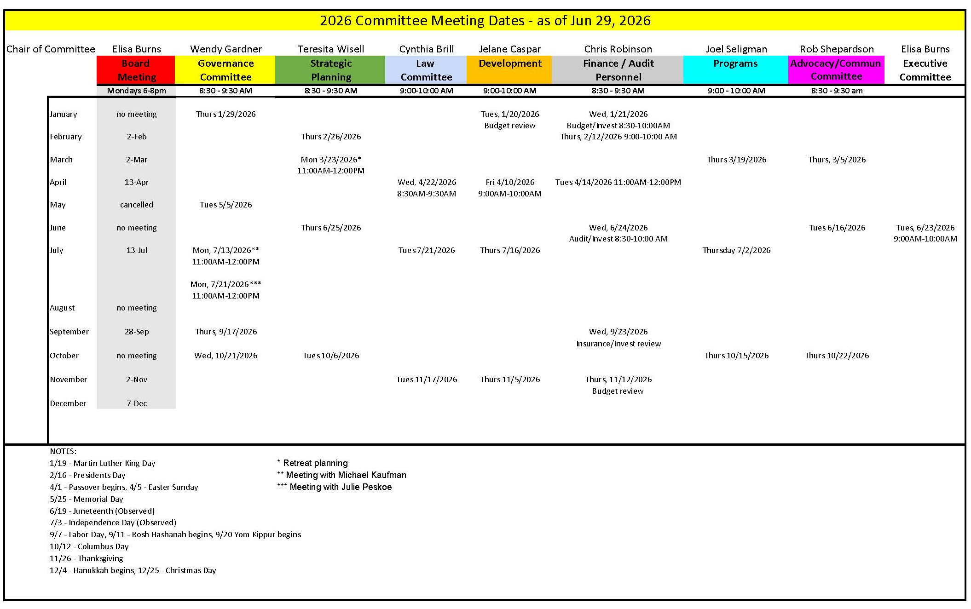

Committee Meeting Dates 2027

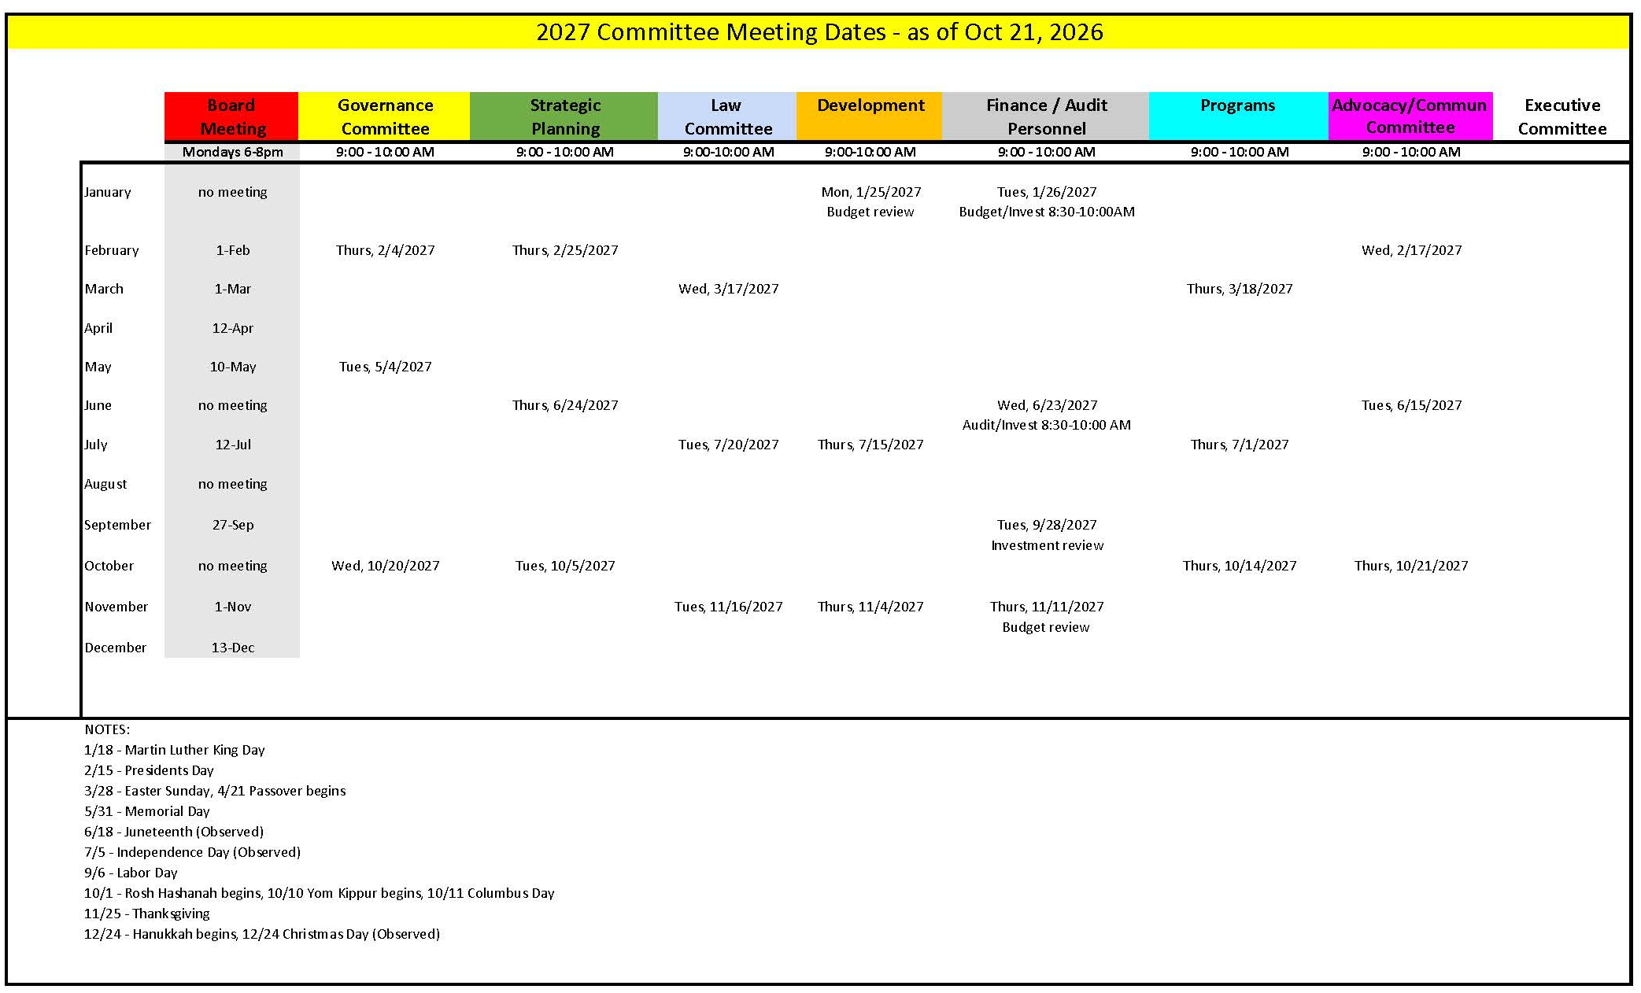

Committee Charters

COMMITTEE CHARTERS
Approved by board of directors: April, 2024 Board Meeting

- ADVOCACY AND COMMUNICATIONS COMMITTEE CHARTER

The Advocacy and Communications Committee provides strategic oversight and direction on the advocacy and communications initiatives of Neighbors Link.

Responsibilities

- Work with Neighbors Link staff on the development of an annual communications strategy focused on the organization’s work to strengthen the whole community through the empowerment and integration of immigrants.
- Provide direction to ensure that communications and advocacy functions are integrated with the other departments to broaden and deepen the community’s awareness and support, financially and otherwise.
- Work with Neighbors Link staff on the development of an annual advocacy strategy consistent with our mission and 501c3 tax classification. Ensure the strategy is flexible and allows for the inclusion of various advocacy issues that may surface throughout the year.
- Educate the Board regularly on advocacy and policy issues, paying special attention to how they align with our mission.
- Integrate and engage Friends of Neighbors Link in advocacy and recognize their significant contributions.
- Support the organization in outreach to elected officials on the highest priority advocacy issues.
- Semi-annually, review the implementation and impact of the communications and advocacy strategies.

- AUDIT COMMITTEE CHARTER

The Audit Committee assists the board to safeguard the organization’s financial integrity,
provide oversight of the financial reporting process, the audit process, the company’s system of
internal controls, and compliance with laws and regulations and best practices.

Responsibilities

- Oversee the annual independent audit process.
- Retain or renew the retention of an independent auditor to conduct the audit and annually review the auditor’s performance and independence.
- Review with the independent auditor the scope and planning of the audit before the audit begins.
- Upon the completion of the audit, receive all reports and management letters from the
independent auditor and review and discuss with the auditor (1) any material risks and
weaknesses in the internal controls identified; (2) any restrictions on the scope of the
auditor’s activities or access to information; (3) any significant disagreements between
the auditor and management; and (4) the adequacy of the Corporation’s accounting and
financial reporting process.
- Report the Audit Committee’s findings to the Board.
- Review the annual information returns (IRS Form 990 and the form NY CHAR 500, related schedules, and forms) and recommend for approval, signature, and submission by the appropriate officer.
- Ensure the organization complies with best practices and all required statutory policies, including risk-management, conflict of interest, whistleblower and all other policies as required by law.

- DEVELOPMENT COMMITTEE CHARTER

The Development Committee ensures the organization’s total development program is in concert with
the organization’s strategic direction and needs.

Responsibilities

- Review the annual development plan, which includes the development strategy and annual budget and make recommendations as appropriate
- Understand and recommend to the finance committee the revenue objectives for the annual budget.
- Ensure the Board is educated about the annual development plan along with recommendations
for funding the resources needed to meet the plan.
- Understand the financial returns on fundraising activities and ensure they are aligned with the
annual plan objectives.
- Monitor the actuals to budget progress throughout the year and ensure the Board is updated regularly.
- Encourage the Board’s full participation in fundraising activities including events, appeals and
Campaigns.
- Meet with key donors in alignment with the Development Director and Executive Director
- Introduce potential donors to the organization.
- Integrate and engage the Friends in fundraising and recognize their significant contributions.

- EXECUTIVE COMMITTEE CHARTER

Responsibilities

- Meet as it deems necessary to carry out its responsibilities.
- Recommend the succession plan to the Board of Directors for approval.
- Carry out the responsibilities as outlined in the Succession Plan in the event of a temporary or permanent absence of the Executive Director.
- Provide guidance and support to the Executive Director during emergency situations for the organization. In such situations, the Board Chair is authorized to act on behalf of the committee in other than legally binding obligations.
- Take action when required with a minimum of three of the four members present, provided that all three members vote in agreement.
- Formulate the ED annual goals and evaluate the ED’s annual performance.
- FINANCE AND PERSONNEL COMMITTEE CHARTER
(revision approved at the May 2024 board meeting)

The Finance and Personnel Committee is responsible for assisting the board in monitoring the
financial operations and financial health of the organization.

Responsibilities
- Oversee the timely preparation of financial statements & maintenance of financial records
- Monitor income and expenditures against projections.
- Review and recommend financial policies to the board, including internal controls and maintaining financial records in accordance with standard accounting practices.
- Present quarterly or monthly financial statements to the board, as well as the financial report required by the by-laws.

- Oversee budget preparation and financial planning
- Propose for board approval a budget that reflects the organization’s goals and board policies including the needs, expenses, and revenue of the organization.

- Collaborate with the Executive Director and CFO to safeguard the organization’s assets
- Review the organization’s insurance and risk-management procedures.
- Review capital spending budgets to insure the appropriate use of resources.
- Develop and modify an Investment Policy to manage the investment assets of Neighbors Link. The specific responsibilities of the committee as it relates to the Investment policy include:
    - Establish reasonable and consistent investment objectives, policy guidelines and allocations, which will direct the investment of the assets, to be reviewed by the Board of Directors on an annual basis.
    - Prudently and diligently select an Investment Manager for asset manager selection of funds.
    - Work with the Executive Director and Chief Financial Officer to communicate the organization’s financial needs to the Investment Manager on a timely basis.
    - Regularly evaluate the performance of the Investment Manager to assure adherence to policy guidelines and to monitor investment objective progress.
    - Develop and enact proper control procedures, replace an Investment Manager due to a fundamental change in the investment management process or for failure to comply with established guidelines, or based on performance.
    - Report on investment results and investment objective progress to the Board of Directors on a quarterly basis.

- Assist the board in understanding the organization’s financial affairs.
- Ensure that the board is well informed about the organization’s finances.
- Educate the board about financial matters.

- Review with Executive Director overall compensation and benefits strategy on an annual basis, including 401k plan.

- GOVERNANCE COMMITTEE CHARTER

The Governance Committee helps the Board reach its potential as an effective oversight entity, by recommending board education and ensuring proper governance practices, including compliance with state and federal statutory changes and board responsibilities.
Responsibilities
- Develop and implement a plan for recruiting and nominating diverse and skilled board members
- Ensure that new board members are oriented and assigned to committees in a timely manner
- Conduct a board self-assessment every two years; report results to the board and provide a progress update at midpoint
- Periodically review bylaws and make recommendations for changes to the board
- Review committee charters and make recommendations for changes to the board
- Work with staff to develop meaningful board education sessions
- Recommend officers, committee chairs and committee members to the board for approval
- Conduct other business as requested by the Chair or board

- LEGAL COMMITTEE CHARTER

The Legal Committee supports Neighbors Link by providing oversight and strategic input to the
Neighbors Link Community Law Practice (NLCLP).

Responsibilities

- Assist the Executive Director, Legal Director and NLCLP managing attorneys in assessing the
NLCLP’s scope and priorities.
- Follow current and future shifts in immigration policy.
- Provide strategic input regarding the scope and type of legal services provided by the NLCLP to
ensure the overall model addresses emerging legal needs of community members based on
current immigration policies and adequately prepares for future shifts based on immigration
projections.
- Monitor outcomes of NLCLP.
- Ensure the Board is well informed about important issues relating to the NLCLP including the
legal practice model and immigration policy.
- Interface with advocacy committee, as necessary, on pressing issues facing legal clients.
- Maintain oversight of risk management by advocating that the NLCLP has (i) sufficient
capacity/resources to address the legal needs of its clients and (ii) appropriate liability insurance
in place, consistent with the scope of its legal practice.
- Conduct other business as requested by the Chair or Board.

- PROGRAM COMMITTEE CHARTER

The Program Committee’s role is to support NL staff by providing oversight and a forum for strategic discussion regarding programming, including impact and community needs; to communicate programming information to the board bi-annually as well as to facilitate strategic board discussions in the area of programs; to make programming recommendations to the board; and to implement Board directives. The Program Committee will work with the Strategic Planning Committee when new programs move in new directions.

Responsibilities:

- Maintain general oversight of all existing, pilot, and proposed programming at Neighbors Link.
- Work with the Executive Director and leadership team to address strategic questions regarding programs, including whether current programs meet community needs.
- Ensure that mechanisms are in place to measure impact of programs; analyze those measurements and outcomes to identify strategic issues.
- Ensure the board is well informed about Neighbors Link programs and encourage board member visits to programming annually.
- Support NL staff in strengthening programs by offering expertise, reaching out to board members, identifying partnerships, etc.

- STRATEGIC PLANNING COMMITTEE CHARTER

The Strategic Planning Committee ensures the Board’s support and approval of Neighbors Link’s
strategic direction. This is accomplished through collaboration with the executive director, deputy
director and staff in the development and monitoring of long-term strategic priorities for presentation
to the Board for approval.

Responsibilities

- Collaborate with the executive director, deputy director and staff to develop and regularly
review the long-term strategic priorities of the organization for presentation and
recommendation to the Board for approval.
- Work with the executive director and deputy director to regularly review progress of the strategic
initiatives.
- Ensure the board is well informed and in agreement about Neighbors Link strategic direction.
- Support the executive director and deputy director by keeping current and informed on trends
and opportunities relevant to the strategic priorities of the organization

Governance Committee: New Board Member Process

Neighbors Link
Governance Committee: New Board Member Process

Created by Governance Committee: May 2,2019
Reviewed and final: May 20th, 2019 Board meeting

- Names are brought to the attention of the Governance Committee by the Board, staff, volunteers or community members. The Committee shall ask the Development Director and the Executive Director for research on the candidate. The Committee shall discuss the candidate at a committee meeting.

- If the Committee decides to move forward, it shall schedule recruitment meetings for the candidate to meet multiple Committee members. If the Committee decides to delay recruitment, the candidate must be discussed again at a Committee meeting (or by conference call) immediately prior to beginning recruitment. Following the recruitment meetings, the Committee as a whole shall discuss its recommendation (which may be by conference call if a meeting is not scheduled in the near future).

- All discussions with potential candidates should make clear that no offer of membership can be extended until after a Board vote.

- If the Committee decides to recommend the candidate for Board membership, it shall submit the candidate’s name and resume to the entire Board by email at least 2 weeks prior to a Board meeting at which the Board will vote on the candidate. During that time, Board members shall have the opportunity to submit questions or concerns to the Governance chair. If any concerns or objections are brought forth, the Governance Committee shall reconvene (which may be by conference call) to discuss the issue and will communicate with the Board member raising the concern. The Board vote may need to be delayed in this instance. If the Committee continues to support the candidate, the objection shall nonetheless be discussed at the Board meeting prior to the vote. If the Committee no longer supports the candidate, the candidate’s name will be removed from consideration. Once a candidate is approved at a Board meeting, an offer to join the Board shall be extended to the candidate. If accepted by the candidate, the new Board member would attend the following Board meeting.

Board Candidate Information

Prepared: January 2024
The Neighbors Link Board of Directors is thrilled that you are interested in joining our board of directors! As you consider this commitment, below please find some information about board member responsibilities and our nominating process. Feel free to let us know if you have any questions. Our Executive Director, Carola Otero Bracco, can be reached at cbracco@neighborslink.org . Wendy Gardner, our governance committee chair, can be reached at wendymgardner@gmail.com. Elisa Burns, Chair of the board can be reach at eburnsmd@gmail.com.

Board Member Expectations

We ask that board members:
- attend all board meetings, typically about 8 per year; most of our board meetings are in person at one of our centers and some of our meetings are virtual.
- participate in at least one board committee. Committees meet three times per year and sometimes more when working on special projects. Committee meetings are on zoom. All board meetings and the three committee meetings are scheduled at the beginning of the year.
- serve as an ambassador for the organization and, when possible, speak with friends, colleagues, and community members about the work of Neighbors Link and our mission of integration and inclusion.
- contribute financially, including Neighbors Link as one of your top three philanthropic priorities. This means that Neighbors Link is one of the top three organizations that you donate to financially.
- support our annual spring gala and our fall educational event by purchasing tickets and, when possible, encourage friends and other contacts to attend. If possible, we ask that you consider sponsoring these events.
- suggest possible contacts for our event invite list and annual fundraising solicitations.
- make a pledge to our current Immigrant Empowerment fundraising campaign.
- on an ongoing basis, consider visiting one of our programs annually as a way of learning more about our work and understanding the needs of our clients; new board members are required to visit one program as part of their orientation.
New Board Member Process

- A candidate for the board will have an initial conversation with a current board member or the ED and if interested in serving on the board of directors will share a bio with the organization. The candidate is then invited to meet with members of the governance committee.
- The governance committee will consider the candidate. If the recommendation is to approve the candidate, the board will vote at its next board meeting.
- The Board Chair or the Governance Committee Chair will email the candidate to formally invite him/her to join the board.
- Once on the board, a 1.5 hour orientation session is scheduled to provide information regarding Neighbors Link and our operations. A visit to one of our programs is also scheduled.

Board Committee Structure Guidelines

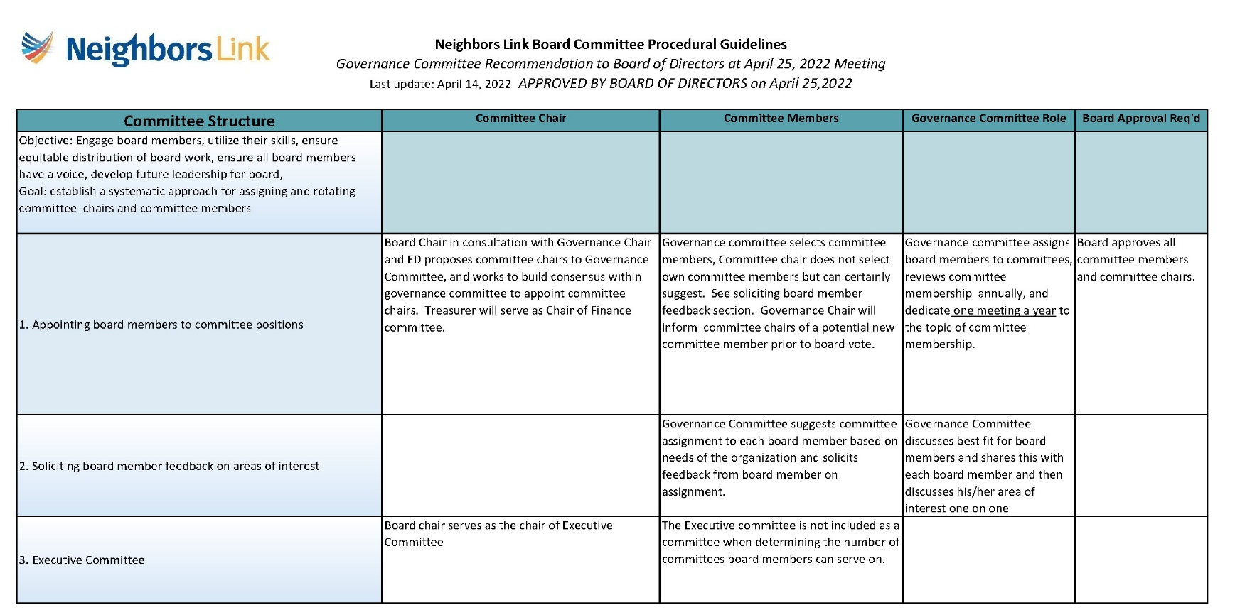

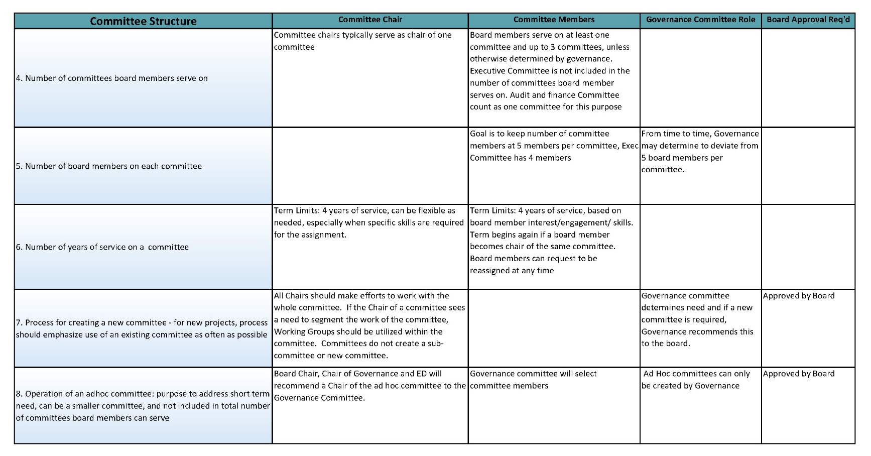

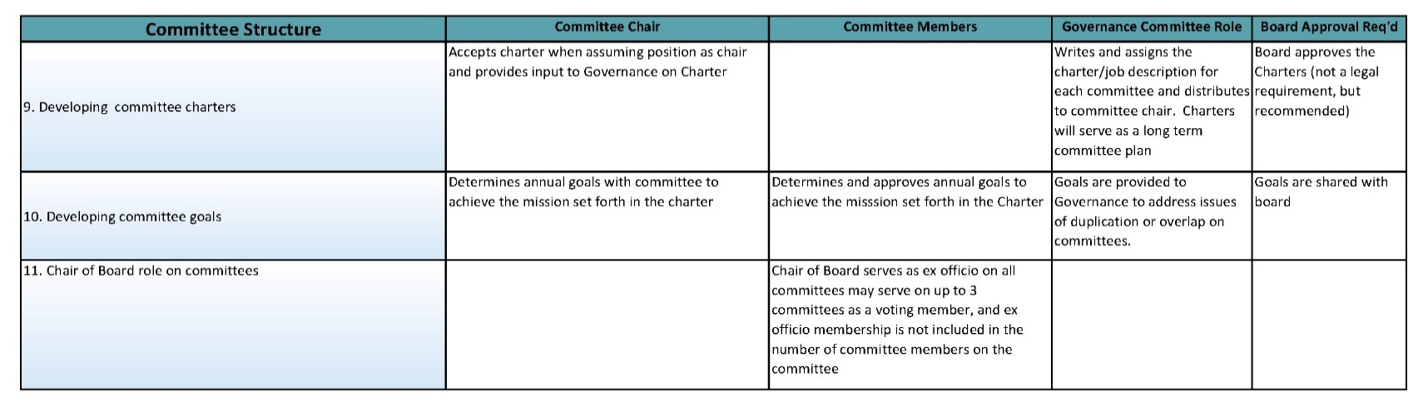

Board Election Dates

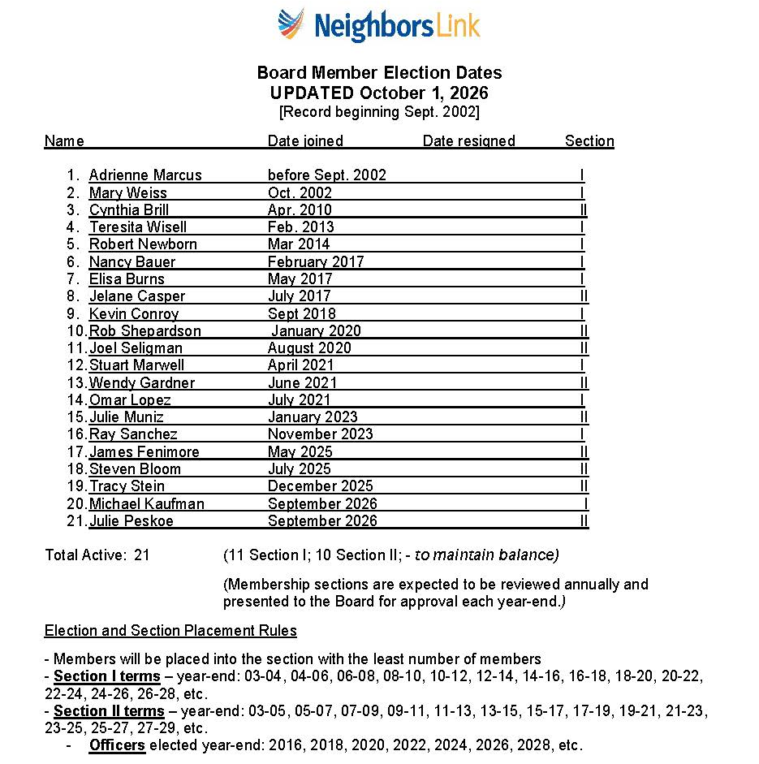



Expectations and Responsibilities of the Board

Conflict of Interest Policy Certificate

Neighbors Link

Conflict of Interest Policy Certificate

This certificate must be signed and delivered to the Secretary pursuant to the Neighbors Link, Corp. (the “Corporation”) Conflict of Interest Policy (the “Policy”) as set forth in the by-laws of the Corporation, at such times as specified in the Policy. Please see the Policy at the end of this certificate.

(a) ____ (initial) I have received a copy of the Policy;

(b) ____ (initial) I have read and understand the Policy; and

(c) ____ (initial) I agree to comply with the Policy;

The undersigned, by his or her signature, certifies as indicated above and acknowledges his or her understanding of the implications of the Policy.

__________________________________

Signature

__________________________________

Printed Name

________________________________

Position

________________

Date

Neighbors Link Corp. (the “Corporation”)

Potential Conflict of Interest Disclosure Form

Name: _________________________________________________

Title/Position: _________________________________________________

In responding to these questions, please note that a “yes” answer does not imply that the relationship or transaction is necessarily inappropriate or prohibited.

- Are you an officer, director, trustee, member, owner, or employee of any entity with which the Corporation has a relationship?

Yes ______________ No____________

If the answer is “yes” please list the names of such entities, your affiliation with that entity, and the approximate dollar amount of business involved with the Corporation in the past year:

- Are any of your Relatives an officer, director, trustee, member, owner, or employee of any entity with which the Corporation has a relationship?

Yes ______________ No____________

If the answer is “yes” please list the names of such entities, your Relative’s affiliation with that entity, and the approximate dollar amount of business involved with the Corporation in the past year:

- Do you have a Financial Interest in any corporation, organization, partnership, or other entity which provides goods or services to the Corporation for a fee or other compensation?

Yes ______________ No____________

If the answer is “yes” please list the names of such entities, the nature of your Financial Interest, and the approximate dollar amount of business involved with the Corporation in the past year:

- Do any of your Relatives have a Financial Interest in any corporation, organization, partnership, or other entity which provides goods or services to the Corporation for a fee or other compensation?

Yes ______________ No____________

If the answer is “yes” please list the names of such entities, the nature of your Relative’s Financial Interest, and the approximate dollar amount of business involved with the Corporation in the past year:

- Do you hold a position or have some other material relationship with any not-for-profit corporation with which the Corporation has a business relationship?

Yes ______________ No____________

If the answer is “yes” please list the names of such entities, the nature of your relationship (e.g., employee, board member), and the approximate dollar amount of business involved with the Corporation in the past year:

- Do any of your Relatives hold a position or have some other material relationship with any not-for-profit corporation with which the Corporation has a business relationship?

Yes ______________ No____________

If the answer is “yes” please list the names of such entities, the nature of your Relative’s relationship (e.g., employee, board member), and the approximate dollar amount of business involved with the Corporation in the past year:

- Are you aware of any other transaction in which the Corporation is a participant and in which you may have a conflicting interest?

Yes ______________ No____________

If the answer is “yes”, please identify the transaction and describe the potential conflict:

I affirm that the foregoing information is true and complete to the best of my knowledge and that should any of my responses to this questionnaire change at any time, I will notify the Corporation’s Board of Directors.

Name: | _________________________________________
Signature: | _________________________________________  Date: _________________

Excerpt from Amended and Restated Bylaws of Neighbors Link Corp., Adopted 10/17/22

ARTICLE IX
Directors' Conflicting Interest and Related Party Transactions

Section 9.1 Purpose. The Corporation's conflict of interest and related party transaction policy in Sections 9.1 through 9.6 hereof (the "Conflicts Policy") shall be as follows. All directors, officers, and Key Employees owe a duty of loyalty to the Corporation that requires them to exercise their powers in good faith and in the best interests of the Corporation. A conflict of interest occurs whenever the interests of the Corporation conflict with a competing Financial Interest of a director, officer, Key Employee or other Related Party. The purpose of this Conflicts Policy is to protect the interests of the Corporation, a tax-exempt not-for-profit corporation, when it is contemplating entering into a transaction or arrangement that might benefit a Related Party. This Conflicts Policy is intended to supplement, but not replace, any applicable state or federal laws regarding conflicts of interest applicable to not-for-profit and tax-exempt organizations.

Section 9.2 Duty to Disclose. Prior to their election to the Board or employment at the Corporation, and for each year of service thereafter, each director, officer and currently employed Key Employee must disclose in writing:
- Any entity of which such person or a Relative of such person is an officer, director, trustee, member, owner, or employee and with which the Corporation has a relationship;
- Any Financial Interest such person or a Relative of such person may have in any corporation, organization, partnership, or other entity which provides goods or services to the Corporation for a fee or other compensation; and
- Any position or other material relationship such person or a Relative of such person may have with any not-for-profit corporation with which the Corporation has a business relationship.

These disclosure statements shall be submitted to the Secretary of the Corporation. A copy of each disclosure statement shall be kept in the Corporation's files and made available to any director, officer or currently employed Key Employee upon request. The Secretary also shall provide a copy of all completed statements to the Chair of the Board.

If at any time during their term of service, a director, officer, or Key Employee acquires any Financial Interest, or when any matter for decision or approval comes before the Board in which a Related Party has a Financial Interest, that Financial Interest or potential Related Party Transaction must be promptly disclosed in writing to each member of the Board, together with all material facts. Failure to disclose to the Board a known Financial Interest, a known Related Party Transaction or a known conflict of interest may be grounds for removal from the Board or termination from the Corporation.

Section 9.3 Review and Approval of Related Party Transactions. If the Corporation is contemplating entering into a Related Party Transaction, the Board must determine if the transaction is fair, reasonable, and in the best interests of the Corporation at the time of such determination before approving the transaction. All transactions, agreements, or any other arrangements between the Corporation and a Related Party shall be reviewed by the Board in accordance with the following.

- Related Party's Involvement. At the Board's request, the Related Party to whom the potential conflict of interest relates may present factual information regarding the matter. However, the Related Party may not be present for, or participate in, the deliberation or vote on the matter giving rise to the conflict. The Related Party to whom the potential conflict of interest relates shall leave the room prior to the conduct of any deliberations or vote on the matter giving rise to the conflict and shall not attempt to influence improperly the deliberation or voting on the matter giving rise to the conflict.

A voting member of the Board or an officer who receives compensation directly or indirectly from the Corporation for services, or a director serving as a voting member of any committee whose jurisdiction includes compensation matters is precluded from voting or acting on matters pertaining to that director's or officer's compensation. However, no voting member of the Board or any committee whose jurisdiction includes compensation matters and who receives compensation, directly or indirectly, from the Corporation is prohibited from providing information to the Board or any committee regarding compensation.

- Investigation of Alternative Transactions; Review of Comparability Data. As part of their investigation, the Board shall consider alternative transactions to the extent available. If the contemplated transaction pertains to compensation for services or the transfer of property or other economic benefit to a Related Party, the Board must determine that the value of the economic benefit provided by the Corporation does not exceed the value of the services, property, or other benefit received in exchange. As part of this determination, the Board shall obtain and review appropriate comparable data.

When considering compensation for services, comparable data may include, but is not limited to:
  - Compensation paid by similarly situated organizations;
  - The availability of similar services within the same geographic area;
  - Current compensation surveys compiled by independent firms; and/or
  - Written offers from similar institutions competing for the same person's services.

When considering a transfer of property, comparable data may include, but is not limited to:
- Current independent appraisals of the property; and/or
- Offers received in a competitive bidding process.

- Approval Requirements. The Board may not approve any Related Party Transaction unless it determines that the transaction is fair, reasonable, and in the Corporation's best interest at the time of such determination. Approval requires the majority vote of the directors present at the meeting.

- Documentation. The Board shall contemporaneously document in the minutes of their meeting:

  - The name(s) of the Related Party or Parties who disclosed or otherwise were determined to have a potential or actual Financial Interest and/or conflict of interest;
  - The nature of the potential or actual Financial Interest and/or conflict of interest;
  - Any actions taken to determine whether a Financial Interest and/or conflict of interest existed;
  - The Board's decision as to whether the Financial Interest and/or conflict of interest existed;
  - The names of the persons who were present for discussions and votes relating to any potential or actual conflict of interest or Related Party Transaction (including whether the Related Party or Parties left the room for all such discussions and vote);
  - The content of such discussions, including the discussion of alternative transactions; and
  - The decision by the Board to approve or not approve the Related Party Transaction.

- Tax Issues. In determining whether to approve such contract or transaction, disinterested directors will take into account the restrictions regarding self-dealing under Section 4941 of the Internal Revenue Code of 1986, as amended (the "Code"), in the case of an organization classified as a Private Foundation, or excess benefit transactions under Section 4958 of the Code, in the case of an organization classified as a Public Charity.

Section 9.4 Annual Statements. Each director, officer and currently employed Key Employee shall annually sign and submit to the Secretary a statement which affirms such person: (a) has received a copy of the Conflicts Policy; (b) has read and understood the Conflicts Policy; and (c) has agreed to comply with the Conflicts Policy.

Section 9.5 Delegation to Audit Committee. The Board may delegate to the Audit Committee, if any, or any other authorized committee composed solely of Independent Directors, the oversight of, implementation of, and compliance with this Conflicts Policy, including the review and approval of any Related Party Transaction; provided that if the Related Party Transaction is of a magnitude that would otherwise require Entire Board approval, the committee shall submit the Related Party Transaction to the Board for consideration, with the committee's recommendation as to whether or not the transaction should be approved.

Section 9.6 Definitions.
- Associated Entity: Any entity associated with the Corporation by a parent subsidiary or sister relationship.
- Entire Board: The number of directors that were elected as of the most recently held election of directors, or in the interim period, as well as any directors whose terms have not yet expired, but excluding directors who have resigned.
- Key Employee: A person who is, or has within the past five years, been in a position to exercise substantial influence over the Corporation's affairs. This includes, but is not limited to:
  - Heads of Corporation, Presidents, Executive Directors, Chief Executive Officers, Chief Operating Officers, or any person holding similar responsibilities;
  - Chief Financial Officers, or any person holding similar responsibilities;
  - "Highly compensated" employees (within the meaning of Section 4958 of the Internal Revenue Code and related guidance) who are in a position to exercise substantial influence over the Corporation's affairs;
  - Founders of the Corporation;
  - Substantial contributors to the Corporation;
  - Persons owning a controlling interest (through votes or value) in the Corporation; and
  - A nonstock entity controlled by any of the persons described in this section 9.6(B).
- Financial Interest: A direct or indirect economic benefit from any transaction, agreement, or compensation arrangement involving the Corporation, including, but not limited to, direct or indirect remuneration, or gifts or favors that are not insubstantial.
- Independent Director: A member of the Board who:
  - Has not been an employee or Key Employee of the Corporation or an Associated Entity within the last three years;
  - Does not have a Relative who is or has been a Key Employee of the Corporation or an Associated Entity within the last three years;
  - Has not received, and does not have a Relative who has received, more than $10,000 compensation from the Corporation (other than reimbursement for reasonable expenses) within the last three years;
  - Has neither been employed by, nor has had a substantial Financial Interest in, any entity that either made or received payments from the Corporation exceeding the lesser of $25,000 or 2% of the entity's gross revenues within the past three years (payments do not include charitable donations);
  - Does not have a relative who has a substantial Financial Interest or was an officer of any entity that either made or received payments from the Corporation exceeding the lesser of $25,000 or 2% of the entity's gross revenues within the past three years (payments do not include charitable donations); and
  - Is not in an employment relationship with, or under the control or direction of, any Related Party and does not receive payments subject to the approval of a Related Party.
- Related Party:
  - Any current or former (within the past five years) director, officer or Key Employee of the Corporation;
  - Any director, officer, or Key Employee of an Associated Entity;
  - Any Relative of a director, officer, or Key Employee of the Corporation; or
  - Any entity in which a director, officer, or Key Employee or the Relative of a director, officer, or Key Employee has a 35% or greater ownership or beneficial interest, or, in the case of a partnership or a professional corporation, a direct or indirect ownership interest in excess of 5%.
- Related Party Transaction: Any transaction, agreement, or compensation arrangement with the Corporation or an Associated Entity in which a Related Party has a Financial Interest.
- Relative: A person's domestic partner, spouse, ancestors, siblings and their spouses, children and their spouses, grandchildren and their spouses, and great grandchildren and their spouses.

Whistleblower Policy
WHISTLEBLOWER POLICY

Neighbors’ Link, Corp. (the “Corporation”) requires its directors, officers, employees, and volunteers to observe high standards of business and personal ethics in the conduct of their duties. All representatives of the Corporation are expected to practice honesty and integrity in fulfilling their responsibilities and to comply with all applicable laws and regulations.

Reporting Responsibility

This Whistleblower Policy (the “Policy”) provides a means for directors, officers, employees, and volunteers of the Corporation to raise good faith concerns about behavior by or within the Corporation that is, or appears to be, illegal, fraudulent, dishonest, unethical, or in violation of any adopted policy of the Corporation (a “Suspected Violation”). It is the responsibility of all directors, officers, employees, and volunteers to comply with this Policy and to report Suspected Violations in accordance with the procedures set forth in this Policy.

A Suspected Violation may involve directors, officers, employees, volunteers, accountants, auditors, consultants, vendors, or other third parties. Examples of Suspected Violations which should be reported under this Policy include, but are not limited to: violations of federal, state, or local laws or regulations; fraud; theft; embezzlement; bribery; kickbacks; payment for services that are not rendered or goods that are not delivered; self-dealing; private inurement or private benefit (e.g., the Corporation’s assets being used for personal gain or benefit); destroying, altering, concealing or falsifying a document, or attempting to do so, with the intent to impair the document’s availability for use in an official proceeding; accounting or auditing irregularities, including providing false information to, or withholding material information from, the Corporation’s auditors, or supplying false or misleading information on the Corporation’s financial documents, federal tax returns (Form 990), or filings with state agencies; violations of ethical standards or corporate policies adopted by the Corporation; or planning, facilitating, or concealing any of the above.

In addition, actions which have not been taken and which a person believes are required to be taken to comply with laws, regulations, or corporate policies, are also Suspected Violations within the meaning of this Policy and should be reported.

Confidentiality

Reports of Suspected Violations will be kept confidential to the extent possible and permissible by law, consistent with the need to conduct a fair and adequate investigation and take necessary corrective action.

No Retaliation

No director, officer, employee, or volunteer who in good faith reports a Suspected Violation or who cooperates with an investigation of such a report (whether by the Corporation, its agents, or auditors, or by any law enforcement officials, government, or regulatory agency) shall suffer intimidation harassment, discrimination, retaliation, or, in the case of an employee, adverse employment consequences, because of such report. Any person who retaliates against someone who has reported a Suspected Violation in good faith will be subject to appropriate discipline and corrective action, up to and including termination of employment or volunteer status, or removal from office or the board.

Notwithstanding anything contained herein to the contrary, this Policy is not an employment contract and does not modify the employment relationship between the Corporation and its employees, nor does it change the fact that employees of the Corporation are employees at will. Nothing contained herein provides any director, officer, employee, or volunteer with any additional rights or causes of actions, other than those provided by Section 1107 of the Sarbanes-Oxley Act of 2002.

Oversight of Policy and Designation of Compliance Officer

The Audit Committee shall oversee the implementation of and compliance with this Policy. The Chair of the Audit Committee is designated as the Compliance Officer responsible for investigating and overseeing the resolution of all reported complaints concerning Suspected Violations, in accordance with the procedures set forth in this Policy.

Reporting Procedure

Any person may report a Suspected Violation, either in writing or verbally. The report should include any available documentation to support a reasonable basis for the allegation(s) and to assist in investigating the complaint.

Reports of Suspected Violations may be made anonymously. Anonymous reports should be detailed to the greatest extent possible, as follow up questions will not be possible.

All reports of Suspected Violations should be directed to the Compliance Officer. If the Compliance Officer is the subject of the Suspected Violation, or if a person is not comfortable reporting a Suspected Violation to the Compliance Officer or is unsatisfied with the response of the Compliance Officer, the person is encouraged to instead speak with his or her supervisor, or anyone in management with whom he or she is comfortable. In such cases, the manager to whom the Suspected Violation is reported shall in turn report such Suspected Violation to the Compliance Officer, unless the Compliance Officer is the subject of the report, in which case the manager shall submit the report to the Audit Committee. If the Compliance Officer is the subject of the report, the Audit Committee shall designate someone to act in place of the Compliance Officer and all references to the Compliance Officer in this Policy shall be applicable to such designee. Such report shall include a statement as to whether the Suspected Violation was reported first to the Compliance Officer; if it was not, the report shall indicate why.

Persons who report Suspected Violations are not responsible for investigating the activity or for determining fault or corrective measures.

Although a person is not expected to prove the truth of the allegation(s) asserted in his or her report, she or he must demonstrate reasonable grounds for concern and act in good faith. No investigation will be made of unspecified wrongdoing or broad allegations. A report that proves to be unsubstantiated and to have been made maliciously or with the knowledge that such allegations were false will be viewed as a serious offense.

Handling Reports of Suspected Violations

Unless the report is submitted anonymously or there are overriding legal or public interest concerns, the Compliance Officer will provide the person who made the report an acknowledgment of receipt of his or her report within ten business days.

All reports will be promptly investigated and resolved by or under the direction of the Compliance Officer. Depending on the Compliance Officer’s determination of the seriousness or severity of the report, the Compliance Officer may resolve a report without consulting others; discuss such report with the Audit Committee, any other Board Committee(s), or the Board of Directors before taking action; or refer the matter to the Audit Committee or the Board of Directors for action. The Compliance Officer may delegate the responsibility to investigate a report to one or more employees of the Corporation, or to any other individual, including persons not employed by the Corporation; provided that the Compliance Officer may not delegate such responsibility to an individual who is the subject of such report, or in a manner that would compromise the identity of a person who made a report anonymously, the confidentiality of the report, or the confidentiality of the investigation.

Appropriate corrective action will be taken if warranted by the investigation.

On at least a quarterly basis, the Compliance Officer shall provide the Audit Committee a written report identifying all reports of Suspected Violations made under this Policy during the preceding quarter or indicating that no such reports were made. The Compliance Officer shall also report to the full Board of Directors at least annually regarding such reports. Records of all reports and investigations shall be maintained in accordance with the Corporation’s record retention policy.

Questions and Distribution

Any questions, concerns, or suggestions regarding this Policy should be addressed to the Compliance Officer.

Copies of this Policy shall be distributed to all directors, officer, employees and volunteers providing substantial services to the Corporation.

* * *

Adopted by the Board of Directors of Neighbors’ Link, Corp. on February 23, 2015

Last updated: February 23, 2015

Board Member Condensed Biography

Periodically, we have to include condensed biographies for Board Members with grant submissions, so we request a short paragraph from Board Members.

Please see a sample biography below. If you have not yet submitted a biography, please send one to Katie Graves-Abe at kgraves-abe@neighborslink.org. If you have submitted a biography in the past but want to update it, please email the updated version to Katie.

Sample Biography:

Jelane Caspar, Vice Chair - has been a resident of Westchester County, NY for 35 years and
recently moved to Greenwich, CT. She and her husband, David, raised two daughters in Briarcliff
Manor. Professionally, Jelane has held various management and sales roles in the technology
sector, predominantly with global communications services providers and specifically in their
multinational enterprise segments. She takes a new position as VP Industry Lead-
Communications, Media & Utilities for Oracle Corporation in August 2021. Outside of work,
Jelane has been involved in a number of non-profit organizations, most of which focus on
education and workforce development. A former Peace Corps volunteer (Cameroon) and
frequent global traveler for work, Jelane has great appreciation for diverse culture and the
benefits that can be realized from harmonious integration.

Board Self Evaluation
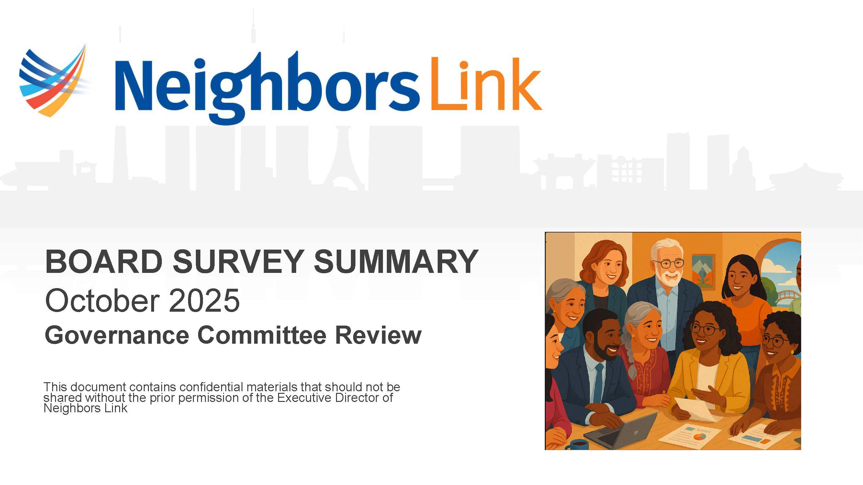

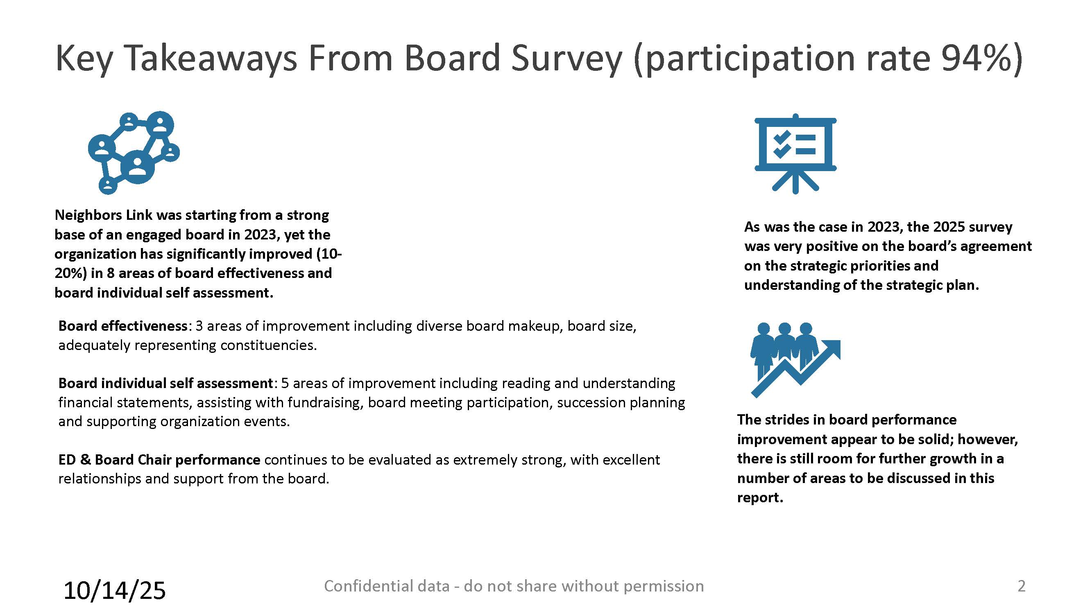

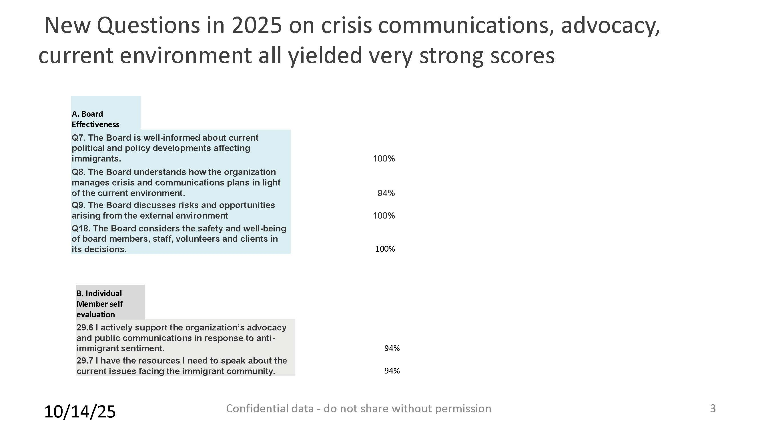







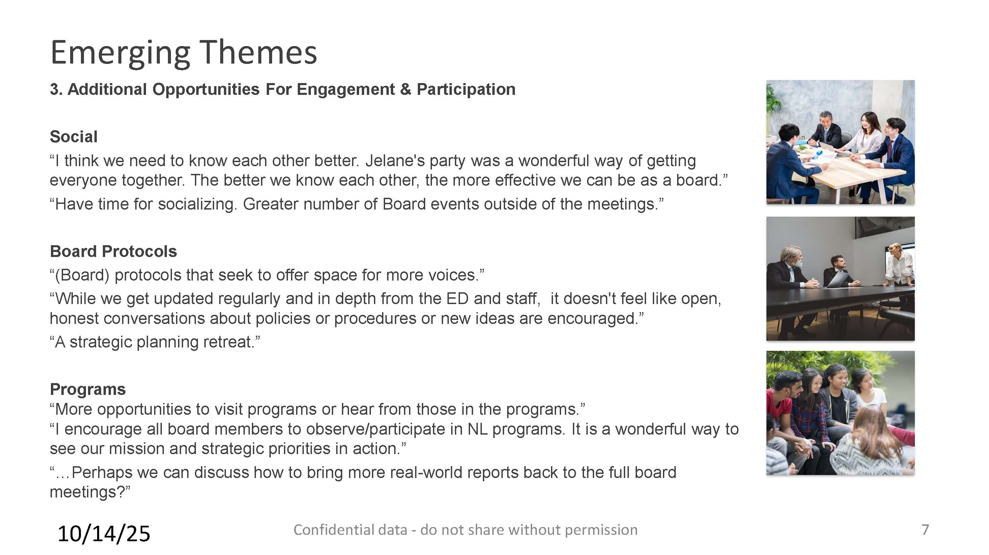


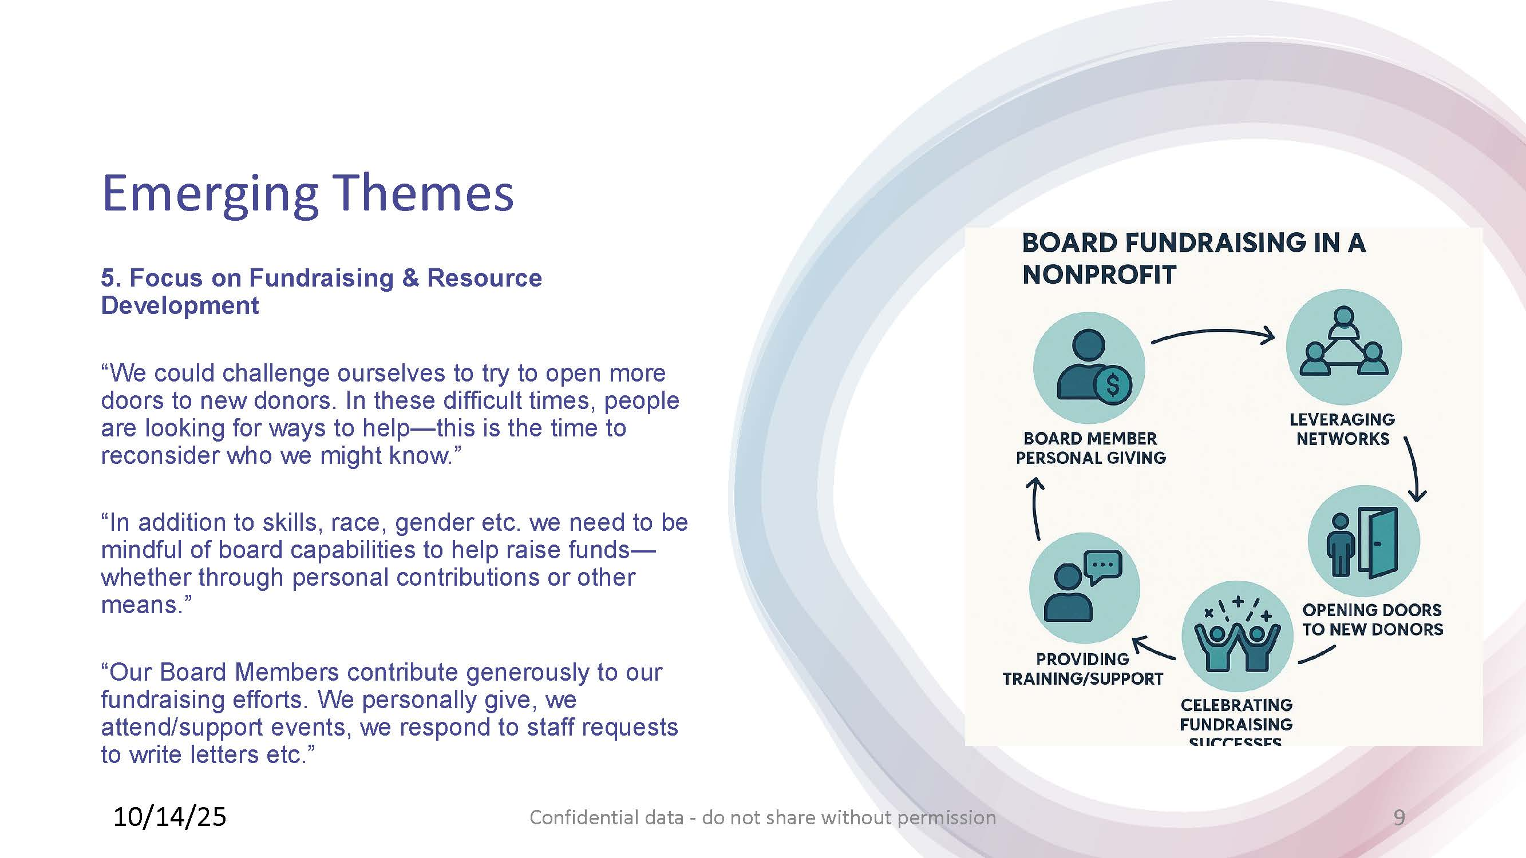
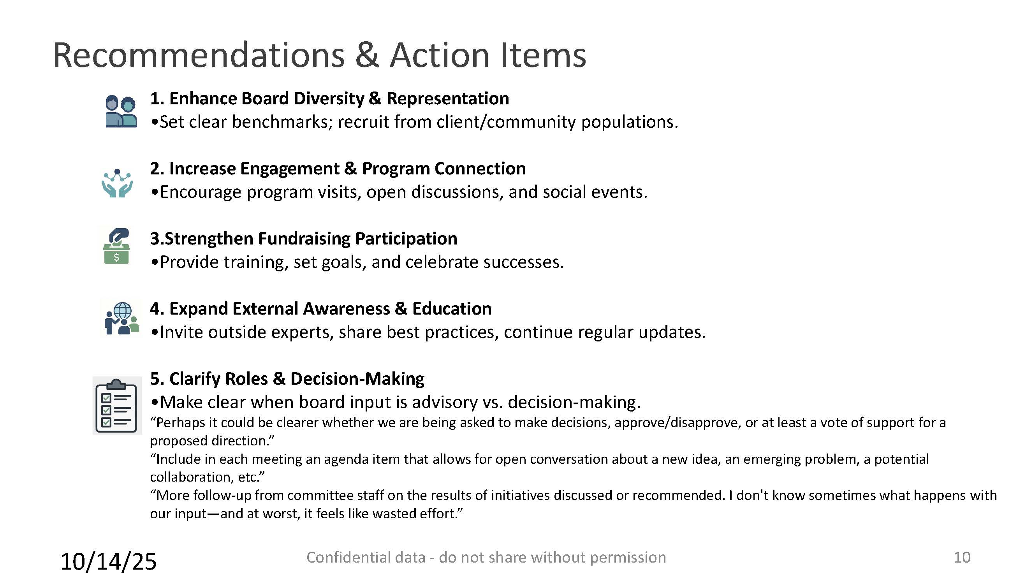


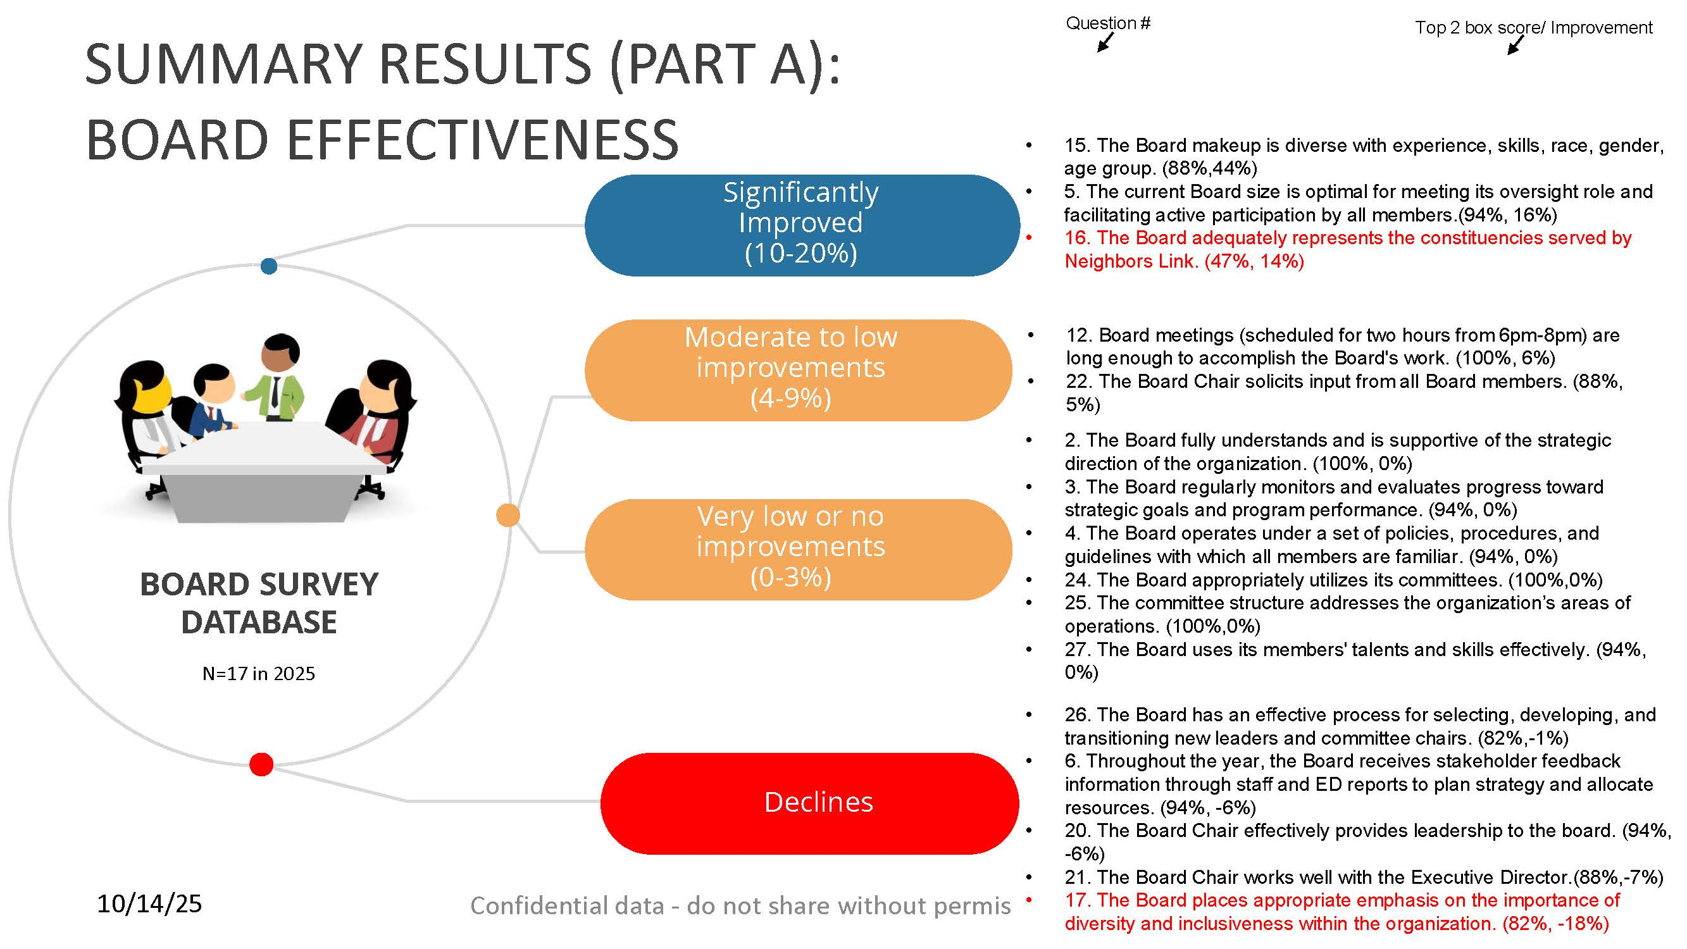

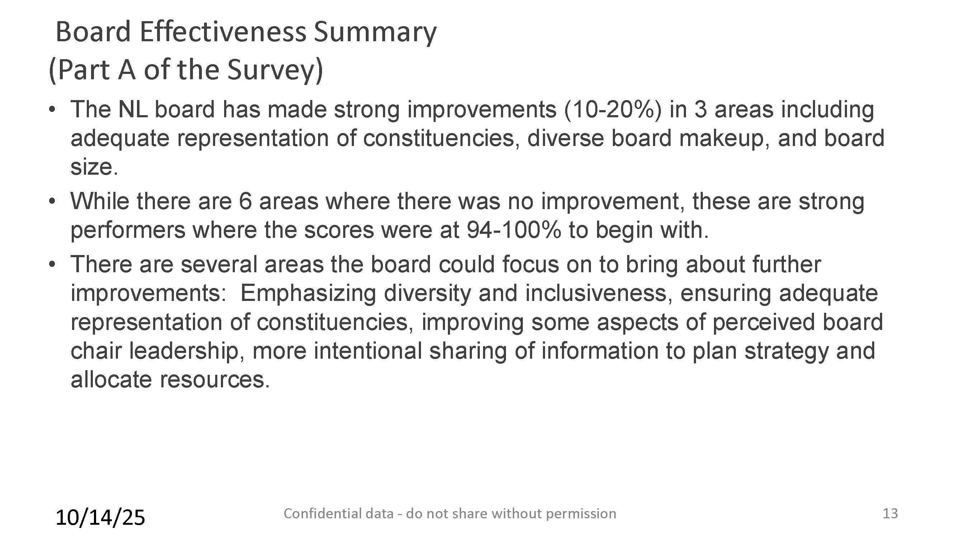
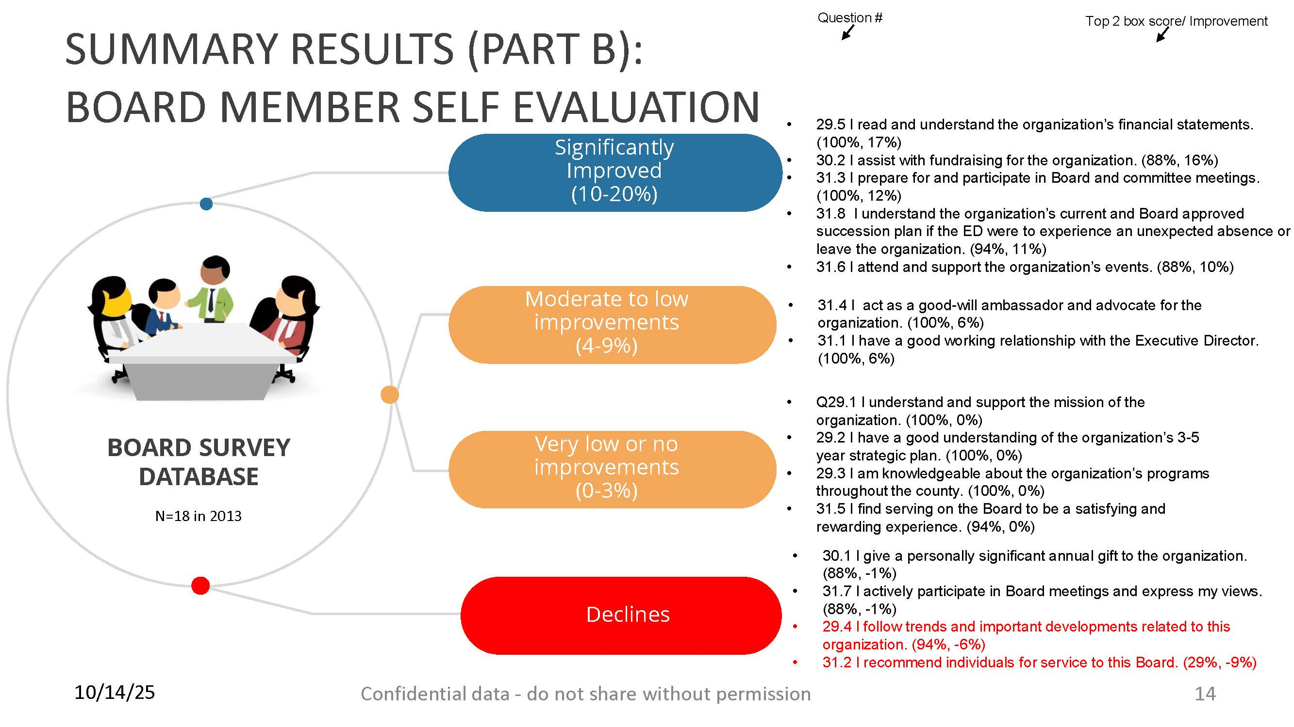

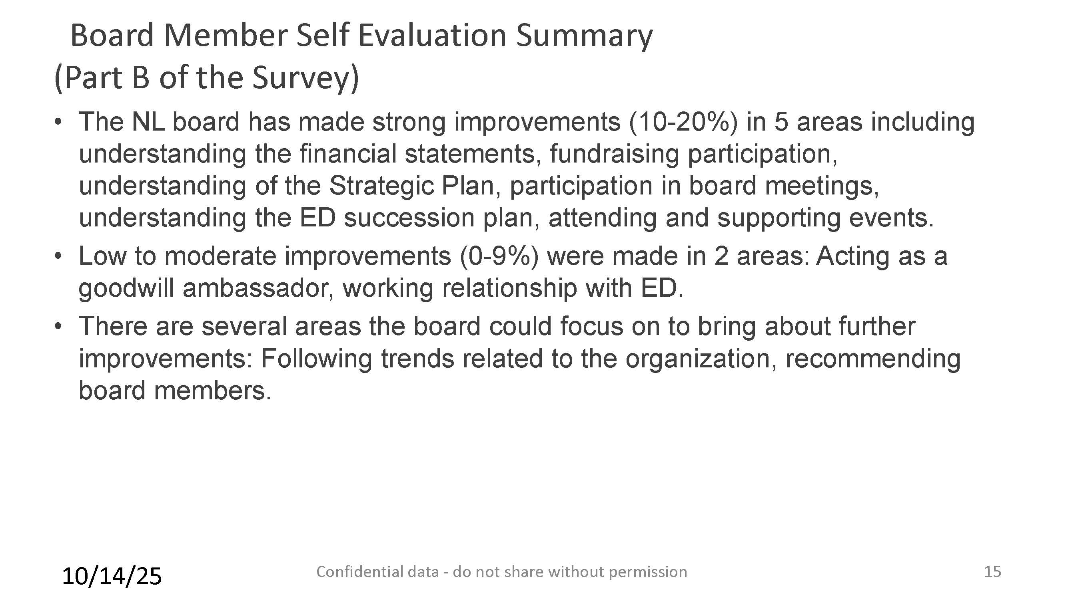
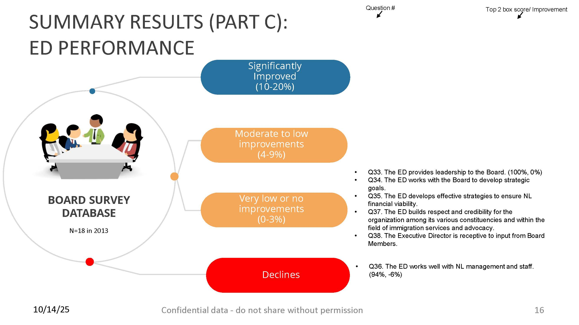

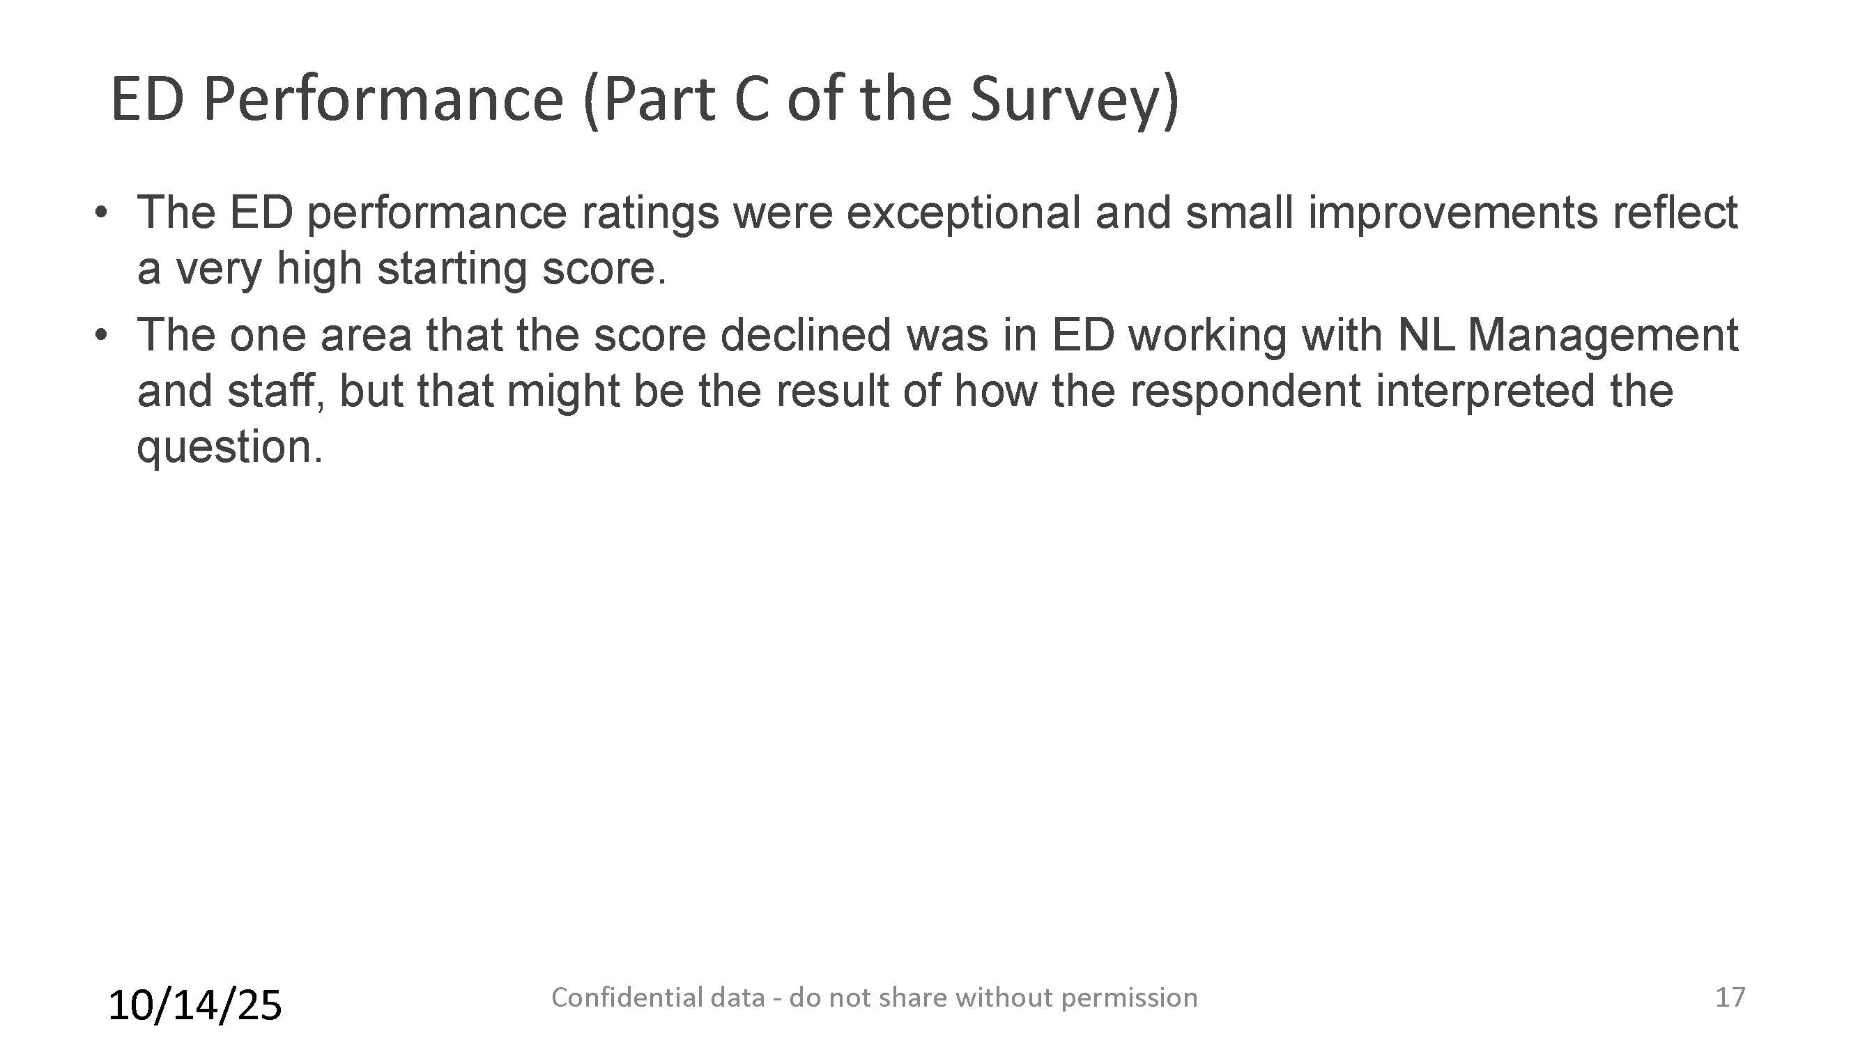
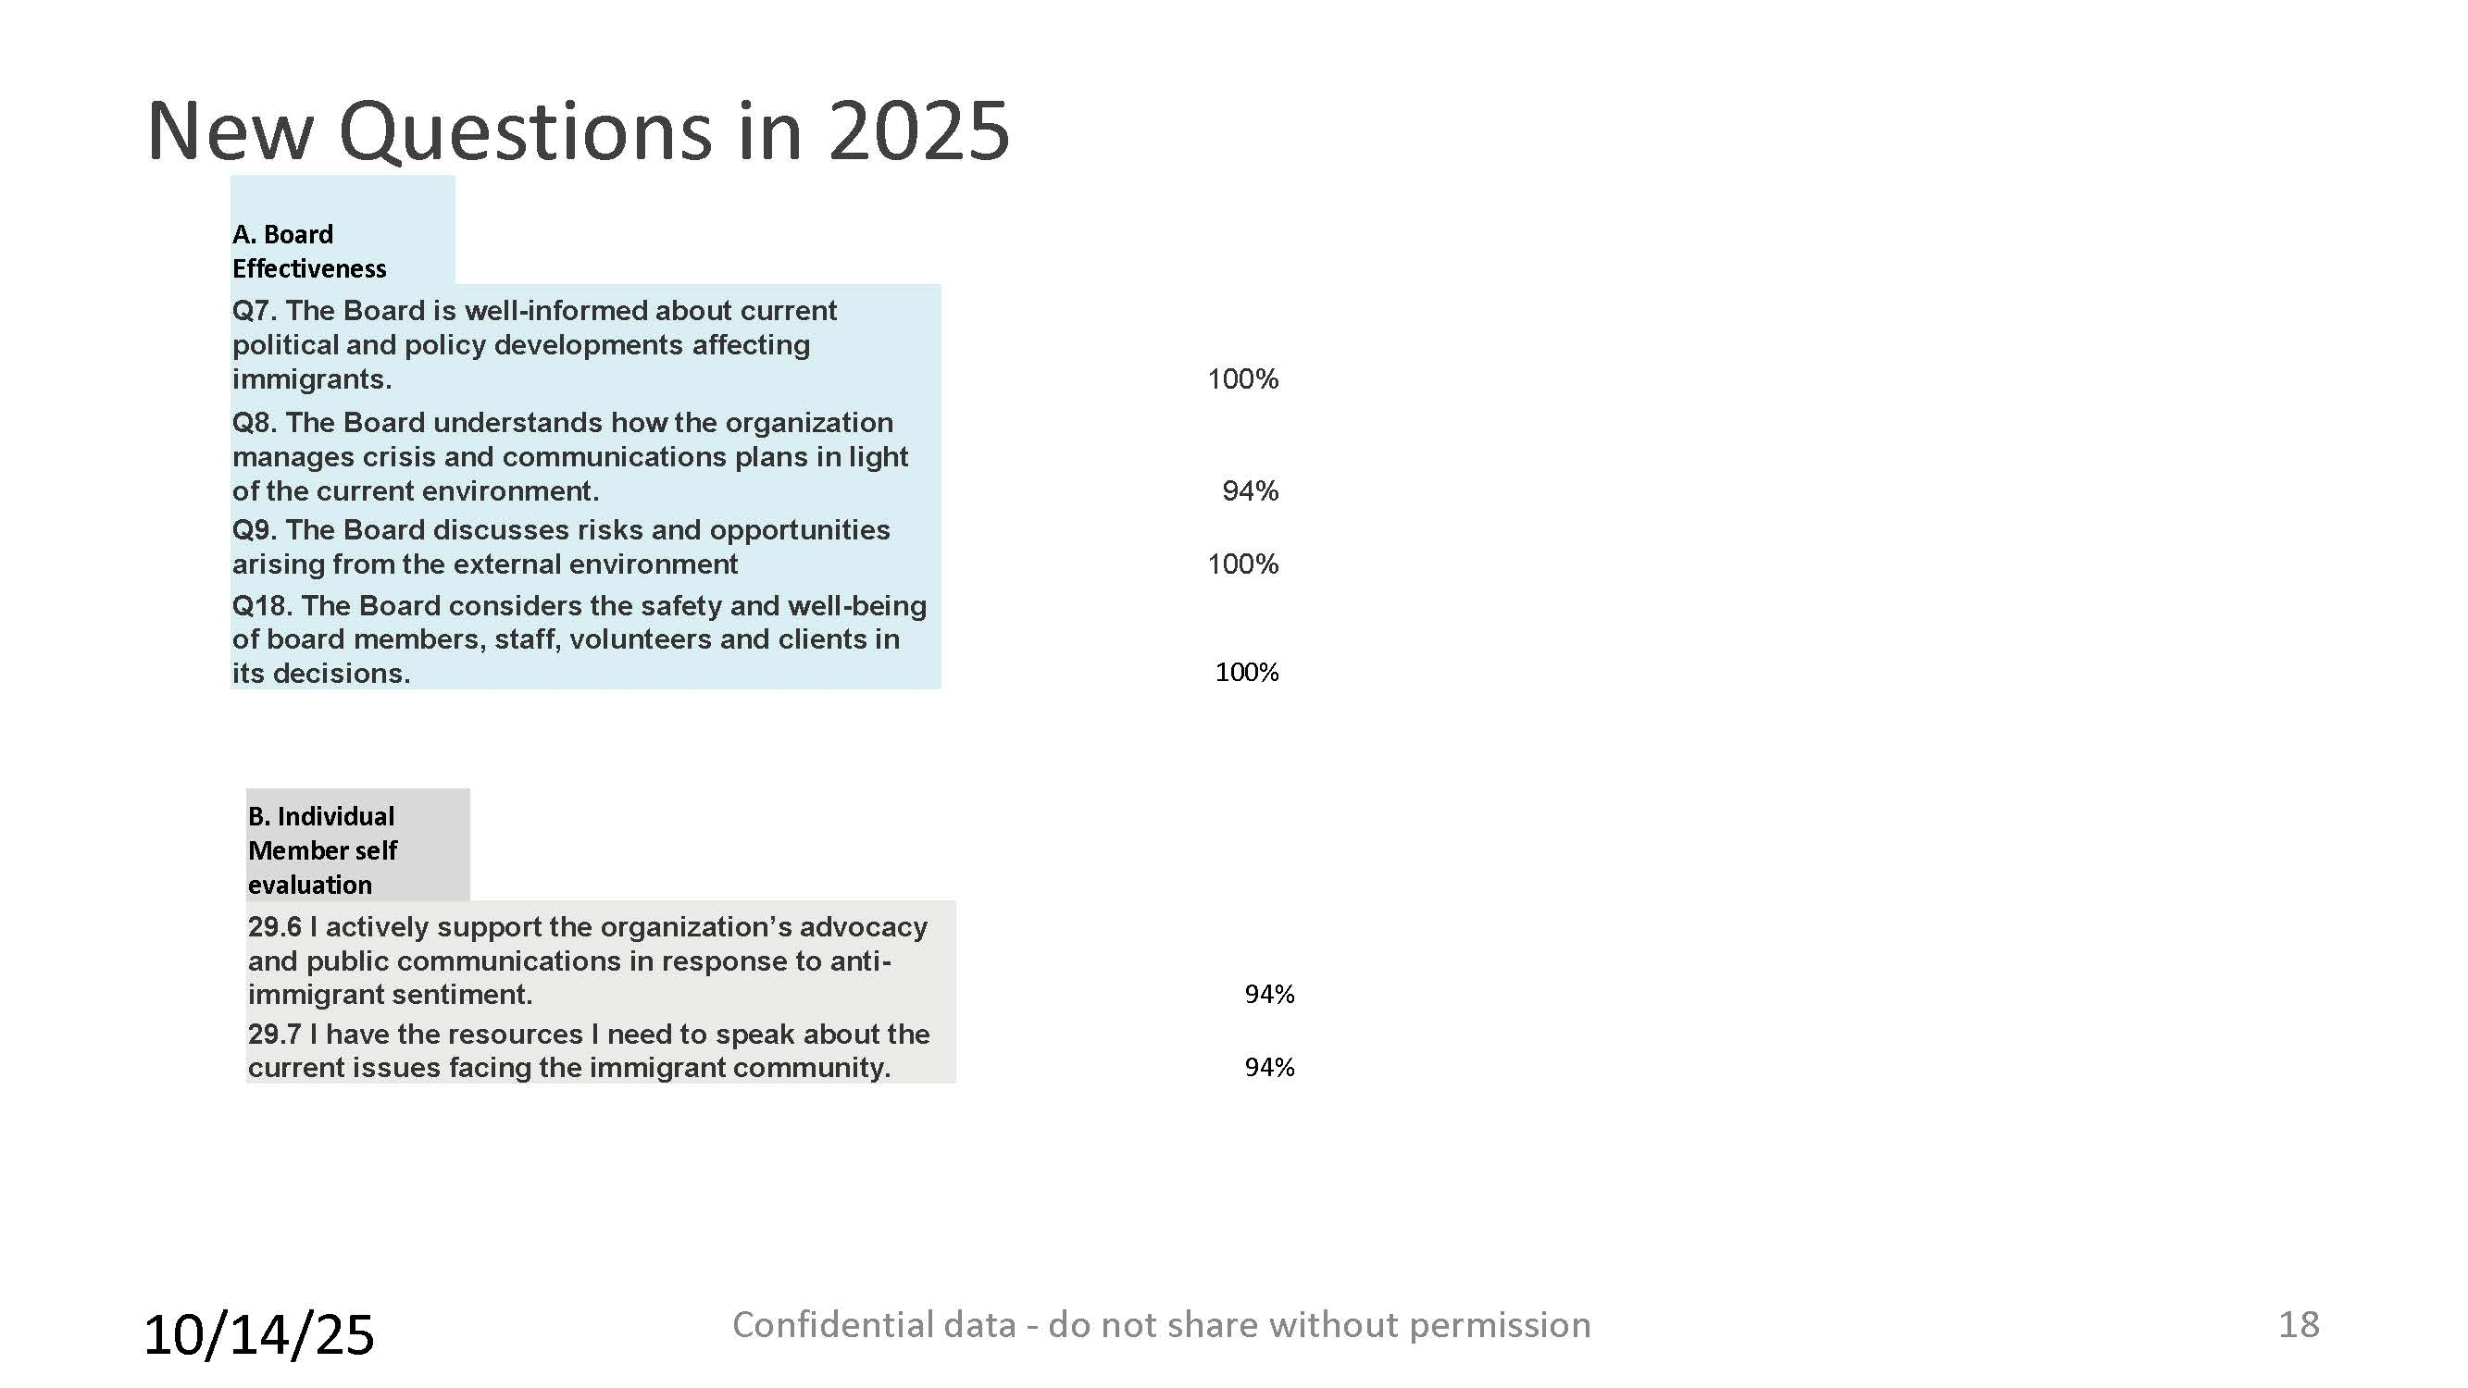

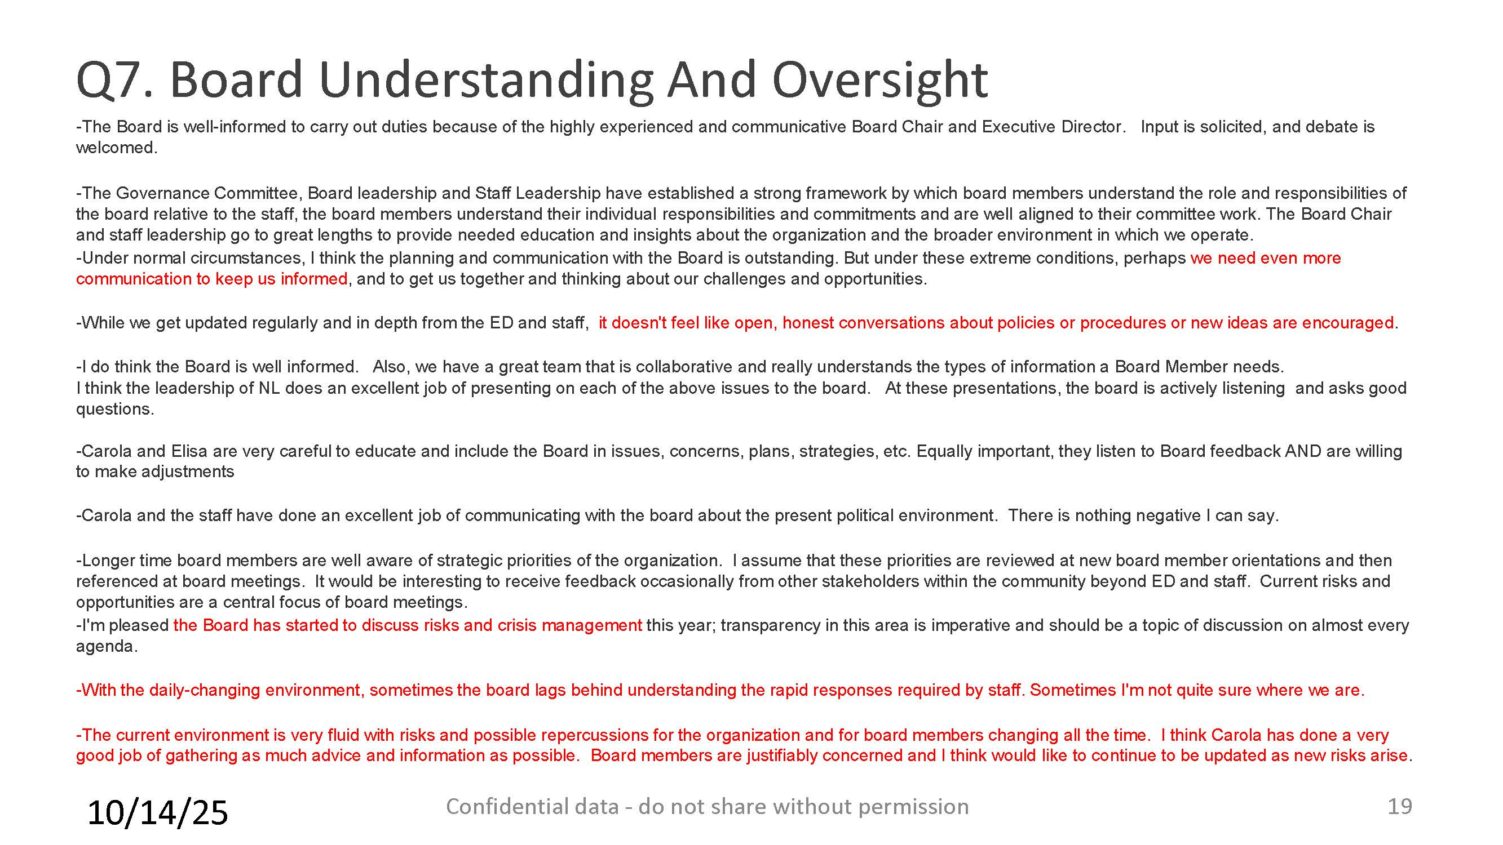
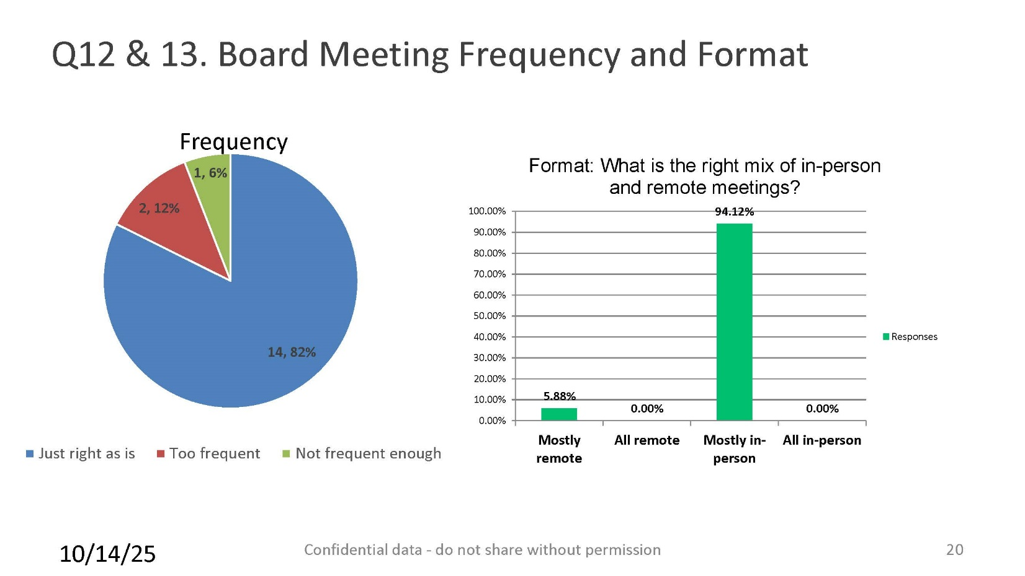

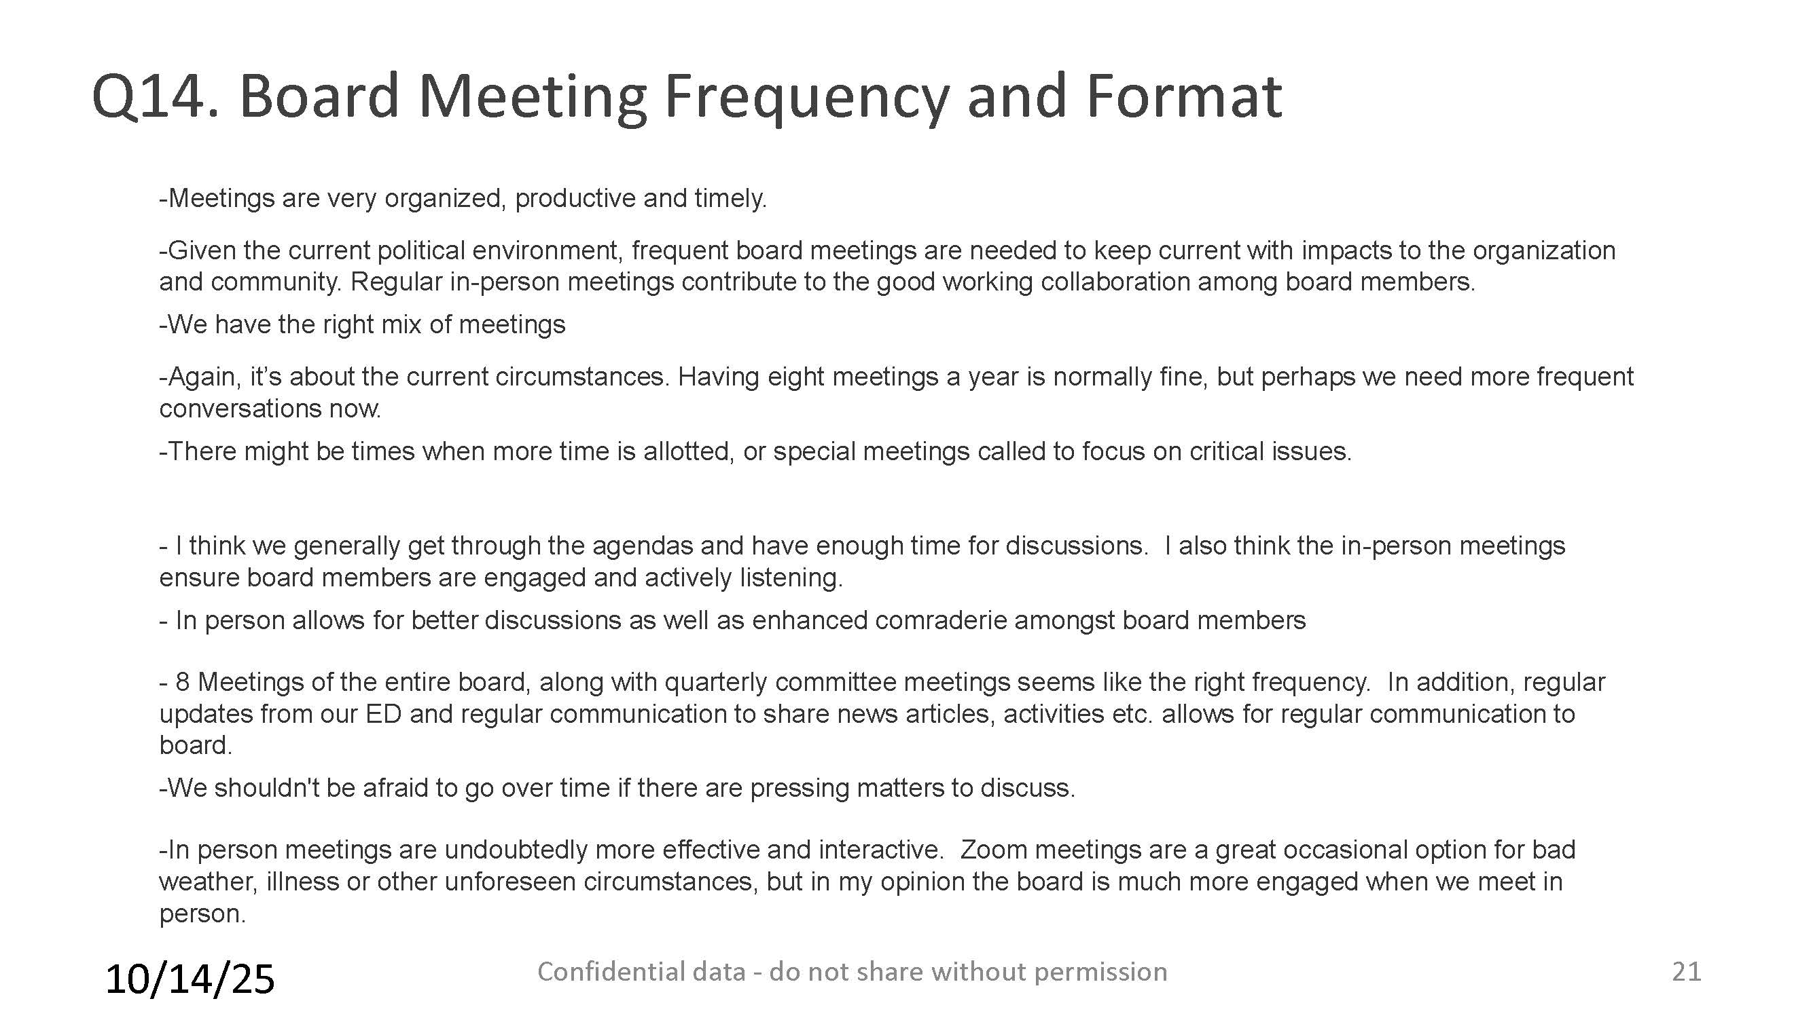
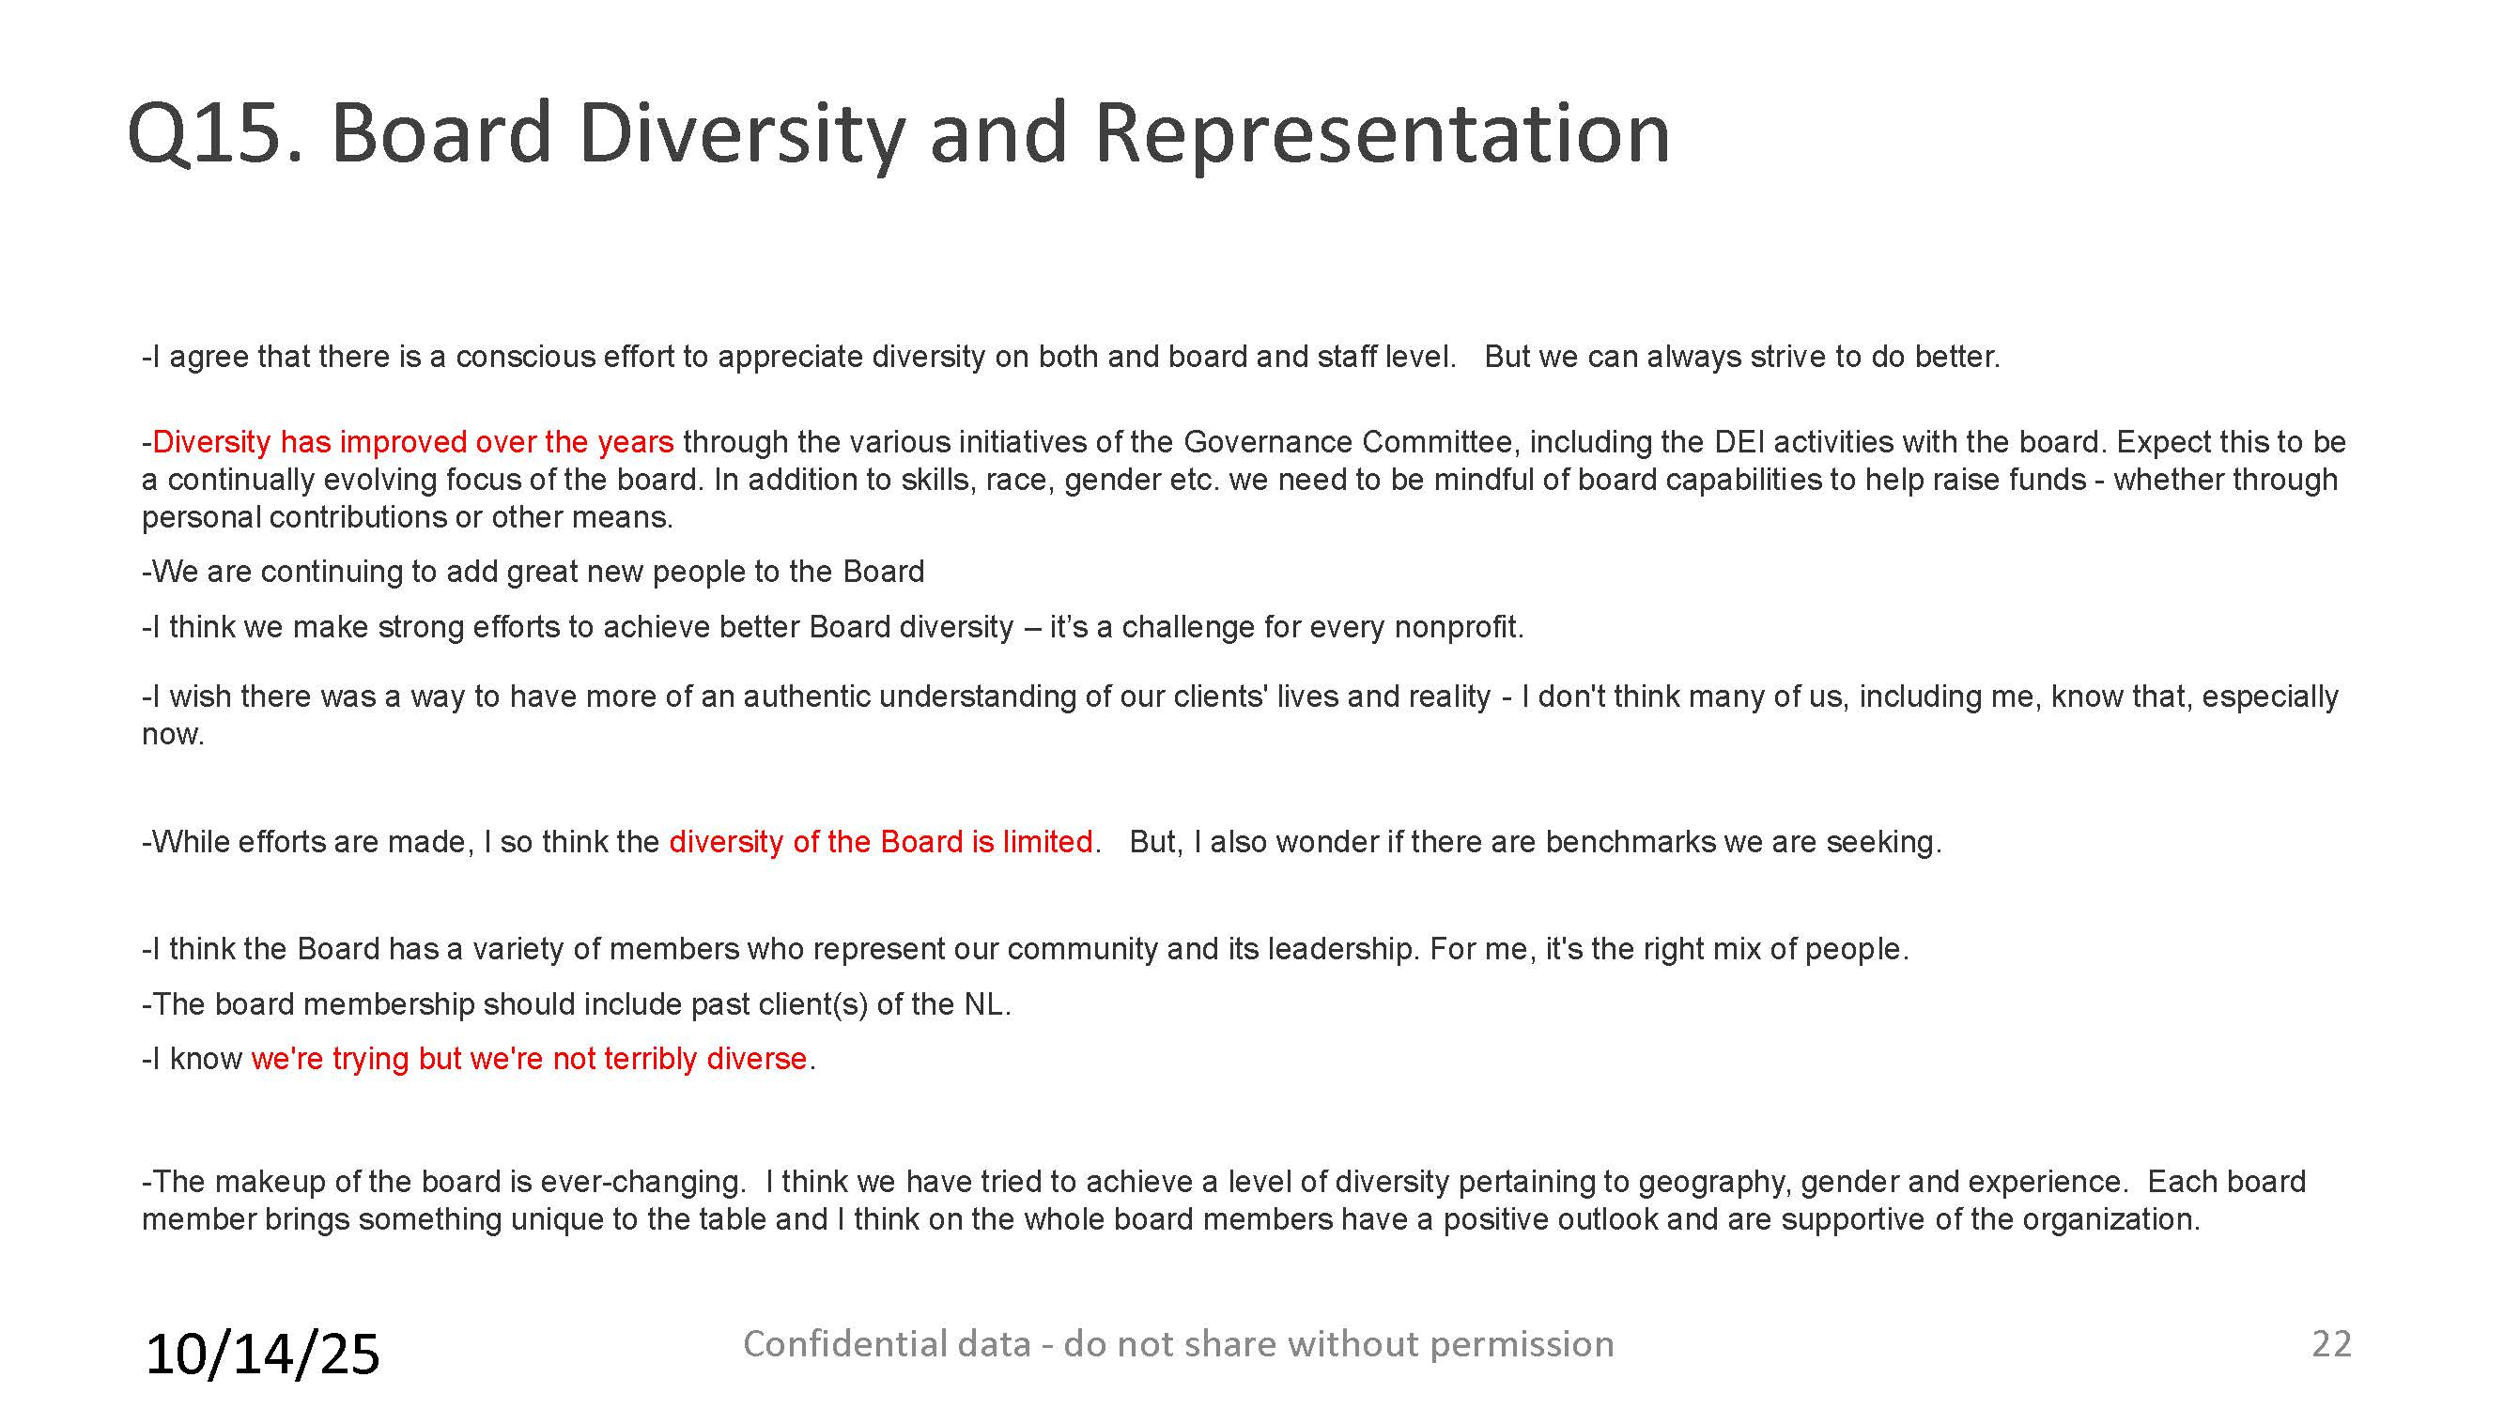

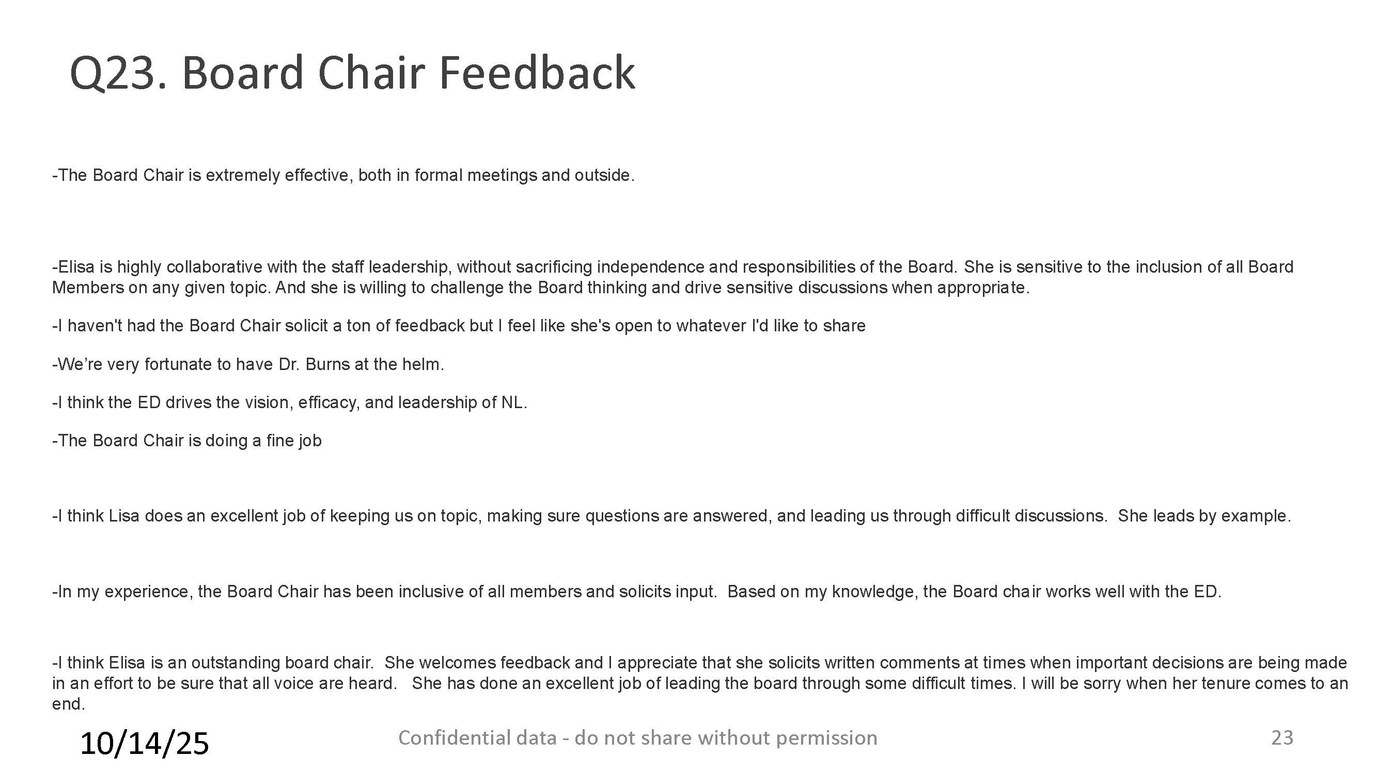

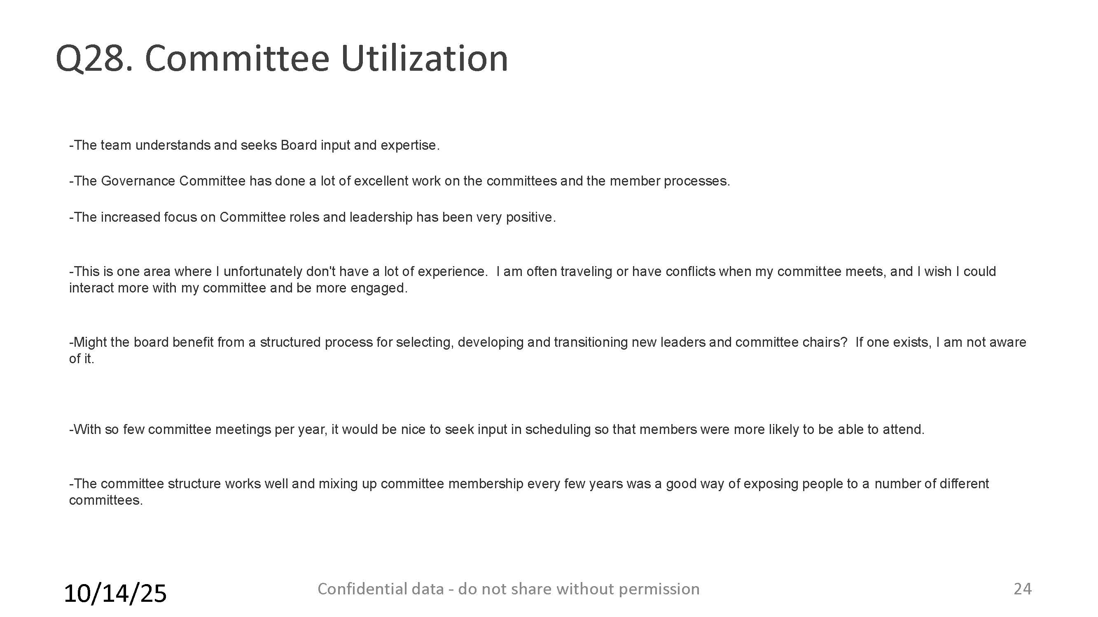

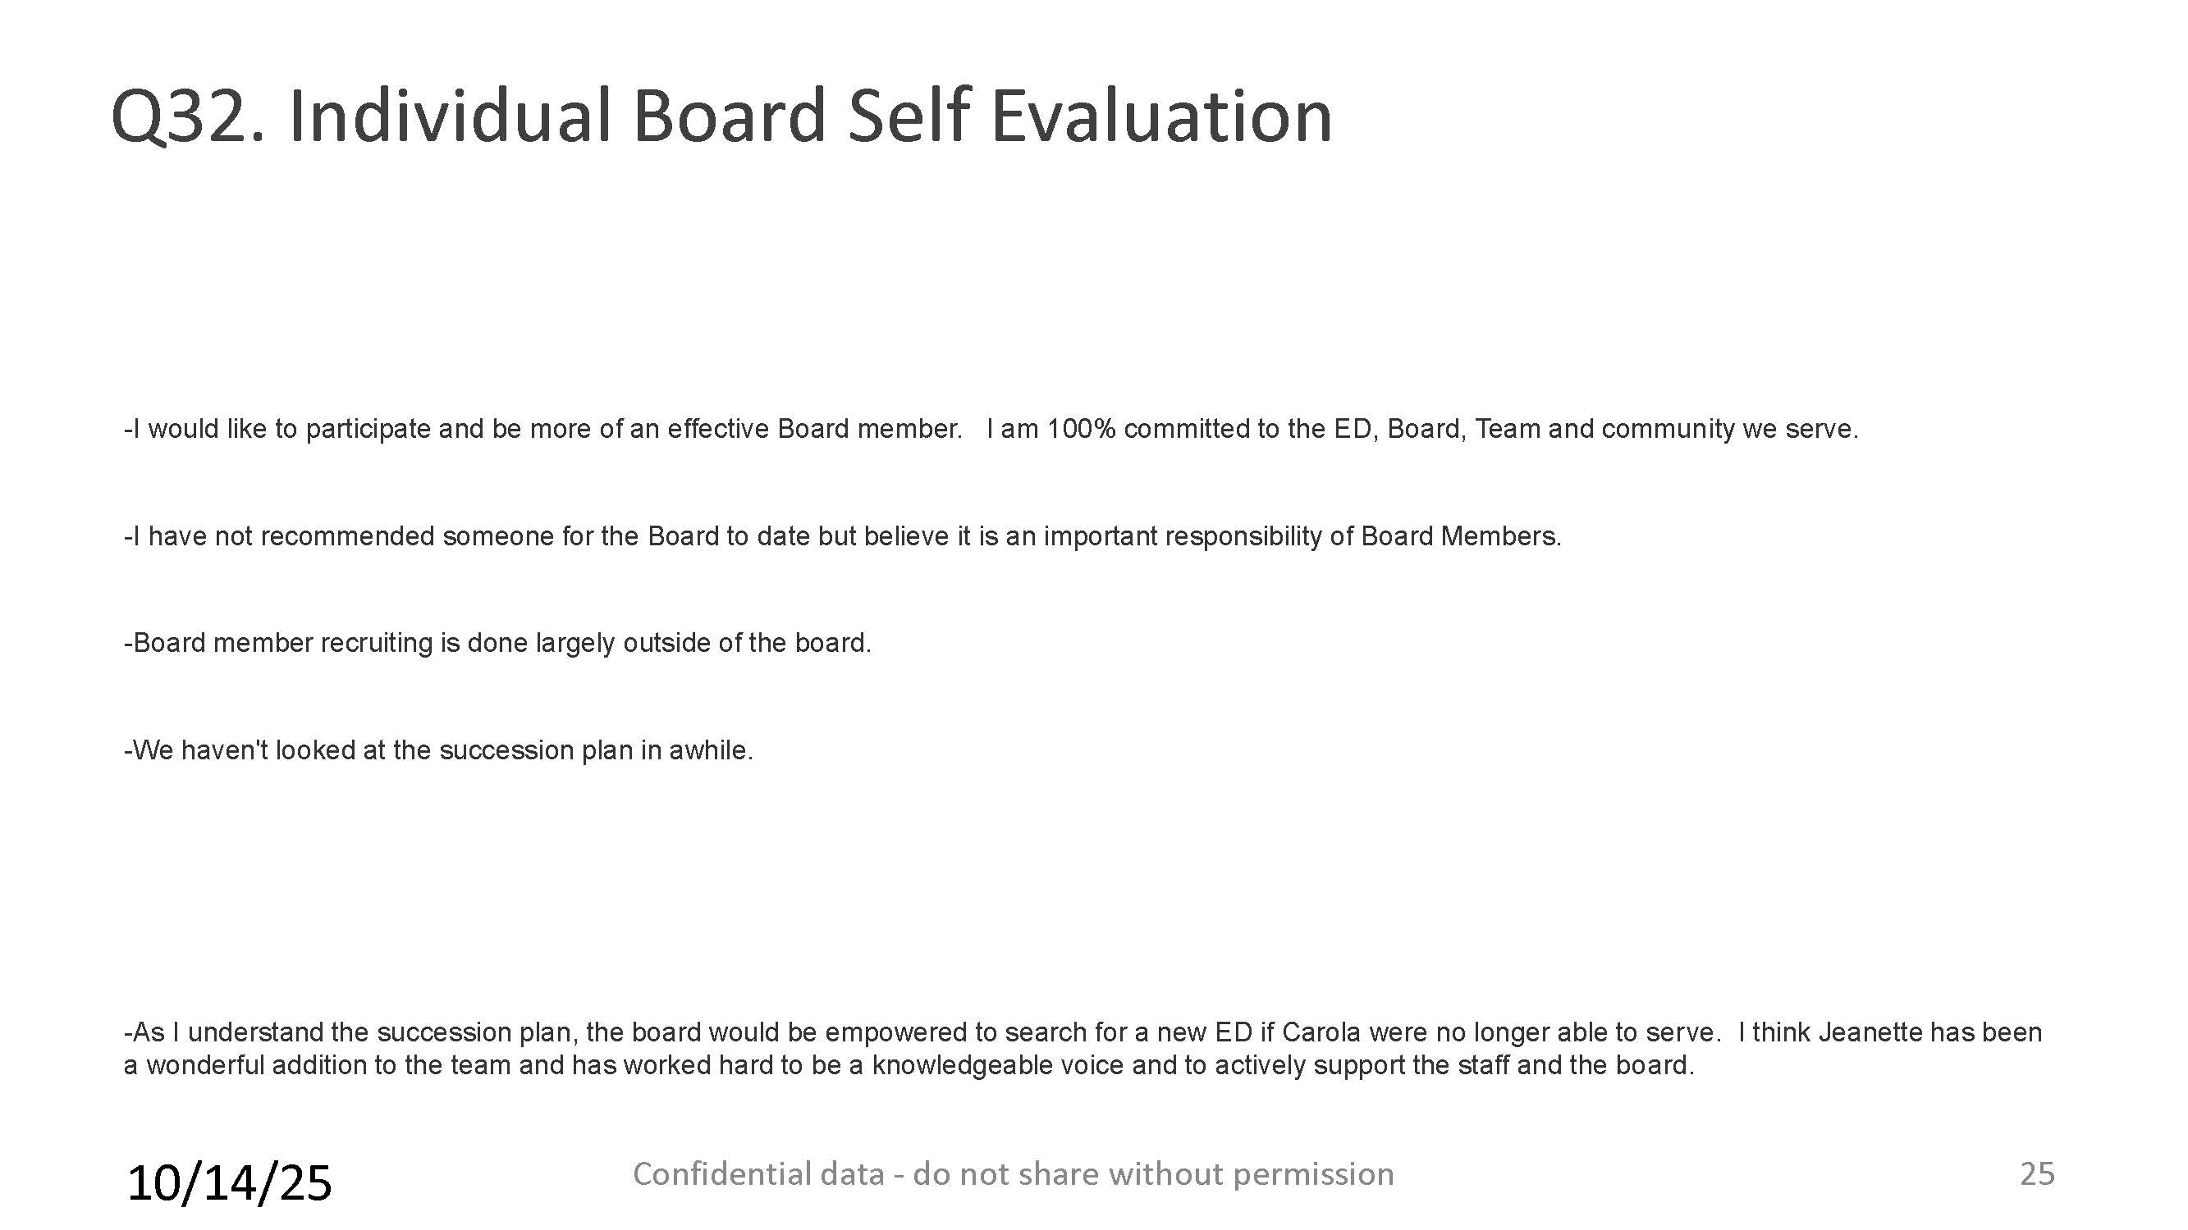

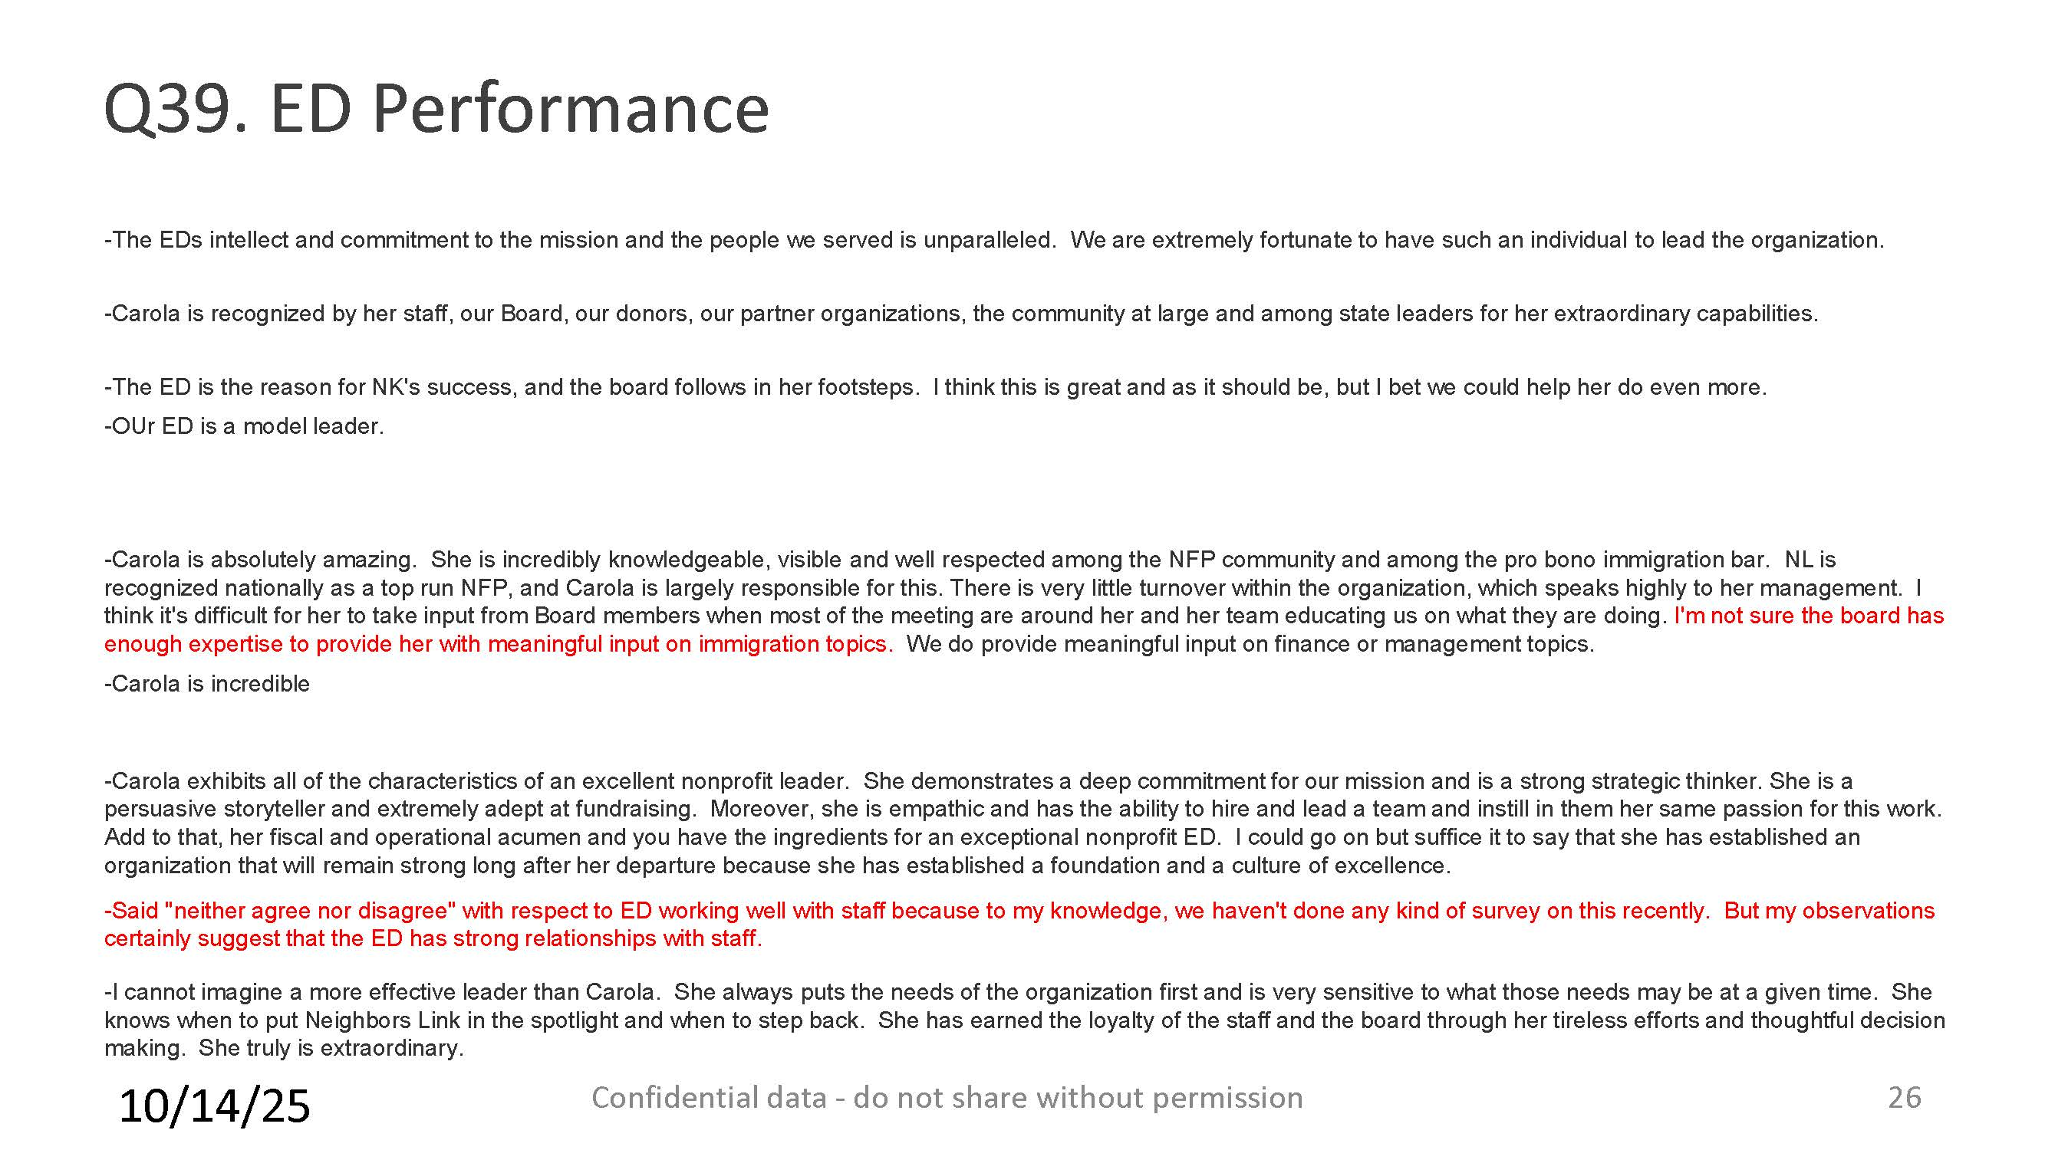

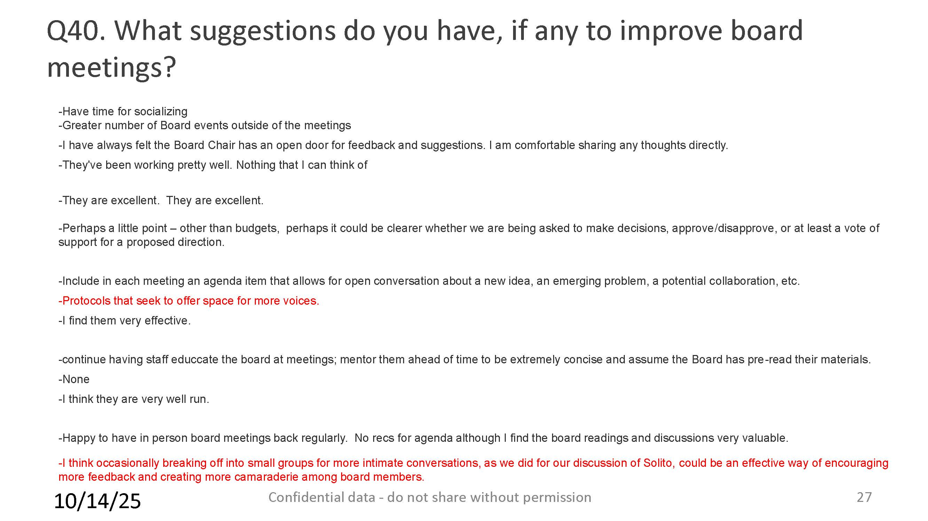
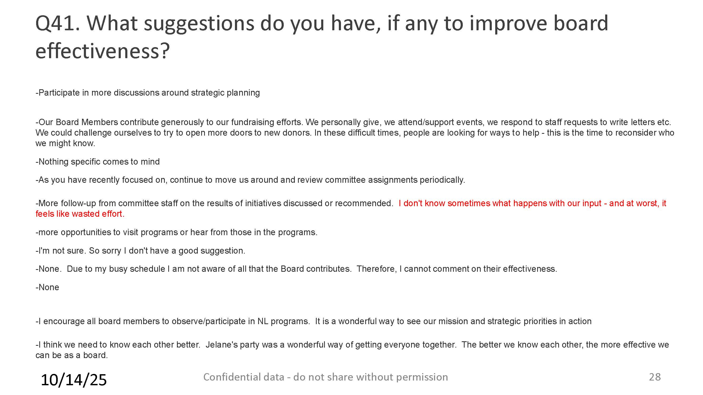

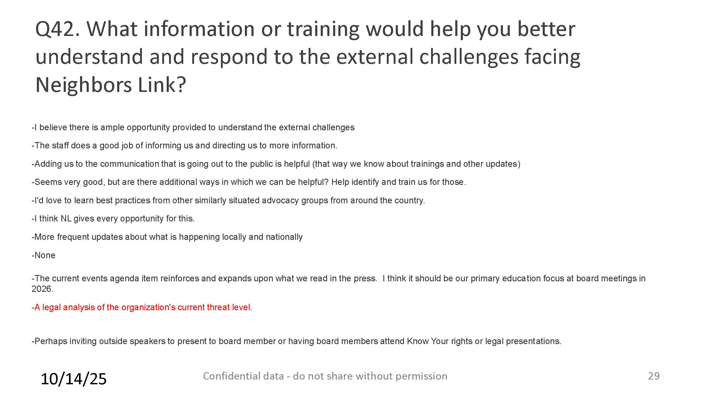
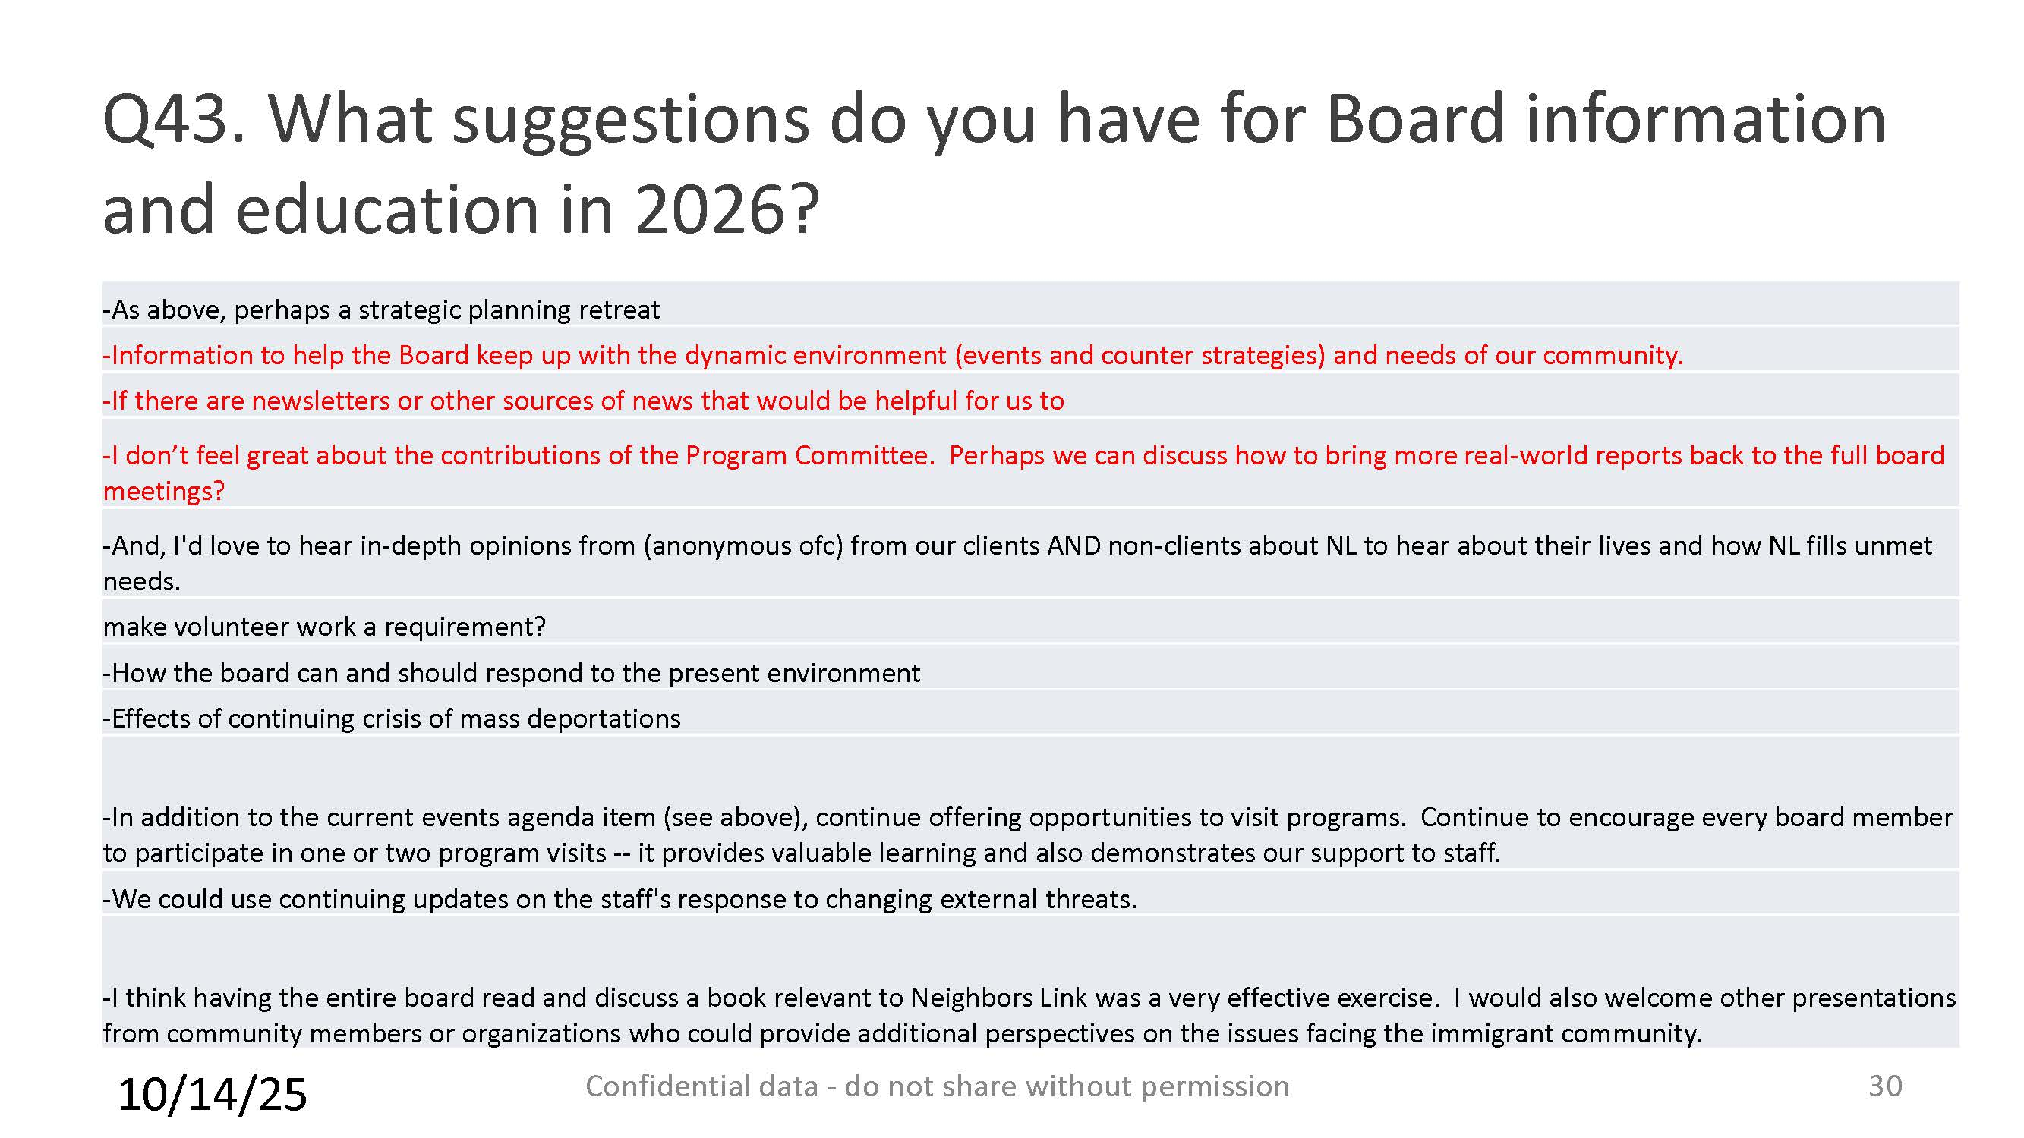

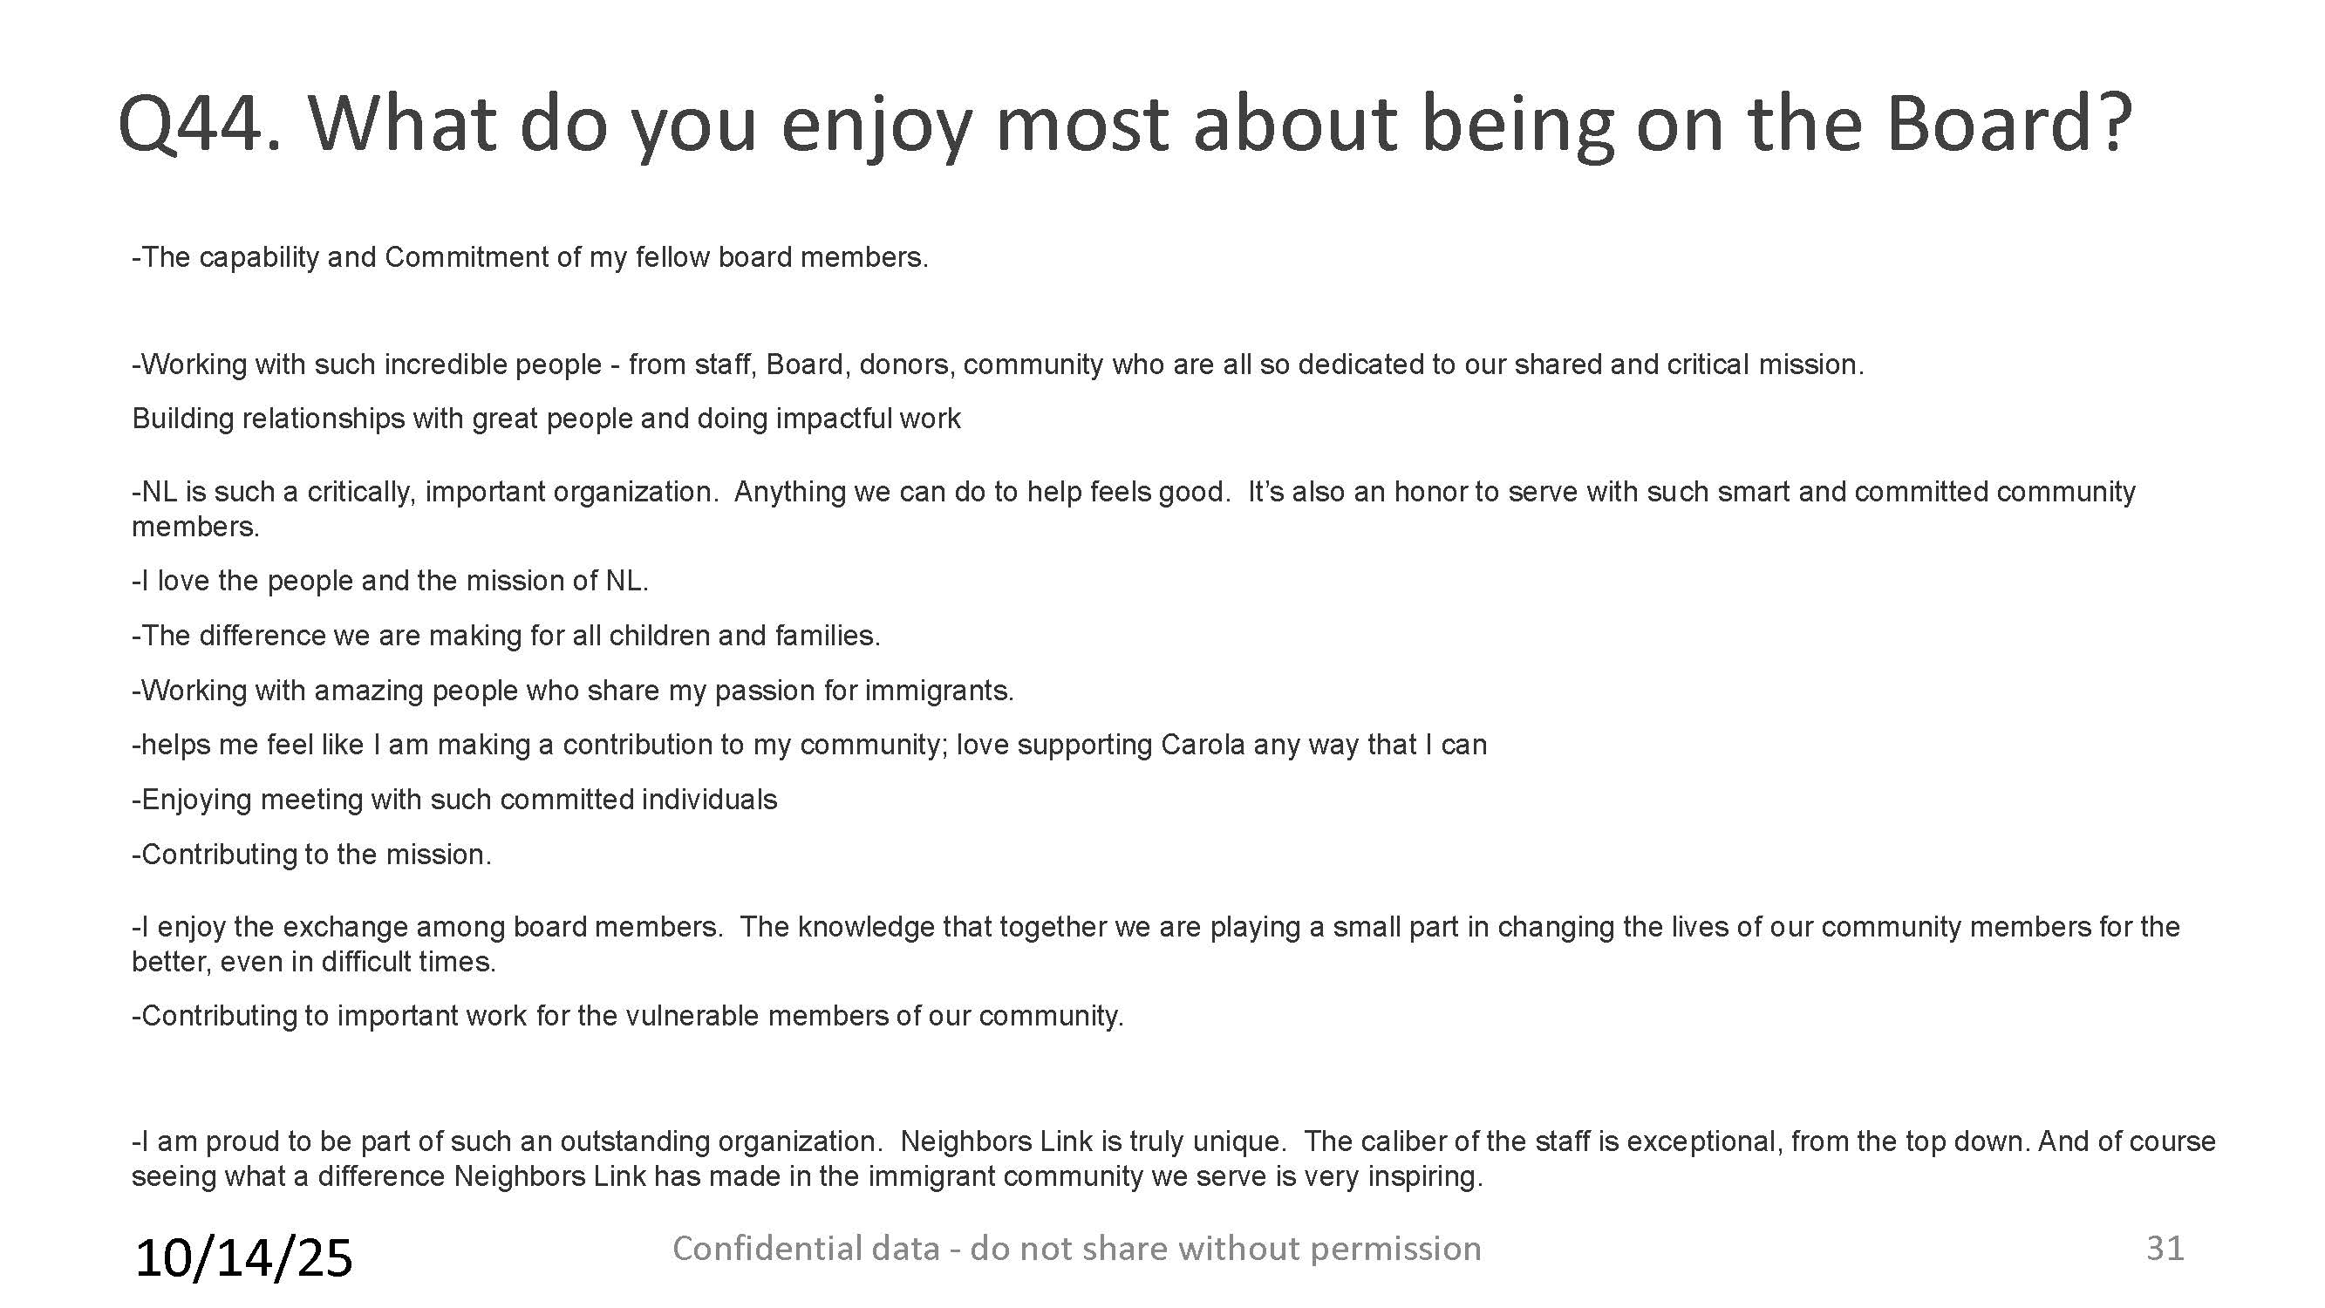


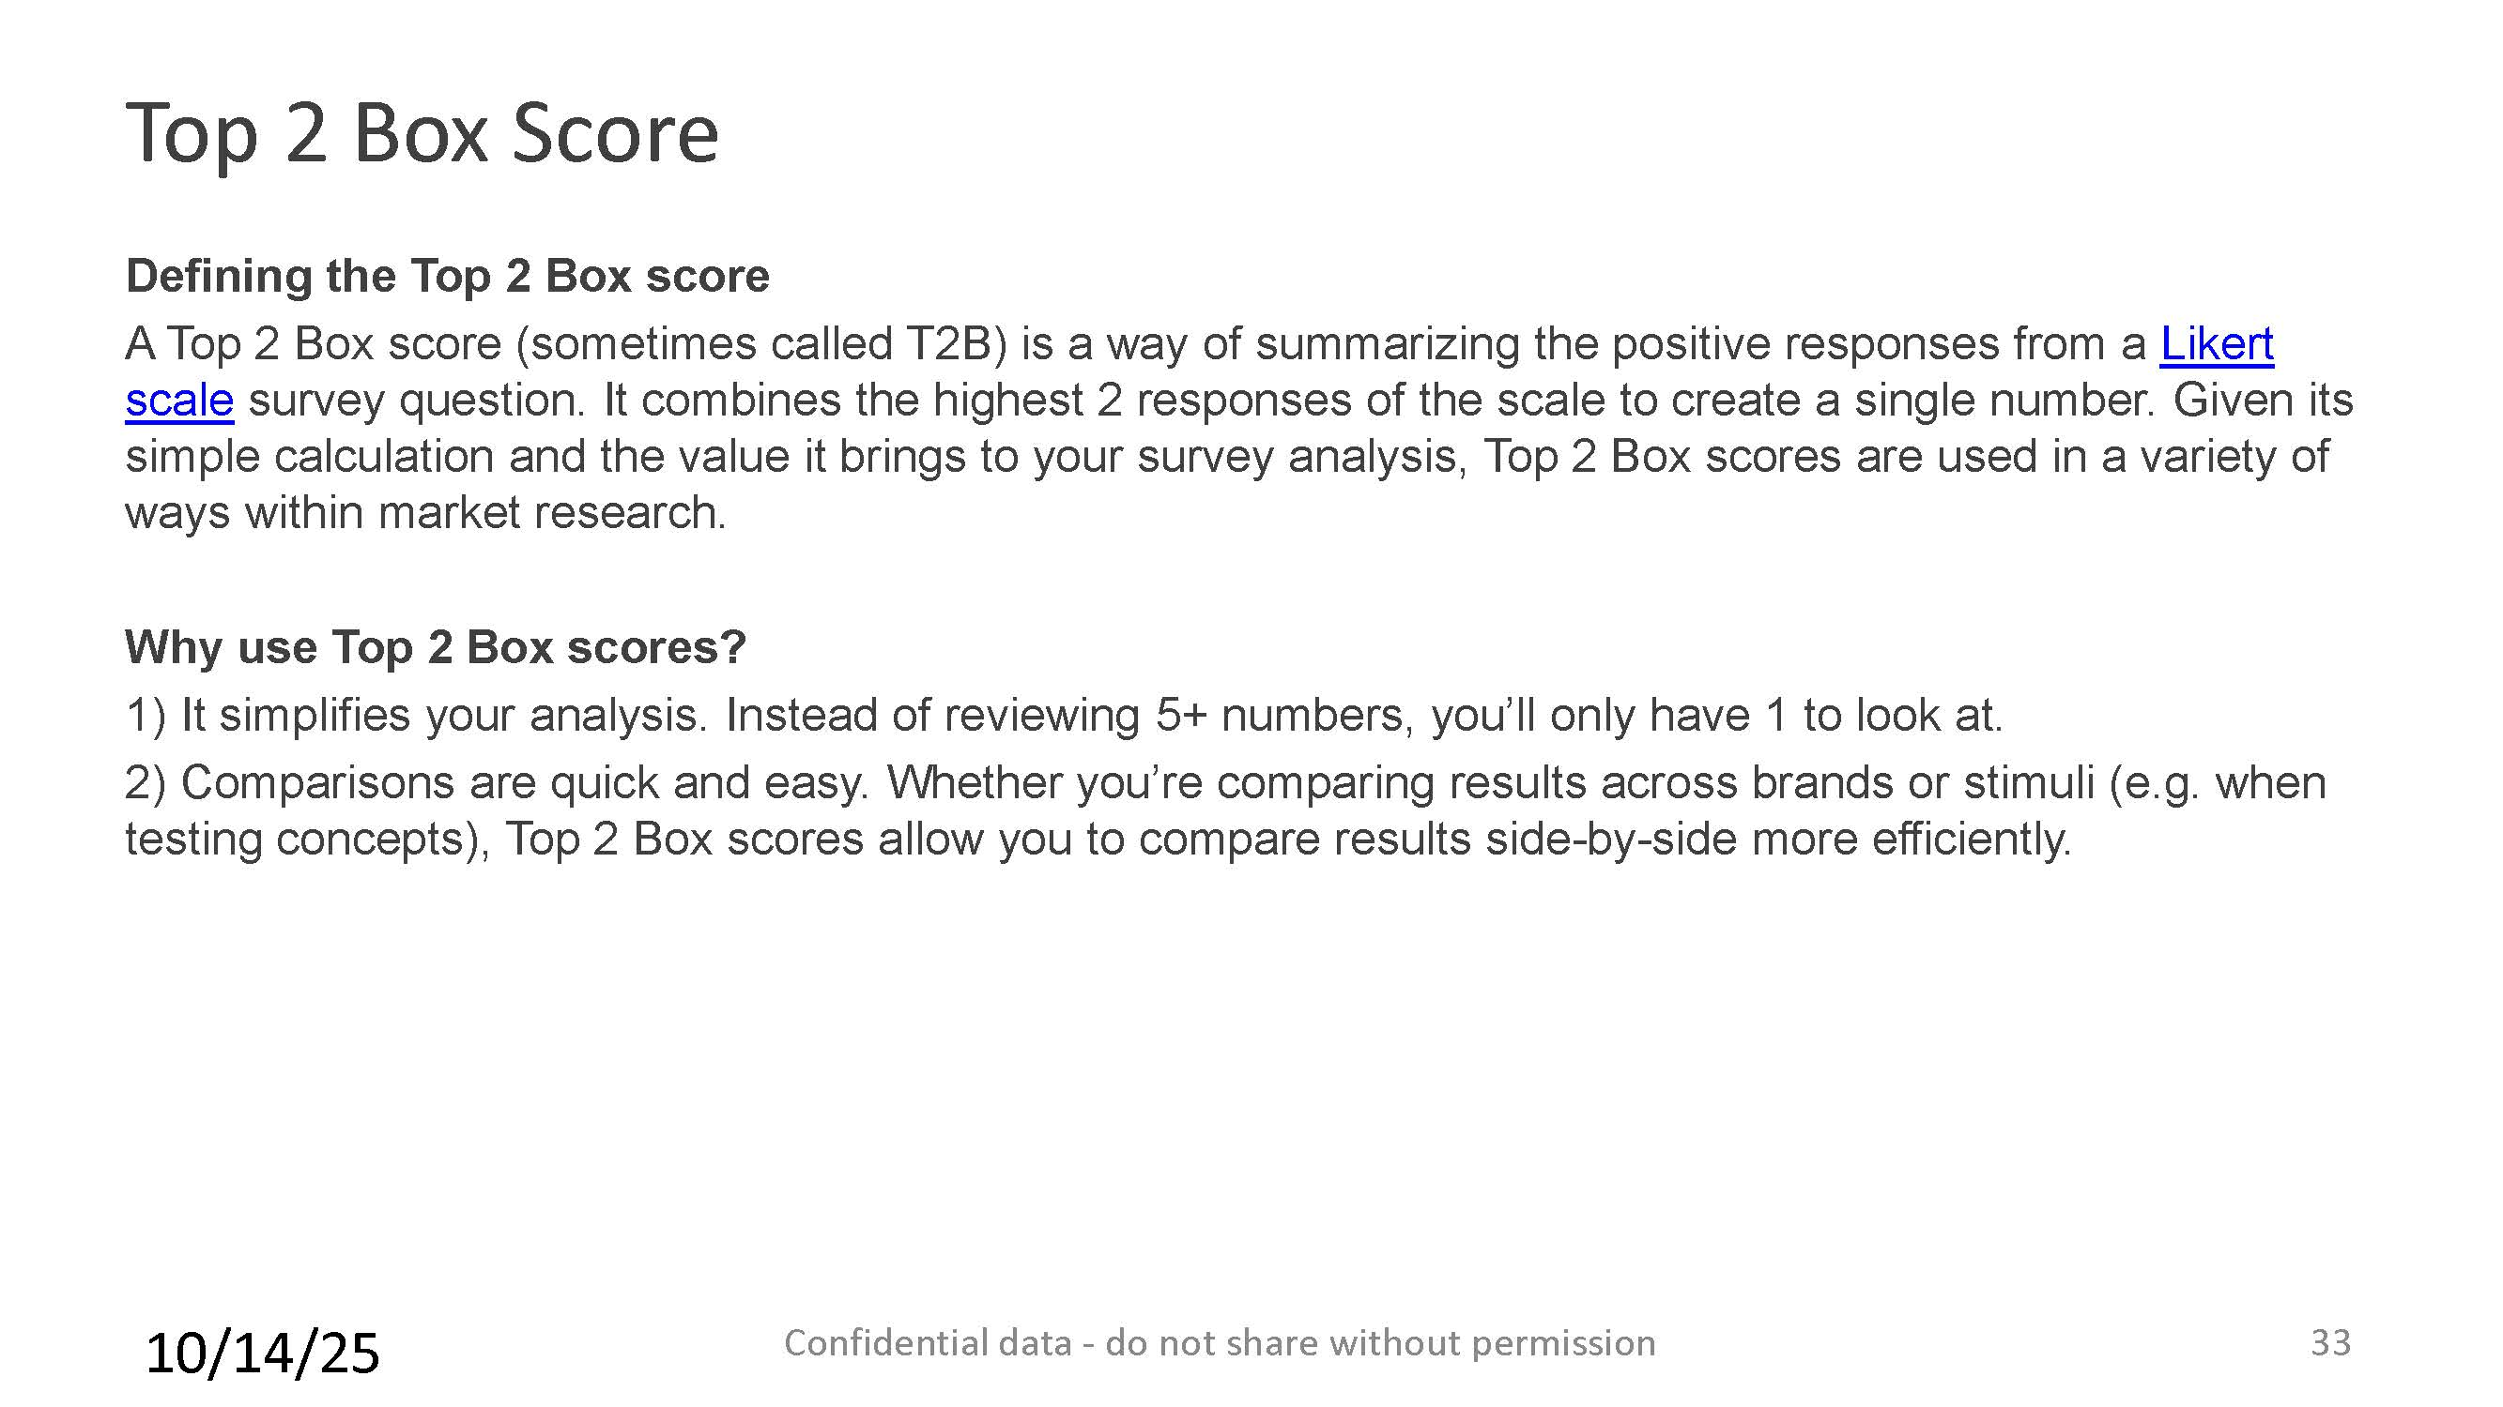

Locations

New Headquarters in Mount Kisco at 350 Lexington Avenue – we moved from 27 Columbus Avenue on August 1, 2025. We have 8,000 sq feet for our programming.
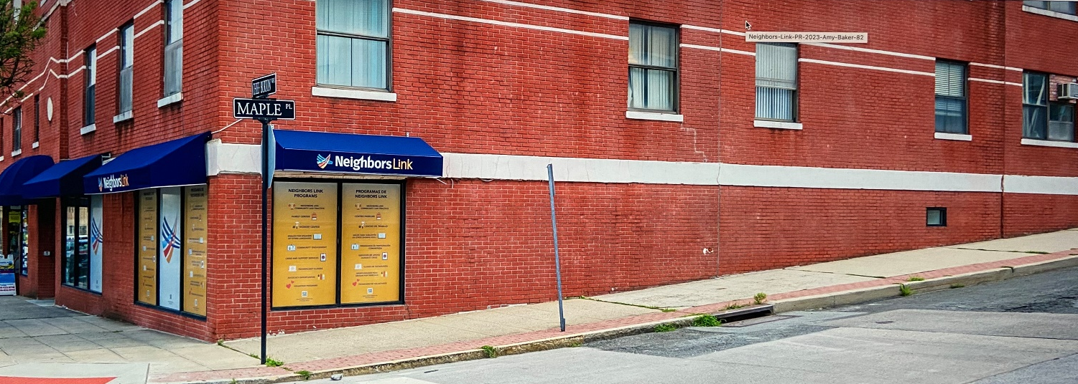
Our Ossining Center at 23-25 Spring Street was opened in 2018 and in 2021 we completed a construction project to provide more than 5,000 square feet for our programming.
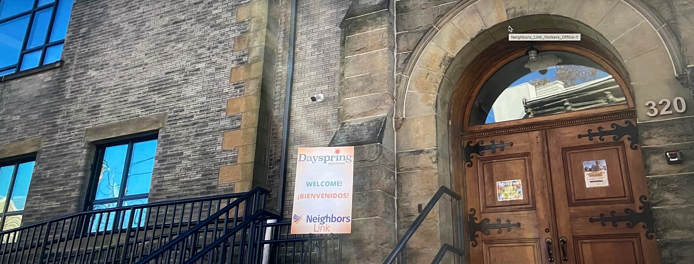
Our programming in Yonkers is at the Dayspring Community Center, 320 Walnut Street, since 2022.
We have partnered with Westhab, a large nonprofit organization focused on quality affordable housing.

Organizational Chart

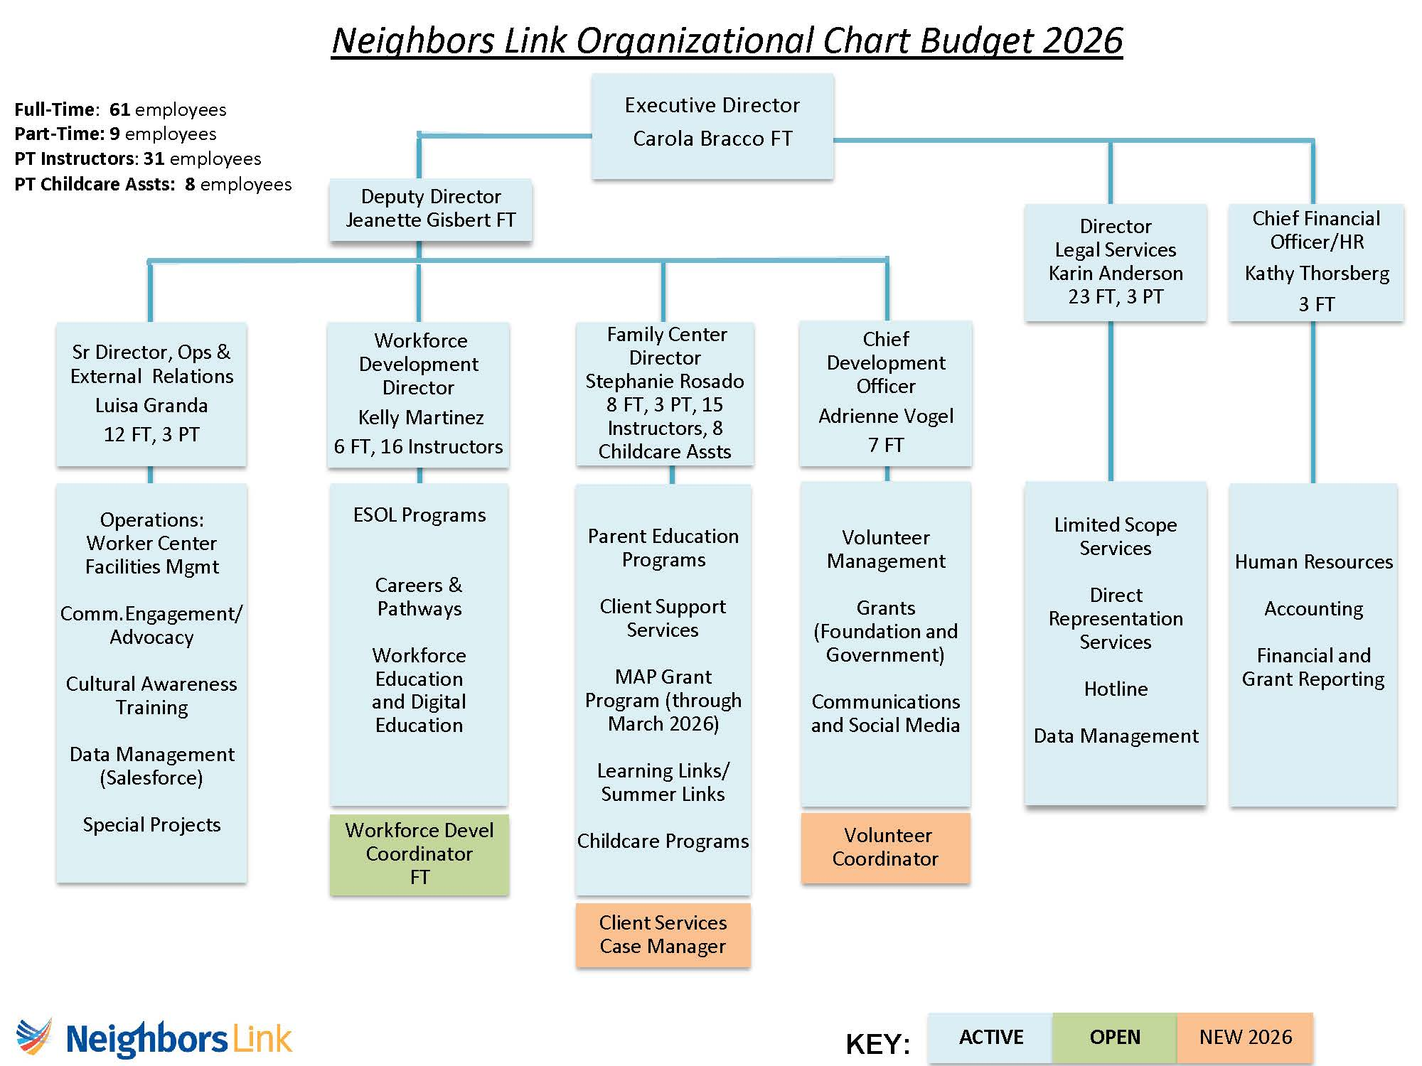

Programs at Neighbors Link

2025 Program Impact – Presented at March 2, 2026 Board Meeting

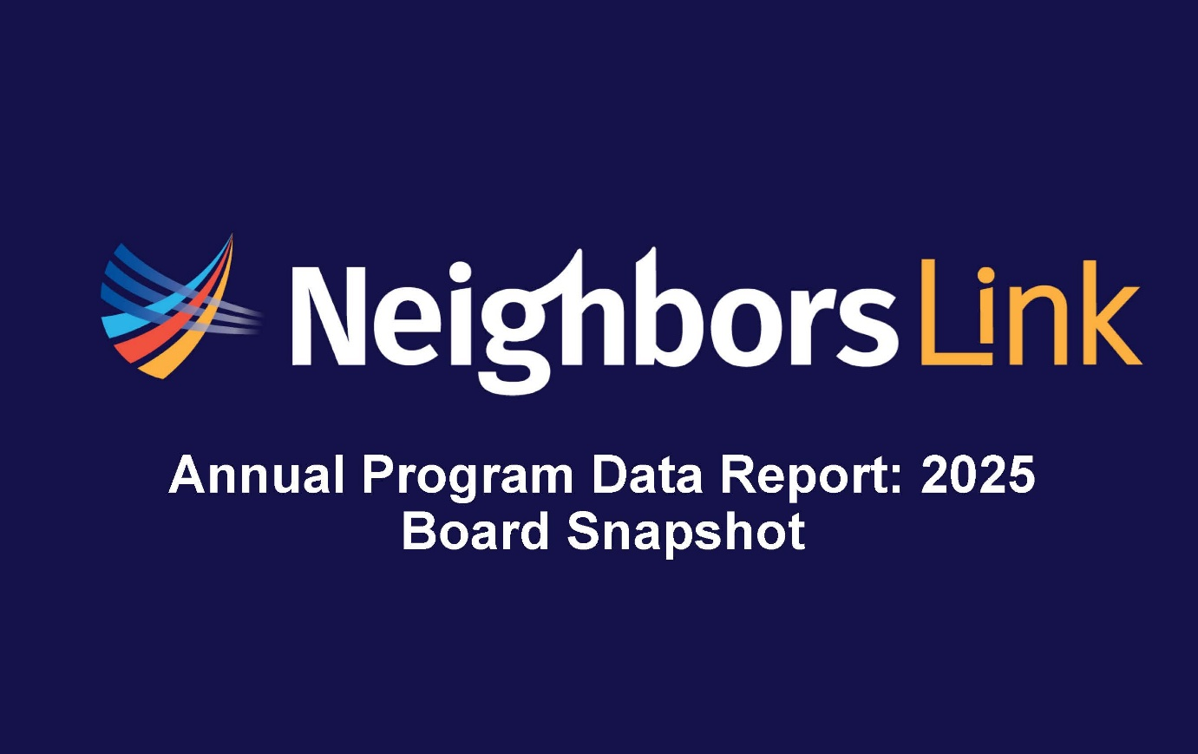

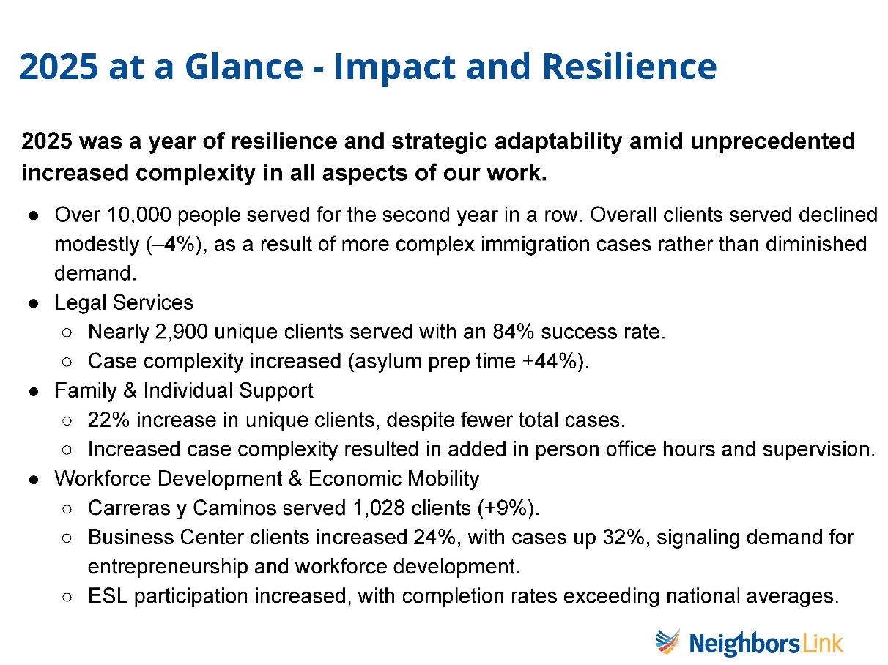

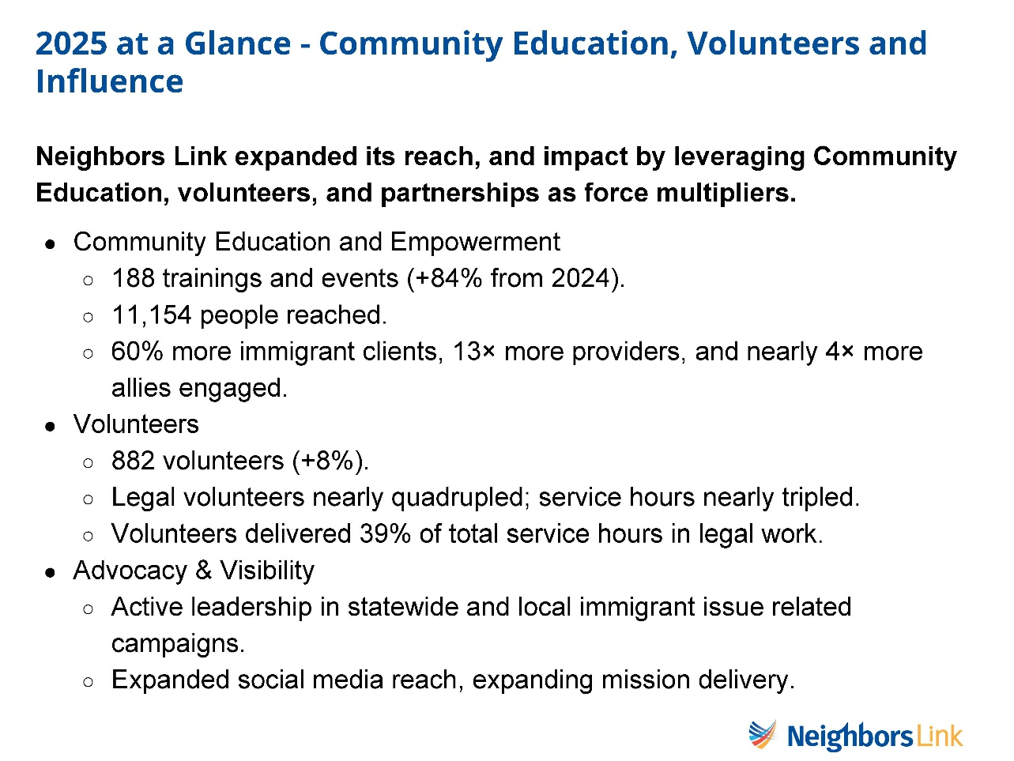

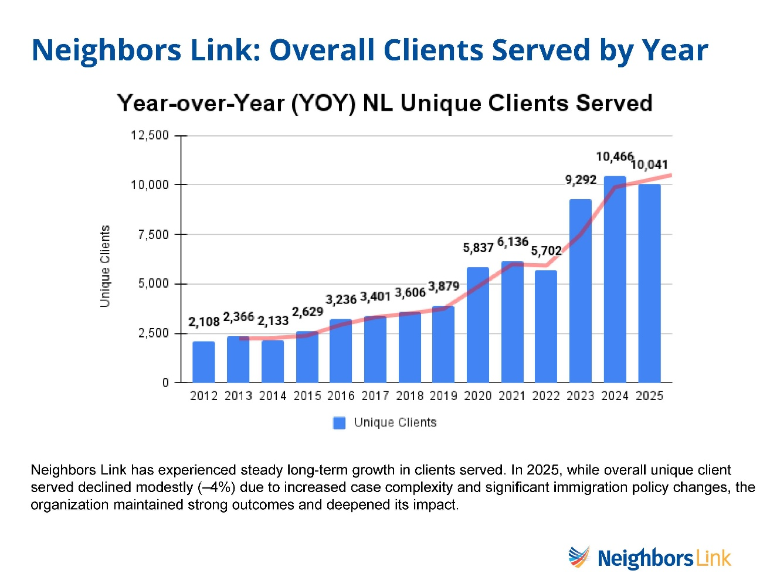

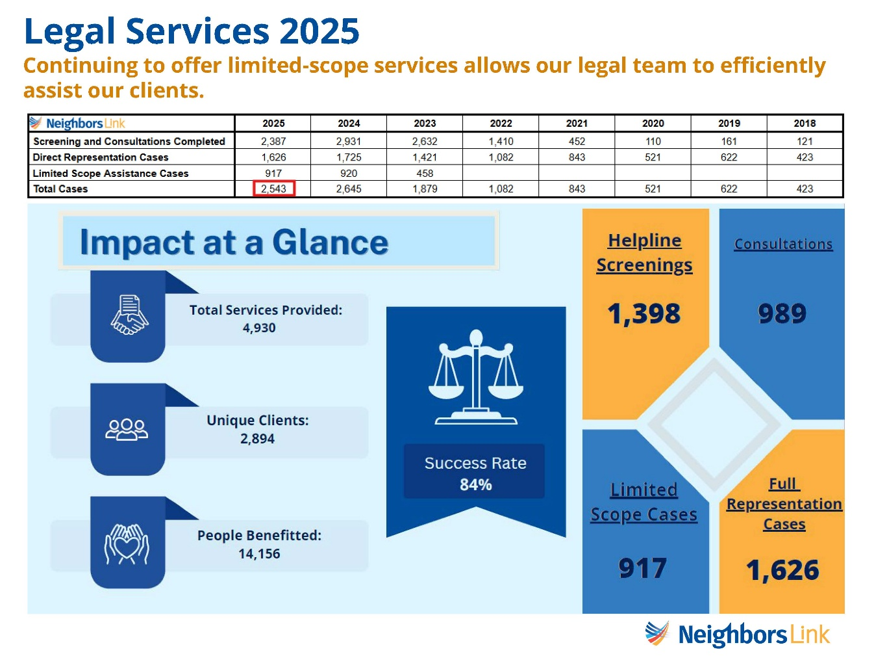

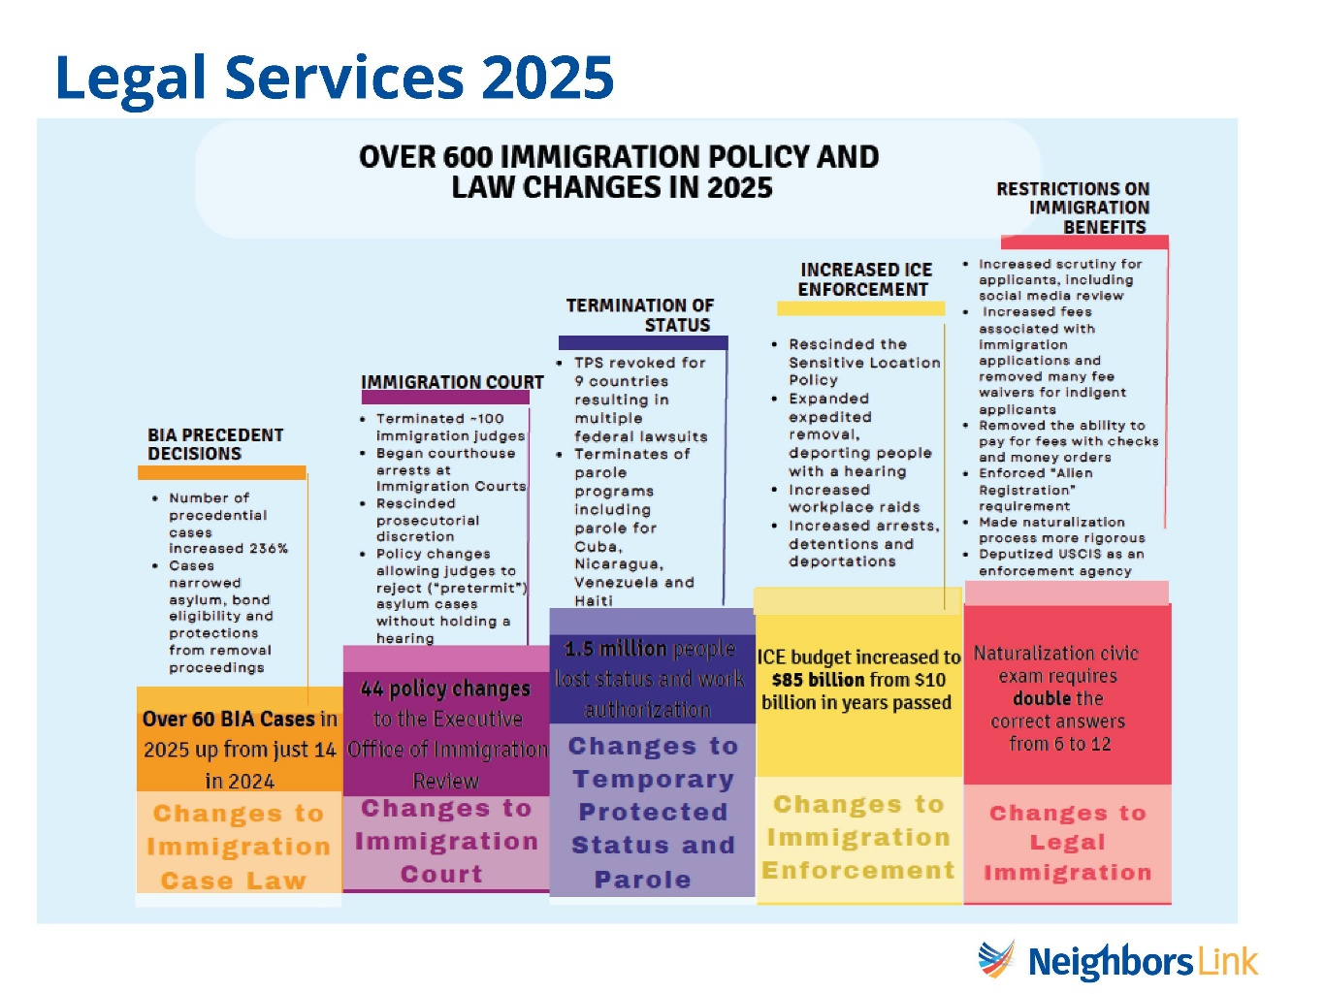

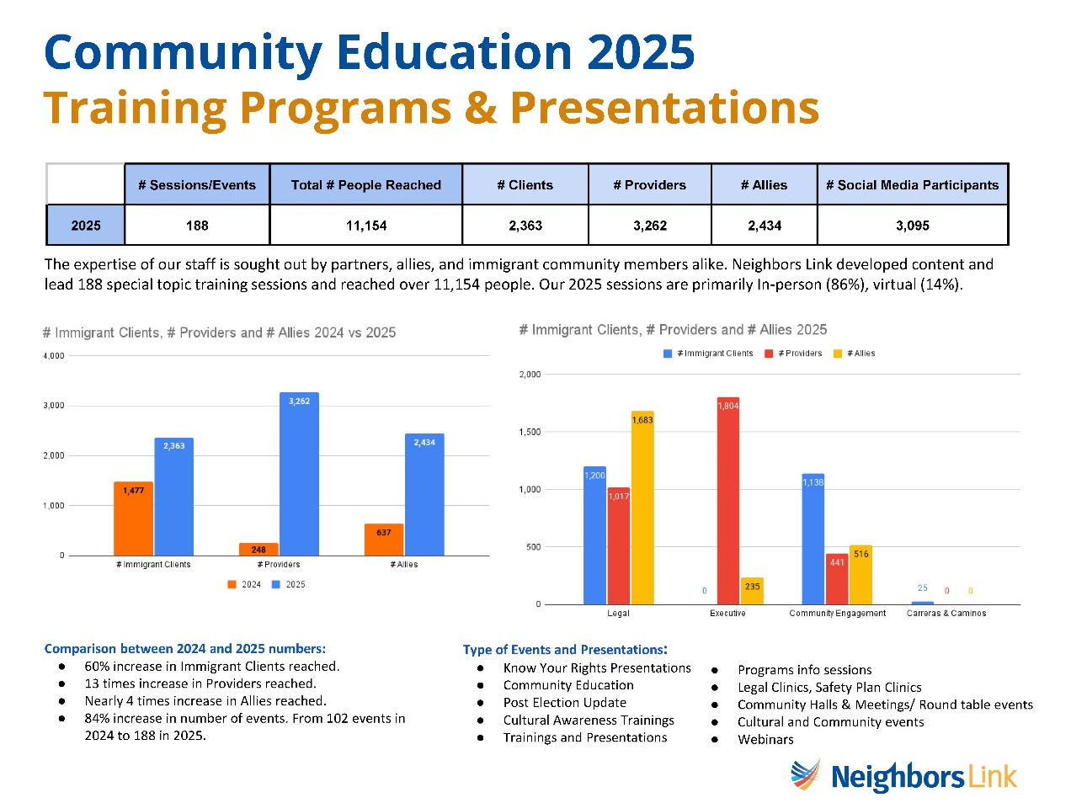

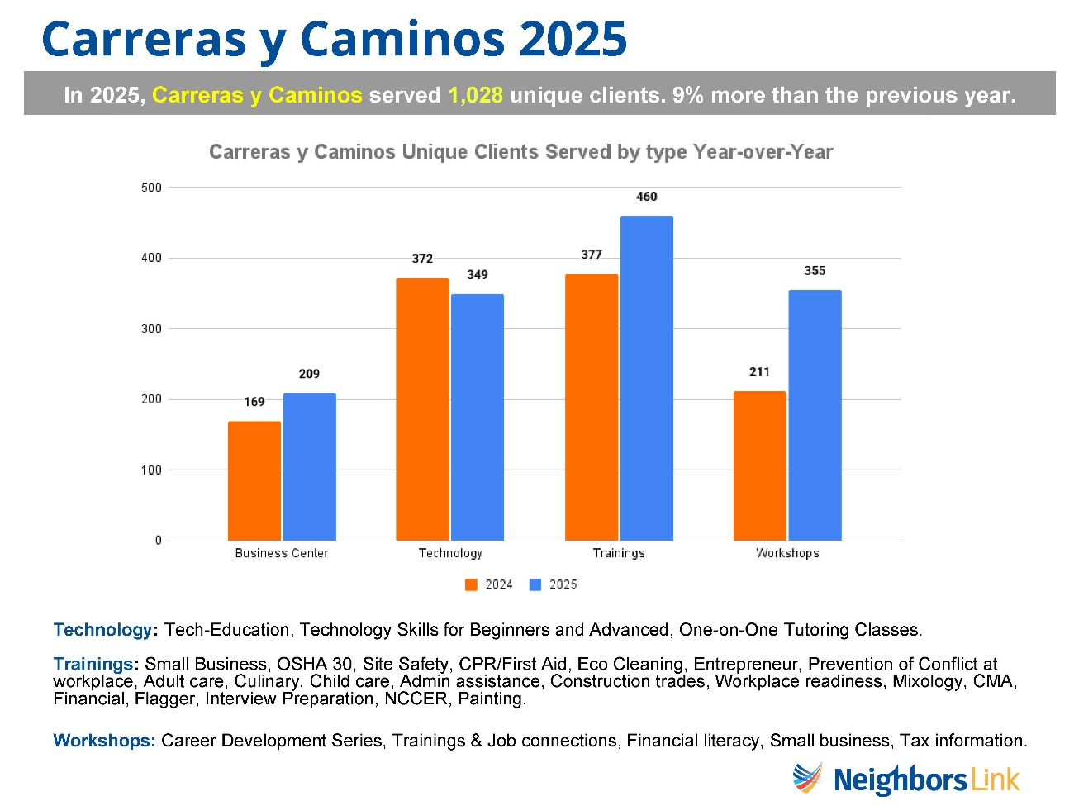

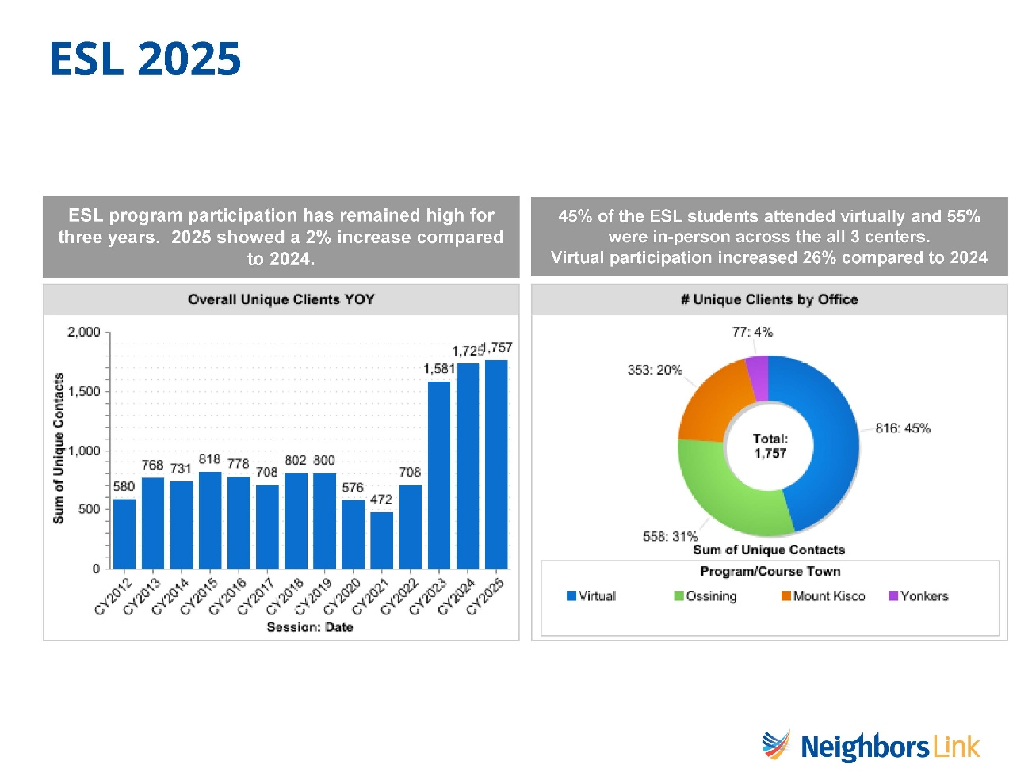

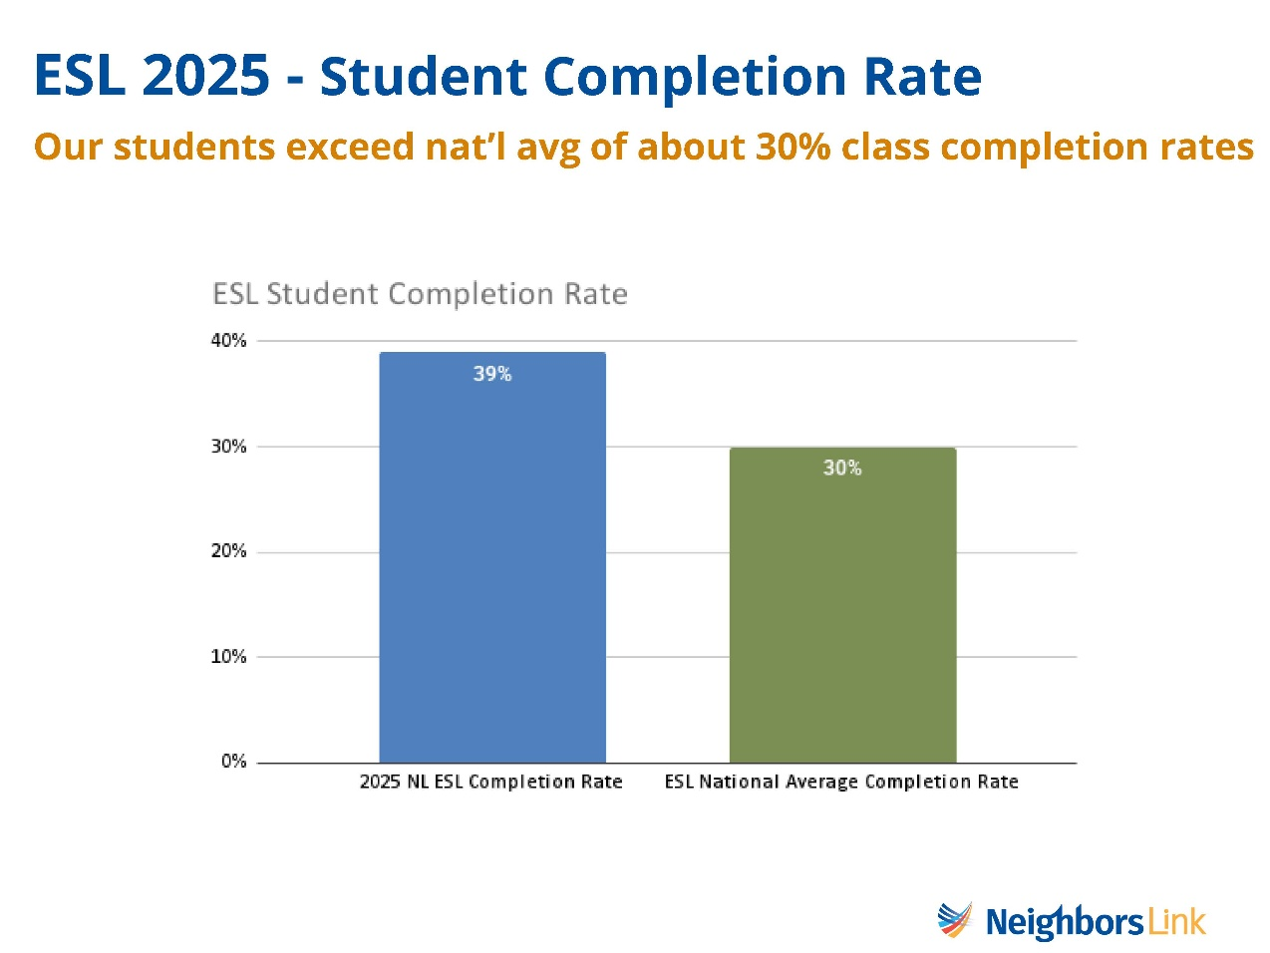

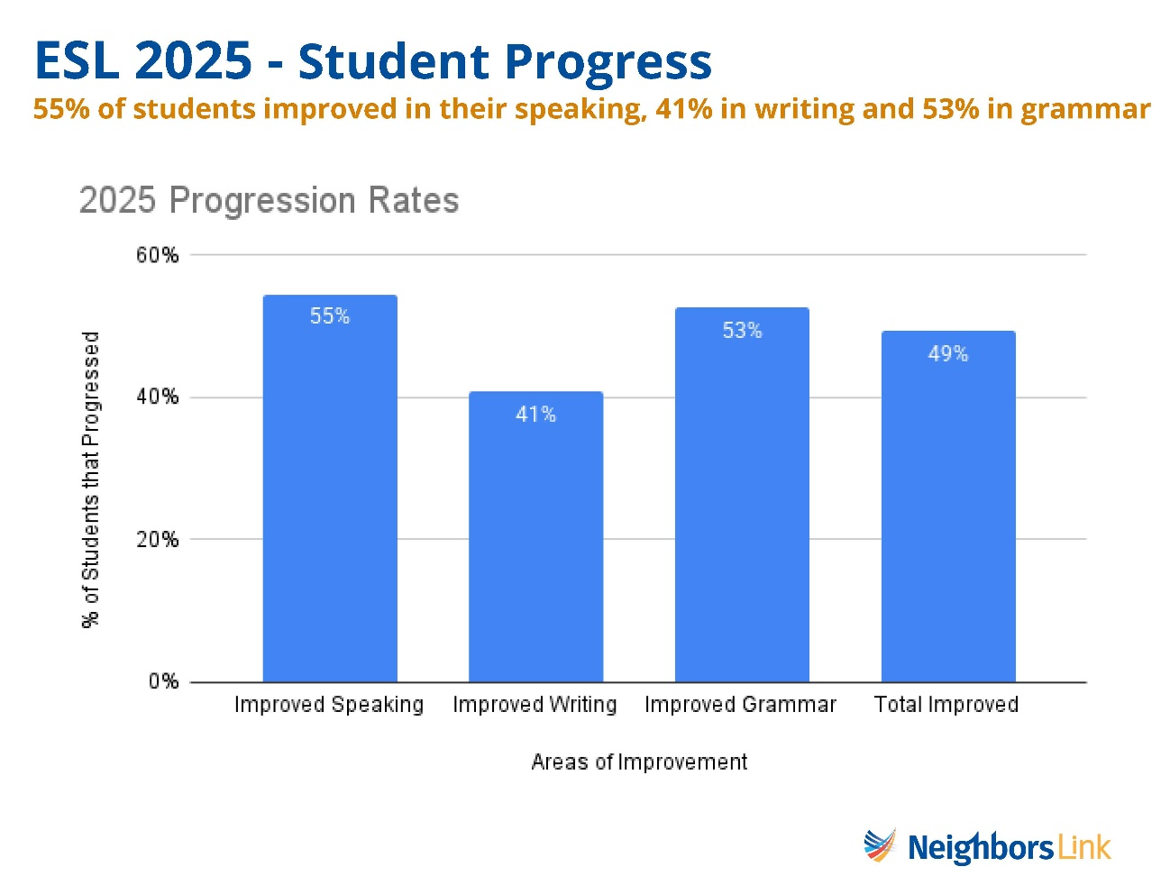

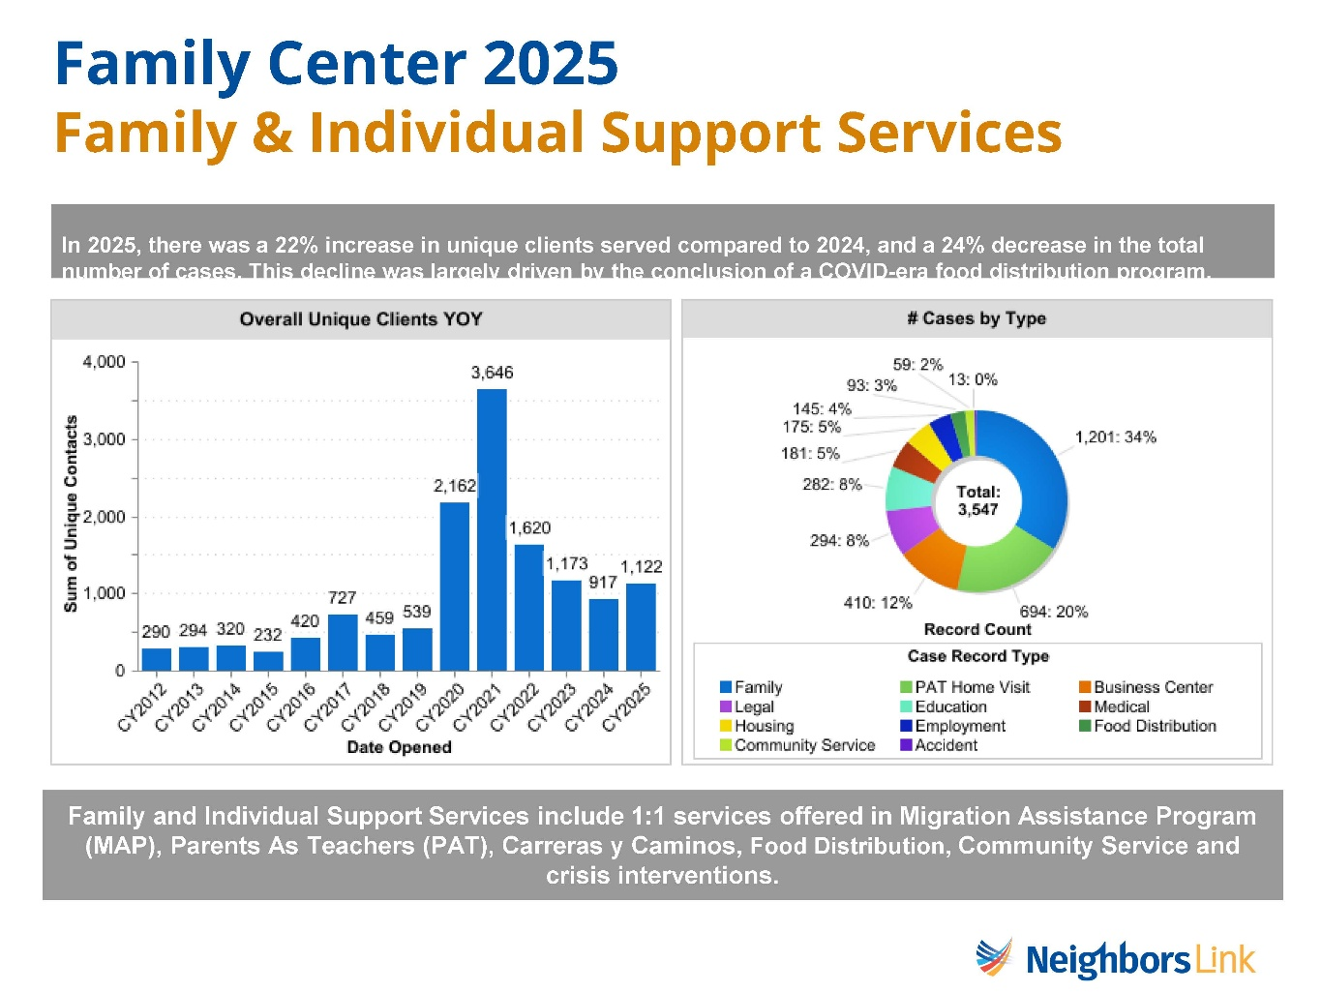

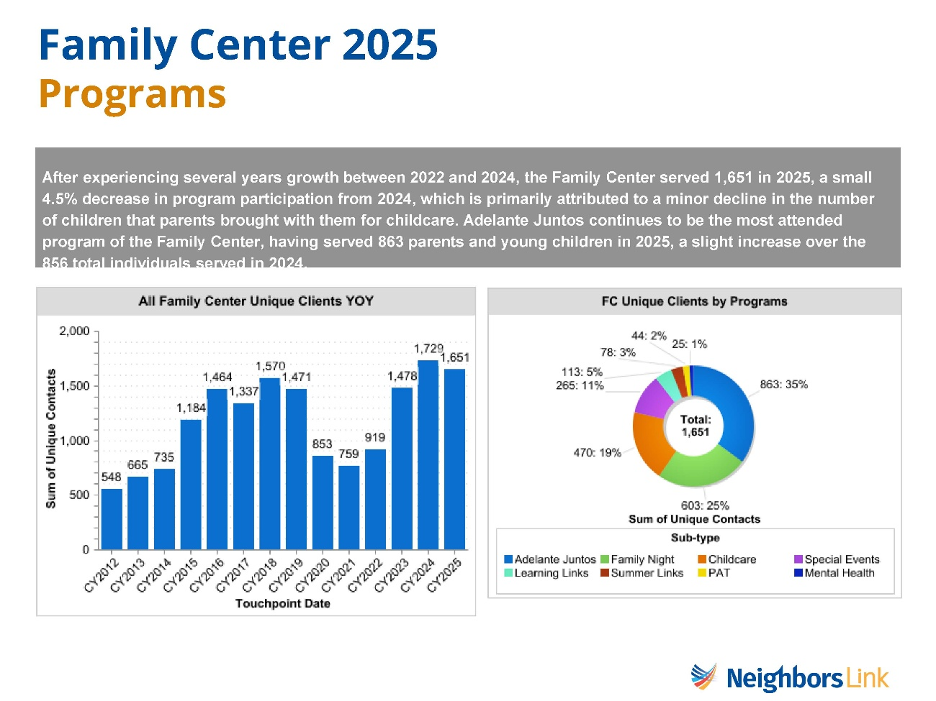

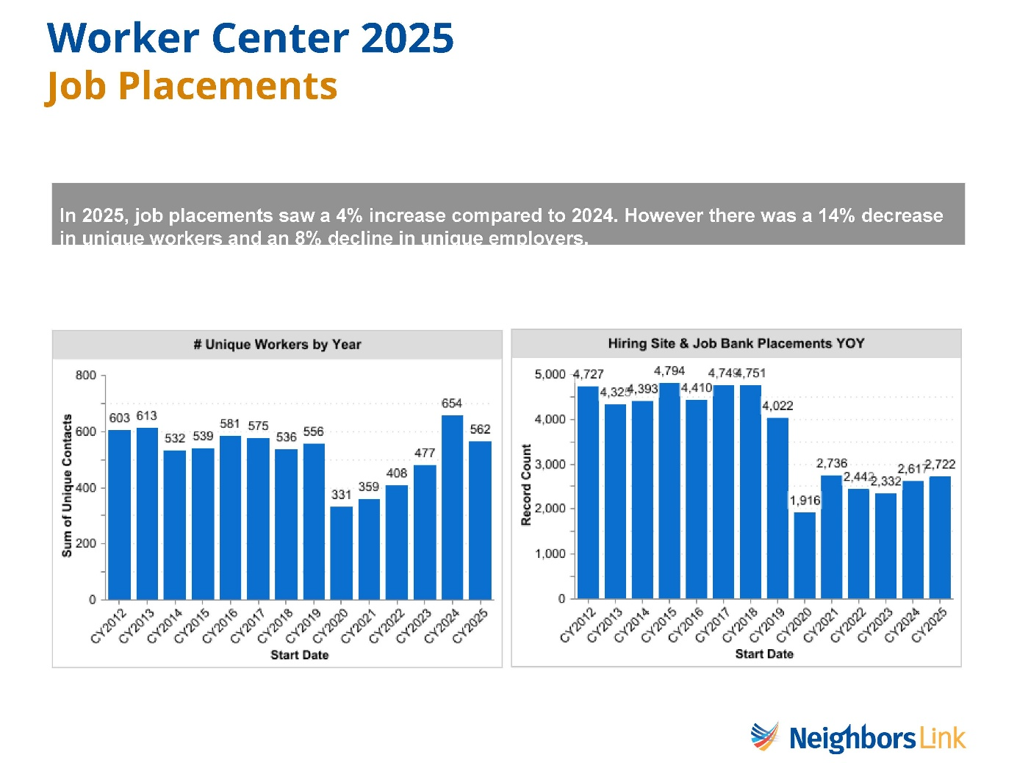
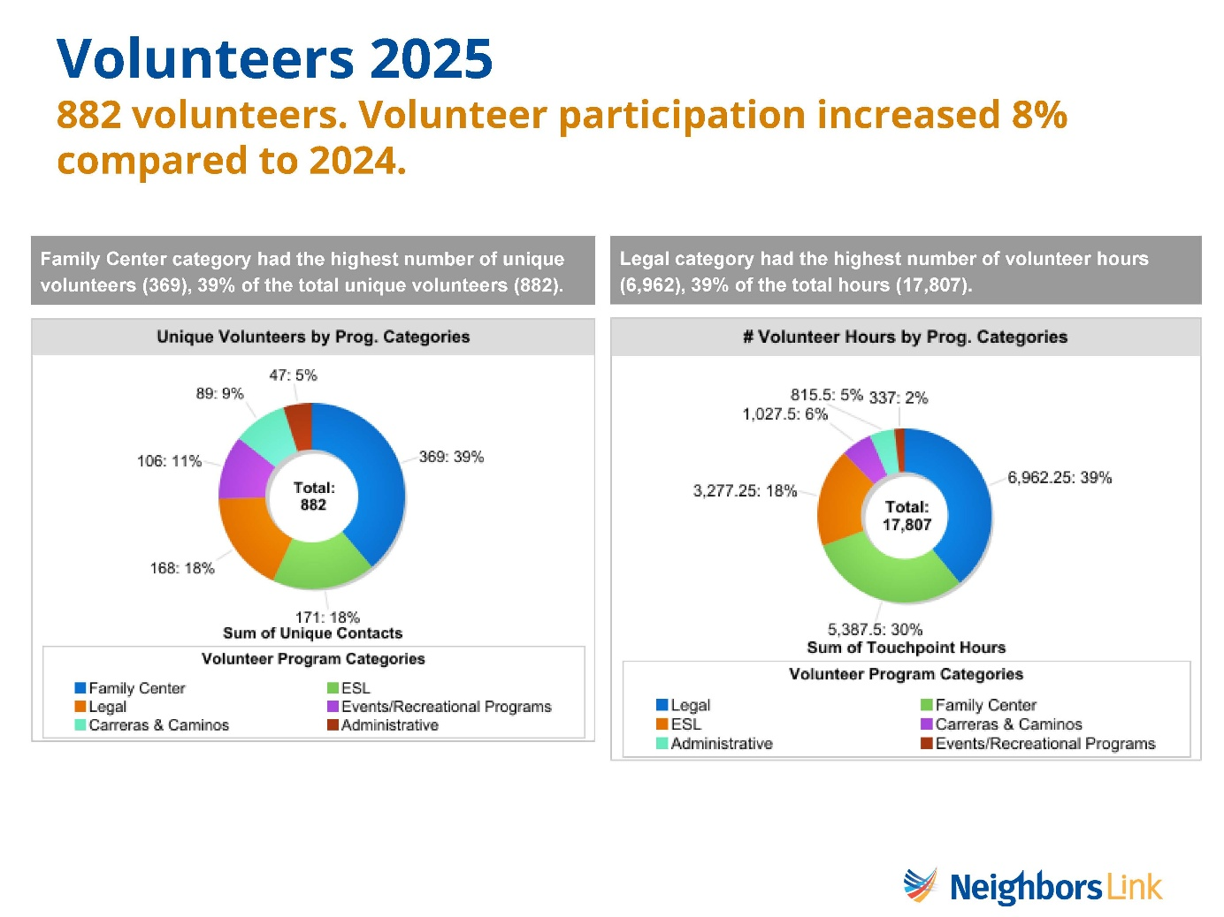

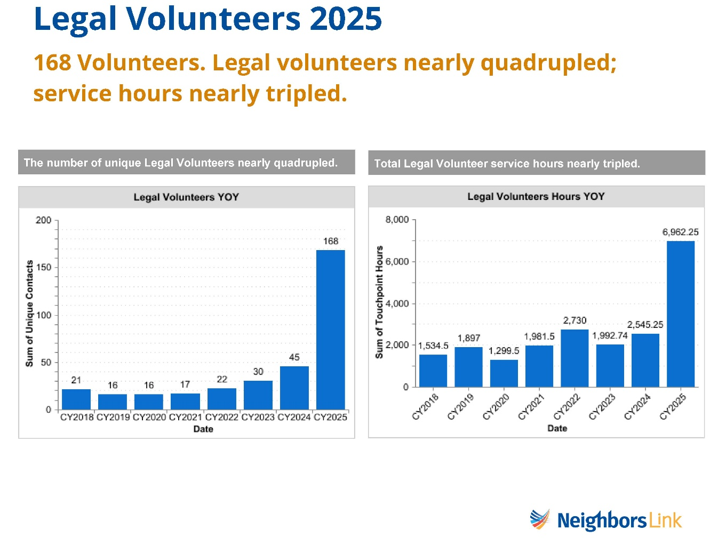
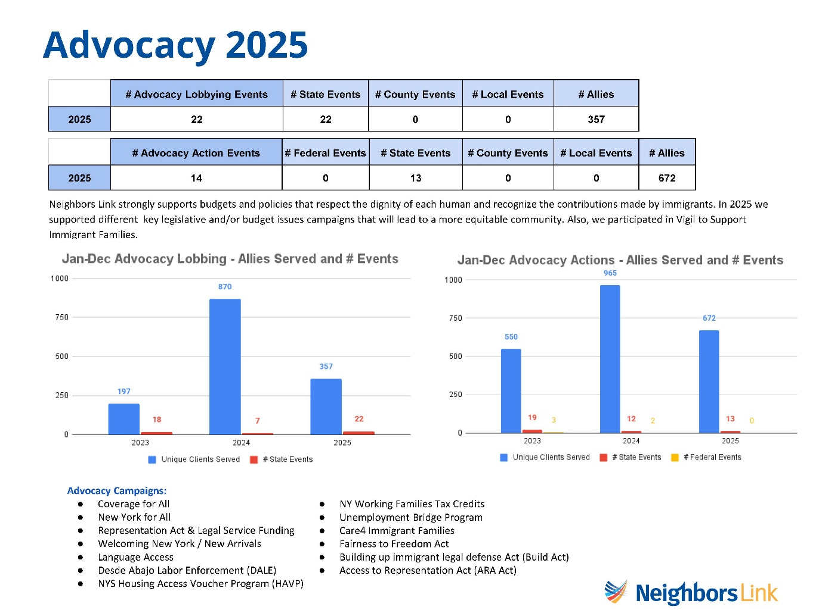

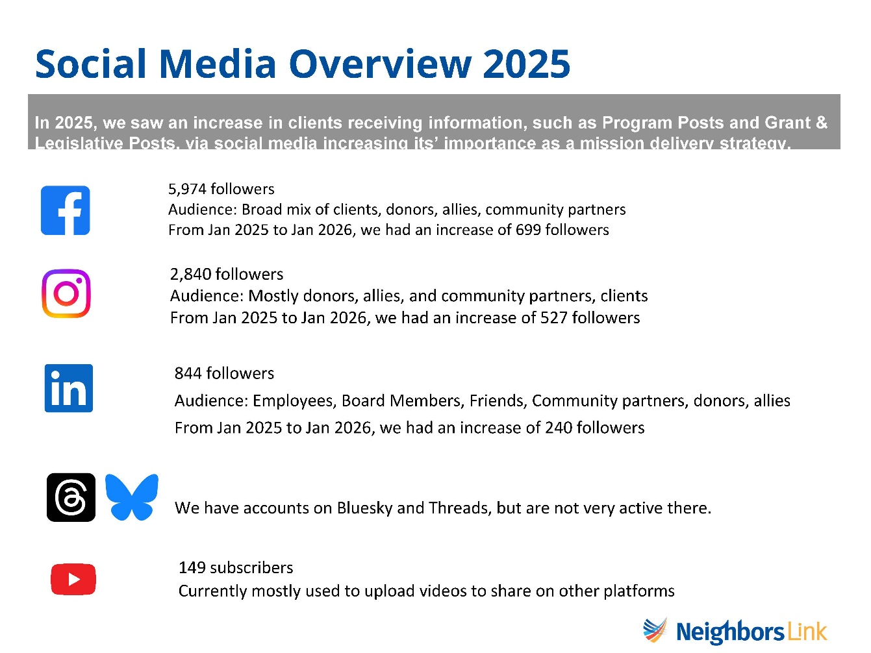

Advocacy Priorities – Legislative Newsletter June 2026

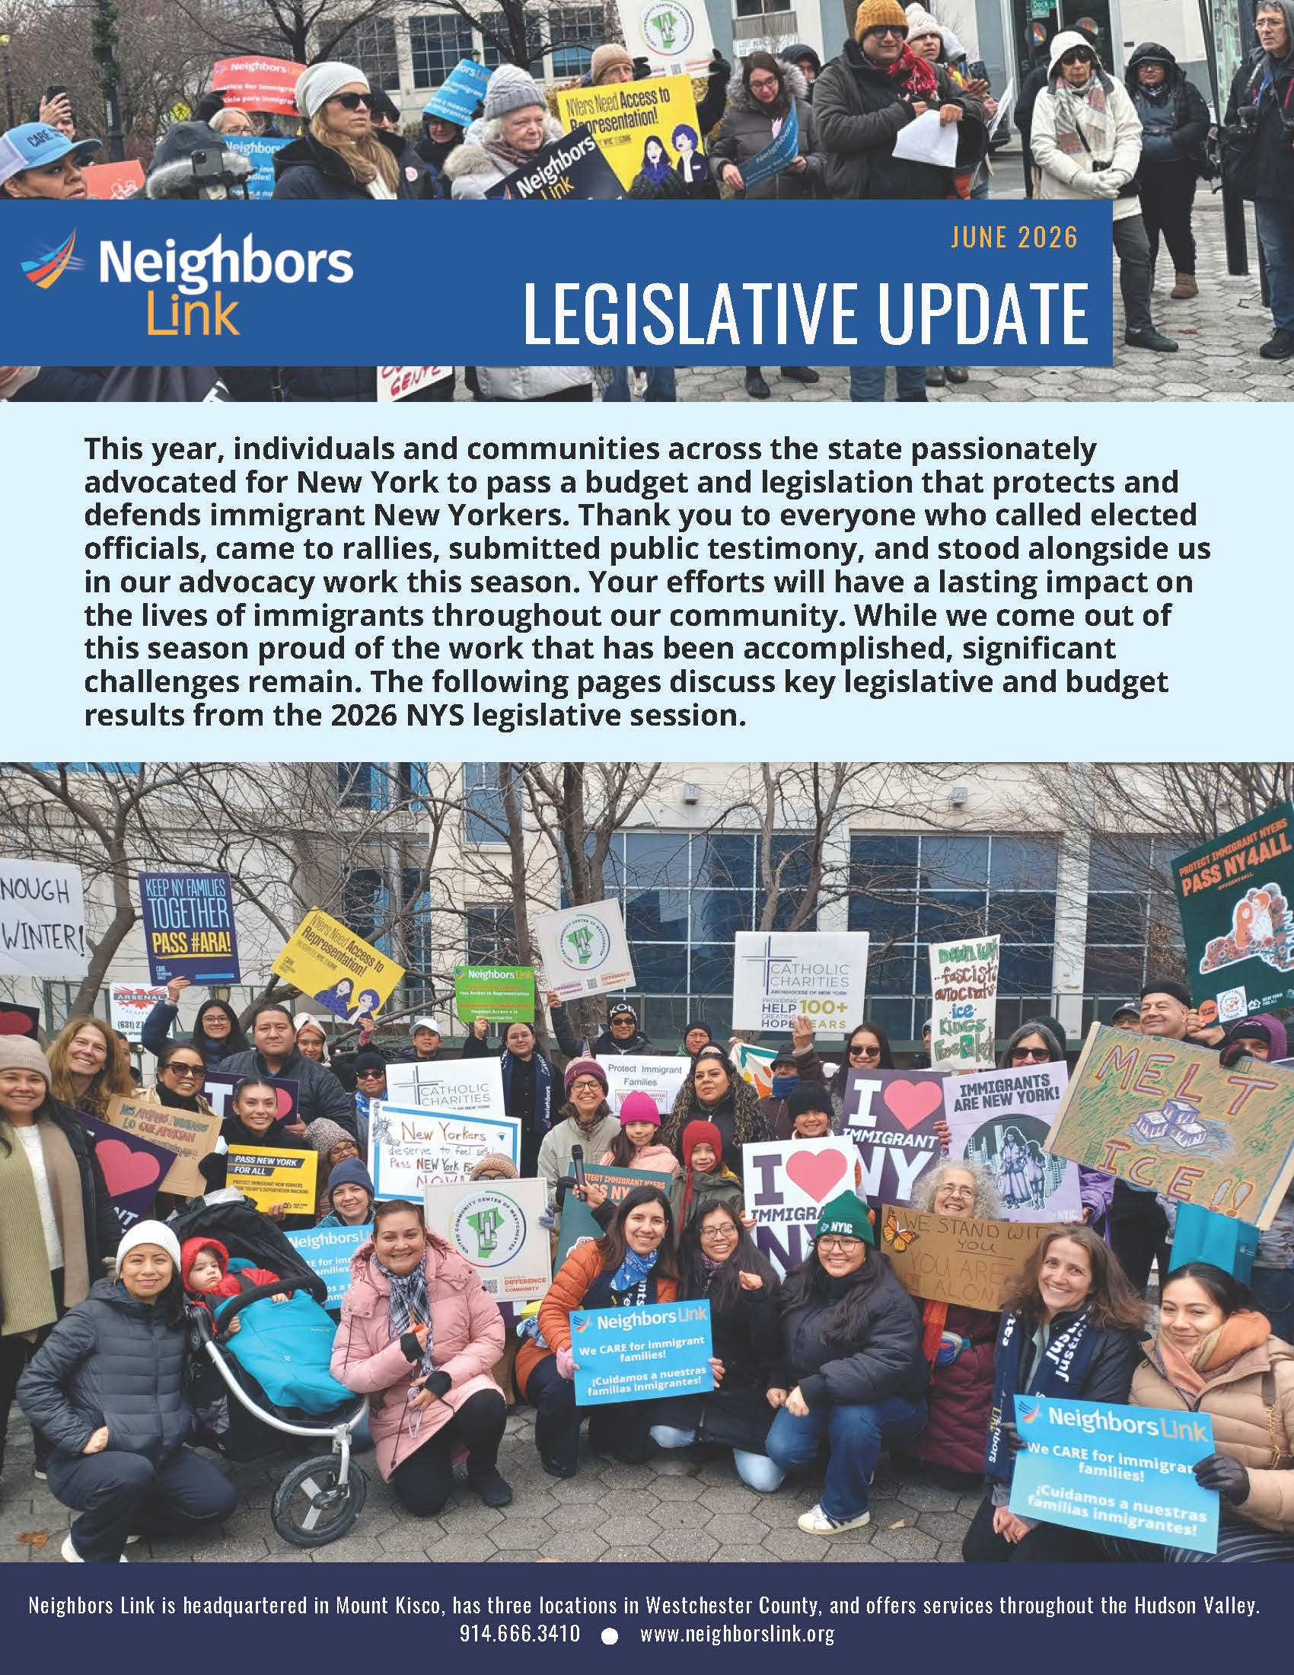
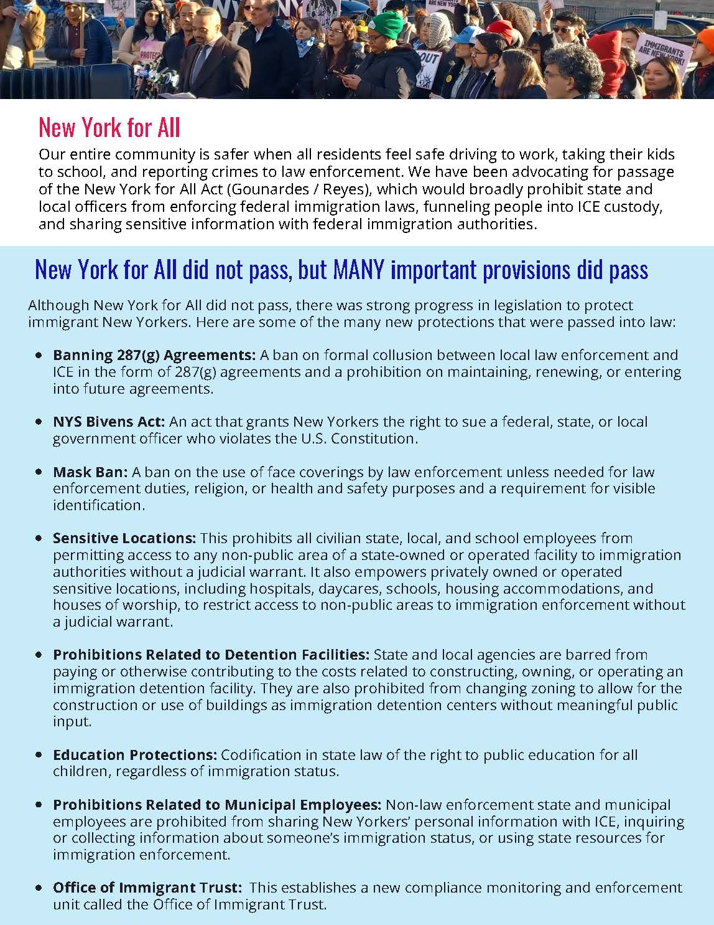

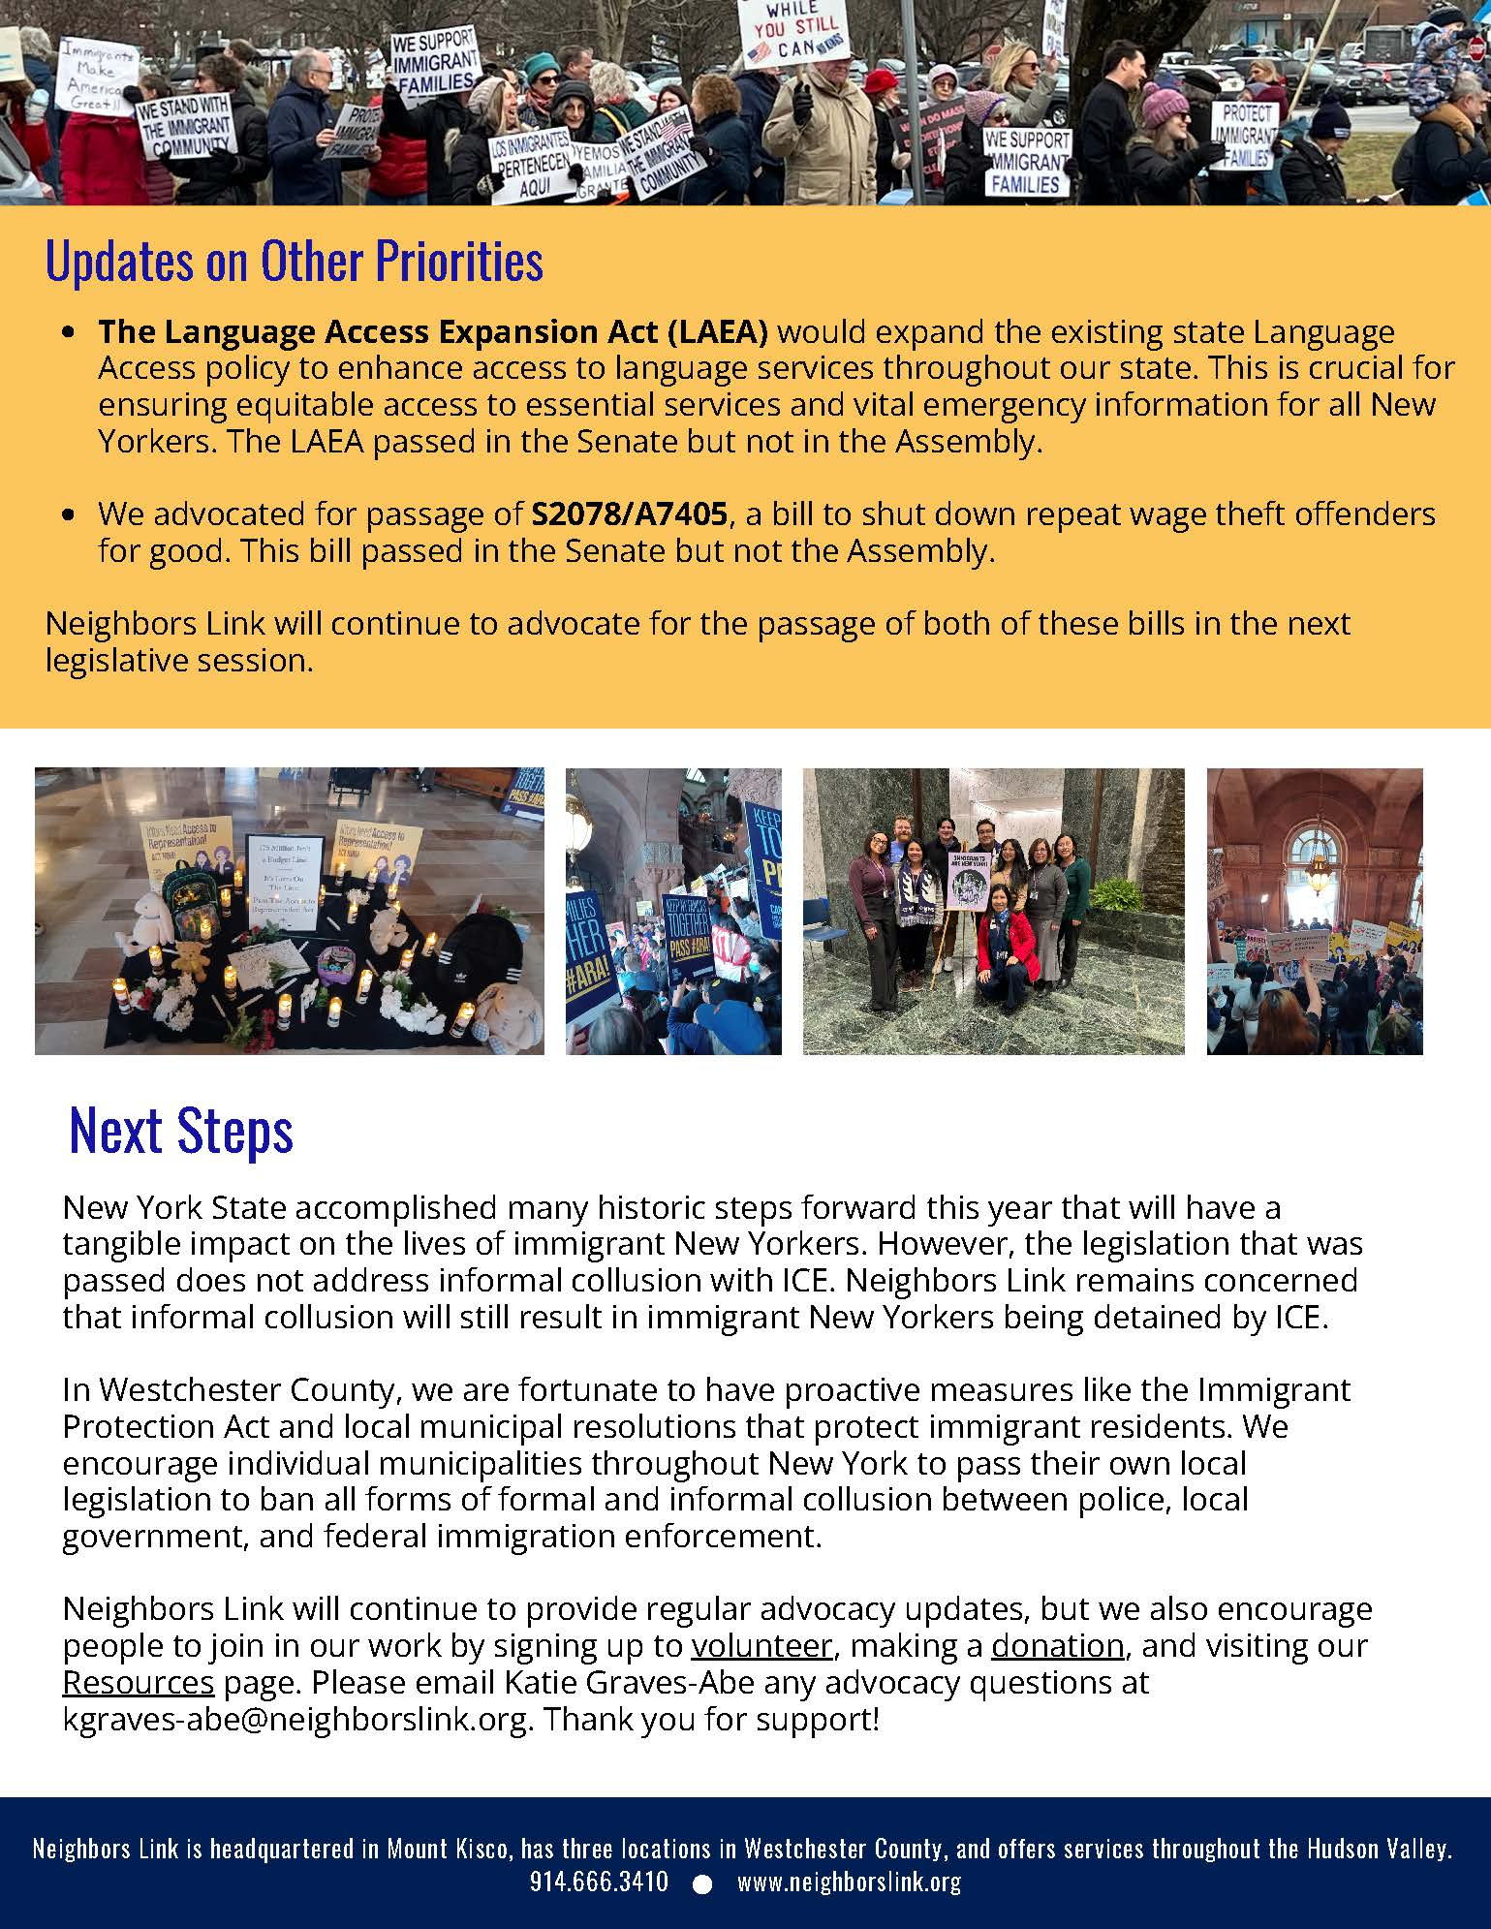

Financial Reports and 2026 Budget

Financial Trends

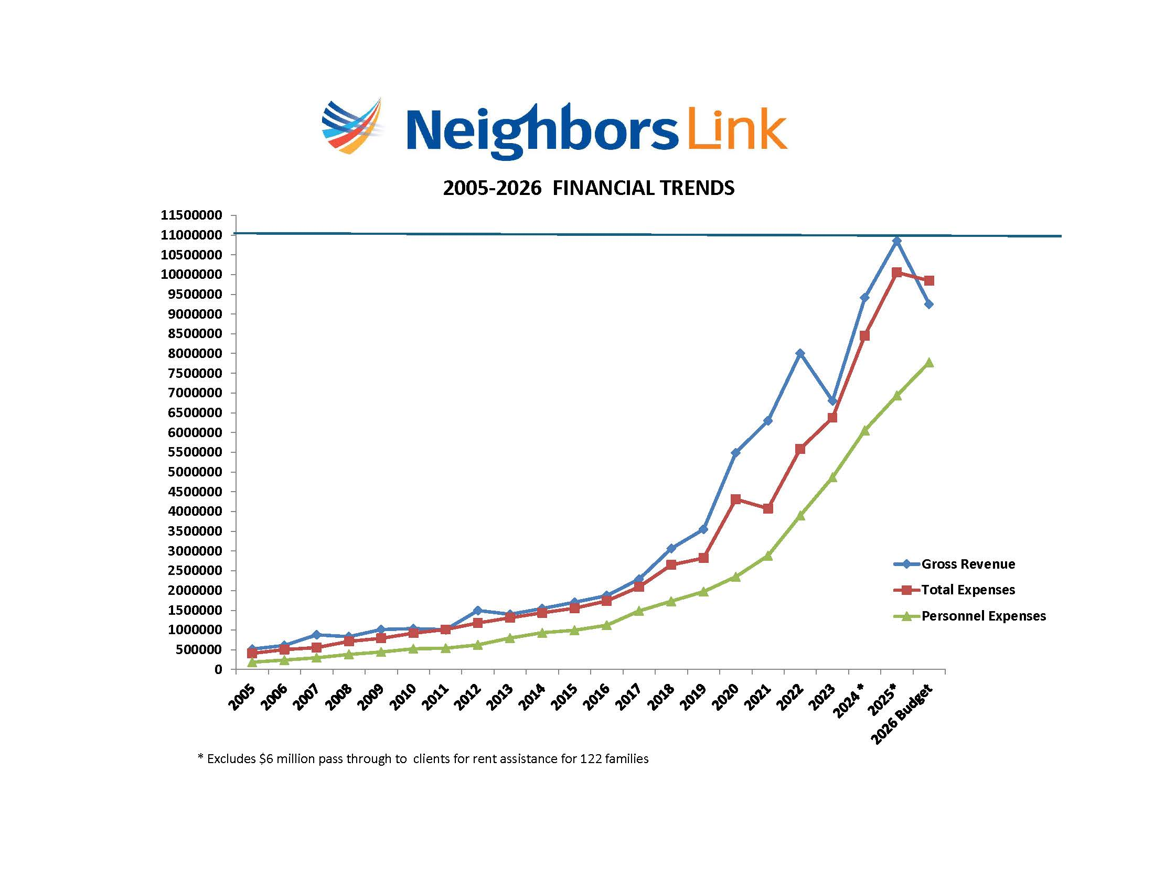

The Inclusion Campaign – Executive Summary
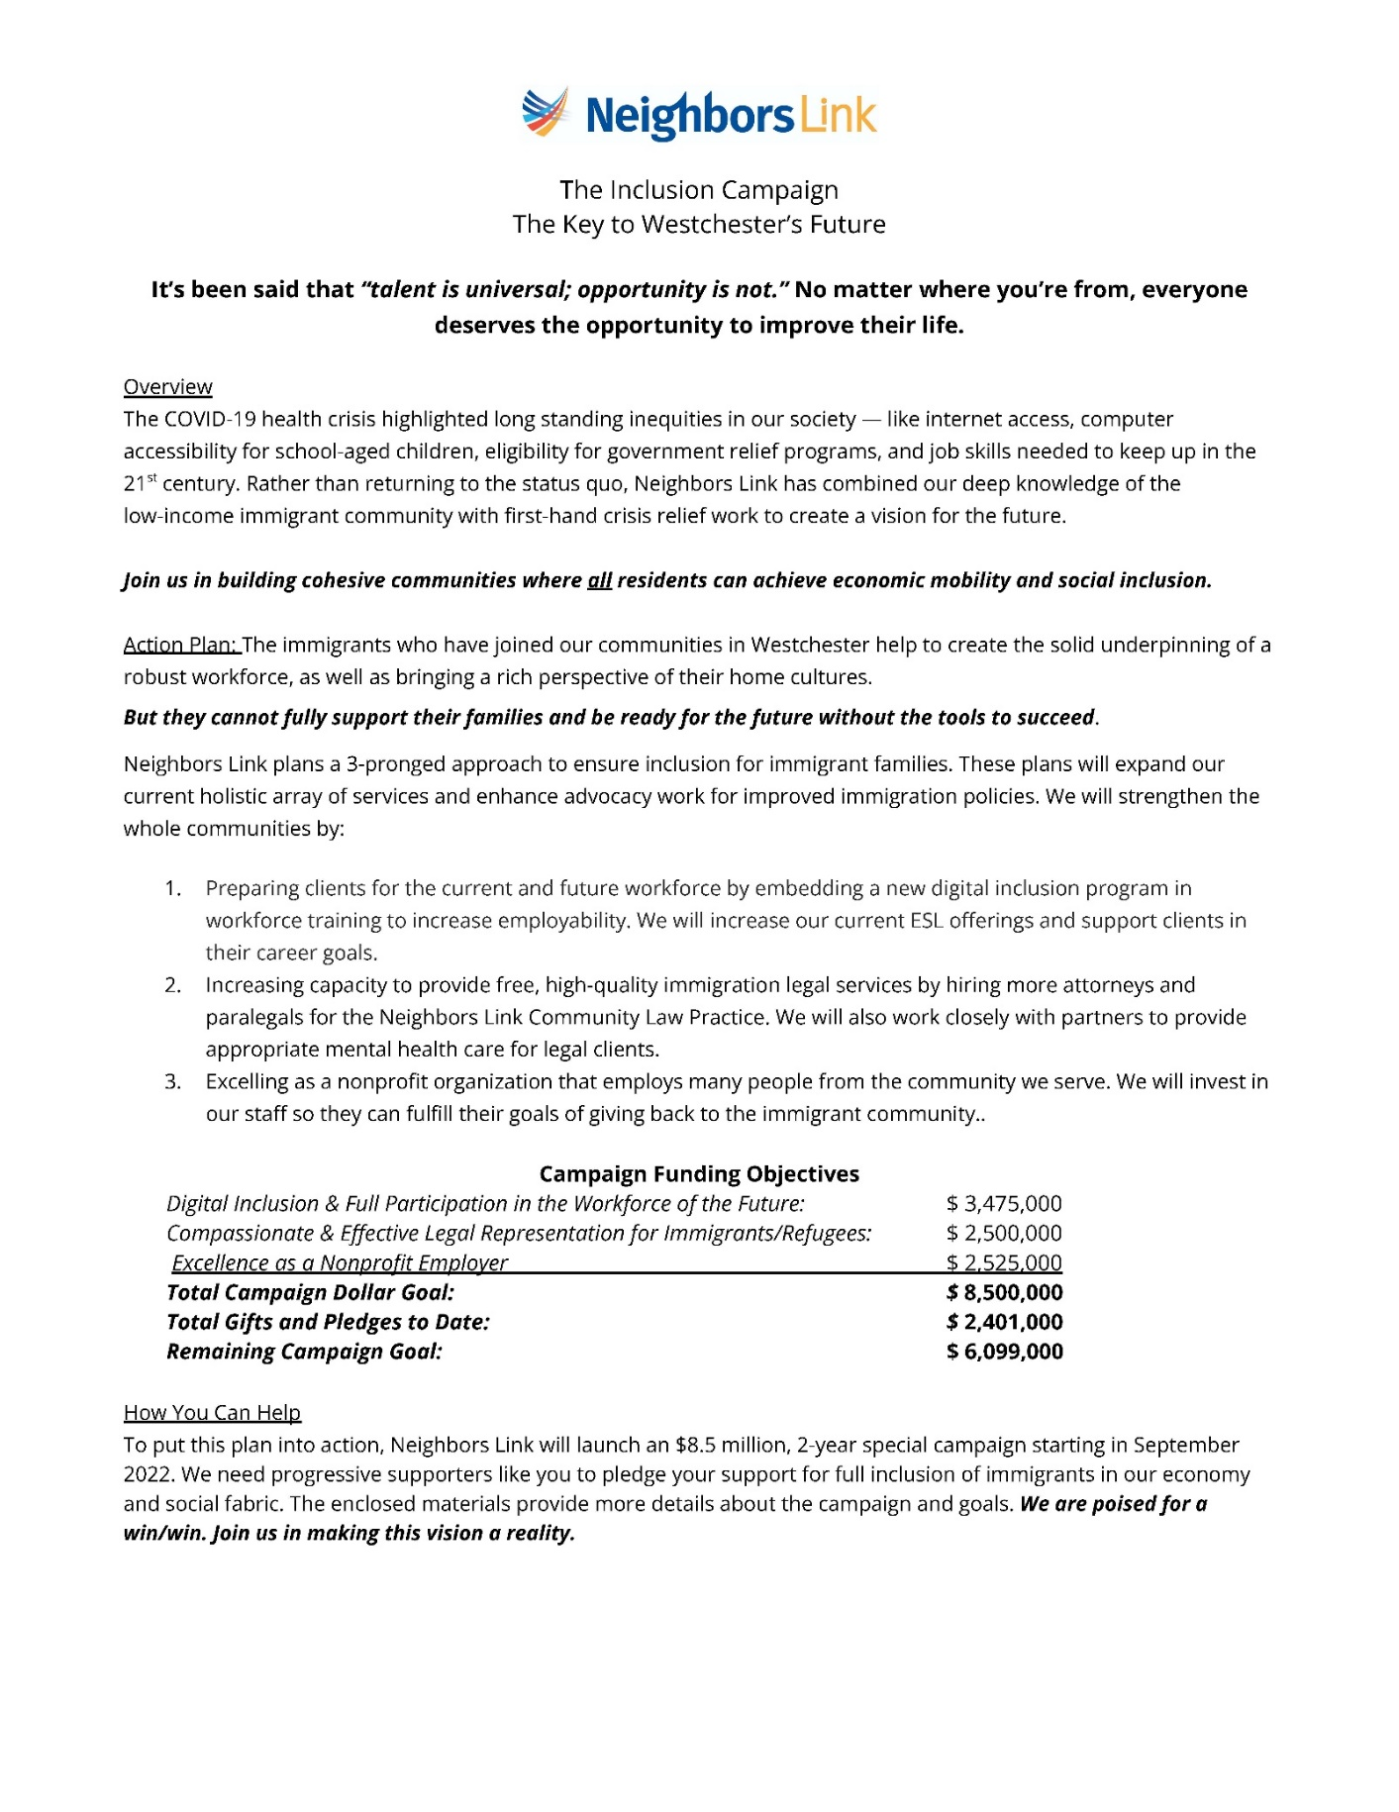


Campaign Update September 2025


2026 Budget Presentation



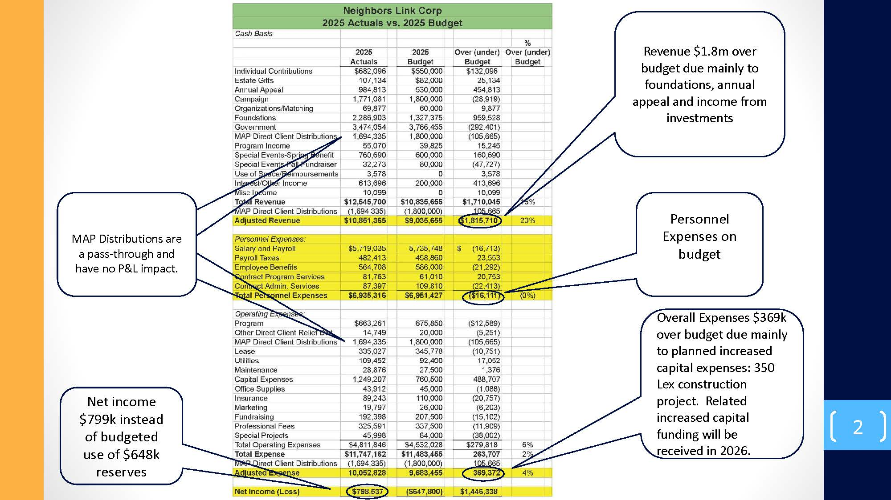

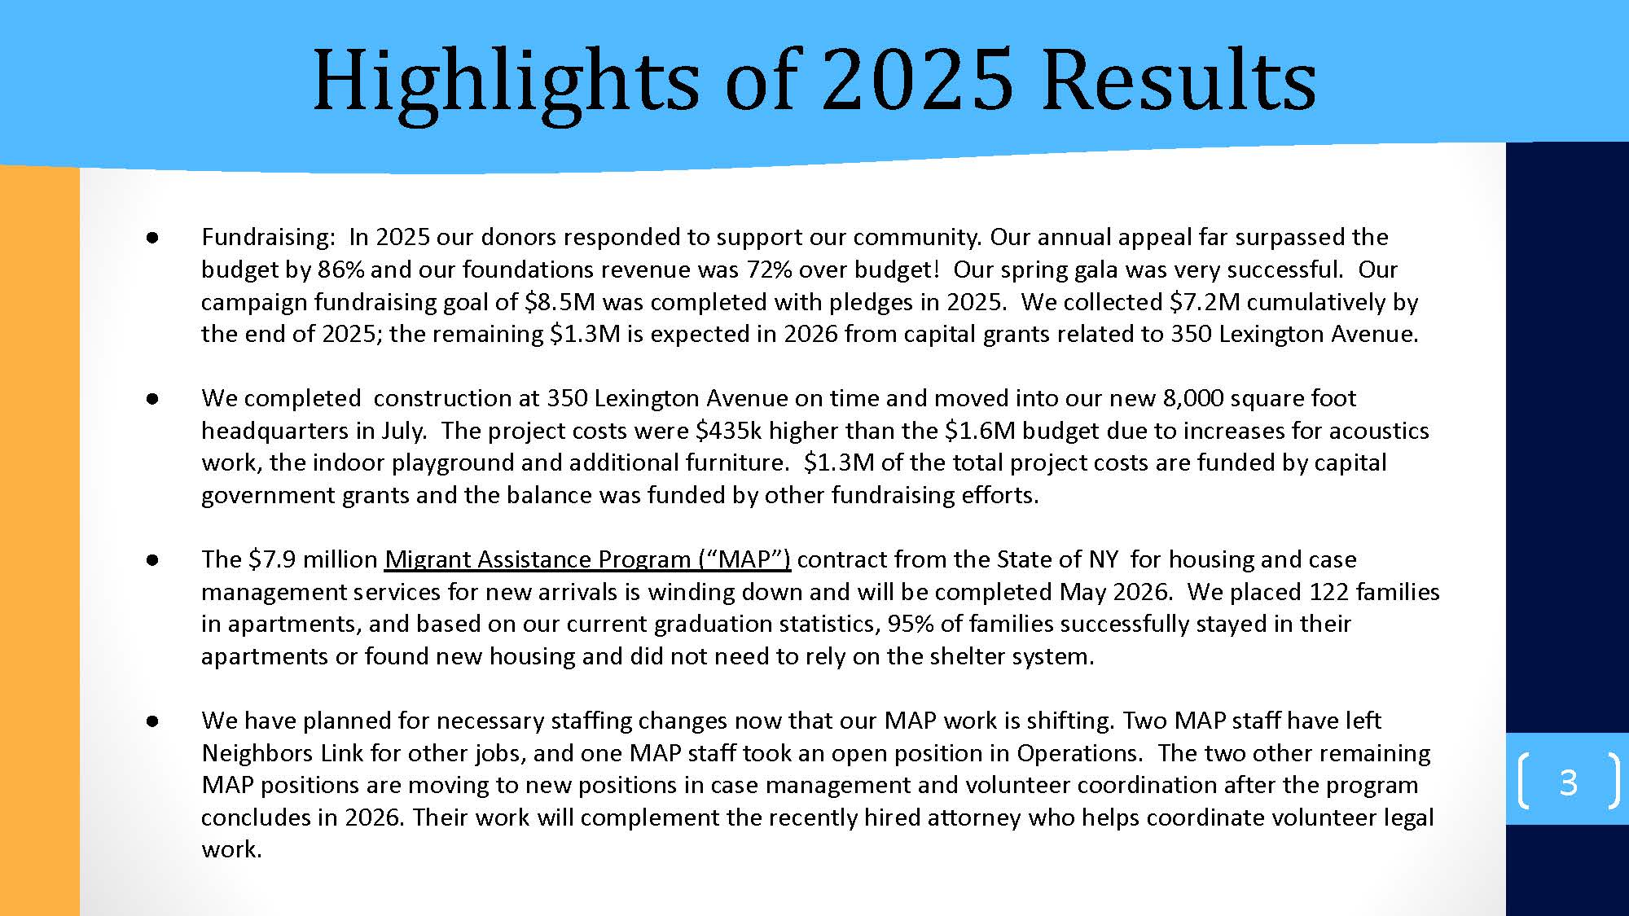

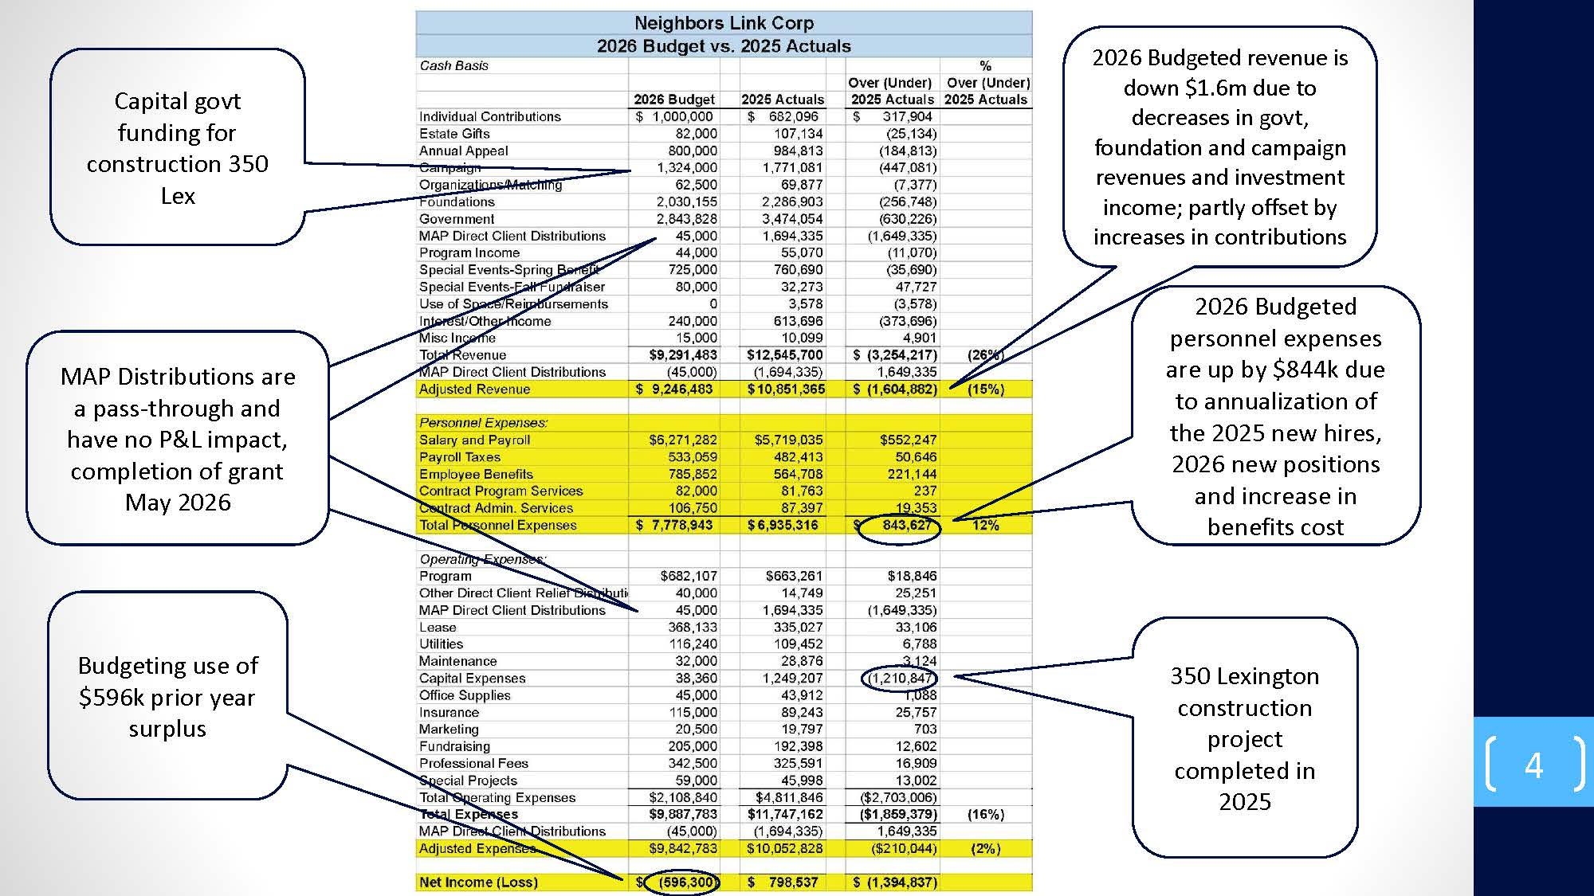

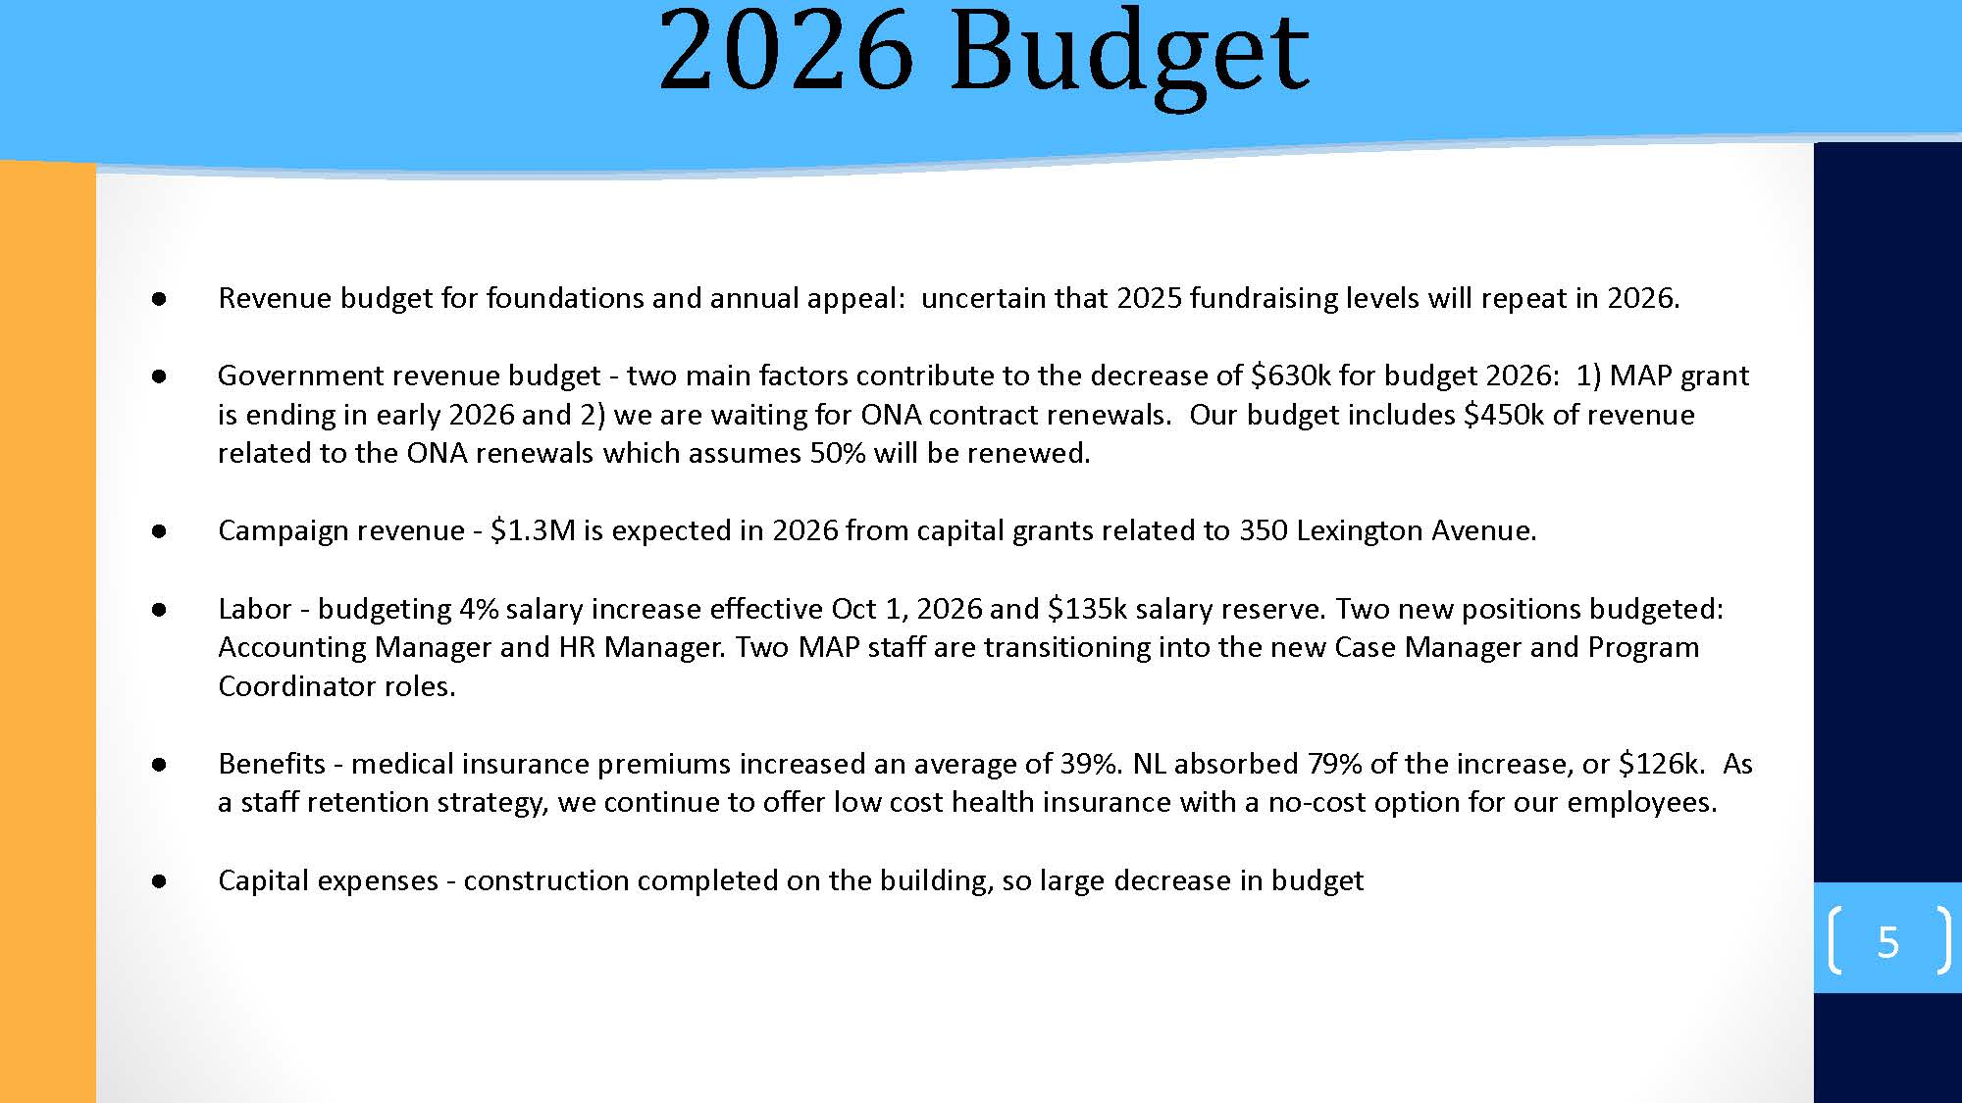

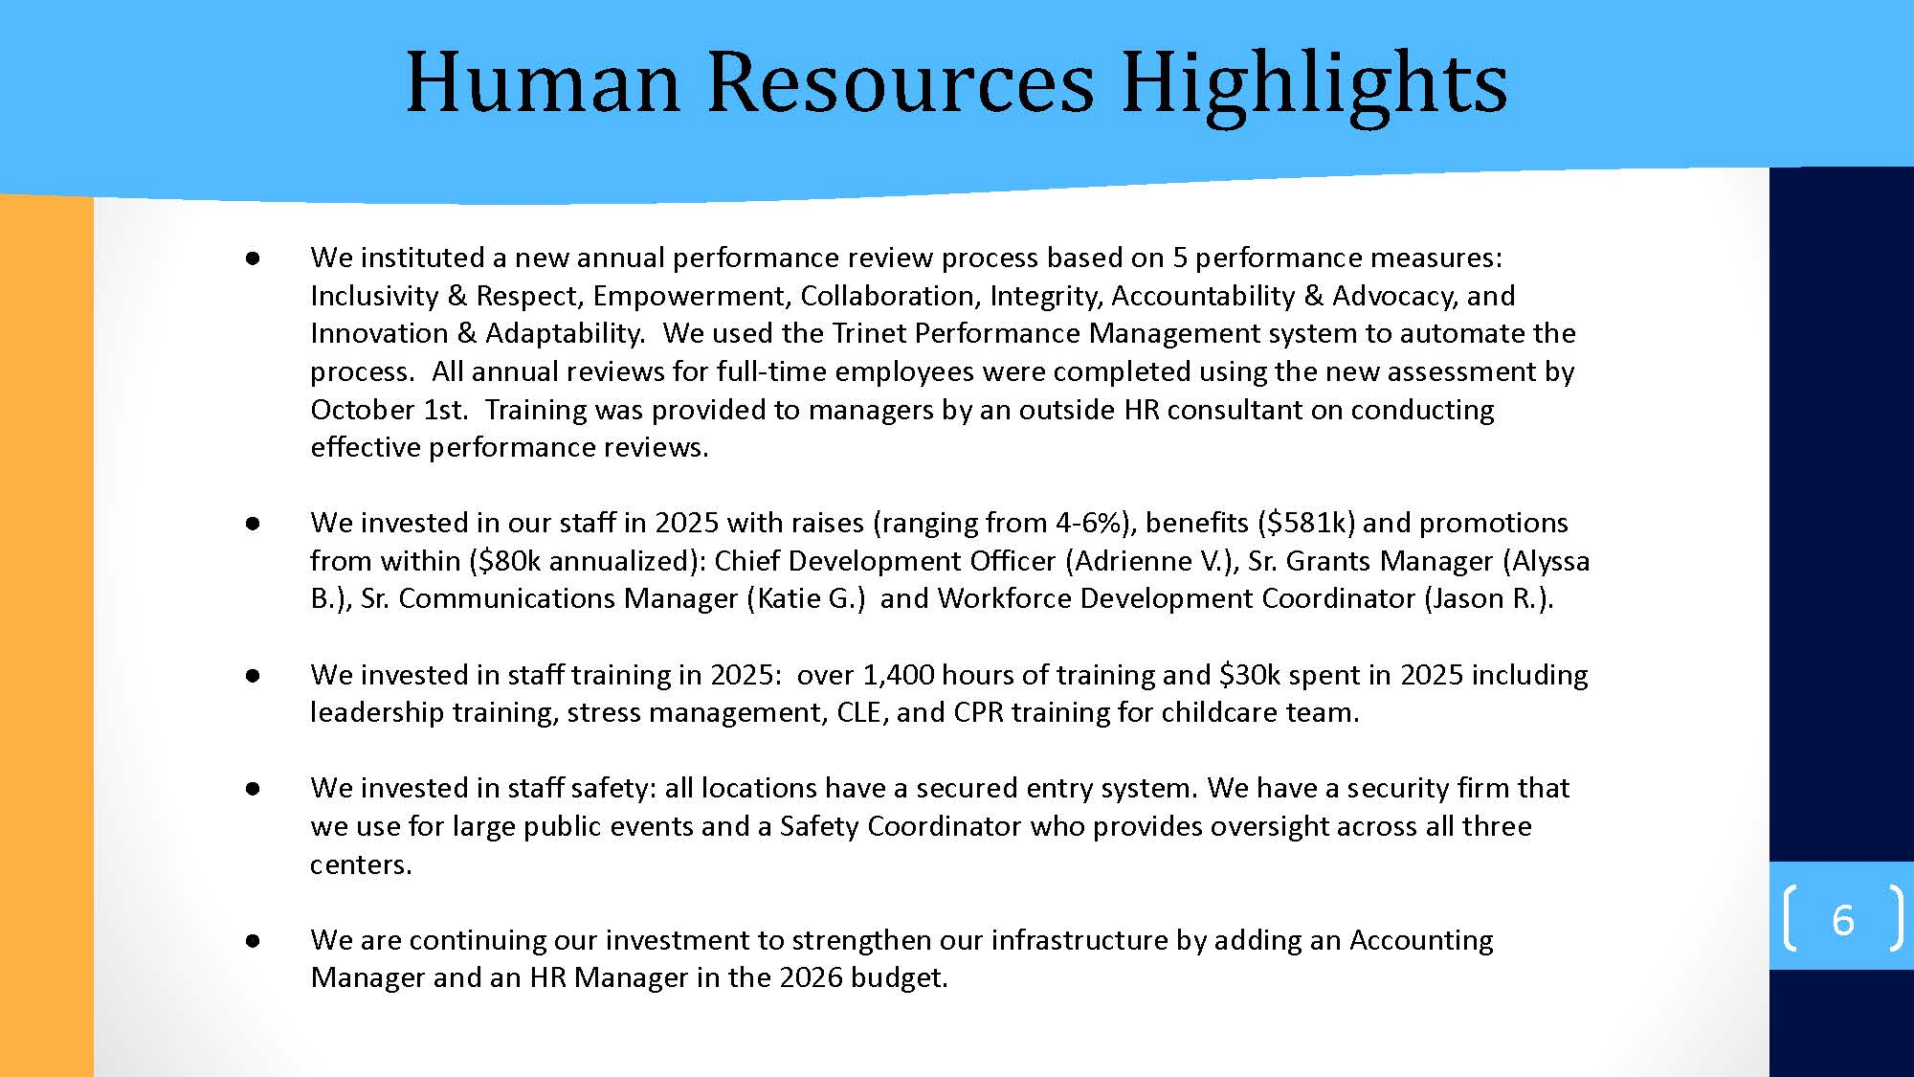



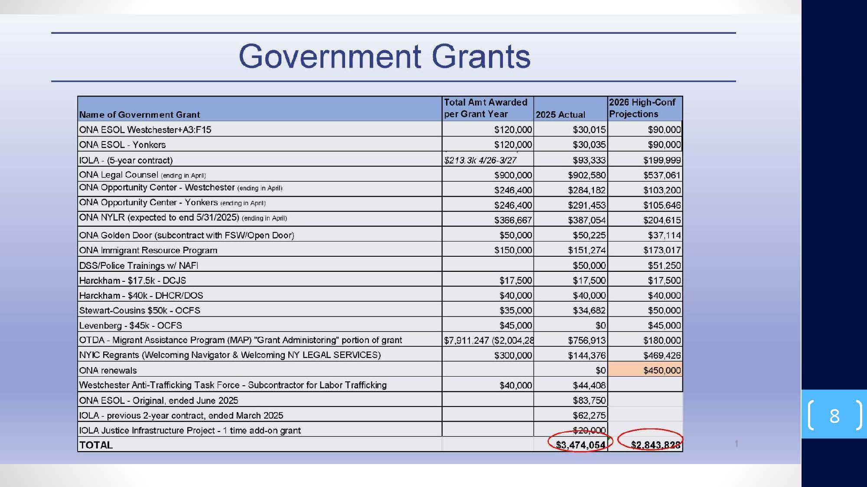

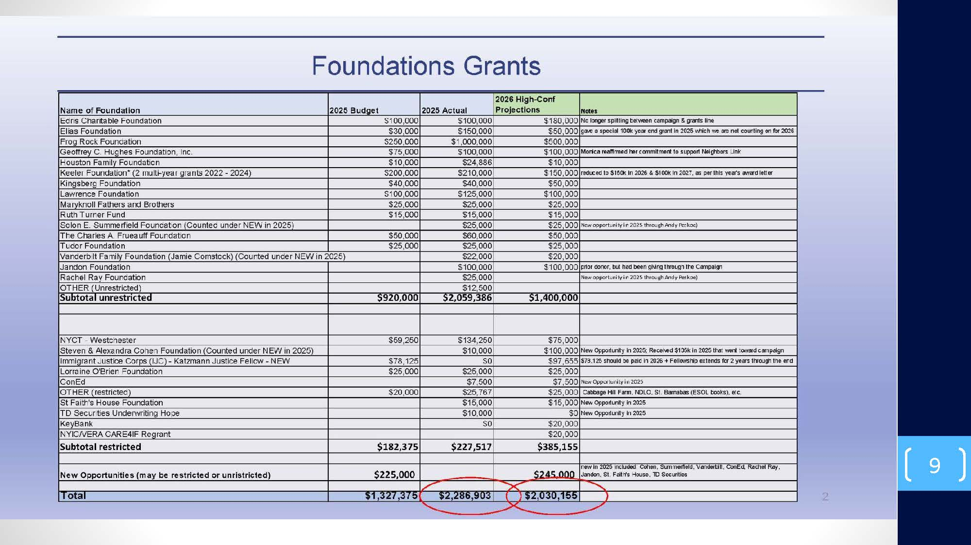

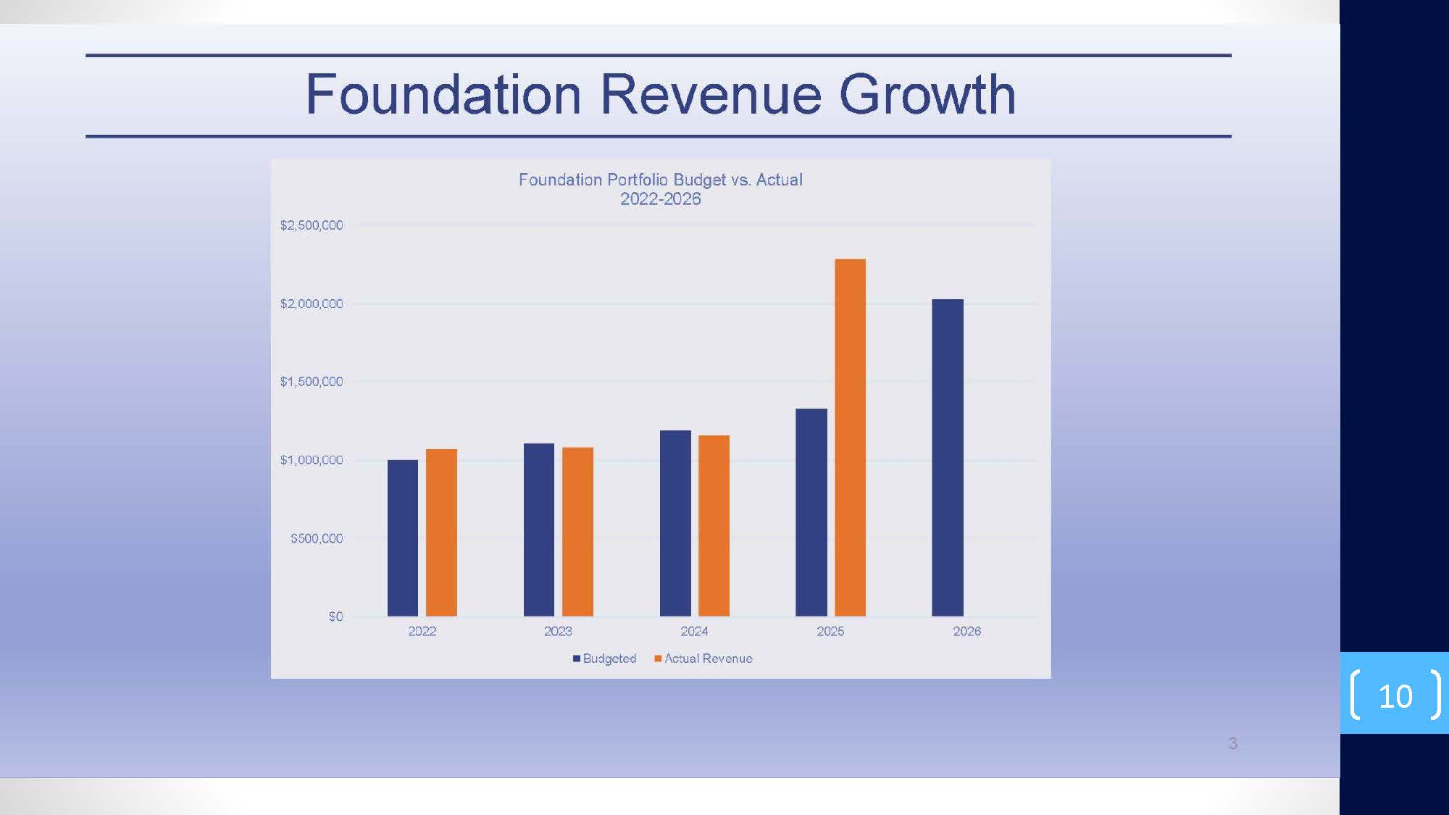

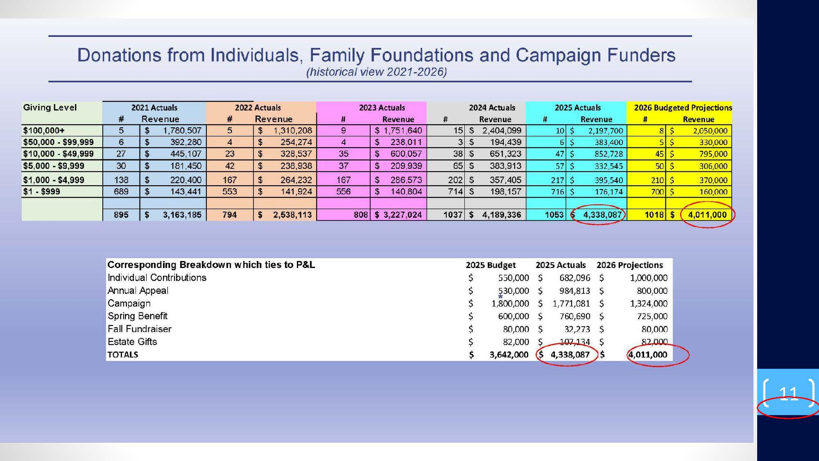

Insurance Coverage Overview (updated Oct 18, 2025)

Coverage |  | Description | Term | Limits | Company | Premium
General Liability INCL Abuse and Molestation and Social Professional | Covers 3rd party lawsuit brought against you for bodily injury and property damage |  | 8/1/25-26 | $1,000,000 occurrence  $2,000,000 aggregate | Alliance Nonprofits | $17,464
Commercial Umbrella | Excess Liability Above GL Only |  | 8/1/25-26 | $1,000,000 liability | Alliance Nonprofits | $1,373
Commercial Umbrella | Excess Liability Above GL Only |  | 9/16/25-8/1/26 | $2,000,000 liability | Century Surety | $3,105
Excess Professional Liability | Any professional services advice, not including attorneys |  | 9/23/25- 8/1/26 | $1,000,000  liability | Kinsale | $9,151
Property Insurance | Contents, Computers, and Improvements & Betterments |  | 8/1/25-26 | See below | Hartford | $3,735
Employee Dishonesty | Employee Theft |  | 8/1/25-26 | $1,000,000 | Chubb | $2,561
Directors and Officers with Employment Practices | Liability to cover the individual board members for wrongful acts |  | 9/25/25-26 | $3,000,000 D&O  $3,000,000 EPLI | CNA (Continental Casualty Co) | $5,833
Cyber Security | Liability for Hacking Incidents |  | 11/19/25 - 26 | $1,000,000 per claim | Chubb | $3,676
Employed Lawyers Professional | Liability for the in-house lawyers that work for NL and volunteers |  | 6/1/25-26 | $1,000,000 occurrence  $2,000,000 aggregate | Cincinnati Specialty Underwriters  (CSU Producer Resources Inc) | $19,244
Disability (ST & LT) & Employee Life Insurance | Off the job injury |  | With PEO (benfits) | 60% of wages | The Hartford | $19,467
Workers Compensation | On the job injury |  | With PEO | $2,000,000 | Aon Risk Services | $38,000
Total Premiums |  |  |  |  |  | $123,609

Property Insurance (Additional Information)
350 Lexington Avenue, Mount Kisco, NY - $210,000 Business Personal Property (BPP), $65,000 Computers, $1,410,813 Improvements & Betterments
23-25 Spring Street, Ossining, NY - $80,300 BPP, $46,000 Computers, $188,000 I&B
320 Walnut Street, Yonkers, NY - $13,700 BPP, $10,000 Computers

Lobbying Regulations

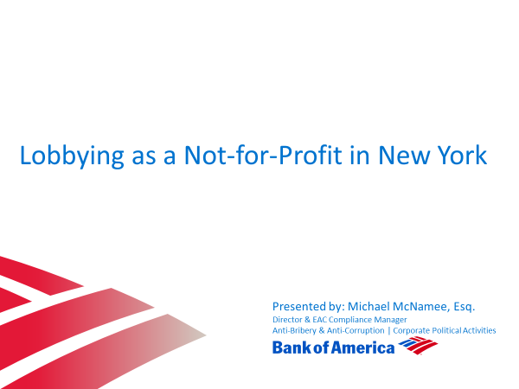



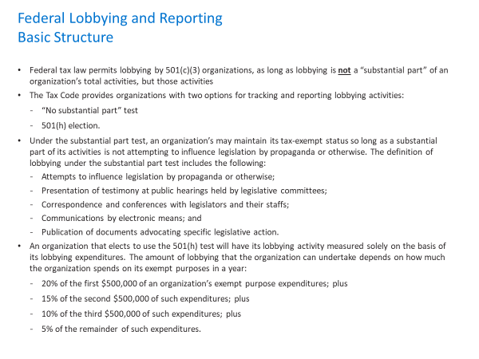
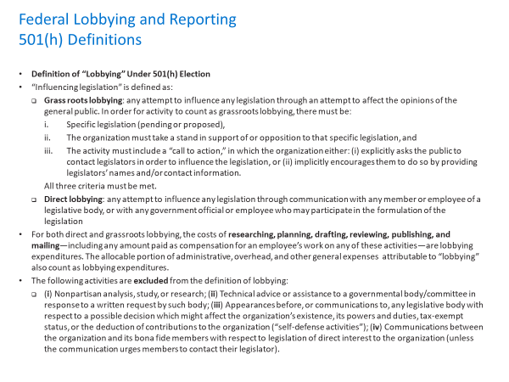
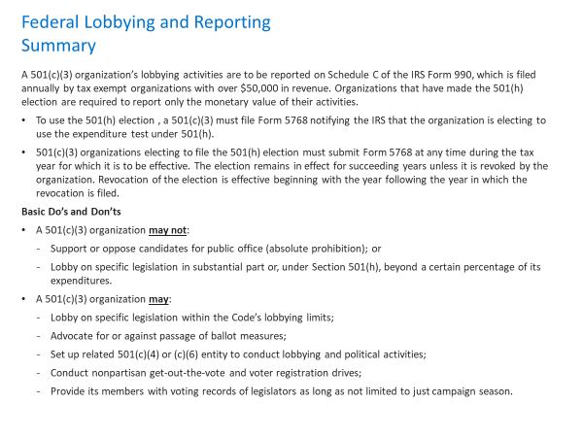



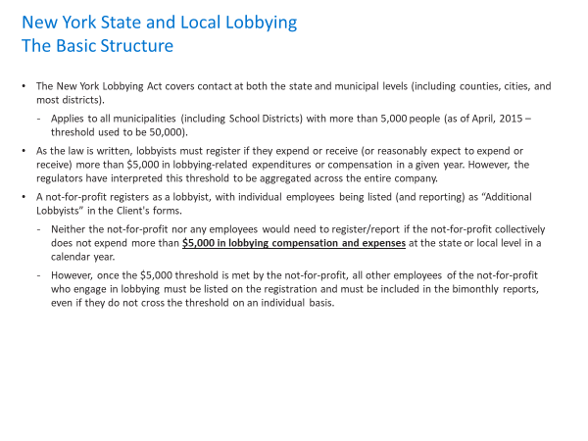
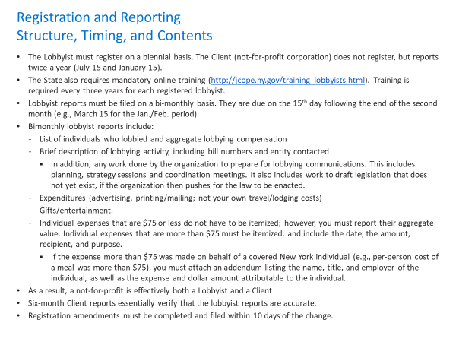

Appendix

Employee Emergency Fund



The Neighbors Link Employee Emergency Fund - Helping One Another
April 1, 2020

The Neighbors Link’s Employee Emergency Fund (EEF) was formed to provide financial as well as other forms of assistance to Neighbors Link’s employees and their families who are in crisis. The Employee Emergency Fund is a way to address these crises by providing financial and other forms of assistance to those affected by extreme hardship.

A committee of 3 people comprised of 2 board members and one management team members evaluates requests for assistance from affected individuals and/or requests from concerned parties, allowing a multitude of perspectives on how best to address the request. Human Resources will clear all applicants as In Good Standing with the organization. Requests are kept strictly confidential and secure and committee members and HR Director are asked to sign a confidentiality statement.

Requests for assistance from the Employee Emergency Fund can be made by completing an application for assistance to our Controller and HR Director, Kathy Thorsberg at kthorsberg@neighborslink.org

- All employees are eligible
- Tenure with the organization will be included in the evaluation process
- Employees must be in good standing with the organization
- Each application must include some form of documentation to substantiate the crisis or expense
- Employees will be informed of the committee’s decision within one week
- Applications can be written in Spanish or English

- APPLYING DOES NOT GUARANTEE DISTRIBUTION OF FINANCIAL ASSISTANCE. ALL DISTRIBUTIONS ARE BASED ON NEED AND MONETARY AVAILABILITY OF THE FUND.

A few more things to consider:
Let’s assess when we have given $30k and reevaluate
Should there be any criteria or way to prioritize?
A few employees may need immediate assistance, can we move fast for those and get them approved by the Executive Committee before the committee is formed

Client Cash Relief Program

“Relative” means your domestic partner, spouse, ancestors, siblings and their spouses, children and their spouses, grand children and their spouses, and great-grandchildren and their spouses.
“Financial Interest” means a direct or indirect economic benefit from any transaction, agreement, or compensation arrangement involving the Corporation, including, but not limited to, direct or indirect renumeration, or gifts or favors that are not insubstantial.

