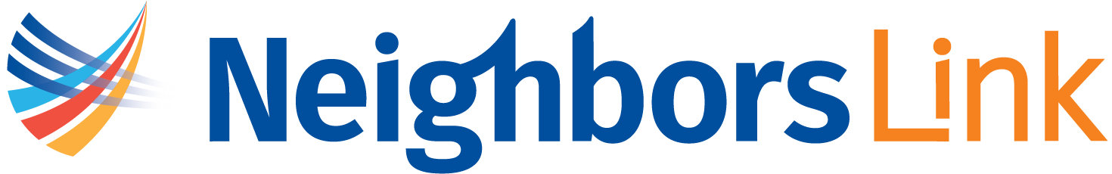
NEIGHBORS LINK STRATEGIC PLANNING PRIORITIES
Strategic Priorities — Preliminary Draft
Prepared: September 2026; revised October 2026 with feedback from the Strategic Planning Committee
Status: For Strategic Planning Committee discussion — not yet approved by the Board of Directors
Introduction
For more than 25 years, Neighbors Link has worked to strengthen the whole community through the healthy integration of immigrants. We advance our mission by empowering families through a range of programs and welcoming community gathering places, by engaging the broader community, and by advocating for healthy immigrant integration. All of these efforts rely on a strong organization and on strong community partnerships.
The environment in which our clients live and our organization operates has changed dramatically. A sustained and escalating immigration crisis has placed unprecedented demands on our community, our staff, and our services. At the same time, rapid changes in technology, including artificial intelligence, and in the regional economy are reshaping how people learn, work, and connect. This moment calls for an organization that is both steady and bold: grounded in the trust we have earned, and ready to learn, experiment, and invest in new ideas.
The following priorities serve as a roadmap for the future, guiding how Neighbors Link invests its time and resources. Across all three, Neighbors Link will seek out, learn from, and invest in new, creative, and innovative ideas, including thoughtfully exploring where emerging technologies can strengthen our programs and operations.

Strategic Priority 1: Protect, Defend, and Empower
Neighbors Link will protect, defend and empower the clients, their families, and the community we serve with the information and education, legal support, and mental health resources they need to withstand a sustained and escalating immigration crisis. Neighbors Link will strengthen its legal practice infrastructure, deepen community engagement and education, advance public advocacy for policies that respect the dignity of every person, expand access to mental health support and evolve its rapid response model to anticipate emerging needs.
Strategic Priority 2: Economic Mobility
Neighbors Link will create clear, connected pathways that help clients build skills, earn credentials, and advance in careers of their choosing so that they can move towards greater financial stability. Neighbors Link will offer a continuum of ESOL and technology classes, keep digital literacy offerings current, and build partnerships with employers to create a pipeline to quality jobs. As we deepen the Carreras y Caminos program, we will bring the same entrepreneurial spirit we see in our clients to our work, testing new approaches, learning quickly, and growing what works.
Strategic Priority 3: Organizational Strength and Sustainability
To advance as a leader in immigrant integration, Neighbors Link will invest in the people, systems, and resources that power its mission, including: (1) investing in its people and culture through professional and leadership development, staff mental health and wellness and engaging volunteers who extend our capacity; (2) sustaining, growing and diversifying our fundraising to support new and innovative work; and (3) investing in technology, such as artificial intelligence and data management, to improve program outcomes and efficiencies.

